

**18 Days To Go for the MORE JOZI Event!**

With just 18 Days To go before the Gauteng SANSUI Summer Cup “MORE JOZI” event which will be hosted by the dazzling Dineo Moeketsi at the Turffontein Racecourse on the 28th November 2015, there is no slowing down for RBJ Marketing Solutions with their craze for Public Relations and Marketing.

RBJ Marketing Solutions is the official PR Team for this year`s MORE JOZI event!

Known for their flair in marketing and speciality in events management, the RBJ Team lead by CEO- Jeff Madibeng surely knows how to keep the ball rolling when it comes to PR. There has been no stopping of the hard work since the very first activation which took place at club Taboo in Sandton on the 24th October 2015, next on the list was club Movida in Sunninghill on their busiest day of the year and by no surprise everyone came out to play in their Halloween costumes. Prizes were given away including a 32” SANSUI TV which was awarded to Bianca Balutto for best Halloween dressed!

The RBJ Team took the activation to an even bigger crowd at the Ligwalagwala FM 1st Annual Hip Hop Summer Jam. The event captivated a massive Hip Hop crowd at the Centurion`s famous Shisa Nyama. With over 900 people who attended the event, there was no doubt that the Gauteng SANSUI Summer Cup activation would be epic and indeed it was so. The SANSUI prize was given to the well-deserved popular MC Lolli from Pretoria for his best rapper performance. In an interview after the performance, MC Lolli thanked Gauteng SANSUI Summer Cup for giving him the prizes and concluded the interview by saying, “Catch me at the Turffontein Racecourse on the 28th November 2015 at the Jozi Circle”. All 3 other rappers were each awarded X1 double tickets for the Jozi Circle.

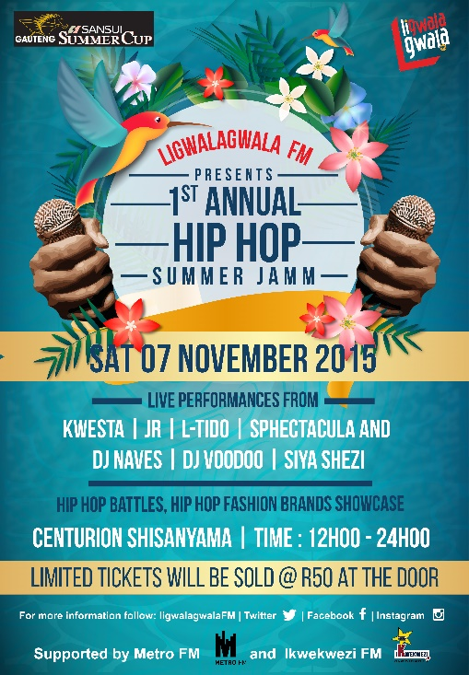For updates on the Gauteng SANSUI Summer Cup Activations and for a chance to win prizes, follow **@RBJ_MARKETING @SASNUISUMMERCUP**

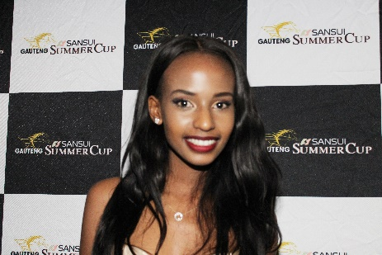[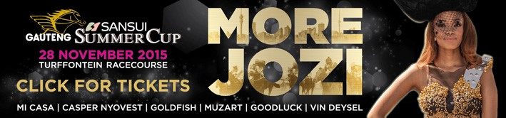](http://sansuisummercup.co.za/)