

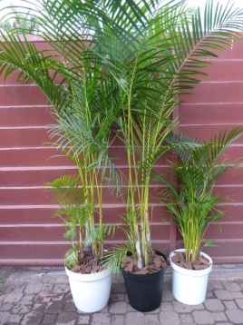 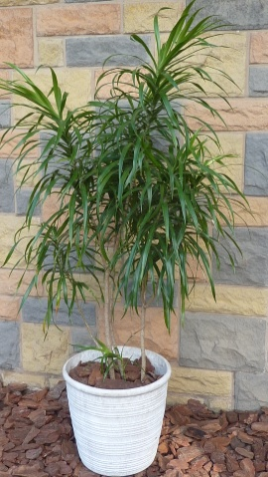 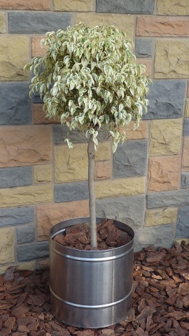 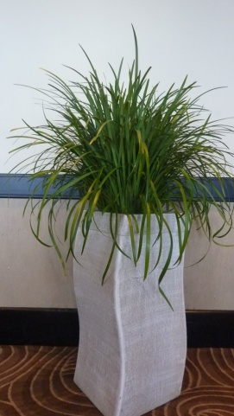 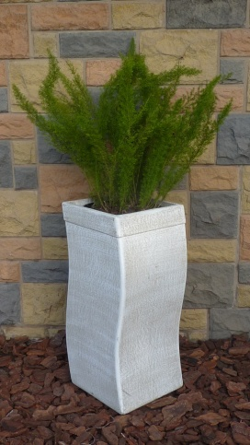

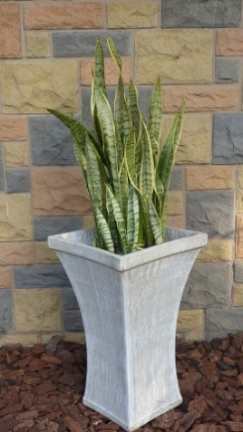 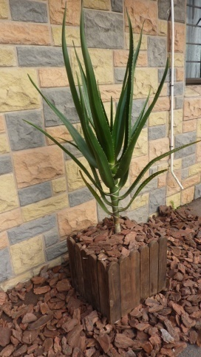 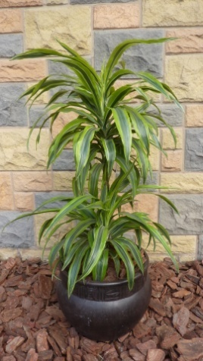 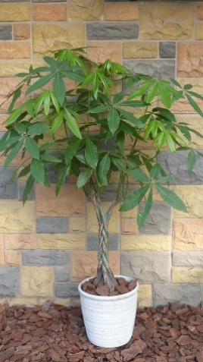 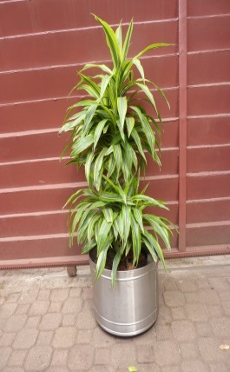

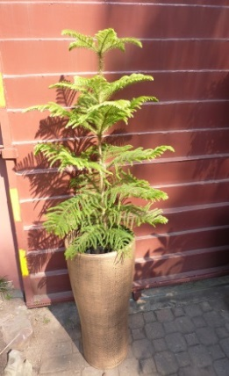 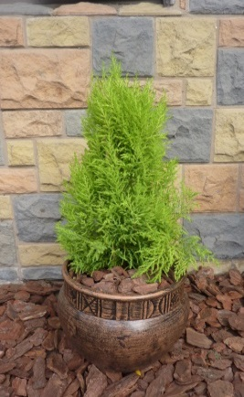 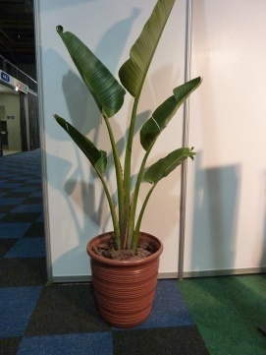 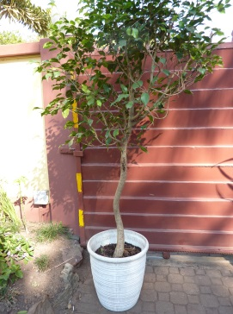 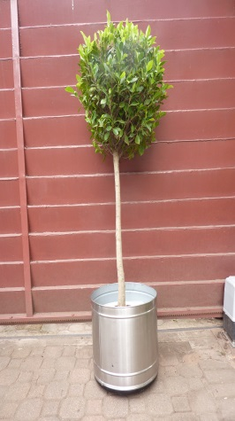

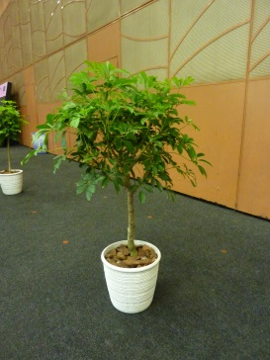 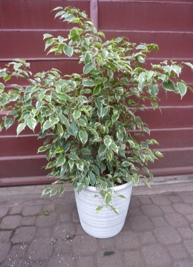 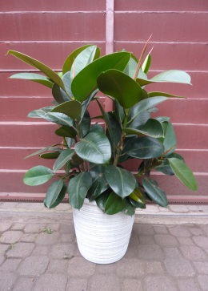 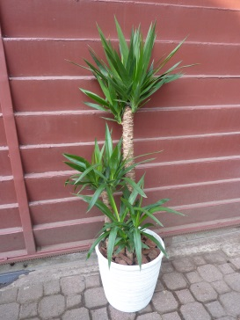 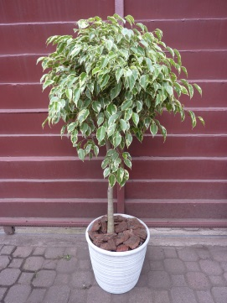

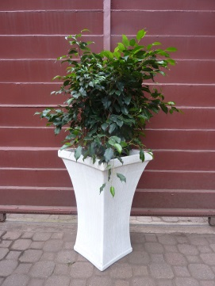 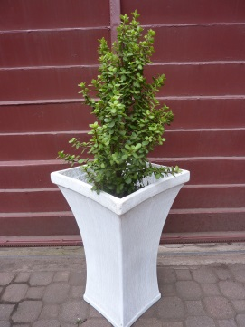 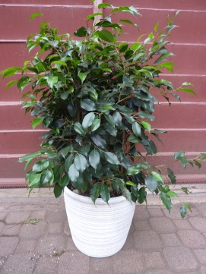 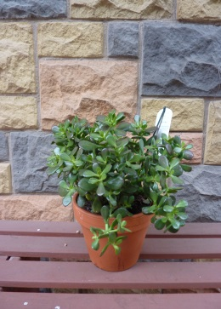 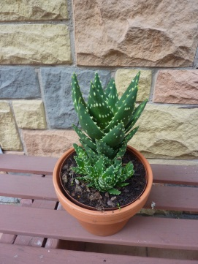

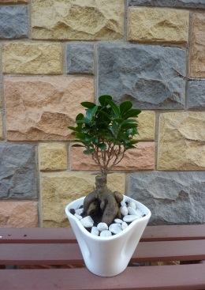 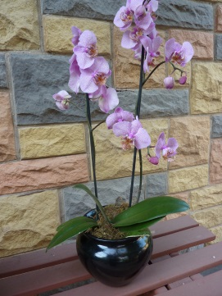 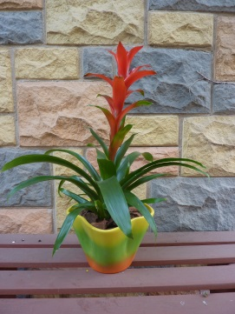 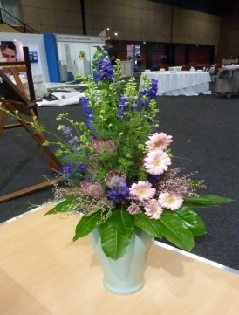 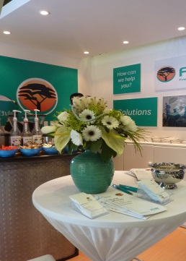

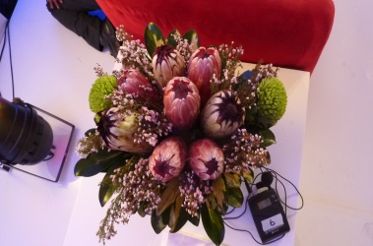 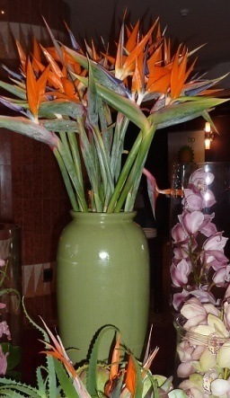 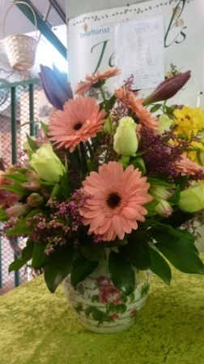 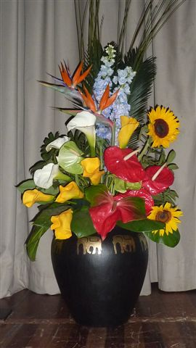 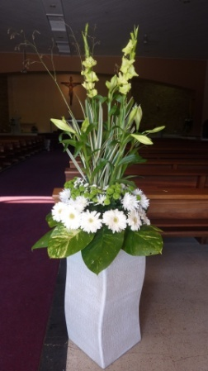

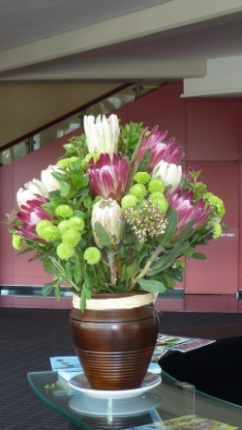 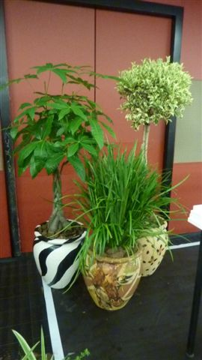 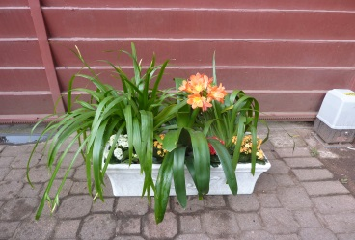 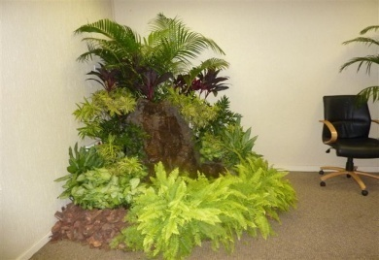

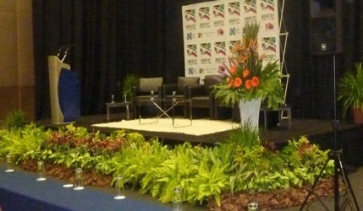 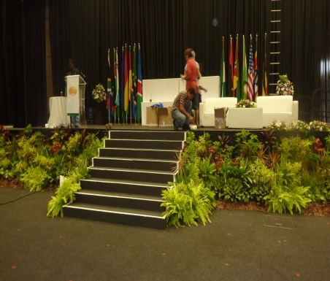 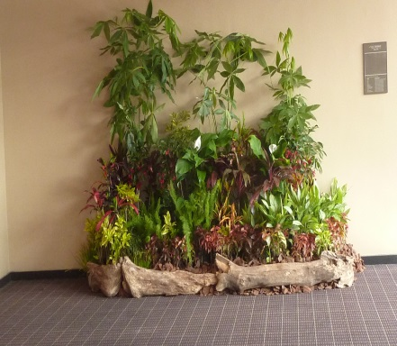



|  |  |  |  |  |  |  |
| --- | --- | --- | --- | --- | --- | --- |
| **Company Name :** | |  | | | | |
| **Tel/Fax/Email :** | |  | | | | |
| **Stand No. :** | |  | | | | |
| **Authorised Person :** | |  | | | | |
| **Name of Exhibition/time/venue:** | |  | | | | |
| **PLEASE EMAIL TO plantinn@telkomsa.net / call on 082 4429775 PRICE HIRE 2016** | | | | | | |
| **ITEM** | **DESCRIPTION** | | **HEIGHT IN POT** | **PRICE** | **QTY** | **SUB TOT** |
| **1** | **Bamboo palm in white plastic pot** | | **2m – 3m** | **300** |  |  |
| **2** | **Bamboo palm in black/ white plastic pot** | | **1.2m-1.8m** | **250** |  |  |
| **3** | **Bamboo palm in white plastic pot** | | **0.8m – 1.2m** | **200** |  |  |
| **4** | **Dracaena in white/terracota pottery pot** | | **1.2m** | **250** |  |  |
| **5** | **Lollypop ficus, variegated in silver pot** | | **1.8m** | **400** |  |  |
| **6** | **Lirope in white/brown CYCLONE pot** | | **1.4m** | **380** |  |  |
| **7** | **Asparagus in white CYCLONE pot** | | **1.2m** | **300** |  |  |
| **8** | **Sanseveria in white CLASSIC pot** | | **1.3m** | **300** |  |  |
| **9** | **Aloe in wooden box/pottery pot** | | **1m** | **250** |  |  |
| **10** | **Dracaena in ULUNDI pot** | | **1.4m** | **300** |  |  |
| **11** | **Pachira in white/brown pottery pot** | | **1.6m** | **350** |  |  |
| **12** | **Dracaena on silver pot** | | **1.4** | **350** |  |  |
| **13** | **Conifer in brown/white pottery TIVOLEE pot** | | **1.6** | **300** |  |  |
| **14** | **Conifer in ULUNDI pot** | | **1.6m** | **250** |  |  |
| **15** | **Strelitzia in brown/white pottery pot** | | **1.8m** | **350** |  |  |
| **16** | **Ficus in white/brown pottery pot** | | **2.2m** | **350** |  |  |
| **17** | **Lollypop green ficus in silver pot** | | **1.8m** | **400** |  |  |
| **18** | **Scheflera in white pottery pot** | | **1.6m** | **350** |  |  |
| **19** | **Ficus bush, variegated in white pottery pot** | | **1.2m** | **250** |  |  |
| **20** | **Ficus Elastica in white pottery pot** | | **1.2m** | **250** |  |  |
| **21** | **Yucca in white pottery pot** | | **1.6m** | **350** |  |  |
| **22** | **Lollypop ficus in pottery pot** | | **1.8m** | **350** |  |  |
| **23** | **Ficus green, bush in CYCLONE pot** | | **1.6m** | **300** |  |  |
| **24** | **Aloe in Cyclone pot** | | **1.4m** | **300** |  |  |
| **25** | **Ficus green, bush in white pottery pot** | | **1.2m** | **250** |  |  |
| **26** | **Succulent for desk in pottery pot** | | **0.4m** | **200** |  |  |
| **27** | **Cactus for desk in pottery pot** | | **0.4m** | **200** |  |  |
| **28** | **Bonsai for desk in ceramic pot** | | **0.4m** | **300** |  |  |
| **29** | **Orchid (white,pink,yellow) in ceramic pot** | | **0.8m** | **300** |  |  |
| **30** | **Potplant for desk in ceramic pot** | | **0.4m** | **200** |  |  |
| **31** | **Tall vase with flowers – colour…………………….** | | **0.9m** | **650** |  |  |
| **32** | **Medium vase with flowers – colour…………….** | | **0.6m** | **500** |  |  |
| **33** | **Small vase with protea** | | **0.4m** | **450** |  |  |
| **34** | **Tall vase with strelitzia** | | **0.8m** | **550** |  |  |
| **35** | **Medium vase with gerbera – colour…………..** | | **0.6m** | **500** |  |  |
| **36** | **Large stage flowers – colour………………………..** | | **1.2m** | **1200** |  |  |
| **37** | **Large stage flowers – colour………………………..** | | **1.4m** | **1400** |  |  |
| **38** | **Medium vase with protea** | | **0.6m** | **550** |  |  |
| **39** | **Animal pottery pots with mix plants** | | **1.4m** | **350** |  |  |
| **40** | **0.8m long pottery/wooden tray with mix plants** | | **0.6** | **350** |  |  |
| **41** | **Landscaping with water feature** | | **1.8** | **2000** |  |  |
| **42** | **0.5m tall STAGE landscaping with mix plants** | | **0.5m** | **650** |  |  |
| **43** | **1m tall STAGE landscaping with mix plants** | | **1m** | **700** |  |  |
| **44** | **Tropical landscaping per square meter** | | **0.3m – 2.5m** | **750** |  |  |