Kodie Grantham

Des Moines, Iowa

kodie.grantham@gmail.com

kodieg.com linkedin.com/in/kodie github.com/kodie

Background

Selftaught in all skills listed above. Over 17 years of personal computer and web development experience. Excellent ability to investigate, diagnose, and resolve all technical problems. Extremely quick learner with the desire to always be learning and broadening my knowledge while staying up to date with new technologies.

Skills

Languages

HTML(5), CSS(3), PHP, JavaScript, C#, XML, JSON, Shell, Visual Basic and a little Java.

Tools/Frameworks

Node.js, jQuery, Underscore.js, Grunt,

Gulp.js, Bower, Composer, MySQL,

MongoDB, and Meteor.

Operating Systems

Microsoft Windows, Linux, Google Android,

and Apple macOS / iOS.

Miscellaneous

Wired and wireless networking, hardware (diagnoses, repair, and replacement), and electrical wiring.
Work Experience
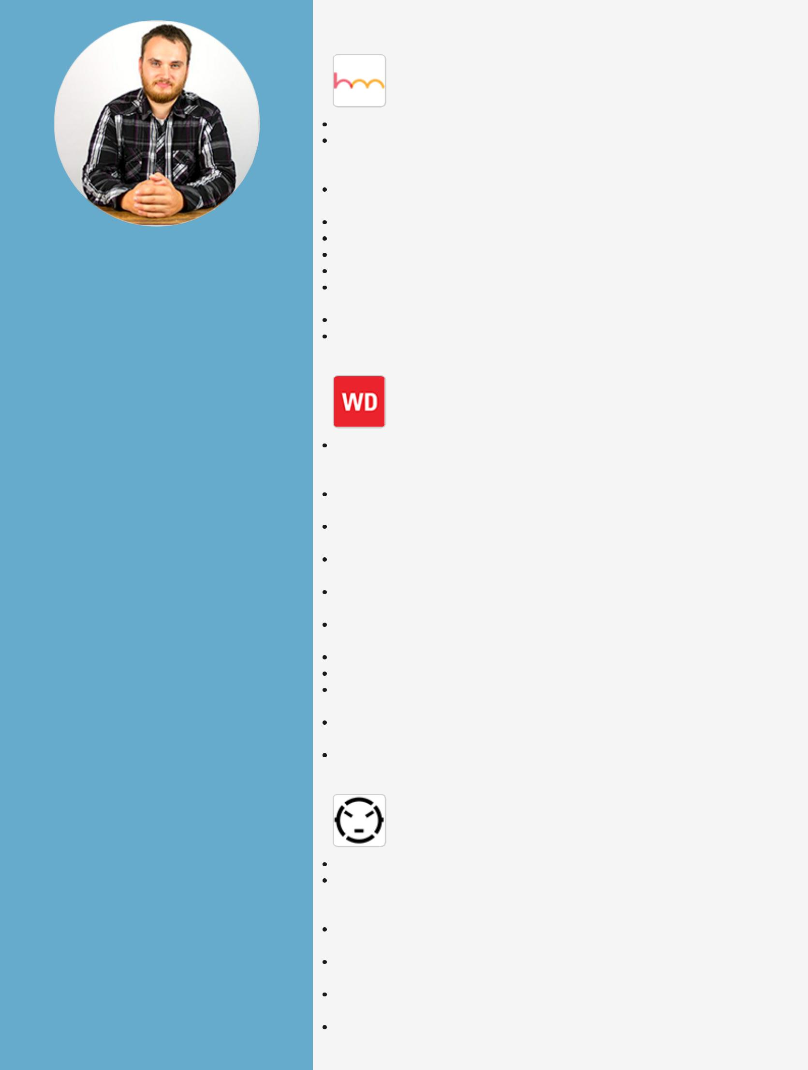
Senior Product Engineer

Happy Medium

March 2016 Current

Sole Engineer/Developer of product software and hardware. Development of web software using Meteor, NodeJS, Blaze, and MongoDB using programming languages such as HTML, CSS, SASS, Javascript, jQuery, JSON, and Mustache.

Development of Androidbased firmware as well as webbased APIs for updates to software.

Development of Wordpress managed, mobileresponsive websites. Development of custom, SHELLbased internal tools.

Onsite installation of digital signage hardware for clients. Management and maintenance of Linuxbased web servers.

API implementation for various uses such as payment gateways, file storage/access, and social media.

Creation of custom CSS3 animations for web projects.

Some minor work with Adobe Photoshop and Illustrator as well as Sketch.

Web Developer

Webspec Design

June 2015 March 2016

Development of custom websites for clients using programming languages such as HTML, CSS, SASS, Javascript, jQuery, PHP, JSON, and more.

Working with designers to create custom, mobile responsive websites for clients.

Development of custom internal tools for use by the development team to help make creating and launching websites more efficient. Development of custom web applications such as employee dashboards, coupon systems, airline tracking systems, etc. Development of custom mobile applications for both Android and Apple devices for clients.

Converting NonCMS websites over to WordPress, SASS, Gulp, Bower, and Composer.

Making desktoponly websites mobile responsive.

Transferring website files along with databases to different servers. Transferring DNS records for websites and changing A, CNAME, and MX records for domain names.

Meeting with clients to discuss potential custom websites as well as working with Project Managers to come up with proposals for clients. Use of web development commandline production tools such as Gulp, Grunt, and Bower.

Owner/Operator
Five Fifteen Printing & Design

November 2013 June 2015

Started the business from the ground up.

Made custom designs to be printed onto tshirts for customers as well as prepping of designs for screen printing using Adobe Photoshop & Illustrator.

Screen printed tshirts and other merchandise using a manual, 4 color screen printing press.

Mixed plastisol inks to create custom Pantone colors at the request of customers for printing.

Coated screens with emulsion as well as exposed designs onto screens for printing.

Handled all customer service, emails, quotes, invoicing, taxes, finances, equipment repair, and ordering of supplies.

Download my resume in other formats at kodieg.com/resume
Work Experience (Continued)
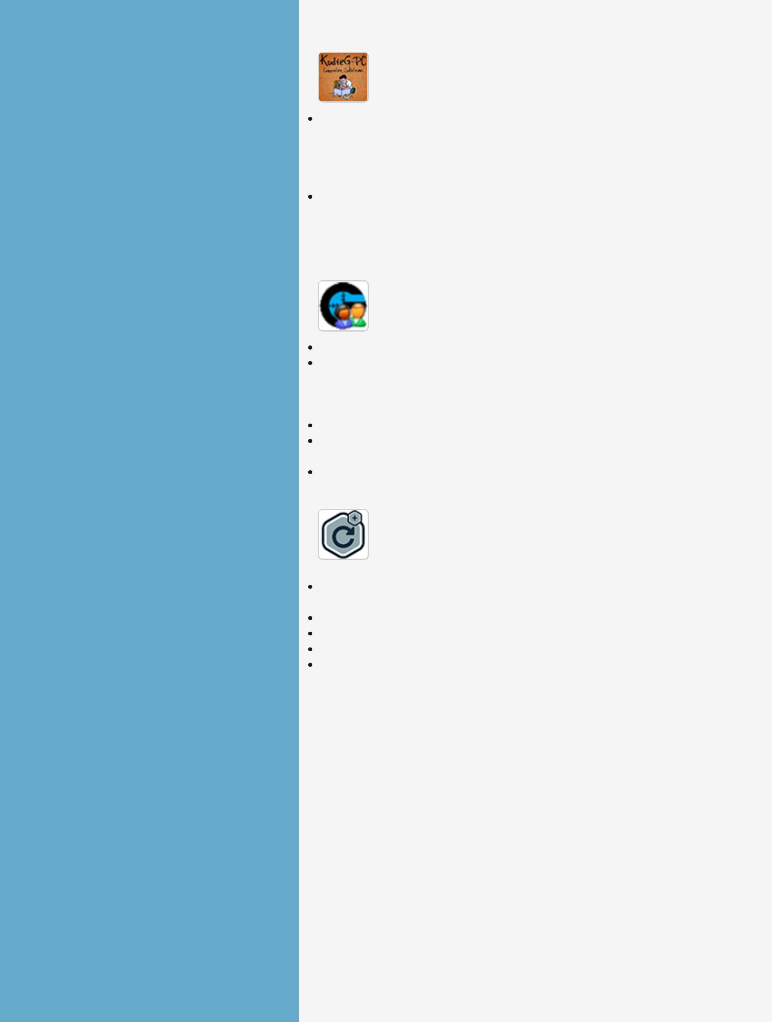
Computer Repair Technician/Web Developer

KodieGPC Computer Solutions

April 2012 June 2015

Diagnosis and repair of any and all technical related problems for customers including but not limited to computer software and hardware, wired and wireless networking, and even troubleshooting of entertainment devices such as TVs, surround sound systems, gaming consoles, and smartphones.

Custom web design and programming as well as web hosting for customers using a wide variety of tools and skills.

Projects

GameRanger Account Switcher (GRAS) kodieg.com/projects/gras/ github.com/kodie/gamerangeraccountswitcher/

A Windows desktop application developed in C#.

A tool for the multiplayer gaming client known as GameRanger. It allows you to log out of a user and log in as a different one so that gamers who share a computer can use their own accounts rather than share one.

Handles moving, renaming, and modifying GameRanger files. Checks for running GameRanger processes and closes them after prompting the user.

Has had over 26,400 downloads since version 1.0 was released October 16th, 2010.

Gravity Forms Repeater AddOn (gfRepeater) kodieg.com/projects/gravityformsrepeateraddon/ github.com/kodie/gravityformsrepeater/ wordpress.org/plugins/repeateraddonforgravityforms/

A WordPress plugin addon for Gravity Forms developed in PHP, JavaScript (jQuery), and CSS (SASS).

Allows specified groups of fields to be repeated by the user.

Hooks into WordPress and Gravity Forms filters.

Extends existing JavaScript functions.

Had had over 4,100 downloads since version 1.0 was released October 11th, 2015.

