**Vandana – Week6 – Task1:**

1. Download postman.
2. Create Postman collection using swagger - <https://petstore.swagger.io/> (POST, GET, PUT, DELETE)

Create Pet using **POST**:

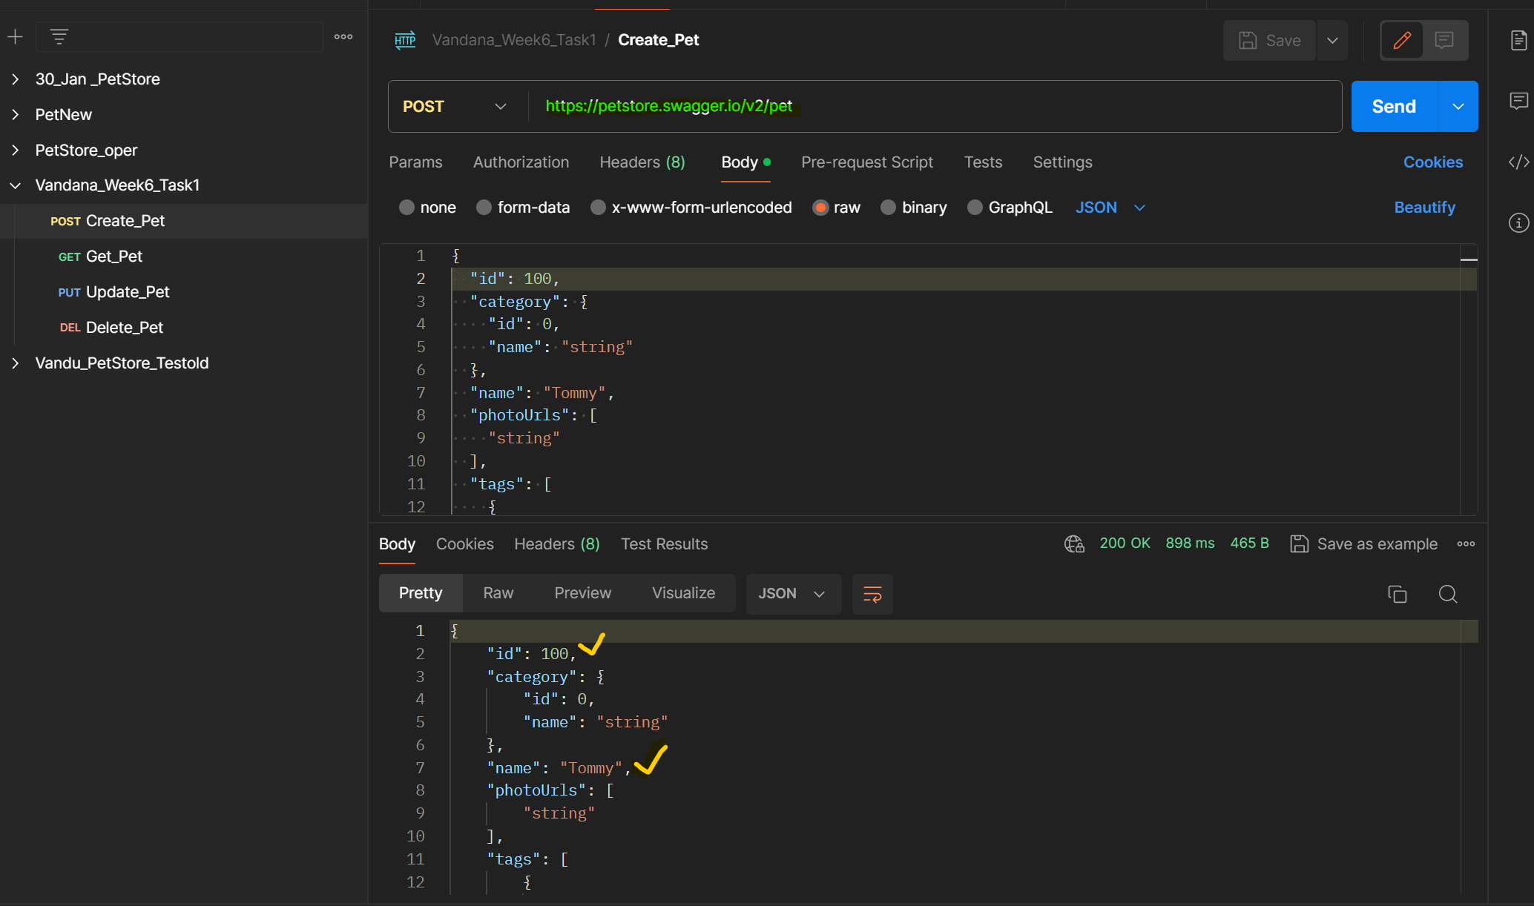

Get Pet Using GET:

Update Pet Using PUT

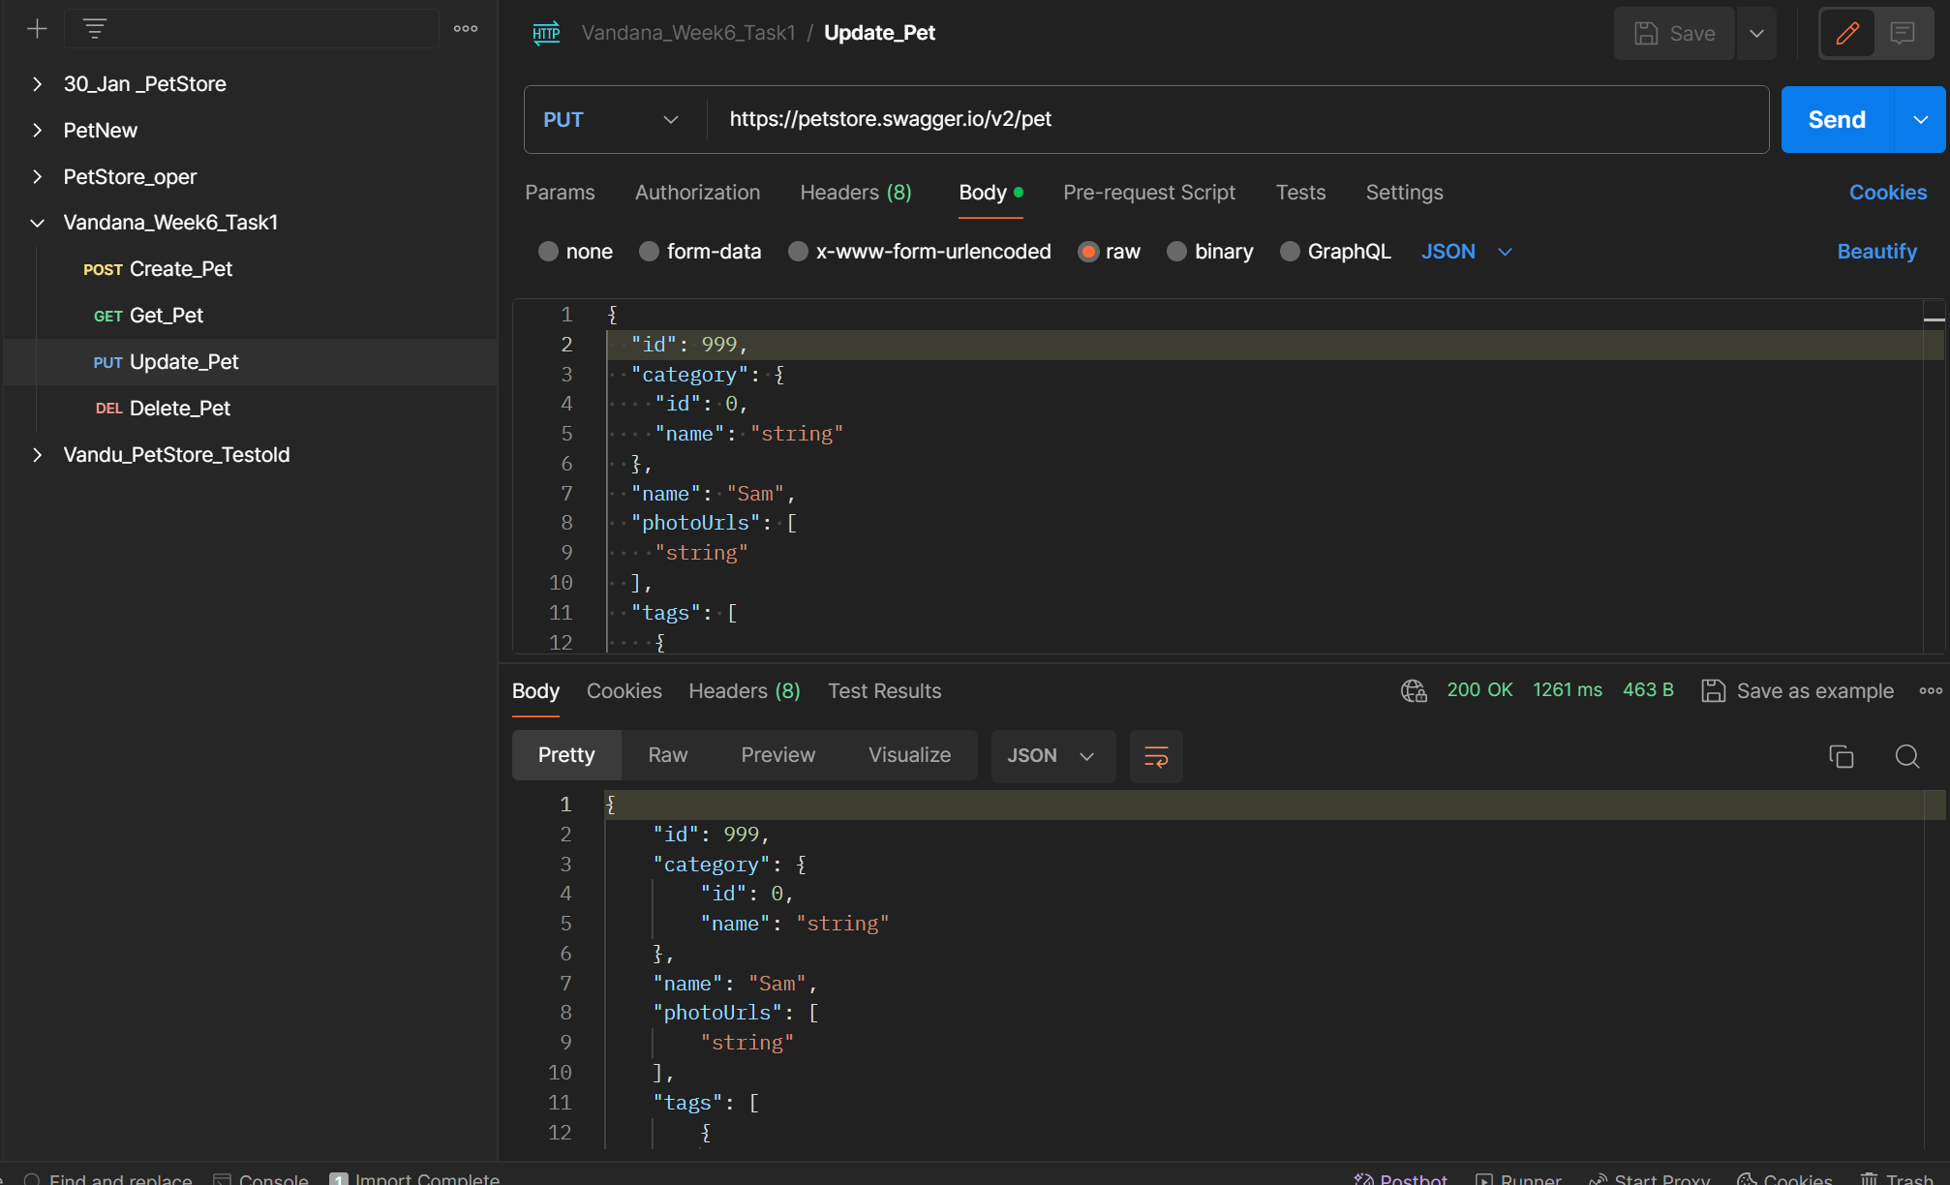

Get Pet After Using Update—GET

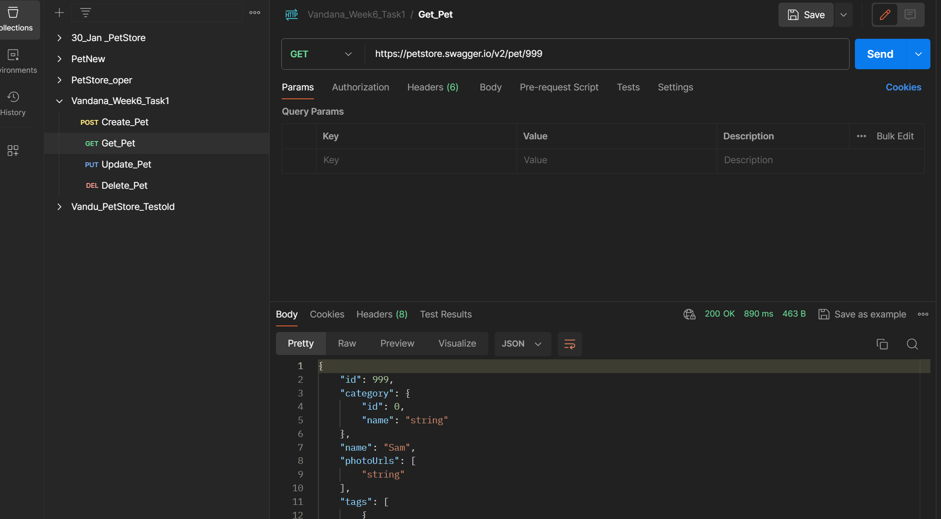

Delete Pet

Get Pet Record After DELETE

