package assignment1;

public class Employee {

private int Empid;
private String Empname;
private double EMPsalary;
public int getEMpid()
{

return Empid;

}
public void setEmpid(int Empid ) {

this.Empid=Empid;
}

public String getEMpnmae()
{

return Empname;
}
public void setEmpname(String Empname ) {

this.Empname=Empname;
}
public double getEMpSalary()
{

return EMPsalary;

}
public void setEmpsalary(double Empsalary ) {

this.EMPsalary=Empsalary;
}

public void displaydeatils() {

System.out.println("Employee Details");
System.out.println("EMpid "+ Empid);
System.out.println("EMPnmae "+ Empname);
System.out.println("EMPSalary "+ EMPsalary);
}

public static void main(String[] args) {
// TODO Auto-generated method stub
Employee emp=new Employee();
emp.setEmpid(300);
emp.setEmpname("Swetha");
emp.setEmpsalary(67000);
emp.displaydeatils();

}

}

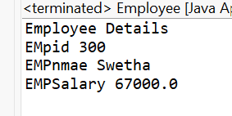
package assignment1;

public class Inhritanc1 {

public static void main(String[] args) {
// TODO Auto-generated method stub
Eletric ec=new Eletric();
ec.fuel();
ec.fuels();
}

}
class Vechile{

void fuels() {

System.out.println("Run on fuel");
}
}
class Eletric extends Vechile{

void fuel() {
System.out.println("Run on the eletric");
}
}

OUTPUT

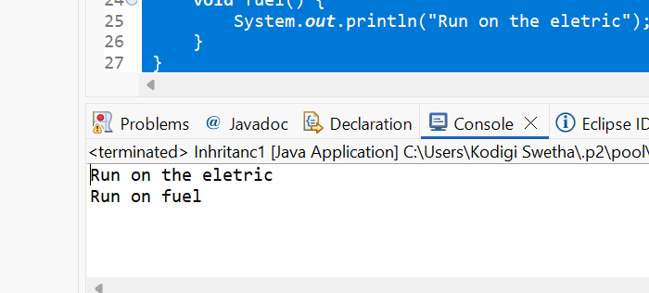
3.Constructor overloading
package assignment1;
class Product{
int productid;
String productname;
double productprice;
Product(){
System.out.println("prodcut created");
System.out.println("######################");
}
Product(int productid,String productname,double productprice)
{
this.productid=productid;
this.productname=productname;
this.productprice=productprice;

}
public void displayDetails()
{

System.out.println("productid "+ productid);
System.out.println("productname "+ productname);
System.out.println("prodcutprice "+ productprice);
}
}

public class ConstructorOverloaing {

public static void main(String[] args) {
// TODO Auto-generated method stub
Product pd=new Product();
pd.displayDetails();
System.out.println("=================================");

Product pd2=new Product(1234,"sahana",4300);
pd2.displayDetails();
System.out.println("=================================");
Product pd3=new Product(3234,"shabbu",8300);
pd3.displayDetails();

}

}
OutPut
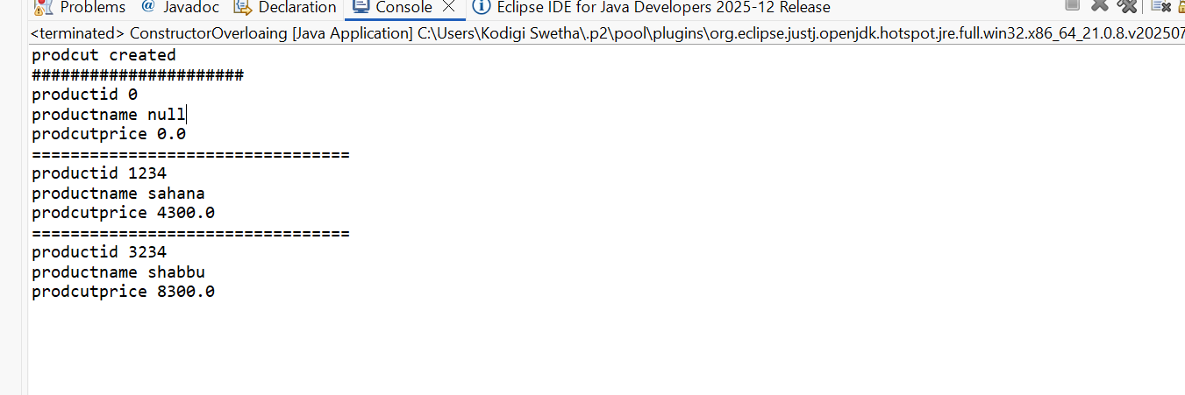
4.Method overload
package assignment1;
class Calculator{

int add(int x,int y) {
return x+y;

}
double add(double p,double q,double r)
{
return p+q+r;

}

}

public class MethodOverloading {
public static void main(String[] args) {

Calculator cal=new Calculator();
System.out.println("add of the two numbers "+ (cal.add(4, 87)));
System.out.println("");
System.out.println("Adding of the double numbers "+(cal.add(25.98, 67.89, 89.98)));
}

}

Output

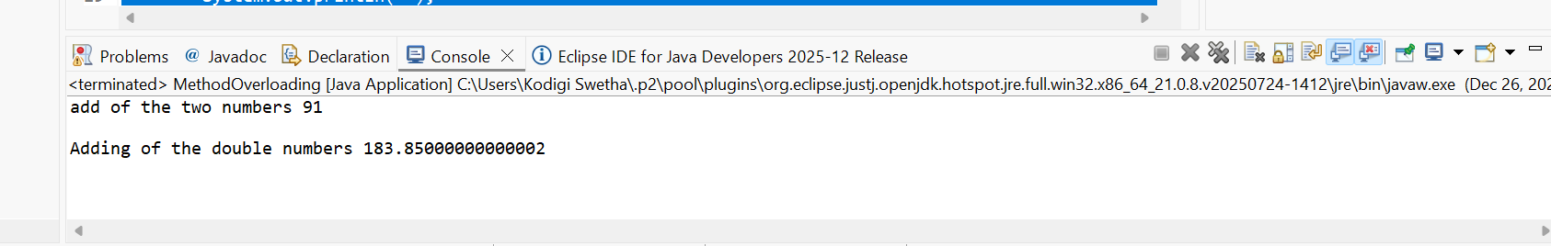
5.Abstraction
package assignment1;

public class Abstraction {
public static void main(String[] args) {
Cat c=new Cat();
c.sound();
Dog d=new Dog();
d.sound();

}

}

abstract class Animal{

void sound() {

}
}
class Dog extends Animal
{

void sound() {

System.out.println("Barking");

}
}
class Cat extends Animal
{

void sound() {

System.out.println("MEew");

}
}

Output

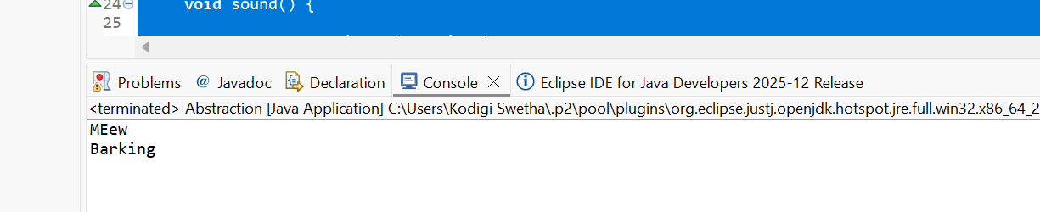
Interface Implementation

package assignment1;

interface
Payment
{
void Payment();
}

class UPI implements Payment
{

@Override
public void Payment() {
System.out.println("Payment done by UPI");

}

}
class CreditCard implements Payment
{

@Override
public void Payment() {
System.out.println("Payment done by Creditcard");
}
}

public class Interface {
public static void main(String[] args) {

Payment p1=new UPI();
p1.Payment();
Payment p2=new CreditCard();
p2.Payment();

{

}
}

}

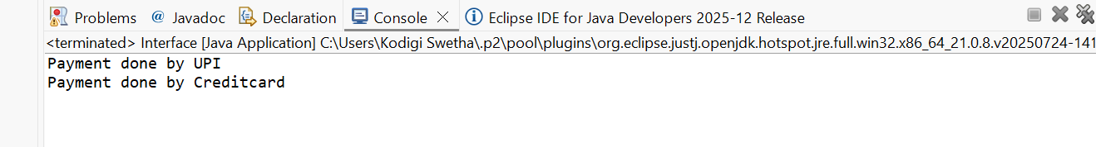
Super keyword

package assignment1;

class Person{

Person()
{

System.out.println("Person Created");
}

}
class Student extends Person{

Student(){
super();
System.out.println("Student created");
}

}

public class Super_keyword {

public static void main(String[] args) {
new Student();
}

}

Output

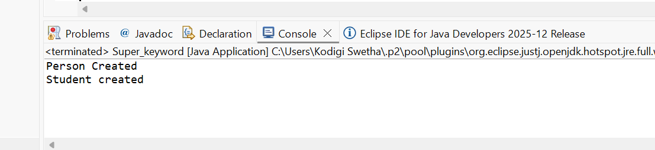
Polymorphism

package assignment1;
class Shape{
double area(double x, double y)
{
return 0;
}
}

class Rectagle extends Shape{

double area(double x,double y)
{
return x*y;

}
}
class Circle extends Shape{

double pi=3.14;
double area(double x, double y)
{
return pi*x*y;

}
}

public class Polymorphism {

public static void main(String[] args) {
Shape s1=
new Circle();
System.out.println("Area of circle " +s1.area(12, 34));
Shape s2=new Rectagle();
System.out.println("Area fo rectangle "+ s2.area(32, 30));

}

}

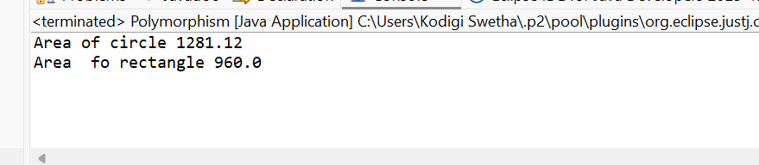
Final_keyword

package assignment1;
class Bank{

final String IFSC="ICIC18000";

final void showifsc() {

System.out.println("The ifsc code is "+IFSC);
}

}
class HDFC extends Bank{

//final void showifsc() {

//System.out.println(" The ifsc code is not able to overrride if it is final method");
// }
void display() {
System.out.println("This is hdfc BANK");
}
}

public class Final_Key {
public static void main(String[] args) {
HDFC hd=new HDFC();
hd.display();
hd.showifsc();

}
}

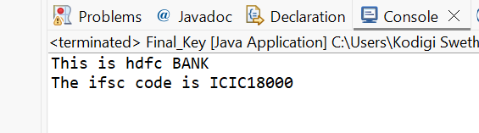

Static keyword
package assignment1;
class Std
{

static String colleageName="PQR";
String Stdname;
int rollNo;

void displaydetails(String name,int No) {

Stdname=name;
rollNo=No;

System.out.println("THe colleage name is " + colleageName + "The student name is "+name +" and the roll no is " +No );
}

}

public class Static_keyword {

public static void main(String[] args) {
Std s1=new Std();
s1.displaydetails("Ramesh", 10);
s1.displaydetails("MAoj", 20);

}

}

OUTPUT

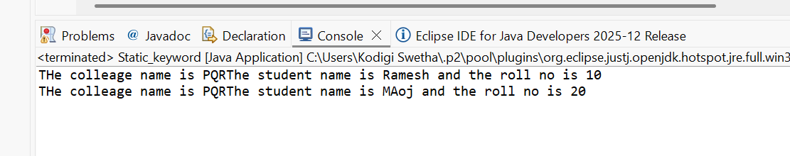
Class+Object+Method

package assignment1;

class Library{

String LibraryName="The cetral Libraray";

public Library() {
System.out.println("Welcome to the library");

}
void Showloaction() {

System.out.println("The library is licated in the MUmbai");
}

}

public class Class_Object_Method {

public static void main(String[] args) {
// TODO Auto-generated method stub
Library Lb=new Library();

Lb.Showloaction();
System.out.println("The name of the library is "+Lb.LibraryName);

}

}

