MOONSHOOT AI – KIMI K2 | K2.5
Sign in using Ollama Download Install the model
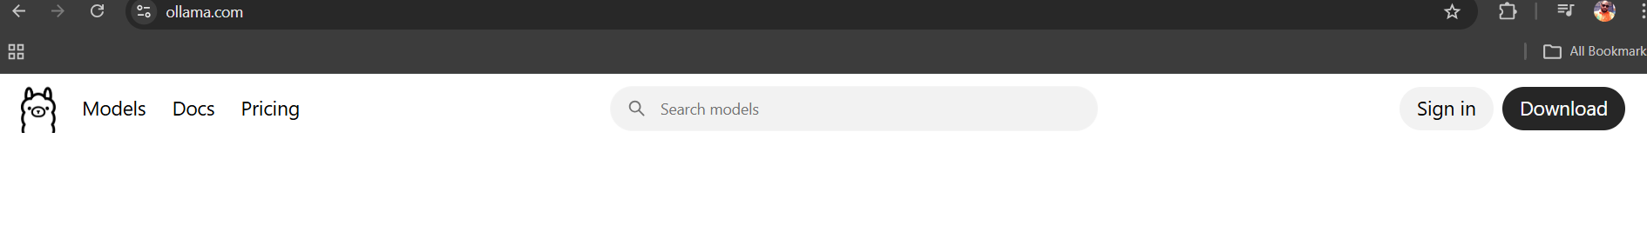
Signin using your gmail account after signin please generate api key paste
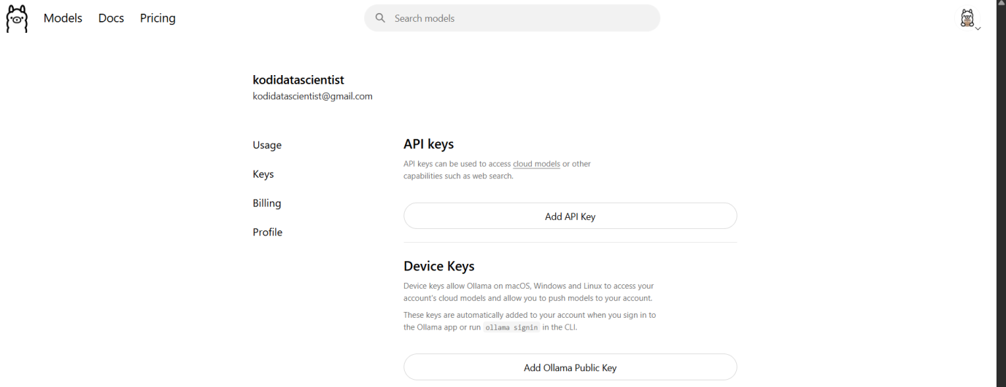
https://docs.ollama.com/integrations/claude-code refer the doc for ollama + claude code
after install ollama open cmd prompt ollama

