Setup:

1. Burp Suite Community Edition installed
2. Configure burp’s Proxy settings to listen on an open port across all interfaces
3. Configure iPhone proxy manually to specified port and navigate browser to <http://burp> in order to install SSL certificate.
4. Version 10.0.2 of Tinder from AppStore on iOS 12.0.1 as of Nov 1 2018

Focused on these endpoints:

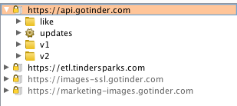

So we booted up the app. Liked a few people. Let’s see what our requests looked like:

