JAVA AWT BASED -TRANSPORT MANAGEMENT SYSTEM FOR INTRA CITY TRAVELS -SQL CONNECTIVITY USING JDBC

A

Report

submitted in partial fulfilment of

***BE IV SEMESTER DATABASE MANAGEMENT SYSTEM LAB***

**INFORMATION TECHNOLOGY**

By

**Kodipyaka Vinay Babu <1602-18-737-117>**

**Under the Guidance of**

** B.Leelavathy**

**Department of Information Technology**

**Vasavi College of Engineering(Autonomous)**

**(Affliated to Osmania University)**

**Ibrahimbagh, Hyderabad-500031**

2019-2020

**AIM AND PRIORITY OF THE PROJECT:**

To create a GUI based form for the project of **TRANSPORT**

**MANAGEMENT SYSTEM FOR INTRA CITY TRAVELS**

where in a passenger checks a set of vehicles and their cost and

reserves a vehicle according to his budget and finally makes payment.

The values entered (insertion, updation, deletion)by the user for

respective table in **GUI** should be updated in the database using

**JDBC.**

**ABSTRACT:** The project is about transport management

system for intra city travels. Starting with intracity refers to outside

the city. There will be different ways of transportation to move from

one place to another. The project is about creating a application

where in user can book different modes of transport in a single place.

Starting with user creates a account giving the details such as name,

id, age mobile number, email id etc. cost for each vehicle varies based

on its specification. User after creating the account selects the vehicle

based on his requirement that is he will select’s the vehicle based on

the cost and finally makes the payment and user gets the receipt

of his transaction. As the details of the availability of each vehicle is

stored in the database. After booking the vehicle availability will be

decremented.

**INTRODUCTION :**

**REQUIREMENTS:**

**Tables Required:** (5) Passenger, checks, typeofvehicle , reserves, payment

|  |  |  |  |
| --- | --- | --- | --- |
| TABLE NAME | DESCRIPTION | ATTRTIBUTE | DATATYPE |
| PASSENGER | Passenger id | pid | Number (10) |
| Age of passenger | age | Number(5) |
| Mobile number | mobnum | Number(10) |
| Email id of passenger | emailid | Varchar2(20) |
| Name of the passenger | pname | Varchar2(20) |
| CHECKS | Passenger id | pid | Number(10) |
| Vehicle id | vid | Number(10) |
| Date of travel | day | Date |
| RESERVES | Passenger id | pid | Number(10) |
| Vehicle id | vid | Number(10) |
| Payment id | payid | Number(10) |
| Date of Reservation | day | date |

|  |  |  |  |
| --- | --- | --- | --- |
| TYPE OF VEHICLE | Vehicle id | vid | Number(10) |
| Availability Number | availability | Number(5) |
| Cost of the vehicle | cost | Number(5) |
| Specification | type | Varchar2(10) |
| Type of vehicle chosen | Modeoftransport | Varchar2(20) |
| PAYMENT | Payment id | pid | Number(10) |
| Payment Status | status | Varchar2(10) |
| Bill Reciept | bill | Varchar2(10) |

**ARCHITECTURE AND TECHNOLOGY USED:**

Java Eclipse, Oracle 11g Database, java SE version 8, SQL *plus ,java AWT

**Eclipse:** It is an integrated development environment (IDE) used in computer programming. It contains a base workspace and an extensible plug in system for customizing the environment. The Eclipse software development kit (SDK), which include java development tools is meant for java developers.

**SQL *plus:** SQL *plus is a command line tool proprietary to oracle. You can send SQL Queries to the server using the tool. It can also help you format the result of query. SQL is the query language that is used to communicate with the oracle server to access and modify data.

**JAVA AWT:** Abstract window tool kit is an API to develop GUI or Window based applications in java. Java AWT components are platform dependent i.e components are displayed according to the view of operating system. AWT is heavy weight that is components are using the resources of O.S.

**JDBC:** Java Database Connectivity is an application programming interface (API) for the programming language java **,** which defines how a client may access database. It is a java based data access technology used for java database connectivity. It is the part of java Standard Edition Platform, from oracle corporation.

**ER DIAGRAM OF THIS PROJECT:**

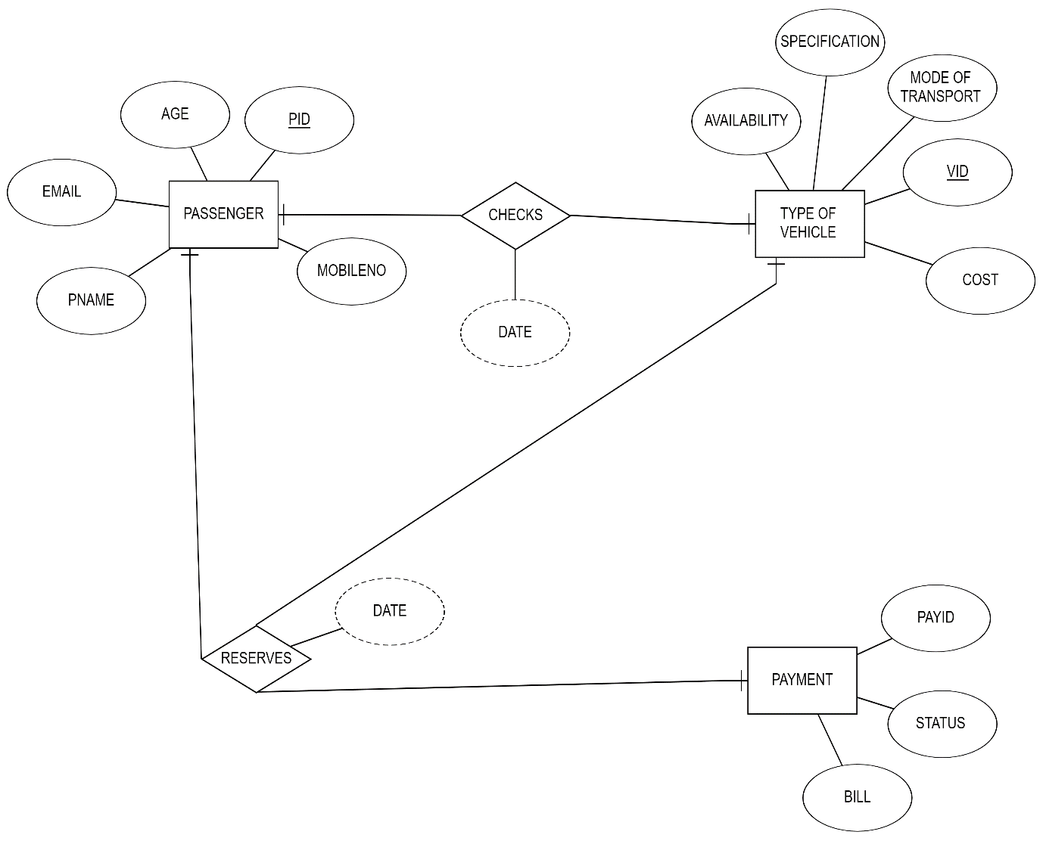

**CREATION OF TABLES:**

**SQL>** create table passenger(pid number(5) primary key ,

2 age number(5) ,

3 emailId varchar2(20) ,

4 pname varchar2(20),

5 mobnu number(10) );

**SQL>** create table typeofvehicle(vid number(5) primary key ,

2 modeoftransport varchar2(10) ,

3 cost number(5) ,

4 availability number(10) ,

5 type varchar2(10) );

**SQL**> create table payment(payid number(10) primary key ,

2 status varchar2(20) ,

3 bill varchar2(10) );

**SQL**> create table checks(pid number(5) ,

2 vid number(5),

3 day date,

4 primary key(pid,vid) ,

5 foreign key(pid) references passenger ,

6 foreign key(vid) references typeofvehicle );

**SQL**> create table reserves(pid number(5) ,

2 vid number(5) ,

3 payid number(10) ,

4 day date ,

5 primary key(pid,vid,payid) ,

6 foreign key(pid) references passenger ,

7 foreign key(vid) references typeofvehicle ,

8 foreign key(payid) references payment );

**TABLES DESCRIPTION:**

SQL> desc passenger;

Name Null? Type

----------------------------------------- -------- ----------------------------

PID NOT NULL NUMBER(5)

AGE NUMBER(5)

EMAILID VARCHAR2(20)

PNAME VARCHAR2(20)

MOBNU NUMBER(10)

**SQL**> desc checks;

Name Null? Type

----------------------------------------- -------- ----------------------------

PID NOT NULL NUMBER(5)

VID NOT NULL NUMBER(5)

DAY DATE

**SQL**> desc typeofvehicle;

Name Null? Type

----------------------------------------- -------- ----------------------------

VID NOT NULL NUMBER(5)

MODEOFTRANSPORT VARCHAR2(10)

COST NUMBER(5)

AVAILABILITY NUMBER(10)

TYPE VARCHAR2(10)

**SQL**> desc reserves;

Name Null? Type

----------------------------------------- -------- ----------------------------

PID NOT NULL NUMBER(5)

VID NOT NULL NUMBER(5)

PAYID NOT NULL NUMBER(10)

DAY DATE

**SQL**> desc payment;

Name Null? Type

----------------------------------------- -------- ----------------------------

PAYID NOT NULL NUMBER(10)

STATUS VARCHAR2(20)

BILL VARCHAR2(10)

**IMPLEMENTATION**

**I) FRONT END PROGRAMS AND CONNECTIVITY**

**JAVA-SQL CONNECTIVITY USING JDBC:**

The connection to the database can be performed using java programming **(JDBC API)** as**:**

public void connectToDB() {

try {

connection=DriverManager.getConnection("jdbc:oracle:thin:@localhost:1521:ORCL","**dbmsass","dbms"**);

statement = connection.createStatement();

}

catch (SQLException connectException) {

System.out.println(connectException.getMessage());

System.out.println(connectException.getSQLState());

System.out.println(connectException.getErrorCode());

System.exit(1);

}

catch(Exception e){

System.out.println("Unable to find and load driver"); System.exit(1);

} }

AS THIS PROJECT CONTAINS 5 TABLES

i.**e PASSENGER ,CHECKS,TYPEOFVEHICLE, RESERVES, PAYMENT**

BELOW IS THE CODE FOR ALL **DML OPERATIONS** ON THE TABLE **PASSENGER**

**MAIN FRAME GUI :**

package transportmanagement;

import java.awt.*;

import java.awt.event.*;

import javax.swing.*;

class abc extends JFrame{

private JMenuBar mBar;

private JMenu

mnuPassenger,mnuChecks,mnuReserves,mnuTypeofVehicle,mnuPayment;

private JMenuItem

mnuItemInsert,mnuItemInsert1,mnuItemInsert2,mnuItemInsert3,mnuItemInsert4;

private JMenuItem mnuItemUpdate,mnuItemUpdate1,mnuItemUpdate2,mnuItemUpdate3,mnuItemUpdate4;

private JMenuItem mnuItemDelete,mnuItemDelete1,mnuItemDelete2,mnuItemDelete3,mnuItemDelete4;

abc(){

mBar=new JMenuBar();

mnuPassenger=new JMenu("passenger");

mnuPassenger.setOpaque(true);

mnuPassenger.setBackground(Color.blue);

mnuChecks=new JMenu("checks");

mnuChecks.setOpaque(true);

mnuChecks.setBackground(Color.green);

mnuReserves=new JMenu("reserves");

mnuReserves.setOpaque(true);

mnuReserves.setBackground(Color.MAGENTA);

mnuTypeofVehicle=new JMenu("typeOfvehicle");

mnuTypeofVehicle.setOpaque(true);

mnuTypeofVehicle.setBackground(Color.ORANGE);

mnuPayment=new JMenu("payment");

mnuPayment.setOpaque(true);

mnuPayment.setBackground(Color.PINK);

mnuItemInsert=new JMenuItem("insert passenger");

mnuItemInsert.setBackground(Color.yellow);

mnuItemUpdate=new JMenuItem("update passenger");

mnuItemUpdate.setBackground(Color.yellow);

mnuItemDelete=new JMenuItem("delete passenger");

mnuItemDelete.setBackground(Color.yellow);

mnuItemInsert1=new JMenuItem("insert checks");

mnuItemInsert1.setBackground(Color.orange);

mnuItemUpdate1=new JMenuItem("update checks");

mnuItemUpdate1.setBackground(Color.orange);

mnuItemDelete1=new JMenuItem("delete checks");

mnuItemDelete1.setBackground(Color.orange);

mnuItemInsert2=new JMenuItem("insert reserves");

mnuItemInsert2.setBackground(Color.pink);

mnuItemUpdate2=new JMenuItem("update reserves");

mnuItemUpdate2.setBackground(Color.pink);

mnuItemDelete2=new JMenuItem("delete reserves");

mnuItemDelete2.setBackground(Color.pink);

mnuItemInsert3=new JMenuItem("insert typeofvehicle");

mnuItemInsert3.setBackground(Color.green);

mnuItemUpdate3=new JMenuItem("update typeofvehicle");

mnuItemUpdate3.setBackground(Color.green);

mnuItemDelete3=new JMenuItem("delete typeofvehicle");

mnuItemDelete3.setBackground(Color.green);

mnuItemInsert4=new JMenuItem("insert payment");

mnuItemInsert4.setBackground(Color.MAGENTA);

mnuItemUpdate4=new JMenuItem("update payment");

mnuItemUpdate4.setBackground(Color.MAGENTA);

mnuItemDelete4=new JMenuItem("delete payment");

mnuItemDelete4.setBackground(Color.MAGENTA);

mnuPassenger.add(mnuItemInsert);

mnuPassenger.add(mnuItemUpdate);

mnuPassenger.add(mnuItemDelete);

mnuChecks.add(mnuItemInsert1);

mnuChecks.add(mnuItemUpdate1);

mnuChecks.add(mnuItemDelete1);

mnuReserves.add(mnuItemInsert2);

mnuReserves.add(mnuItemUpdate2);

mnuReserves.add(mnuItemDelete2);

mnuTypeofVehicle.add(mnuItemInsert3);

mnuTypeofVehicle.add(mnuItemUpdate3);

mnuTypeofVehicle.add(mnuItemDelete3);

mnuPayment.add(mnuItemInsert4);

mnuPayment.add(mnuItemUpdate4);

mnuPayment.add(mnuItemDelete4);

mBar.add(mnuPassenger);

mBar.add(mnuChecks);

mBar.add(mnuReserves);

mBar.add(mnuTypeofVehicle);

mBar.add(mnuPayment);

setJMenuBar(mBar);

setSize(2000,1000);

setLayout(new GridBagLayout());

JLabel lbl=new JLabel("TRANSPORT MANAGEMENT SYSTEM FOR INTRA CITY TRAVELS");

lbl.setFont(lbl.getFont().deriveFont(40.0f));

add(lbl);

getContentPane().setBackground(Color.cyan);

setTitle("TRANSPORT MANAGEMENT SYSTEM FOR INTRA CITY TRAVELS");

setVisible(true);

mnuItemInsert.addActionListener(new ActionListener() {

public void actionPerformed(ActionEvent ae) {

new Passenger();

}

});

mnuItemUpdate.addActionListener(new ActionListener() {

public void actionPerformed(ActionEvent ae) {

new updatePassenger();

}

});

mnuItemDelete.addActionListener(new ActionListener() {

public void actionPerformed(ActionEvent e) {

new DeletePassenger();

}

});

mnuItemInsert1.addActionListener(new ActionListener() {

public void actionPerformed(ActionEvent ae) {

new insertchecks();

}

});

mnuItemUpdate1.addActionListener(new ActionListener() {

public void actionPerformed(ActionEvent ae) {

new UpdateChecks();

}

});

mnuItemDelete1.addActionListener(new ActionListener() {

public void actionPerformed(ActionEvent ae) {

new DeleteChecks();

}

});

mnuItemInsert2.addActionListener(new ActionListener() {

public void actionPerformed(ActionEvent ae) {

new insertReserves();

}

});

mnuItemUpdate2.addActionListener(new ActionListener() {

public void actionPerformed(ActionEvent ae) {

new updateReserves();

}

});

mnuItemDelete2.addActionListener(new ActionListener() {

public void actionPerformed(ActionEvent ae) {

new DeleteReserves();

}

});

mnuItemInsert3.addActionListener(new ActionListener() {

public void actionPerformed(ActionEvent ae) {

new insertTypeOfVehicle();

}

});

mnuItemUpdate3.addActionListener(new ActionListener() {

public void actionPerformed(ActionEvent e) {

new updateTypeOfVehicle();

}

});

mnuItemDelete3.addActionListener(new ActionListener() {

public void actionPerformed(ActionEvent e) {

new DeleteTypeOfVehicle();

}

});

mnuItemInsert4.addActionListener(new ActionListener() {

public void actionPerformed(ActionEvent ae) {

new insertPayment();

}

});

mnuItemUpdate4.addActionListener(new ActionListener() {

public void actionPerformed(ActionEvent ae) {

new updatePayment();

}

});

mnuItemDelete4.addActionListener(new ActionListener() {

public void actionPerformed(ActionEvent e) {

new DeletePayment();

}

});

this.setDefaultCloseOperation(JFrame.DISPOSE_ON_CLOSE);

}

}

public class FirstFrameGUI {

public static void main(String[] args){

new abc();

}

}

**INSERT PASSENGER:**

import java.awt.*;

import java.awt.event.*;

import java.sql.*;

import javax.swing.*;

public class Passenger extends JFrame{

private JPanel pnl1, pnl2;

private JTextField txtPid,txtAge,txtEmail,txtPname,txtMobnu;

private JLabel lblPid, lblAge, lblEmail, lblPname, lblMobnu;

private JTextArea txtAre;

private JButton btnInsert;

Connection connection;

Statement statement;

Passenger(){

txtPid=new JTextField(15);

txtAge=new JTextField(15);

txtEmail=new JTextField(15);

txtPname=new JTextField(15);

txtMobnu=new JTextField(15);

lblPid=new JLabel("PID");

lblAge=new JLabel("ÄGE");

lblEmail=new JLabel("EMAIL");

lblPname=new JLabel("PASSENGER NAME");

lblMobnu=new JLabel("MOBILE NUMBER");

pnl1=new JPanel();

pnl2=new JPanel();

btnInsert=new JButton("SUBMIT");

txtAre=new JTextArea(20,100);

pnl1.setLayout(new GridLayout(5,2));

pnl1.add(lblPid); pnl1.add(txtPid);

pnl1.add(lblAge); pnl1.add(txtAge);

pnl1.add(lblEmail); pnl1.add(txtEmail);

pnl1.add(lblPname); pnl1.add(txtPname);

pnl1.add(lblMobnu); pnl1.add(txtMobnu);

pnl2.add(btnInsert); pnl2.add(txtAre);

pnl1.setSize(600,500);pnl2.setSize(600,500);

setTitle("INSERT PASSENGER");

pnl1.setBackground(Color.MAGENTA);

pnl2.setBackground(Color.CYAN);

add(pnl1);add(pnl2);

setSize(2000,1000);setLayout(new GridLayout(2, 1));

setVisible(true);

btnInsert.addActionListener(new ActionListener(){

public void actionPerformed(ActionEvent ae){

try {

Class.forName("oracle.jdbc.driver.OracleDriver");

}

catch (Exception e) {

System.err.println("Unable to find and load driver");

System.exit(1);

}

try {

connection = DriverManager.getConnection("jdbc:oracle:thin:@localhost:1521:ORCL","dbmsass","dbms");

statement = connection.createStatement();

}

catch (SQLException connectException) {

System.exit(1);

}

try {

String query= "INSERT INTO passenger VALUES(" + txtPid.getText() + ", " + txtAge.getText() + "," +"'" + txtEmail.getText() + "'," + "'" + txtPname.getText() + "'," + txtMobnu.getText() + " )";

int i = statement.executeUpdate(query);

txtAre.append("\nInserted " + i + " rows successfully");

}

catch (SQLException insertException) {

System.out.println(insertException);

}

}

});

this.setDefaultCloseOperation(JFrame.DISPOSE_ON_CLOSE);

}

}

**UPDATE PASSENGER:**

import java.awt.*;

import java.awt.event.*;

import java.sql.*;

import javax.swing.*;

public class updatePassenger extends JFrame {

private JPanel pnl1,pnl0,pnl2;

private JTextField txtPid, txtAge, txtEmail,txtPname,txtMobnu;

private JLabel lblPid,lblAge, lblEmail, lblPname,lblMobnu;

private List list;

private JTextArea txtAre,txtAre2;

private JButton btnUpdate;

Connection connection;

Statement statement;

public void connectToDB() {

try {

connection = DriverManager.getConnection("jdbc:oracle:thin:@localhost:1521:ORCL","dbmsass","dbms");

statement = connection.createStatement();

}

catch (SQLException connectException) {

System.exit(1);

}

updatePassenger(){

txtPid=new JTextField(15); txtAge=new JTextField(15);

txtEmail=new JTextField(15); txtPname=newJTextField(15);

txtMobnu=new JTextField(15); lblPid=new JLabel("PID");

lblAge=new JLabel("ÄGE"); lblEmail=new JLabel("EMAIL");

lblPname=new JLabel("PASSENGER NAME");

lblMobnu=new JLabel("MOBILE NUMBER");

pnl0=new JPanel(); pnl1=new JPanel(); pnl2=new JPanel();

list=new List(10);

txtAre2=new JTextArea(20, 100);

btnUpdate=new JButton("MODIFY");

setTitle("UPDATE PASSENGER");

pnl0.setBackground(Color.YELLOW);

pnl1.setBackground(Color.MAGENTA);

pnl2.setBackground(Color.BLUE);

pnl1.setLayout(new GridLayout(5,2));

try {

class.forName("oracle.jdbc.driver.OracleDriver");

}

catch (Exception e) {

System.err.println("Unable to find and load driver");

System.exit(1);

}

connectToDB();

try {

ResultSet rs = statement.executeQuery("SELECT PID FROM passenger");

while (rs.next()){

list.add(rs.getString("PID"));

}

}

catch (SQLException e) {

System.out.println(e);

}

list.addItemListener(new ItemListener(){

public void itemStateChanged(ItemEvent e) {

try {

ResultSet rs = statement.executeQuery("SELECT * FROM passenger where pID ="+list.getSelectedItem());

rs.next();

txtPid.setText(rs.getString("PID"));

txtAge.setText(rs.getString("AGE"));

txtEmail.setText(rs.getString("EMAILID"));

txtPname.setText(rs.getString("PNAME"));

txtMobnu.setText(rs.getString("MOBNU"));

}

catch (SQLException selectException) {

System.out.println(e);

}

}

});

btnUpdate.addActionListener(new ActionListener(){

public void actionPerformed(ActionEvent e) {

try {

Statement statement = connection.createStatement();

int i = statement.executeUpdate("UPDATE passenger "

+ "SET age=" + txtAge.getText() + ", "+ "emailid='" + txtEmail.getText() + "', "+ "pname ='"+ txtPname.getText() "+"mobnu="+txtMobnu.getText()+"WHERE pid = + list.getSelectedItem());

txtAre2.append("\nUpdated " + i + " rows successfully");

}

catch (SQLException insertException) {

System.out.println(e);

}

}

});

pnl0.add(list);

pnl1.add(lblPid); pnl1.add(txtPid);

pnl1.add(lblAge); pnl1.add(txtAge);

pnl1.add(lblEmail); pnl1.add(txtEmail);

pnl1.add(lblPname); pnl1.add(txtPname);

pnl1.add(lblMobnu); pnl1.add(txtMobnu);

pnl2.add(btnUpdate); pnl2.add(txtAre2);

pnl1.setSize(600,500); pnl2.setSize(600,500);

add(pnl0);add(pnl1);add(pnl2);

setSize(2000,1000);

setLayout(new GridLayout(3, 1));

setVisible(true);

this.setDefaultCloseOperation(JFrame.DISPOSE_ON_CLOSE);

}

}

**DELETE PASSENGER:**

import java.awt.*;

import java.awt.event.*;

import java.sql.*;

import javax.swing.*;

public class DeletePassenger extends JFrame {

private JPanel pnl1,pnl0,pnl2;

private JTextField txtPid,txtAge,txtEmail,txtPname,txtMobnu;

private JLabel lblPid,lblAge,lblEmail, lblPname,lblMobnu;

private List list;

private JTextArea txtAre,txtAre2;

private JButton btnDelete;

Connection connection;

Statement statement;

public void connectToDB() {

try {

connection=DriverManager.getConnection("jdbc:oracle:thin:@localhost:1521:ORCL","dbmsass","dbms");

statement = connection.createStatement();

}

catch (SQLException connectException) {

System.exit(1);

}

}

DeletePassenger(){

txtPid=new JTextField(15); txtAge=new JTextField(15);

txtEmail=new JTextField(15); txtPname=new JTextField(15);

txtMobnu=new JTextField(15);

lblPid=new JLabel("PID"); lblAge=new JLabel("ÄGE");

lblEmail=new JLabel("EMAIL");

lblPname=new JLabel("PASSENGER NAME");

lblMobnu=new JLabel("MOBILE NUMBER");

pnl0=new JPanel(); pnl1=new JPanel(); pnl2=new JPanel();

list=new List(10);

txtAre=new JTextArea(20,20); txtAre2=new JTextArea(20, 100);

btnDelete=new JButton("DELETE VALUES");

setTitle("DELETE PASSENGER");

pnl0.setBackground(Color.CYAN);

pnl1.setBackground(Color.ORANGE);

pnl2.setBackground(Color.PINK);

pnl1.setLayout(new GridLayout(5,2));

try {

Class.forName("oracle.jdbc.driver.OracleDriver");

}

catch (Exception e) {

System.err.println("Unable to find and load driver");

System.exit(1);

}

connectToDB();

try {

ResultSet rs = statement.executeQuery("SELECT PID FROM passenger");

while (rs.next()) {

list.add(rs.getString("PID"));

}

}

catch (SQLException e) {

System.out.println(e);

}

list.addItemListener(new ItemListener(){

public void itemStateChanged(ItemEvent e) {

try {

ResultSet rs = statement.executeQuery("SELECT * FROM passenger where pID ="+list.getSelectedItem());

while (rs.next()) {

if (rs.getString("PID").equals(list.getSelectedItem()))

break;

}

if (!rs.isAfterLast()) {

txtPid.setText(rs.getString("PID"));

txtAge.setText(rs.getString("AGE"));

txtEmail.setText(rs.getString("EMAILID"));

txtPname.setText(rs.getString("PNAME"));

txtMobnu.setText(rs.getString("MOBNU"));

}

}

catch (SQLException selectException) {

System.out.println(e);

}

});

btnDelete.addActionListener(new ActionListener(){

public void actionPerformed(ActionEvent e) {

try {

Statement statement = connection.createStatement();

int i = statement.executeUpdate("DELETE from passenger where pid=" +list.getSelectedItem());

txtAre2.append("\nDeleted " + i + " rows successfully");

}

catch (SQLException insertException) {

txtAre2.append(insertException.getMessage());

}

}

});

pnl0.add(list);

pnl1.add(lblPid); pnl1.add(txtPid);

pnl1.add(lblAge); pnl1.add(txtAge);

pnl1.add(lblEmail); pnl1.add(txtEmail);

pnl1.add(lblPname); pnl1.add(txtPname);

pnl1.add(lblMobnu); pnl1.add(txtMobnu);

pnl2.add(btnDelete); pnl2.add(txtAre2);

pnl1.setSize(600,500);pnl2.setSize(600,500);

add(pnl0);add(pnl1);add(pnl2);

setSize(2000,1000);

setLayout(new GridLayout(3, 1)); setVisible(true); } }

**ii .GITHUB LINK AND FOLDER STRUCTURE**:

<https://github.com/kodipyaka-vinaybabu/DBMS-PROJECT.git>

GITHUB LINK

DBMS REPORT

JAVADBMS(FOLDER)

DBMS PROJECT (ASSIGNMENT 1)

TRANSPORT MANAGEMENT(PACKAGE)

TRANSPORT MANAGEMENT(PACKAGE)

.PROJECT

.CLASSPATH

SRC

CLASSES

.SETTINGS

TRANSPORT MANAGEMENT SYSTEM FOR INTRA CITY TRAVELS

.METADATA

16 .JAVA FILES

57 .CLASS FILES

**THE FIRST FRAME THAT WILL BE DISPLAYED WHEN WE EXECUTE THE PROGRAM IS**

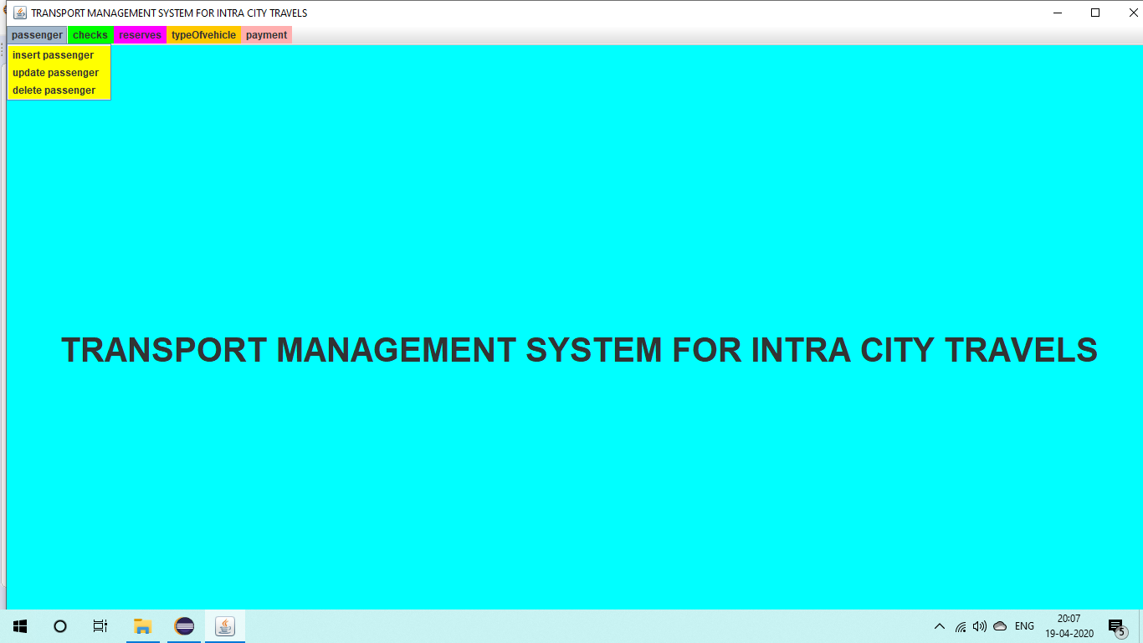

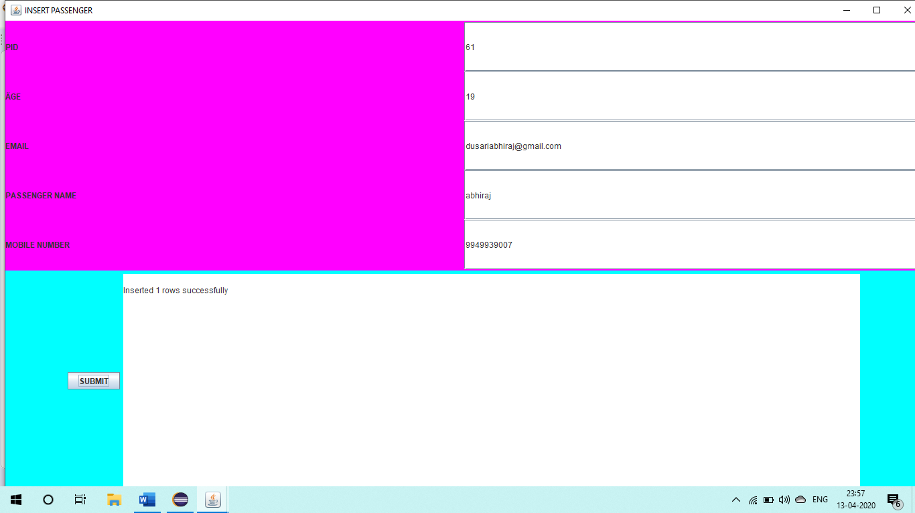**SCREENSHOT OF INSERT PASSENGER**

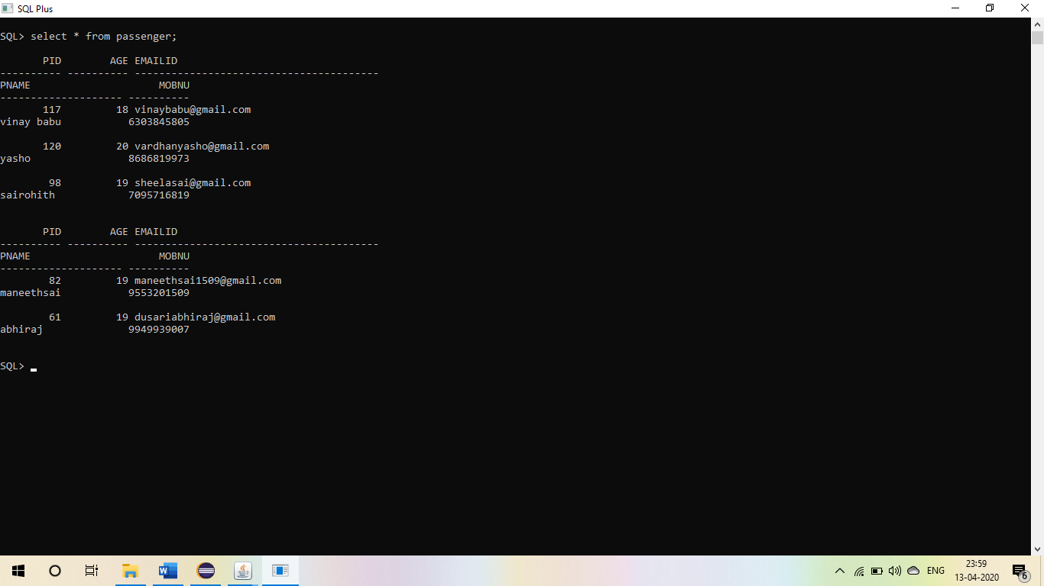

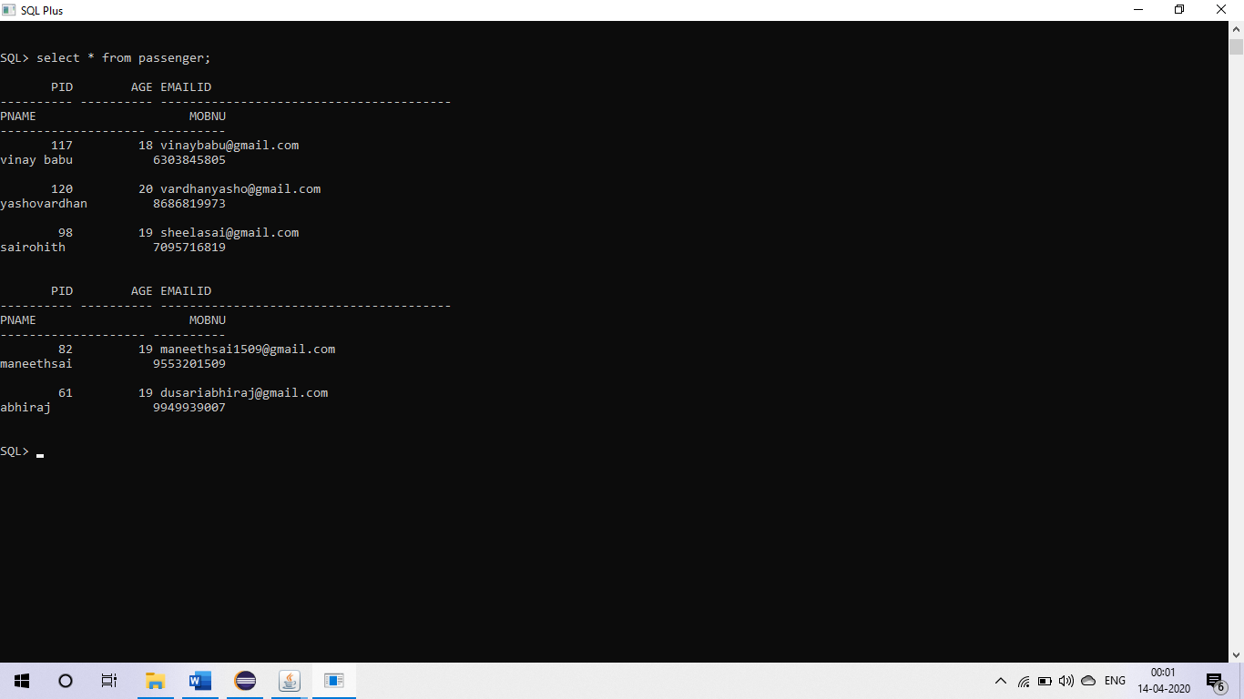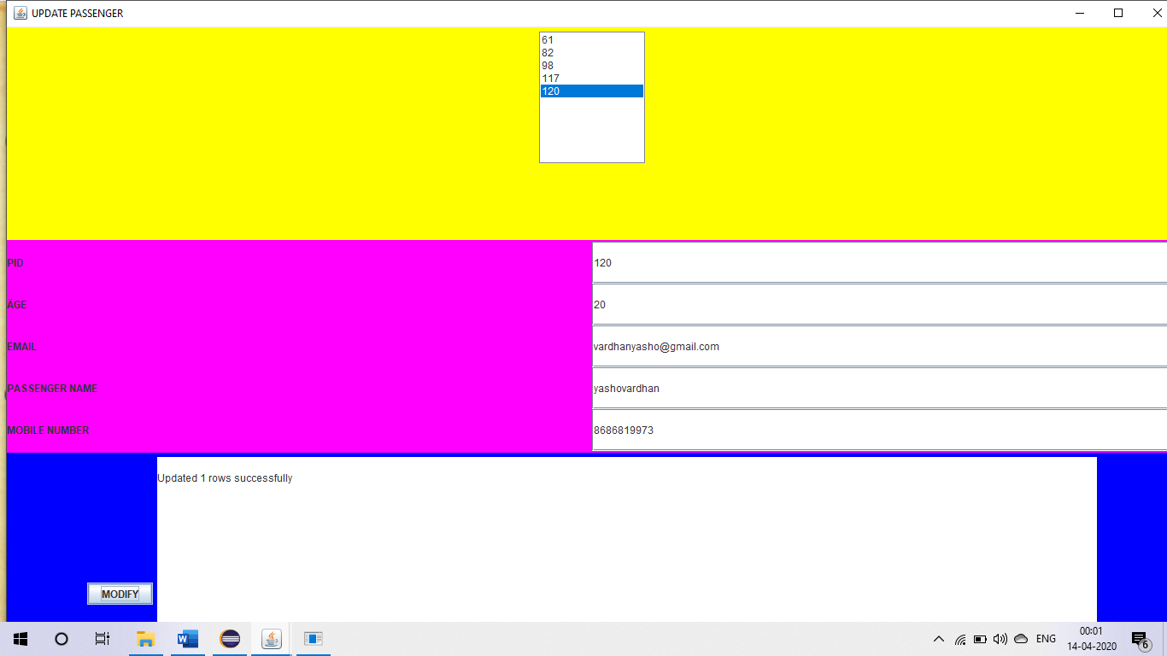**SCREENSHOT OF UPDATE PASSENGER:**

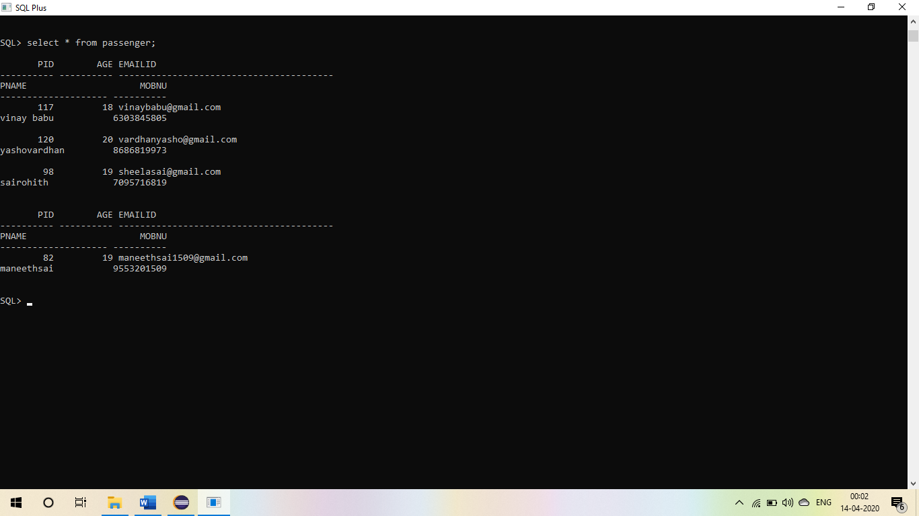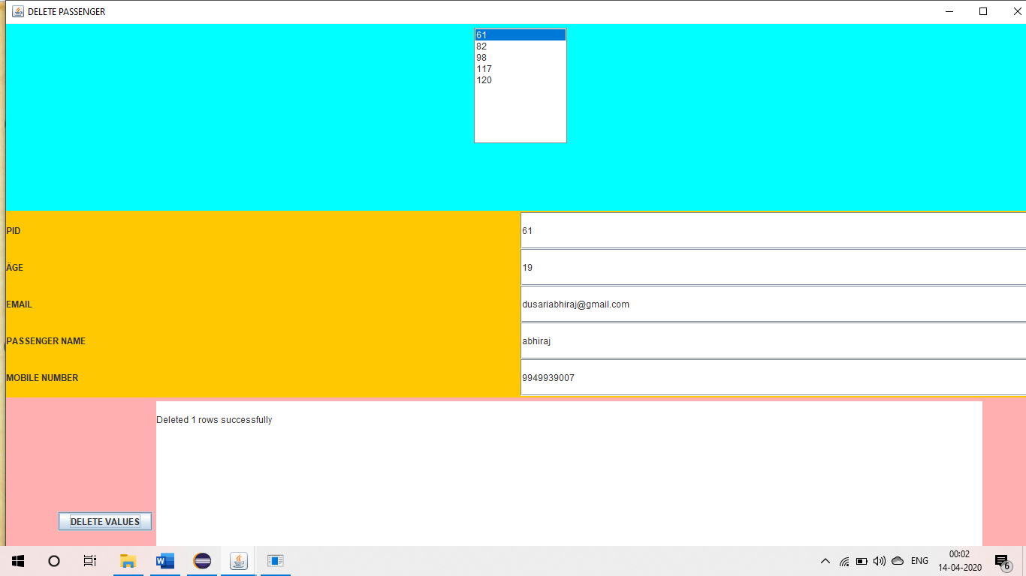**SCREENSHOT OF DELETE PASSENGER**

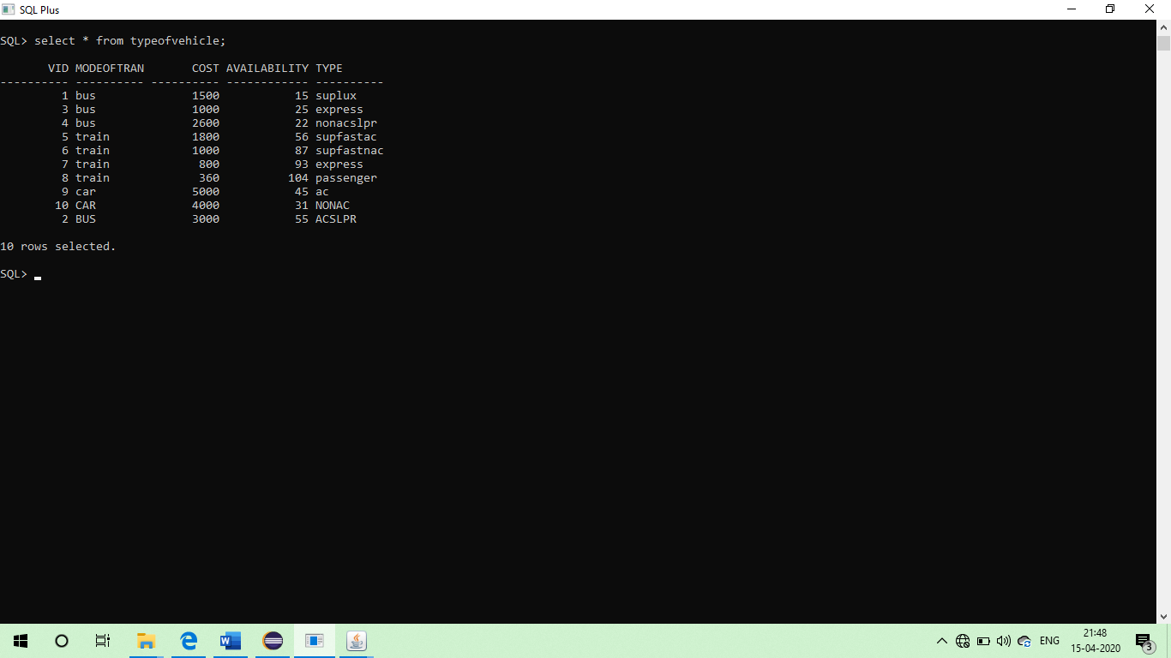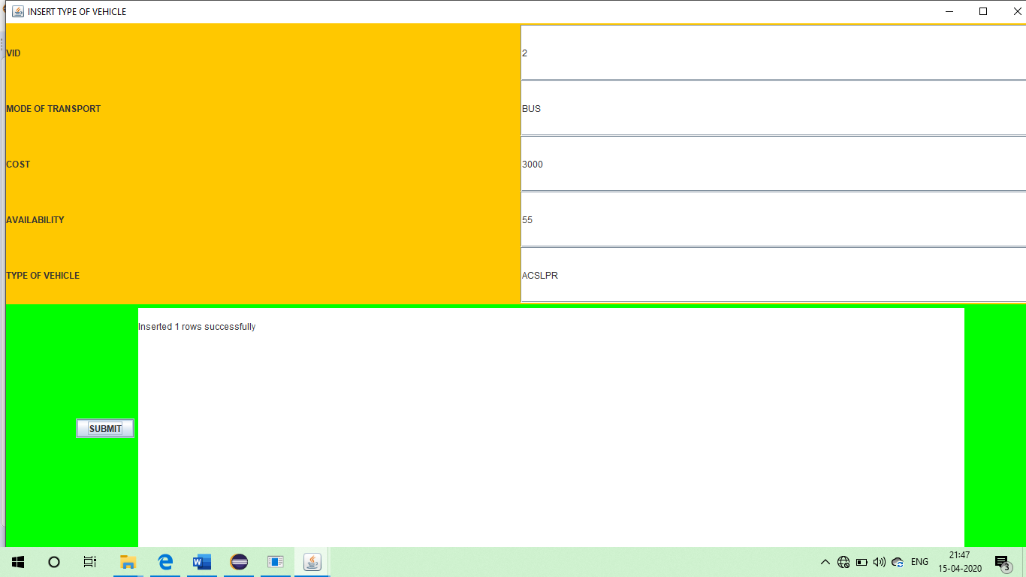**SCREENSHOT OF INSERT TYPEOFVEHICLE**

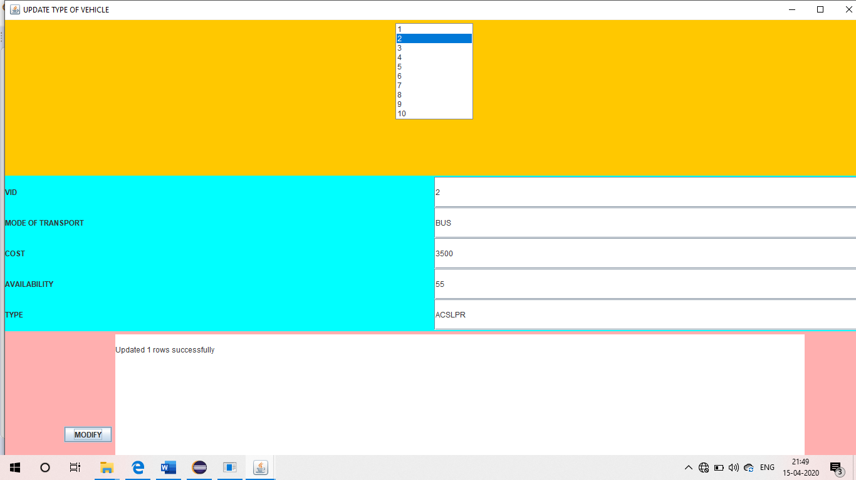**SCREENSHOT OF UPDATE TYPE OF VEHICLE**

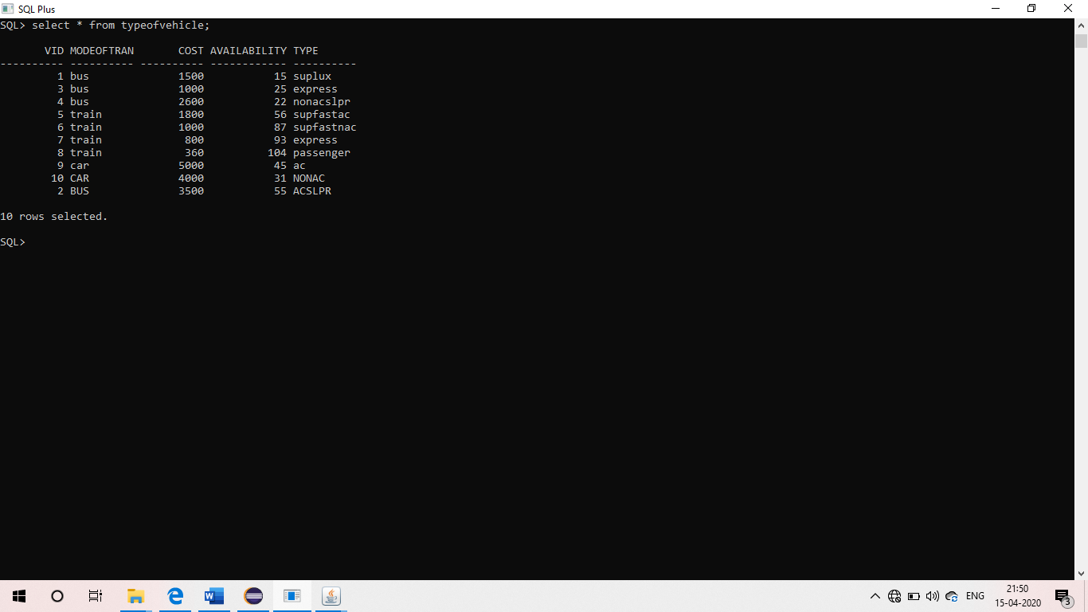

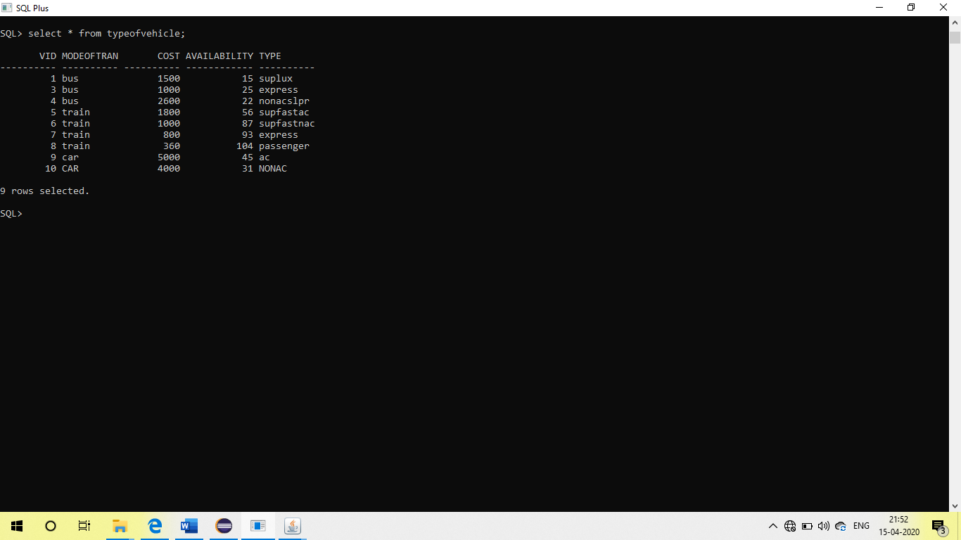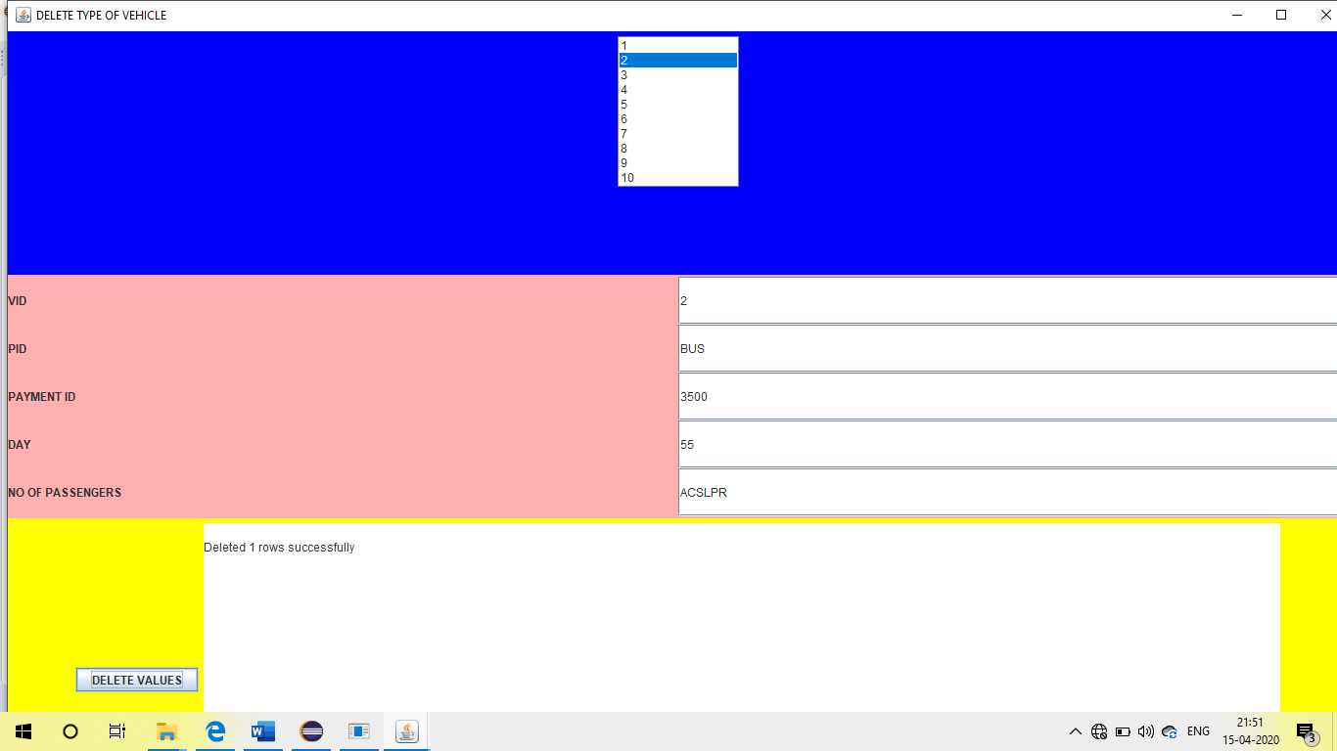**SCREEN SHOT OF DELETE TYPEOFVEHICLE**

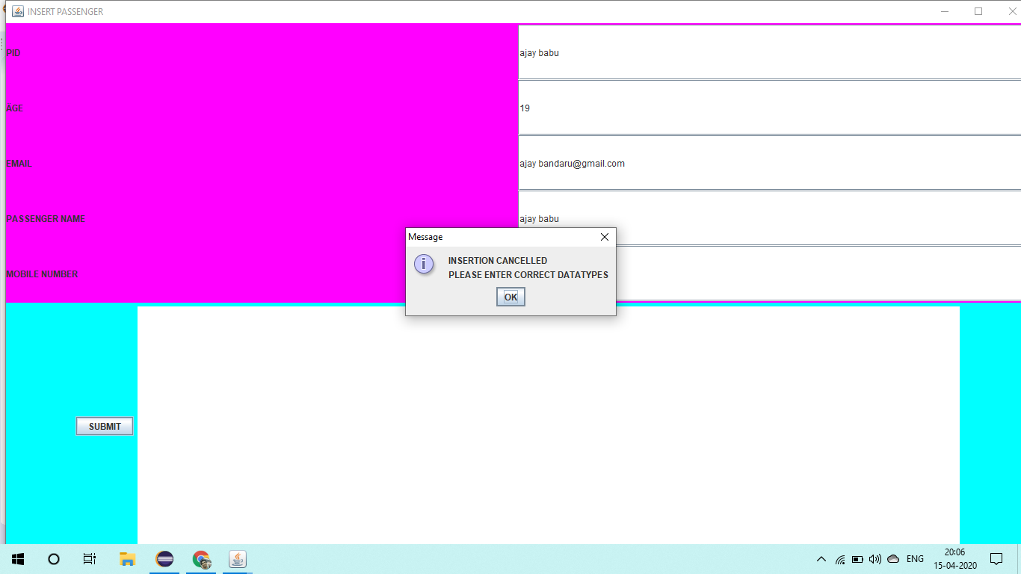**TESTING:**

If a user enters a incorrect datatype the following pop up box will be diplayed!

**RESULT: (**all screenshots of all dml operations are already kept)

The process of entering information into the frame created by java code so that the data is reflected in the database using **JDBC connectivity** is done successfully.

**6.DISCUSSION AND FUTURE WORK!**

The application till now done is a basic interface in which a user

can enter his details and check the required vehicle based on his

budget. **So this project is priorly done for fixed place** i.e fixed

start place and fixed destination place. So **in future the project**

**will be edited in such a manner that the fare is calculated based**

**the number of kilometers between two places.**

**7.REFERENCES:**

<https://docs.oracle.com/javase/8/docs/api/>

<https://www.geeksforgeeks.org/establishing-jdbc-connection-in-java/>

<https://www.javatpoint.com/java-awt>