FBIRN Stability phantom QA procedures:
By G. H. Glover, Stanford University and FBIRN

The Quality Assurance scans must be performed on a routine basis. They are used to verify scanner stability. Analysis can be performed locally.

A. Stability Phantom protocol
The stability (agar) phantom consists of two parts: The spherical phantom itself and the agar material inside. The agar phantom recipe follows this protocol.

The agar phantom (17 cm sphere filled with agar gel) should be scanned at least once/week. The scan is performed with the head coil that is used for the fMRI scans. The scan protocol should be identical to that employed for the human fMRI scans except a straight axial scan plane is used. A consistent protocol should be used so that deviations from the scanner’s usual performance can be detected.

The sequences used originally were:
Pulse sequence = EPI or Spiral GRE
Scan plane = axial
FOV = 22 cm
28 slices, 4mm thick, 1 mm gap
TR = 2000ms
TE = 30ms (3T/4T), 40ms (1.5T)
FA = 90 degrees
BW = ±100 kHz
64x64 matrix, 1 shot
200 time frames (volumes)

(A TR of 3000 ms with 5 mm slices and no gap was also used by the FBIRN in the original multisite stability phantom dataset.)

With reference to Fig. 1, the Matlab analysis software qa_calc_fbirn.m reads 200 images from a central slice (slice # 18) time series and provides readings of RMS stability, drift, mean value, SNR, etc. The first two time frames are discarded.

The script outputs three plots and several images. Figure 1 below is an example. The top plot is the RMS stability calculated using a 20x20 square ROI centered in the image, after a second order detrending fit, and noted as percent fluctuation. Drift is obtained from the fit as 100*(max - min)/mean. The middle plot is the spectrum of the detrended timeseries in the top plot.

The bottom plot is a 'Weisskoff plot' (see Weisskoff, MRM 36:643 (1996)). This shows standard deviation (STD) in a square ROI centered on the image as a function of the size of the box, in pixels. If the noise in the pixels is uncorrelated, the STD should decrease as vnum_pixels (the dashed line). System noise tends to have low spatial frequency influence on the image and leads to cross correlation. Cross correlation in turn results in reduced noise benefit from increased number of pixels in the ROI. For example, if the RF amplitude fluctuates the entire image gain fluctuates and there is complete correlation between pixels. Thus, as the ROI size increases, system noise becomes apparent as a departure of the STD from the dashed line, flattening out. The intercept of a horizontal line at the limiting value measured with 20x20 pixel ROI (largest ROI plotted and that used in the top plot) with the dashed line is thus an estimate of the correlation diameter, in pixels, and is reported as rdc. For an ideal scanner rdc would be 20 pixels (or larger if measurements were extended).

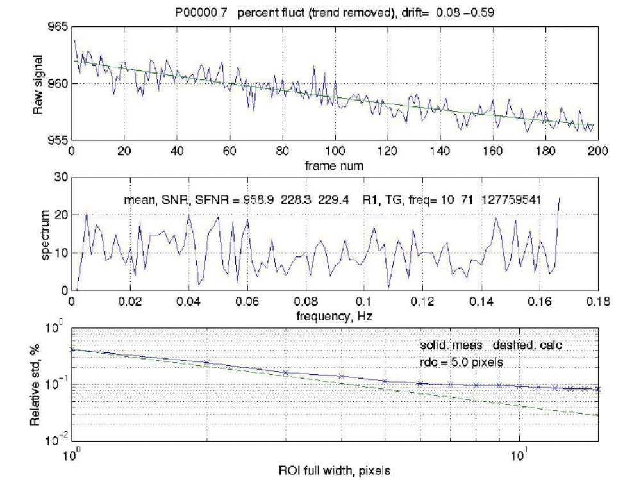
FIGURE 1. Plots obtained from qa_calc_fbirn.m program run on a 200-images time series from the stability scan.

The script also calculates 4 image maps: average, standard deviation, noise average, SFNR (see Fig. 2). The noise average image = average(even numbered frames) – average(odd numbered frames). This should be a featureless noise map. A 20x20 ROI in this image provides the Noise, and a 20x20 ROI in the average image provides Signal. The SNR = Signal/Noise, reported in the second plot. The SFNR (signal to fluctuation noise ratio) map is the average image divided by the standard deviation image, and the SFNR reported is from a 20x20 ROI in this map. In general SNR and SFNR should be close to each other. Other values in the middle plot are mean signal intensity, transmitter and receiver gains and center frequency, obtained from the raw header.

The program is a Matlab script that was built for use with spiral scans on a GE scanner. The image files are flat (headerless) short integers, numbered consecutively. If the script is used with other file formats, suitable modifications will be needed for file conventions and access to header information such as spectrometer frequency and hardware gains (if desired).

Example of data tabulated.

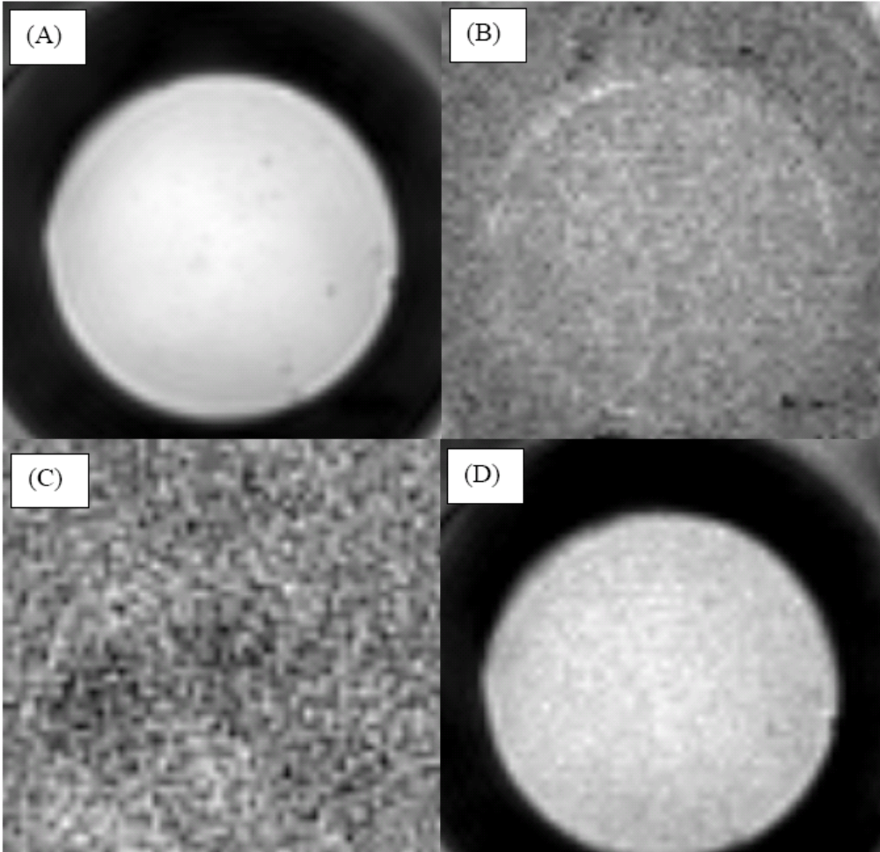

FIGURE 2. Images of time series maps produced by qa_calc_fbirn.m. (A) average, (B) standard deviation, (C) noise average, (D) SFNR.

Stanford Agar Phantom Recipe
2/20/03

The phantom is constructed using 17.5 cm diameter spherical container from Dielectric. To obtain the shell for the phantom, contact:
Greg Brown
UCSD, Center for Functional Magnetic Resonance Imaging
Department of Radiology #0667
9500 Gilman Dr
La Jolla, CA 92093-0667

The basic relaxation agent recipe is from Schneiders [1] and is added to provide T1 and T2 comparable to a gray matter. A small amount of NaCl is added to increase the conductivity to mimic the RF load of a head.

1. Make 21.8mM NiCl₂ mixture:
2.82 grams Nickel Chloride per 1 L H₂O
2. Make agar mixture:
3600 ml H₂O
400 ml 21.8mM NiCl₂
120 grams Agar
20 grams NaCl (0.5%)
1 gram of Sodium Azide (toxic, used to retard growth of evil green things)
3. Boil mixture slowly
Use two 2L beakers, dividing the mixture into halves.
Boil each liter of mixture as follows:
Heat beakers one at a time for 3-5 minutes at high power in kitchen sized microwave. Ours is listed as 750 watt; times may (or may not) scale with power. Be careful that it doesn't boil over and titrate time accordingly, reducing the cycle time as the temp rises. Do not use heating plate to heat beakers to avoid burning the gel.
Remove beaker and stir. Put other beaker in oven, swapping back and forth.
Repeat heat/stir cycles until all the agar is dissolved and liquid is light brown but clear. This will take about 1-2 hours of heating.
Interleave the beakers through the heat/stir cycles unless the microwave is large enough for both at once.
Pour goop into phantom using funnel while boiling hot. If liquid cools it will gel and become a nice waste of time.
4. After final pour, purge all air bubbles using a 50 cc syringe filled with liquid and connected to tubing inserted to bottom of phantom, filling sphere until liquid runs out hole. Doing this will waste a lot of goo, so be prepared to catch the spillover. Plug hole with nylon screw and o-ring gasket while hot.

Note that the starting volume of the mixture is greater than 4/3πr³ = 2800 ml. Reduction occurs by boiling of water, spillover or by magic; however, there will be at least 500 ml left over.

Courtesy Anne Marie Sawyer-Glover.

1. Schneiders NJ. Solutions of two paramagnetic ions for use in nuclear magnetic resonance phantoms. Med. Phys. 15, 12-16 (1988).

B. Geometry Phantom protocol
Three dimensional geometry phantoms for MRI are available from Data Spectrum Corporation, 919-732-6800, part MRI/3D-GEO/P, last known price $3150. Designed by H. Cecil Charles, Ph.D.

The Data Spectrum phantom is used to verify geometry of the scanner's calibration. The recommended scan frequency is once/month or more, and immediately after any software or hardware upgrade or any repairs or significant adjustments to the gradient subsystem that could impact linearity or geometric accuracy. The protocol is:

1. 3-Plane localizer scan, 24 cm FOV.
Using axial slice, adjust phantom so that midline septa are parallel to major axes. Center in S/I direction from sagittal slice.

2. 3D Spoiled Grass/Flash
- Pulse sequence = 3D SPGR (Flash)
- Scan plane = axial
- FOV = 22 cm
- 124-128 slices, 1.8 mm thickness
- TR = 20 ms
- 1 Nex
- TE = minimum, full echo
- FA = 20 degrees
- 256x256 matrix
- Scan time = 11 minutes
Analysis is by manual measurement. The 3D set is reformatted into axial, sagittal and coronal sections.
The phantom has fiducial holes on 15 mm centers. At minimum, 8 measurements should be performed
on each of the three midline planes (axial, sagittal, coronal), as shown in Fig. 3 for the axial section.
Results can be tabulated as pixels or (as in table below) in mm.

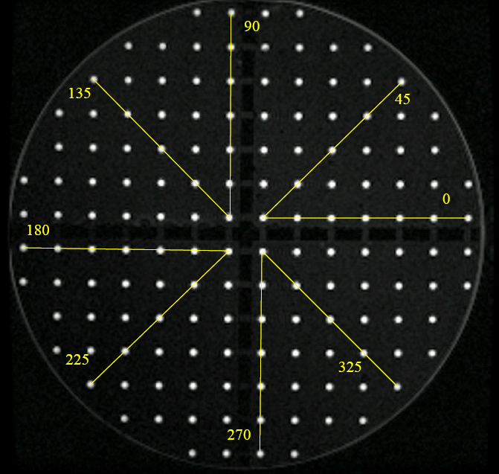
FIGURE 3. Midline axial scan plane showing 8 measurements at angles (shown in degrees). Grid points are 15 mm apart.

