**MATLAB HW2 Report**

B09901142 電機二 呂睿超

1. Plot x[n] vs [n]

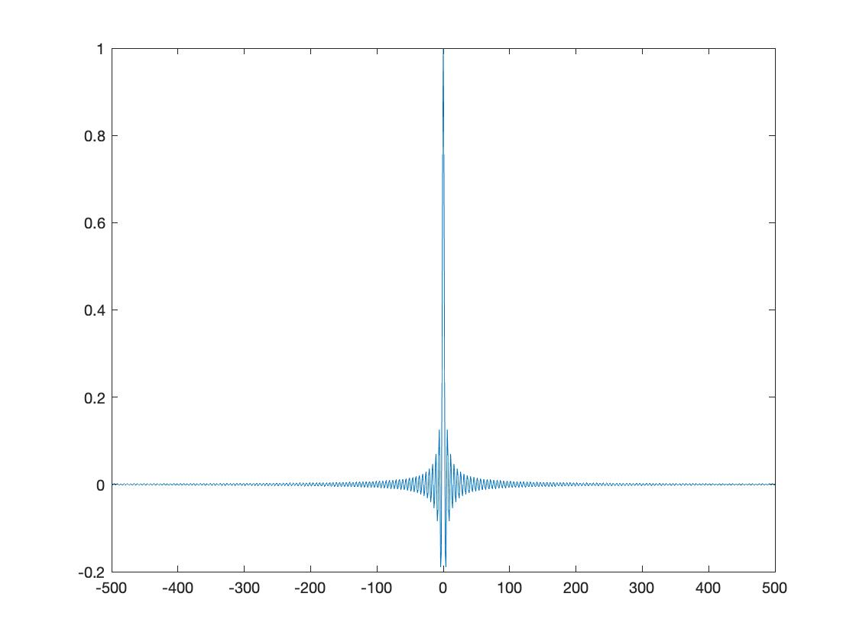

1. Use the MATLAB function fft directly to compute DFT of x[n]

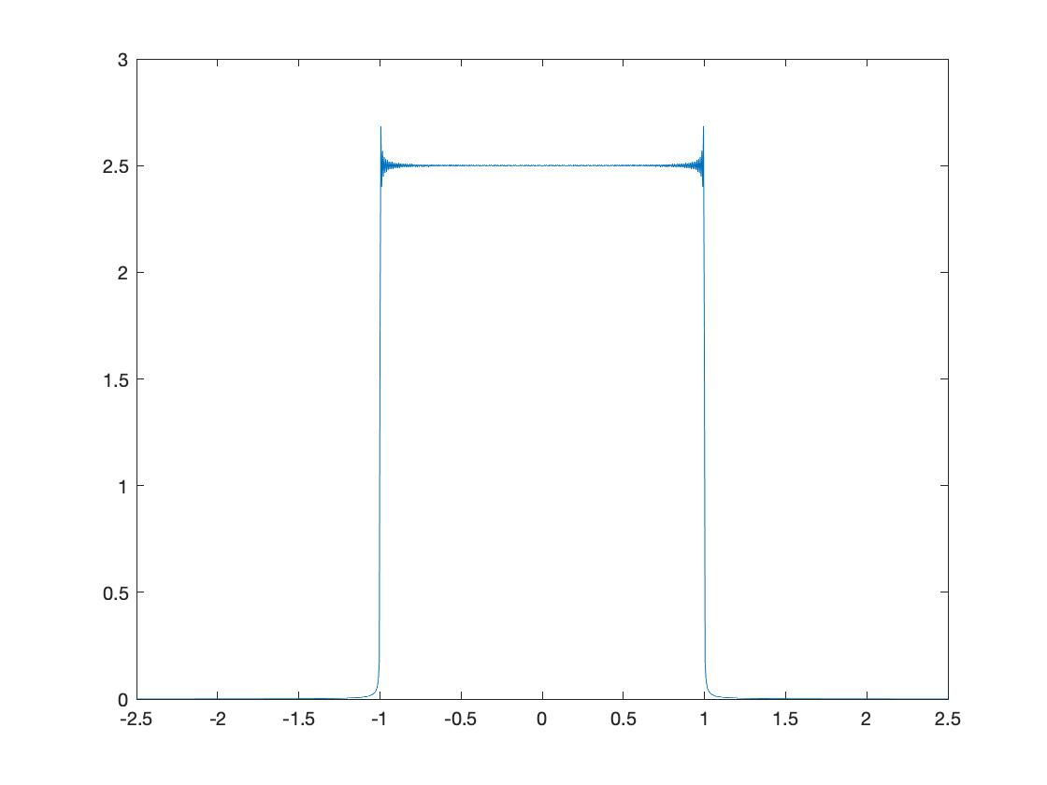

From the image, we can obviously observe Gibbs phenomenon because we sample the input sinc function to transform so that we face discontinuous points. Therefore, as N is finite, Gibbs phenomenon occurs.

1. Create a MATLAB program by yourself to compute Xk(ejw) 。

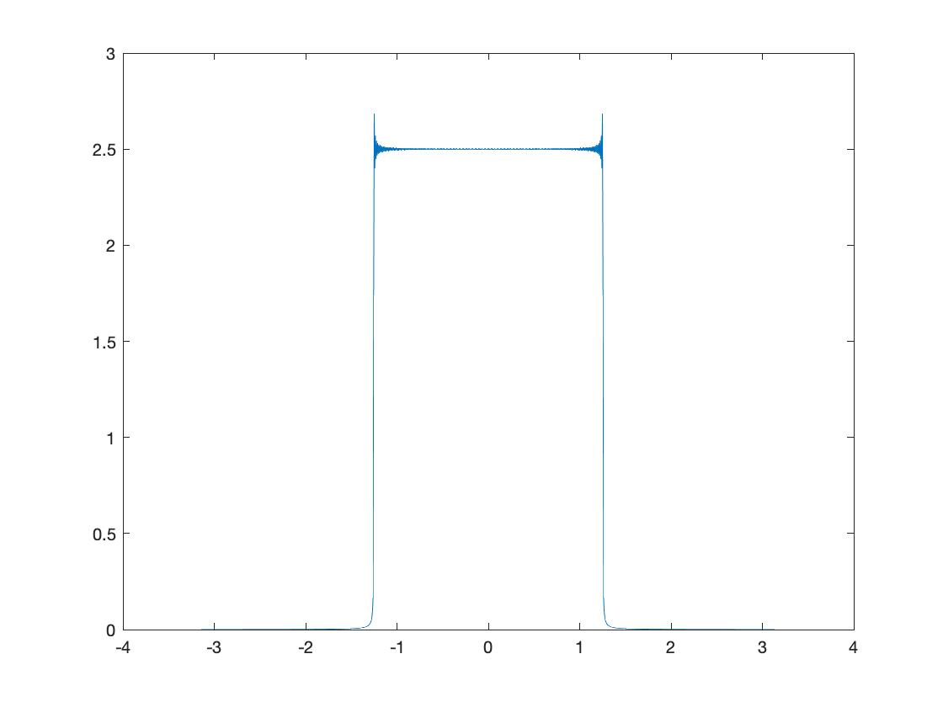

We can easily see that it is identical with the result of (b)

1. Use the MATLAB function plot to plot x[n] vs [n]

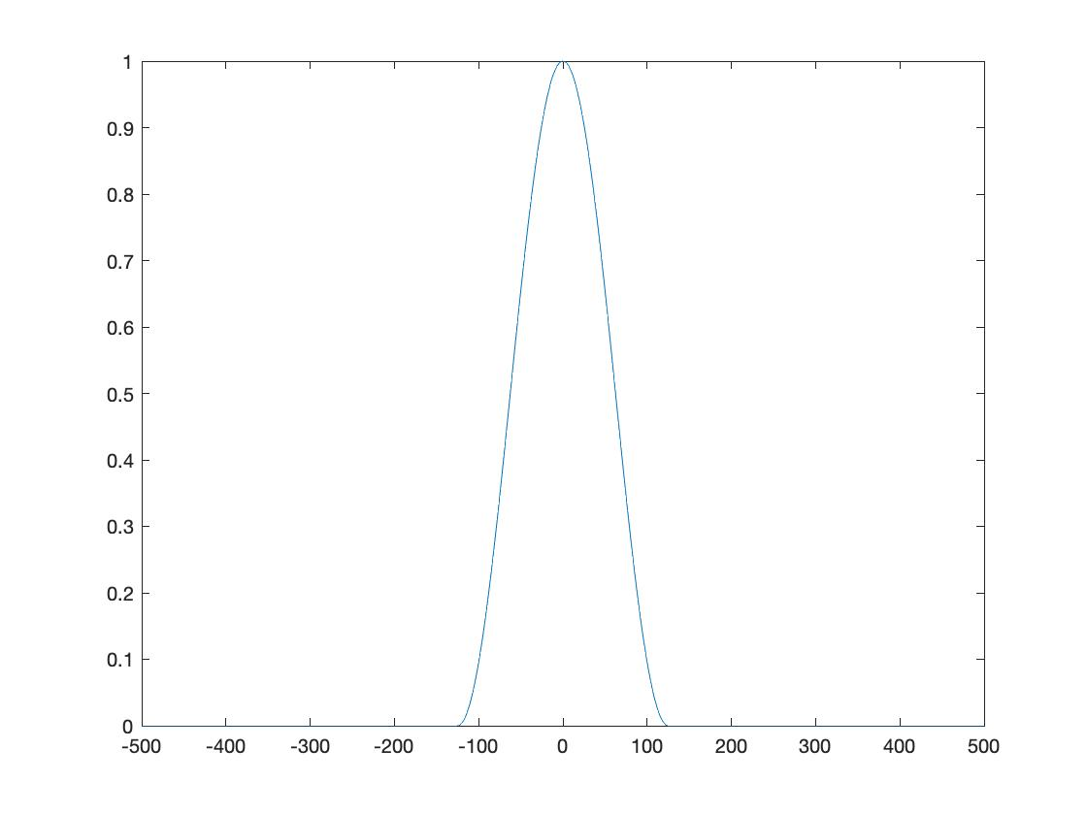

1. Use the MATLAB function plot to plot y[n] vs n, where y[n] = x[n]w[n],and x[n] is the signal plotted in (a).

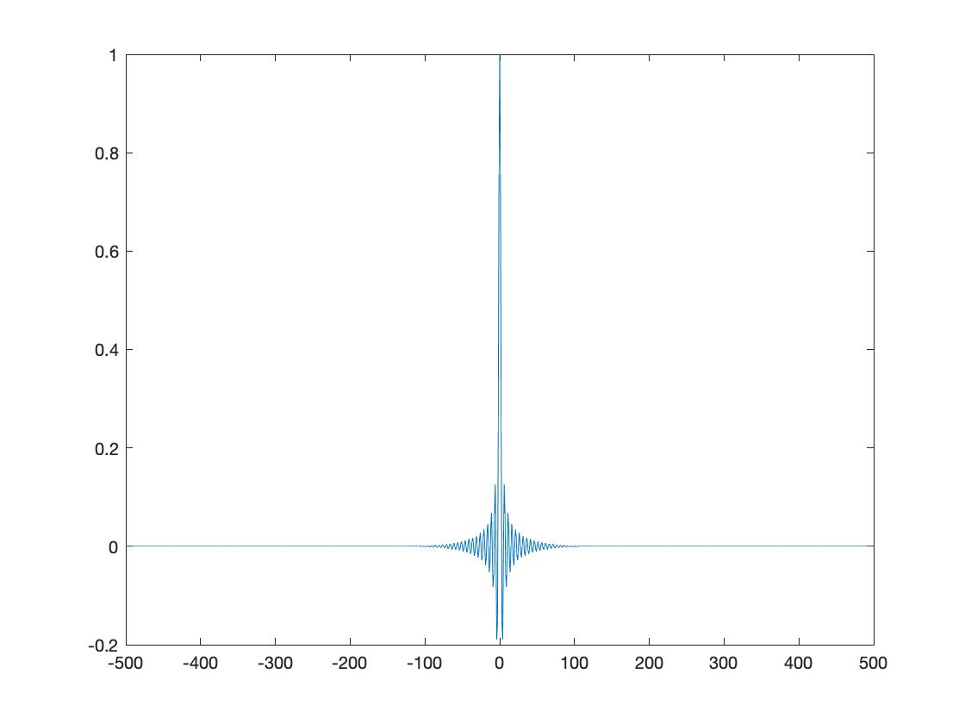

1. Use the MATLAB function fft directly to compute DFT of y[n] in (e)

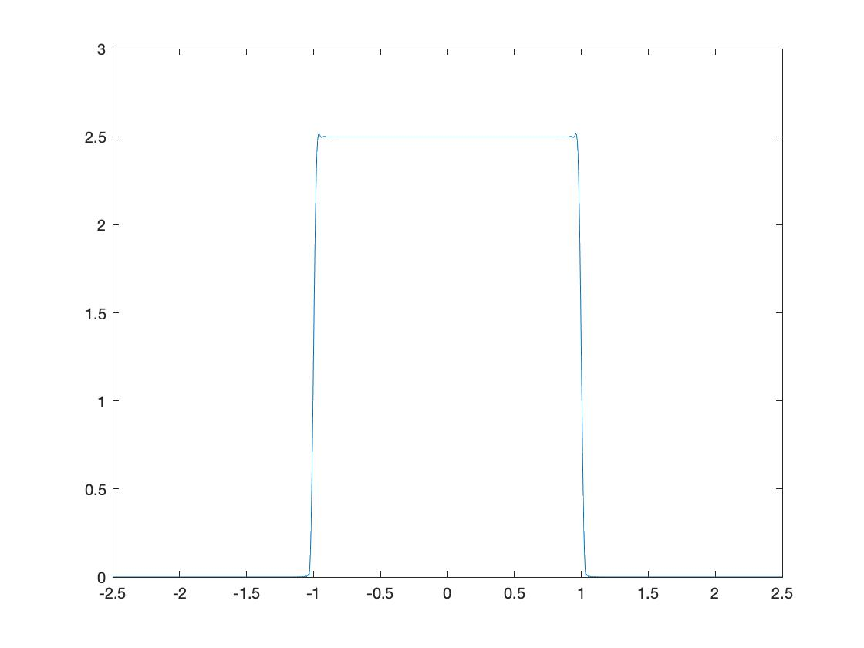

We can see that the Gibbs phenomenon is mitigated by Hanning window function so the ripple is much smaller compared with the result of b.