**MATLAB HW3 Report**

B09901142 EE2 呂睿超

**Part I**

1. Use the MATLAB function plot to plot x[n] vs n.

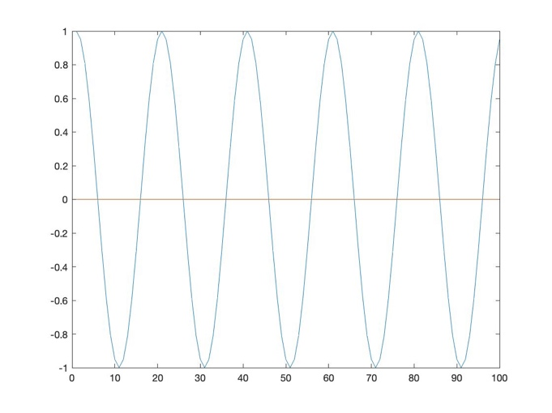\

1. (c) (d)
2. Response plot image

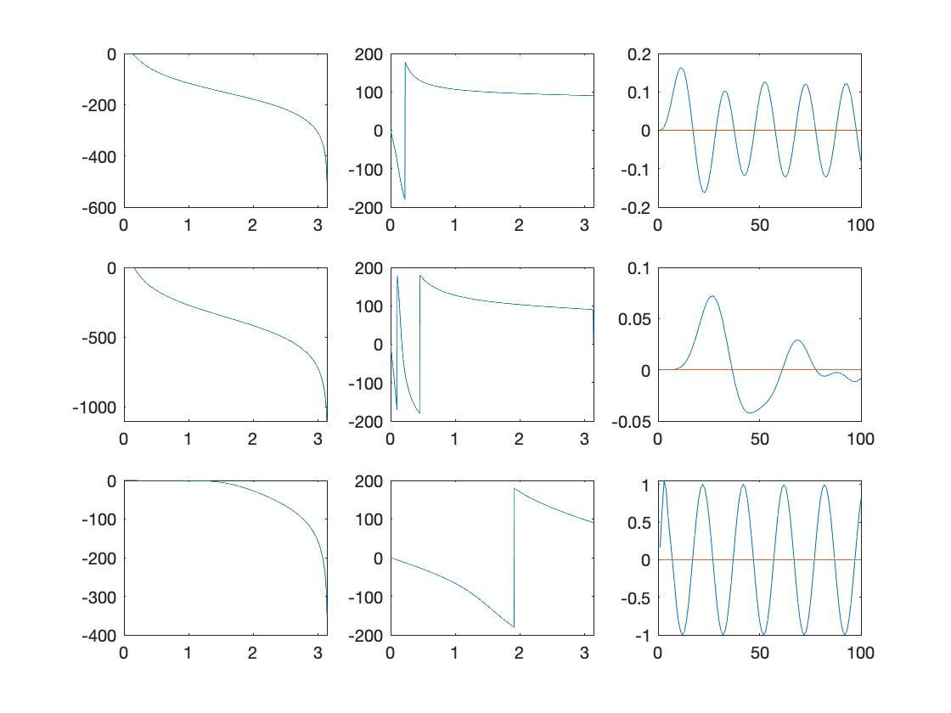

From left to right respectively is magnitude response, phase response, y[n] which is the filtered signal.

From up to down respectively is result of (b) (c) (d)

1. Transfer function coefficients

|  |  |  |  |  |  |  |  |  |
| --- | --- | --- | --- | --- | --- | --- | --- | --- |
|  | 1 | 2 | 3 | 4 | 5 | 6 | 7 | 8 |
| b1 | 0.0004 | 0.0012 | 0.0012 | 0.0004 |  |  |  |  |
| a1 | 1 | -2.6862 | 2.4197 | -0.7392 |  |  |  |  |
| b2 | 1.31E-08 | 9.19E-08 | 2.76E-07 | 4.60E-07 | 4.60E-07 | 2.76E-07 | 9.19E-08 | 1.31E-08 |
| a2 | 1 | -6.29419 | 17.011 | -25.5884 | 23.1343 | -12.5702 | 3.8005 | -0.4932 |
| b3 | 0.1667 | 0.5 | 0.5 | 0.1667 |  |  |  |  |
| a3 | 1 | -5.00E-16 | 0.333 | -1.85E-17 |  |  |  |  |

# b1,a1 for L=3,fc=0.05; b2,a2 for L=7,fc=0.05; b3,a3 for L=3,fc=0.5;

(e) when L increase, we can compare (b) and (c) to see that the main frequency of the signal is filtered out more.

when fc increase, we can compare (b) and (d) to see that the main frequency of the signal is reserved more.

**Part II**

1. (b) (c)
2. Signal Image

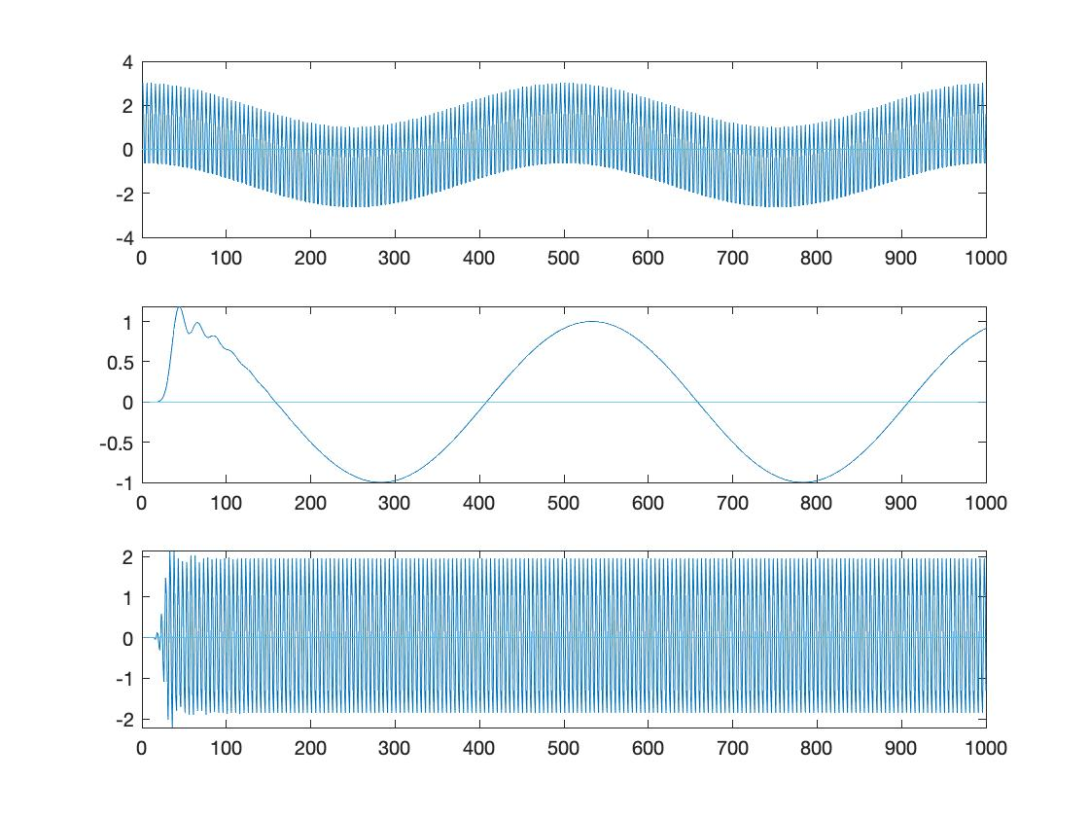

1. Cutoff frequencies

For (b) the lowpass cutoff frequency is roughly fc = 0.1

For (c) the bandpass cutoff frequencies are roughly fb1 = 0.25, fb2 = 0.5

1. Transfer function coefficients

|  |  |  |  |  |  |  |  |  |
| --- | --- | --- | --- | --- | --- | --- | --- | --- |
|  | 1 | 2 | 3 | 4 | 5 | 6 | 7 | 8 |
| b1 | 3.13E-14 | 5.01E-13 | 3.76E-12 | 1.75E-11 | 5.70E-11 | 1.37E-10 | 2.51E-10 | 3.58E-10 |
| a1 | 0.001 | -0.0128 | 0.077 | -0.2894 | 0.7596 | -1.4772 | 2.2009 | -2.5625 |
| b2 | 1.18E-08 | 0 | -1.90E-07 | 0 | 1.42E-06 | 0 | -6.64E-06 | 0 |
| a2 | 1 | -9.9377443 | 54.4906222 | -211.40557 | 642.818918 | -1615.9258 | 3470.87374 | -6510.5527 |

|  |  |  |  |  |  |  |  |  |
| --- | --- | --- | --- | --- | --- | --- | --- | --- |
| 9 | 10 | 11 | 12 | 13 | 14 | 15 | 16 | 17 |
| 4.03E-10 | 3.58E-10 | 2.51E-10 | 1.37E-10 | 5.70E-11 | 1.75E-11 | 3.76E-12 | 5.01E-13 | 3.13E-14 |
| 2.356 | -1.7161 | 0.9869 | -0.4434 | 0.1525 | -0.0388 | 0.0069 | -0.0008 | 0 |
| 2.16E-05 | 0 | -5.18E-05 | 0 | 9.49E-05 | 0 | -0.0001355 | 0 | 0.00015249 |
| 10830.4681 | -16157.842 | 21799.8558 | -26766.138 | 30049.7074 | -30956.139 | 29336.3882 | -25618.367 | 20634.2237 |

|  |  |  |  |  |  |  |  |  |
| --- | --- | --- | --- | --- | --- | --- | --- | --- |
| 18 | 19 | 20 | 21 | 22 | 23 | 24 | 25 | 26 |
|  |  |  |  |  |  |  |  |  |
|  |  |  |  |  |  |  |  |  |
| 0 | -0.0001355 | 0 | 9.49E-05 | 0 | -5.18E-05 | 0 | 2.16E-05 | 0 |
| -15332.662 | 10506.2068 | -6630.9254 | 3847.51541 | -2046.8027 | 994.602217 | -439.30381 | 175.239682 | -62.60049 |

|  |  |  |  |  |  |  |
| --- | --- | --- | --- | --- | --- | --- |
| 27 | 28 | 29 | 30 | 31 | 32 | 33 |
|  |  |  |  |  |  |  |
|  |  |  |  |  |  |  |
| -6.64E-06 | 0 | 1.42E-06 | 0 | -1.90E-07 | 0 | 1.18E-08 |
| 19.8028972 | -5.462836 | 1.28610784 | -0.2501405 | 0.03814916 | -0.0041261 | 0.00024898 |

#b1,a1 for (b) lowpass coefficients, L=16

b2,a2 for (c) bandpass coefficients, L=32