**MATLAB Report 4**

B09901142 EE2 呂睿超

1. The output figures are below

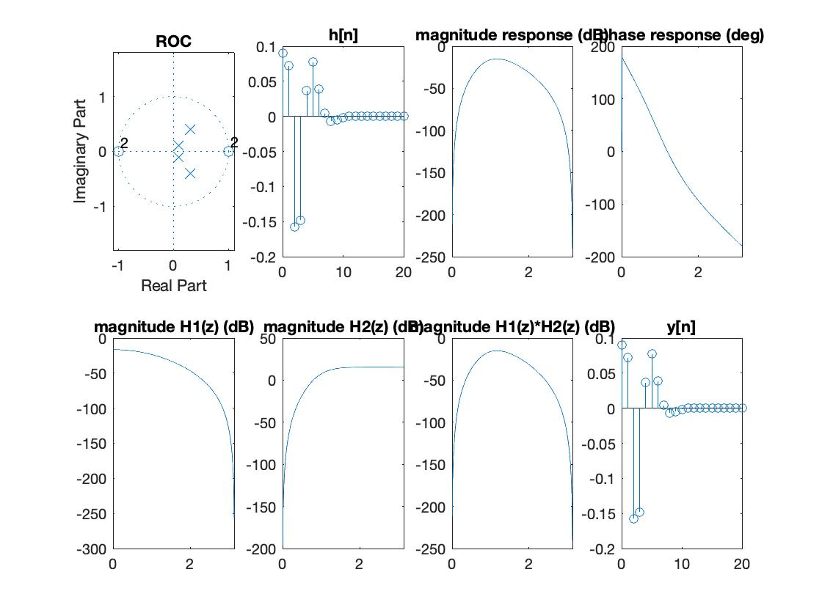

1. Other analysis
2. For question (a) the outmost pole is mag(z) = 0.3^2 + 0.4^2 = 0.5

(d) For question (d) the representation of two cascade systems is

H1(z) = $\frac{0.09(1+2z^{-1}+z^{-2})}{1-0.02z^{-1}+0.02z^{-2}}$

H2(z) = $\frac{1-2z^{-1}+z^{-2}}{1-0.06z^{-1}+{0.25z}^{-2}}$

(e) For question (e) the H1*H2 response is identical with the result of (c)

(f) For question (f) the filtered y[n] is identical with the result of (b)

$$y\left[n\right]=δ\left[n\right]*h\left[n\right]=h\left[n\right]$$

(不好意思助教，期末考週繁忙一時忘記，拜託助教網開一面少扣點分，不然期末考已經沒什麼分數了，拜託拉拉啦啦啦)