**Student ID: b09901142  
Name: 呂睿超**

**RTL Report**

|  |  |
| --- | --- |
| Testbench | Pass (Pass/Fail) |
| Clock Cycle | 10.0 (ns) |
| Total Time | 11420 (ns) |

**Synthesis Report**

|  |  |
| --- | --- |
| Testbench | Pass(Pass/Fail) |
| Clock Cycle | 10.0 (ns) |
| Cell Area | 37487.079181 (Please report **Total cell area**) |
| Total Time | 11420.00 (ns) |
| Area*Time |  |

**APR Report**

|  |  |
| --- | --- |
| Testbench | Pass(Pass/Fail) |
| Clock Cycle | 10.0 (ns) |
| Cell Area | 46861.819 (Please report **Total area of Core)** |
| Total Time | 11420.00 (ns) |
| Area*Time |  |

How to report area in Innovus?

* File > Report > Summary > choose Text only, file name: **summaryReport.rpt**>OK, find **Total area of Core.**

**Synthesis No latch**

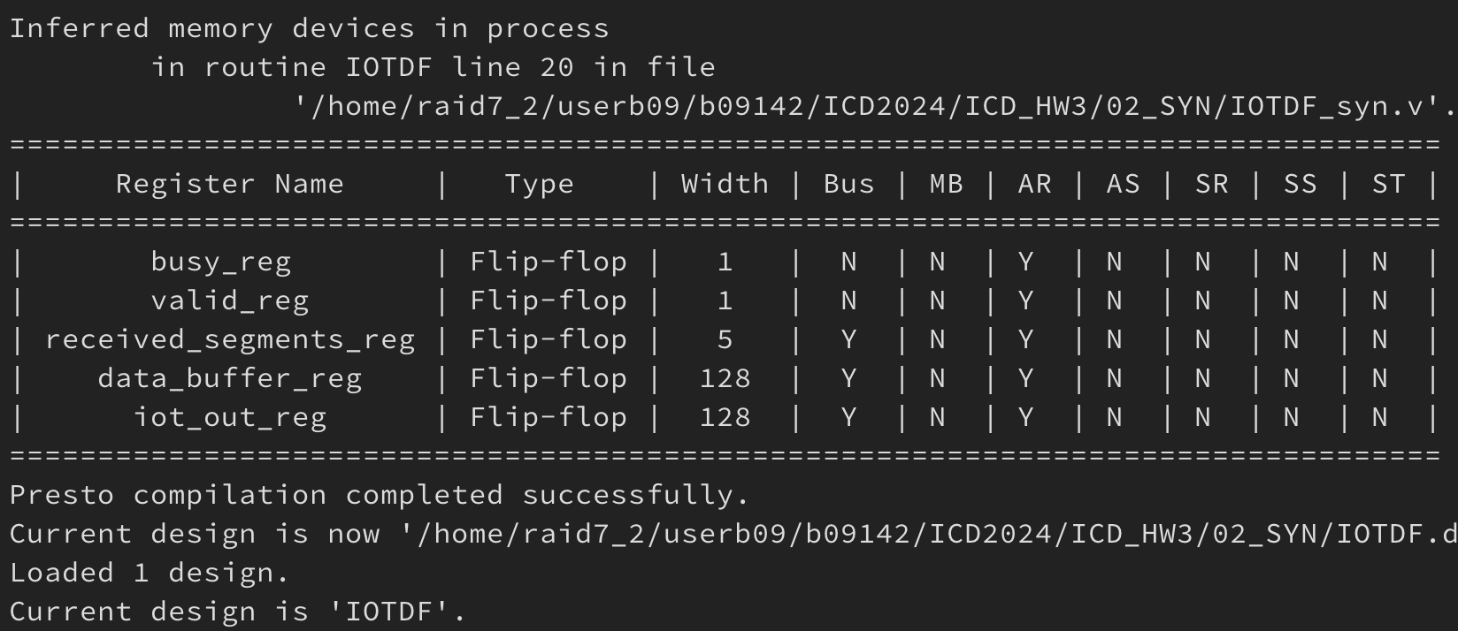

**APR NanoRoute Innovus Result (截圖)**

