Homework #14 Machine Learning 2022Spring

B09901142 EE2 呂睿超 ML HW14 Report

# Question 1

## 1-1

Plot the learning curve of the metric with every method. (The Plotting function is provided in the sample code.) (0.5pt)

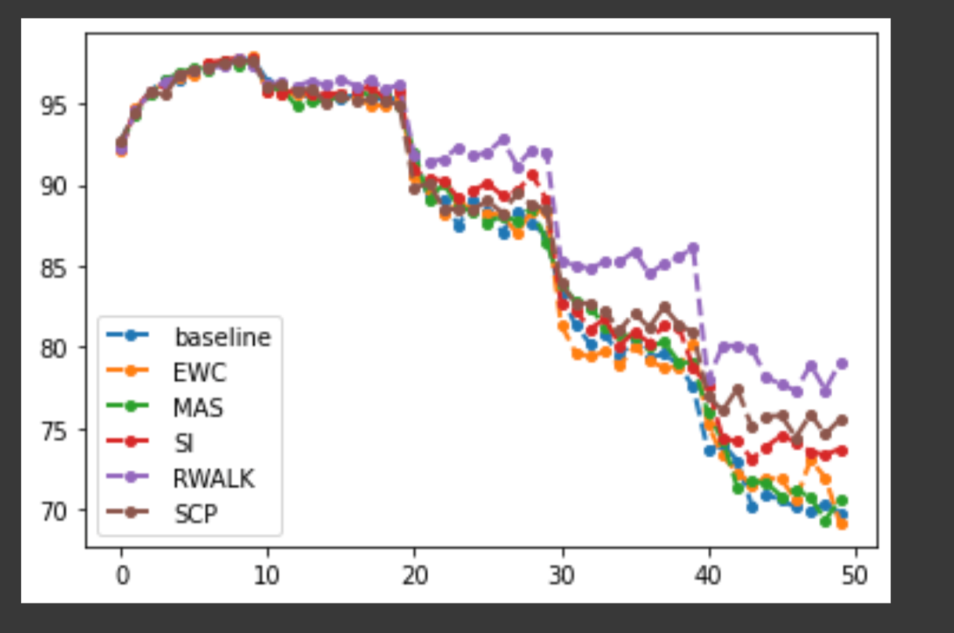

## 1-2

Describe the metric. (0.5pt)

The metric is directly calculated by the ratio of the correct-predicted data over total data.

# Question 2

Paste the code that you implement Omega Matrix for MAS. (1pt)

output.pow_(2)

loss = torch.sum(output,dim=1)

loss = torch.norm(loss)

loss.backward()

for n, p in self.model.named_parameters():

precision_matrices[n].data += p.grad.abs() / num_data