**QUESTION 1: i) Create a shipping address form using html in the format given below.**

**ii) Write an angular script that will be invoked when form is validated successfully.**

**iii) Display the status messages using angular directives and angular class values for all form elements.**

**HTML CODE:**

<html>

<head>

<title>18BIT0048 q1</title>

<script src="angular.min.js"></script>

<style>

div{

border: 1px solid blue;

}

input.ng-invalid

{

background-color:orange;

}

input.ng-valid

{

background-color:green;

}

</style>

</head>

<body ng-app="">

<form name="myform">

<div style="width:30.55%;color:blue;height:4%"><b>Shipping Address</b></div>

<div style="width:30%;background-color:#FFE5B4;padding:4px">

<p>

&nbsp;&nbsp;&nbsp;&nbsp;<font color="red">*</font><b>Name</b>:

<input type="text" name="myname" ng-model="myname" ng-pattern="/^[a-zA-Z]{3,30}$/" required>

<span style="color:red" ng-show="myform.myname.$touched &&myform.myname.$error.required">The name is required.</span>

</p>

<p>

<font color="red">*</font><b>Address</b>:

<input type="text" name="myAddress" ng-model="myAddress" ngminlength="10" ngmaxlength="30" ng-required="true">

<span style="color:red" ng-show="myform.myAddress.$touched &&myform.myAddress.$error.required">The address is required.</span>

</p>

<p>

&nbsp&nbsp<b>Address</b>:

<input type="text" name="myaddress" ng-model="myaddress" ngminlength="10" ng-maxlength="30">

&nbsp <font color="black" size="2"><strong>(optional)</strong></font>

</p>

<p>

&nbsp;&nbsp;&nbsp;&nbsp;&nbsp;&nbsp;&nbsp;<font color="red">*</font><b>City</b>:

<input type="text" name="mycity" ng-model="mycity" ng-pattern="/^[a-zA-Z]{3,30}$/" required>

<span style="color:red" ng-show="myform.mycity.$touched &&myform.mycity.$error.required">The city name is required.</span>

</p>

<p>

&nbsp;&nbsp;&nbsp;&nbsp;&nbsp; <font color="red">*</font><b>State</b>:

<input type="text" name="mystate" ng-model="mystate" ng-pattern="/^[a-zA-Z]{6,30}$/" required>

<span style="color:red" ng-show="myform.mystate.$touched &&myform.mystate.$error.required">The state name is required.</span>

</p>

<p>

&nbsp;&nbsp;&nbsp;&nbsp;&nbsp;&nbsp;&nbsp;&nbsp;<font color="red">*</font><b>Zip</b>:

<input type="text" name="myzip" ng-model="myzip" ng-pattern="/^[0-9]{6}$/" required>

<span style="color:red" ng-show="myform.myzip.$touched &&myform.myzip.$error.required">The zip is required.</span>

</p>

</div>

<input type="submit">

</form>

<h5>Name:{{myform.myname.$valid}}</h5>

<h5>Address:{{myform.myAddress.$valid}}</h5>

<h5>Address:{{myform.myaddress.$valid}}</h5>

<h5>City:{{myform.mycity.$valid}}</h5>

<h5>State:{{myform.mystate.$valid}}</h5>

<h5>Zip:{{myform.myzip.$valid}}</h5>

</body>

</html>

**OUTPUT SCREENSHOT: form with wrong data:**

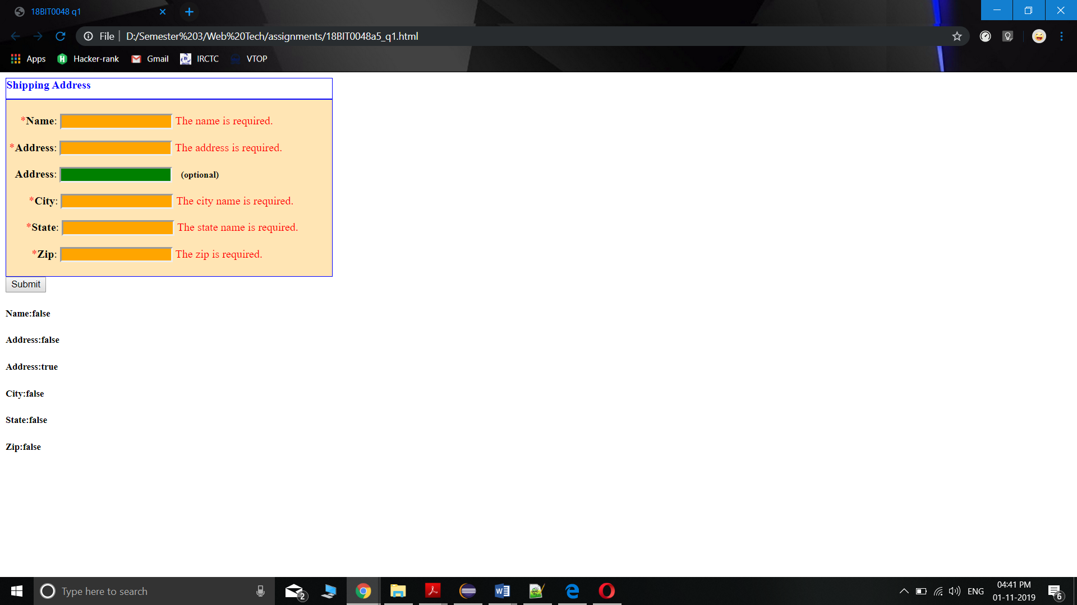

**OUTPUT SCREENSHOT: form with correct data:**

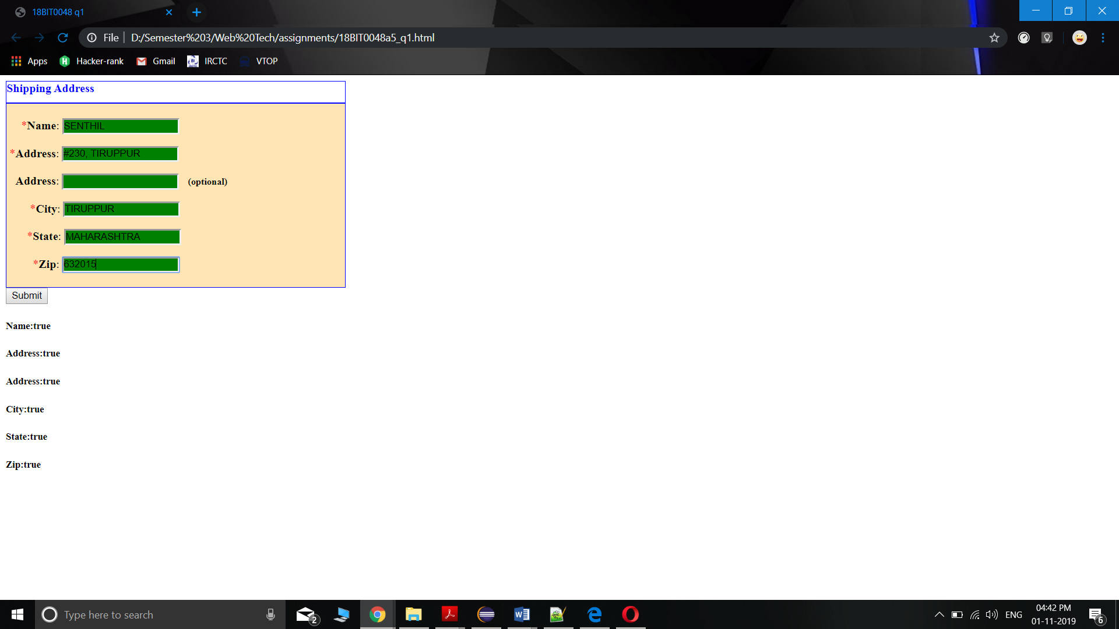

**QUESTION 2: i) Create an angular shopping application to buy books and remove if not required.**

**ii) If the user enters a book in the text box and clicks addbook button, the book is added and if the user clicks on cross symbol next to each book given in the picture below, the book is removed from the list.**

**iii) If the book is selected twice, display an appropriate error message. Use angular animations to add and remove items.**

**HTML CODE:**<!doctype html>

<html>

<head>

<title>18BIT0048 q2</title>

<script src="angular.min.js"></script>

<link rel="stylesheet" href="https://www.w3schools.com/w3css/4/w3.css">

</head>

<body ng-app="myShoppingList" ng-controller="myCtrl">

<script>

var app = angular.module("myShoppingList", []);

app.controller("myCtrl", function($scope)

{

$scope.products = ["Web Technologies","Operating Systems","Database Systems","Computer Architecture"];

$scope.addItem = function()

{

$scope.errortext = "";

if(!$scope.addMe)

{

return;

}

if($scope.products.indexOf($scope.addMe) == -1)

{

$scope.products.push($scope.addMe);

}

else {

$scope.errortext = "The item is already in your shopping list.";

}

}

$scope.removeItem = function(x){

$scope.errortext ="";

$scope.products.splice(x, 1);

}

});

</script>

<div ng-app="myShoppingList" ng-cloak ngcontroller="myCtrl" class="w3-card-2 w3-margin" style="maxwidth:400px;">

<header class="w3-container w3-light-grey w3-padding-16">

<h3>Books</h3>

</header>

<ul class="w3-ul">

<li ng-repeat="x in products" class="w3-

padding16">{{x}}

<span ng-click="removeItem($index)"

style="cursor:pointer;" class="w3-right w3-marginright">×</span>

</li>

</ul>

<div class="w3-container w3-light-grey w3-padding-16">

<div class="w3-row w3-margin-top">

<div class="w3-col s10">

<input placeholder="Add shopping items here" ng-model="addMe" class="w3-input w3-border w3-padding">

</div>

<div class="w3-col s2">

<button ng-click="addItem()" class="w3-btn w3-padding w3- green">Add</button>

</div>

</div>

<p class="w3-text-red">{{errortext}}</p>

</div>

</div>

</body>

</html>

**OUTPUT SCREENSHOT: initial webpage:**

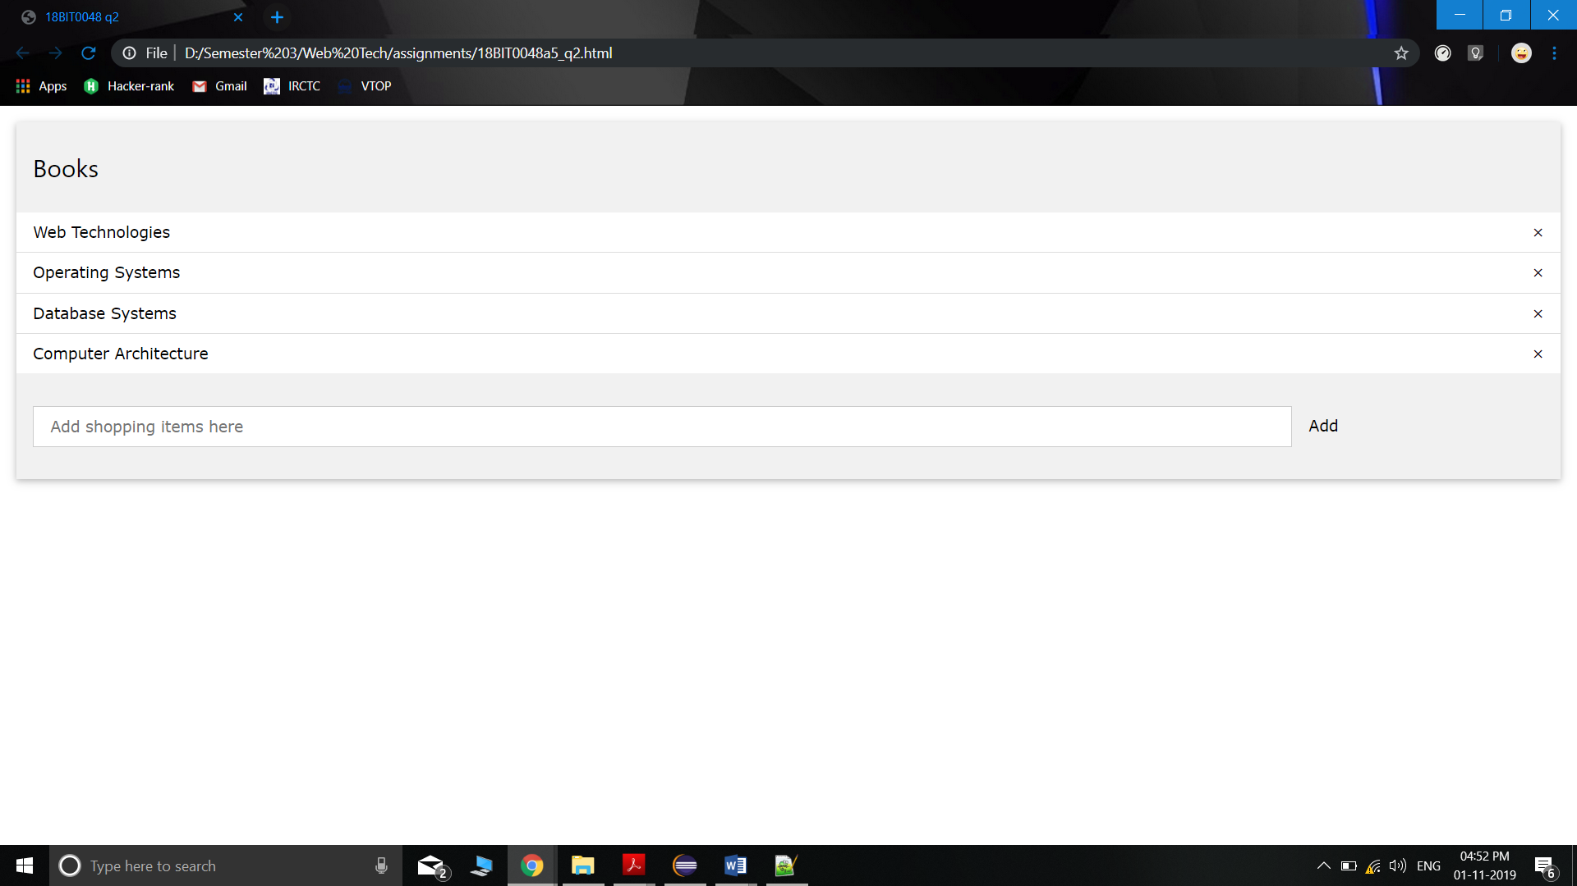

**OUTPUT SCREENSHOT: after adding “discrete maths” book**

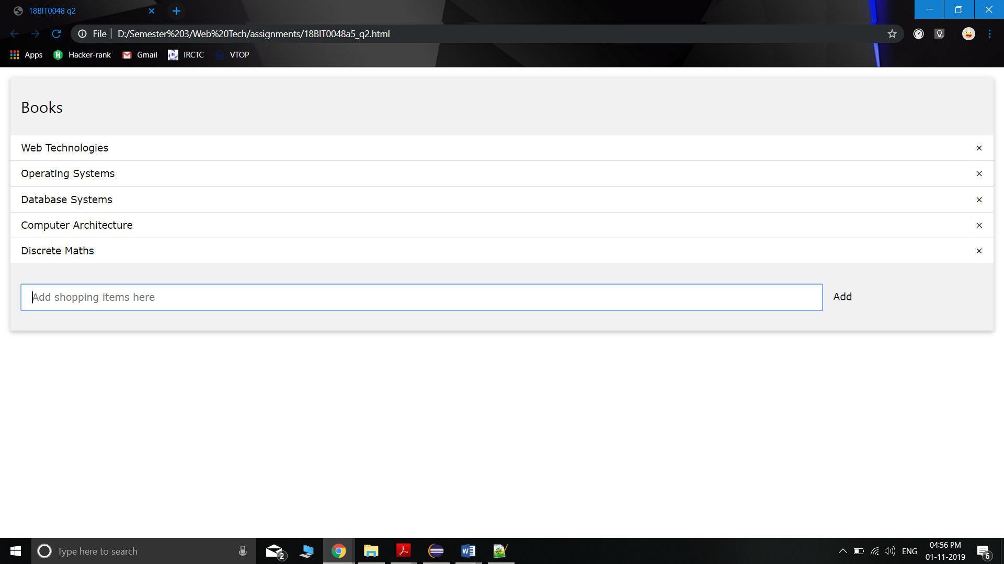

**OUTPUT SCREENSHOT: after deleting Database systems using cross button**

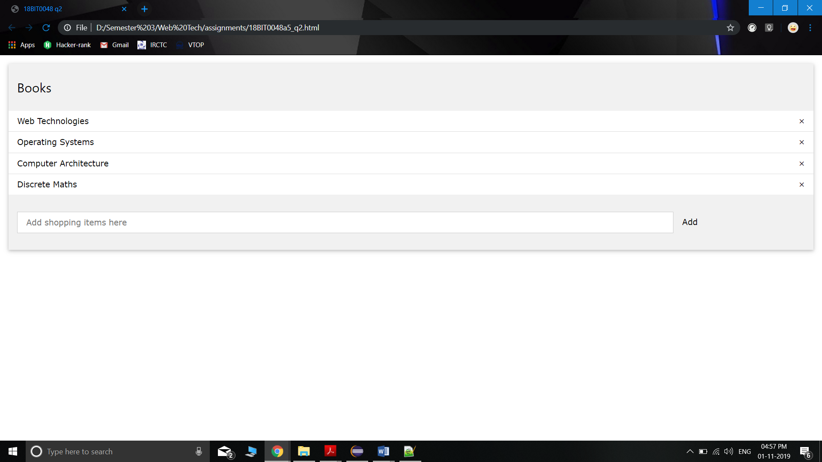

**OUTPUT SCREENSHOT: after entering Computer Architecture again for adding**

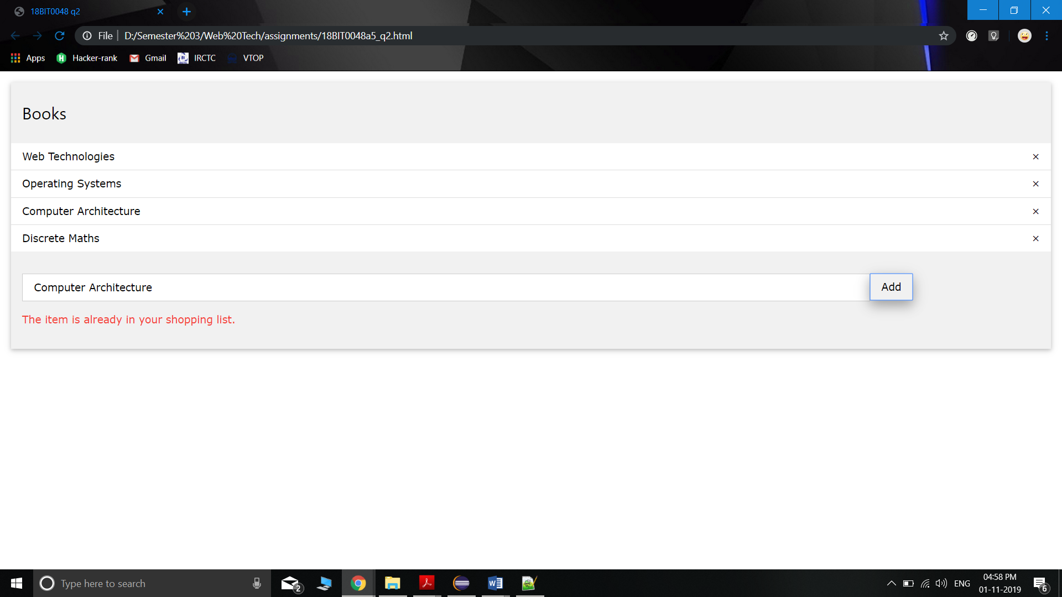

**QUESTION 3: i) Create an angular routing application that displays the default page as the order details page containing three orders as shown below.**

**ii) When the “show details” is clicked for a particular order, the order details of particular order number must be displayed below.**

**HTML CODE: main page:**

<!doctype html>

<html >

<head>

<meta charset="utf-8">

<title>Q4</title>

<script

src="angular.min.js"></script>

<script src="https://ajax.googleapis.com/ajax/libs/angularjs/1.4.7/angular-route.js"></script>

<script src="script.js"></script>

<style>

div{

background-color:#D1D0CE;

color:#000;

borderwidth:3px;

border-color:lightgreen;

border-style:solid;

height:100px

}

</style>

</head>

<body ng-app="myApp">

<table style="width:100%;" border="1" bordercolor="transparent" cellpadding="4px">

<tr bgcolor="#D1D0CE">

<th align="left">#</th>

<th align="left"><b>Order No.</b></th>

<th align="left"><b>Details</b></th>

<th align="left"><b></b></th>

</tr>

<tr bgcolor="#E5E4E2">

<td align="left">1</td>

<td align="left">1234</td>

<td align="left">15<sup>n</sup>Samsung Laptop</td>

<td><b><a href="#!first">show details</a></b></td>

</tr>

<tr bgcolor="#D1D0CE">

<td>2</td>

<td>5412</td>

<td>2TB Segate Hard drive</td>

<td><b><a href="#!second">show details</a></b></td>

</tr>

<tr bgcolor="#E5E4E2">

<td>3</td>

<td>9874</td>

<td>D-link router</td>

<td><b><a href="#!third">show details</a></b></td>

</tr>

</table> <br>

<div ng-view></div>

</body>

</html>

**JAVASCRIPT CODE: script.js**

var app = angular.module("myApp", ["ngRoute"]);

app.config(function($routeProvider) {

$routeProvider

.when("/", { template: "Order Details" })

.when("/first", { templateUrl: "first.html" })

.when("/second", { templateUrl: "second.html" })

.when("/third", { templateUrl: "third.html" })

.otherwise({ redirectto: "index.html" });

}).config(function($locationProvider) {

$locationProvider.hashPrefix('!');

});

**HTML CODE: first.html**

<html>

<div>

<b>ORDER #1234<br>HERE ARE THE DETAILS FOR ORDER

#1234</b>

</div>

</html>

**HTML CODE: second.html**

<html>

<div>

<b>ORDER #5124<br>HERE ARE THE DETAILS FOR ORDER

#5124</b>

</div>

</html>

**HTML CODE: third.html**

<html>

<div>

<b>ORDER #9874<br>HERE ARE THE DETAILS FOR ORDER

#9874</b>

</div>

</html>

**OUTPUT SCREENSHOT: initial website:**

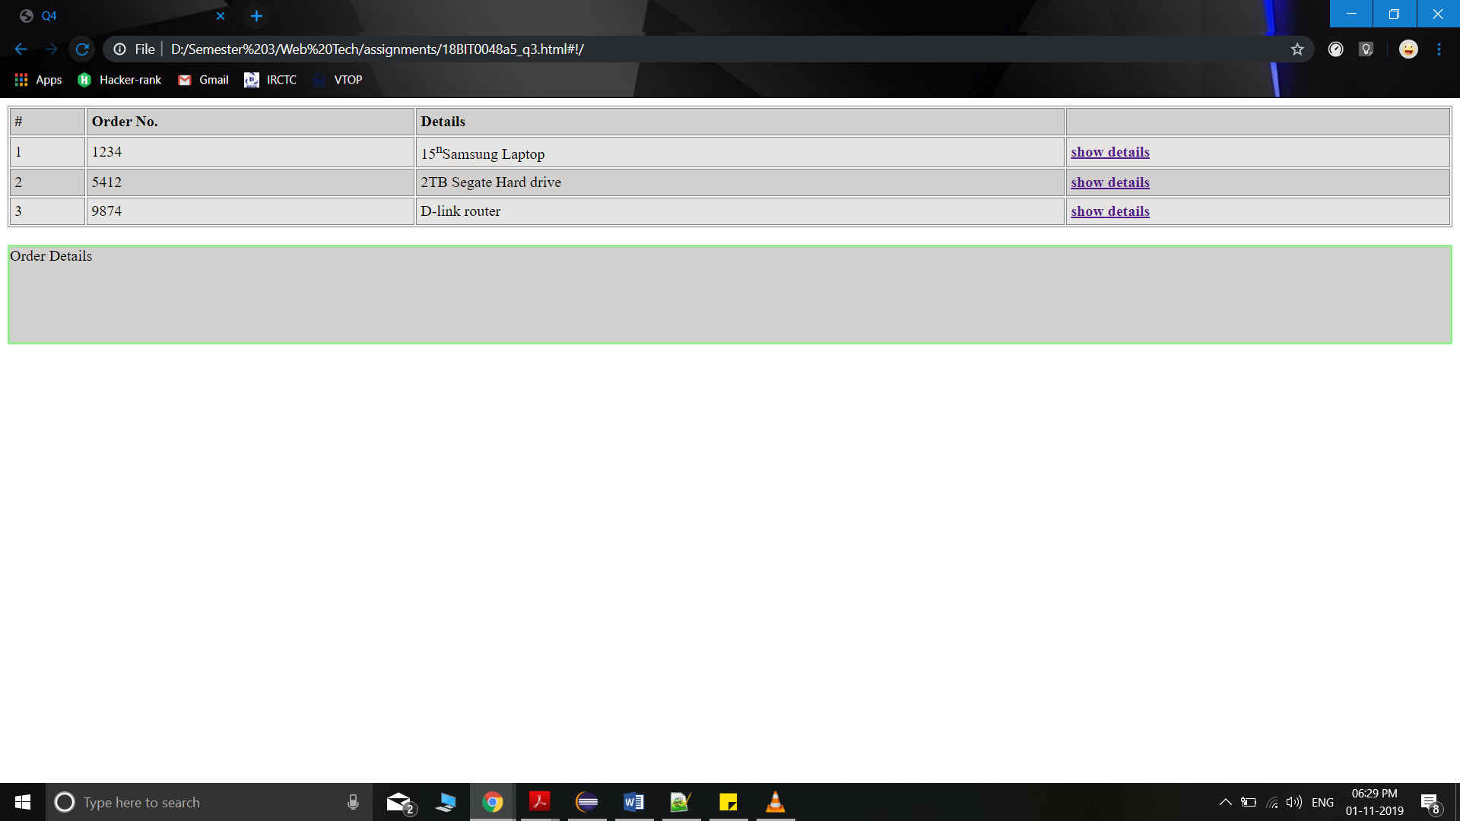

**OUTPUT SCREENSHOT: after clicking “show details” for order 9874:**

