Don Johnson

CSC 585

Assignment 7

1 Assignment 7 (100 points)

Other than a little control code I wrote in the main CPP file, all of my machine vision code is in Functions.cpp and Functions.hpp. All of my output is in the “Data” directory.

1.1 Learning Objectives

1.2 Technical Task (80 points)

1. Given: Skeleton code to read from the camera or a set of images, manage clicking in the

window to initialize features, and save output.

2. Required: implement the trackTemplate function in order to track a feature over time. **All images for HW7_Part1 are in the “Data” directory in my ZIP file.** My program uses histogram correlation to determine when to update the template as the feature keypoints and their templates change in time.

**Submit subsequent images showing the features being tracked as you move your face:**

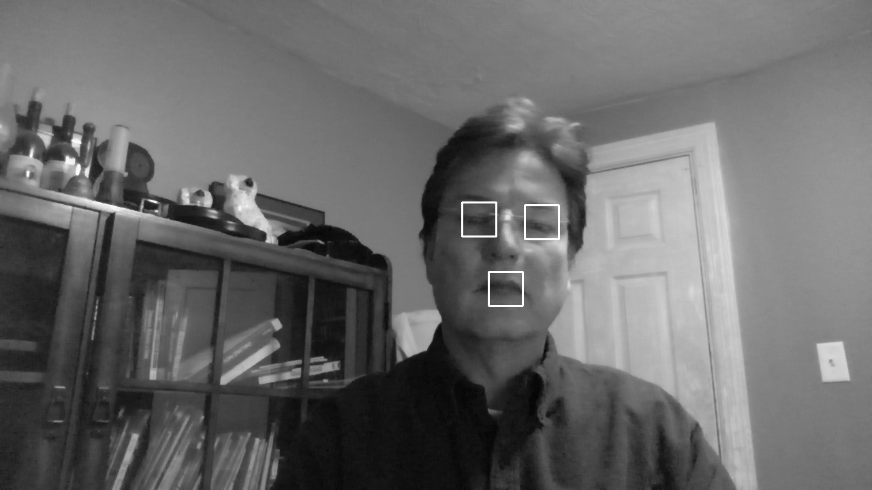

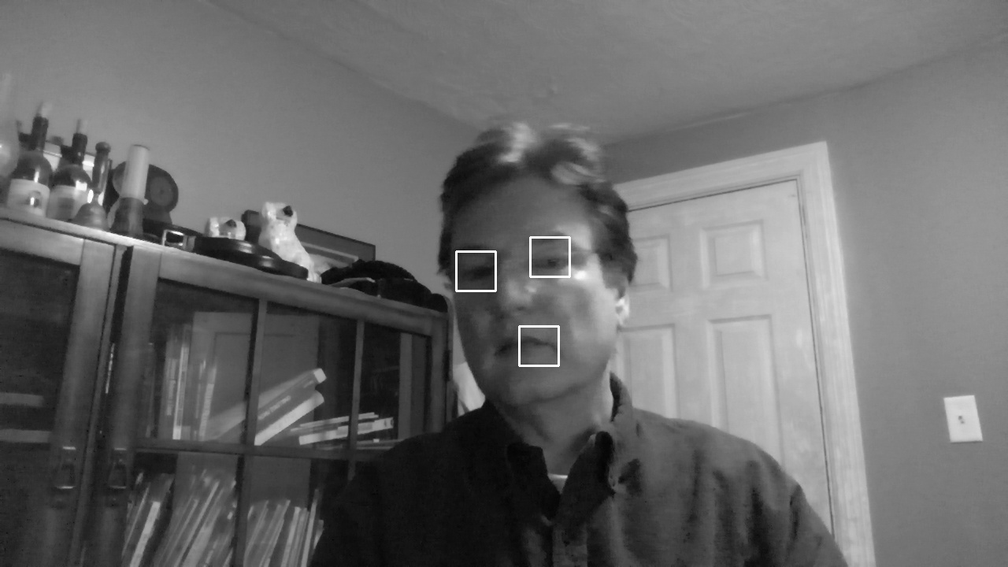



**Also submit one image where one or more of the features has gotten lost, but others remain in their correct location:**

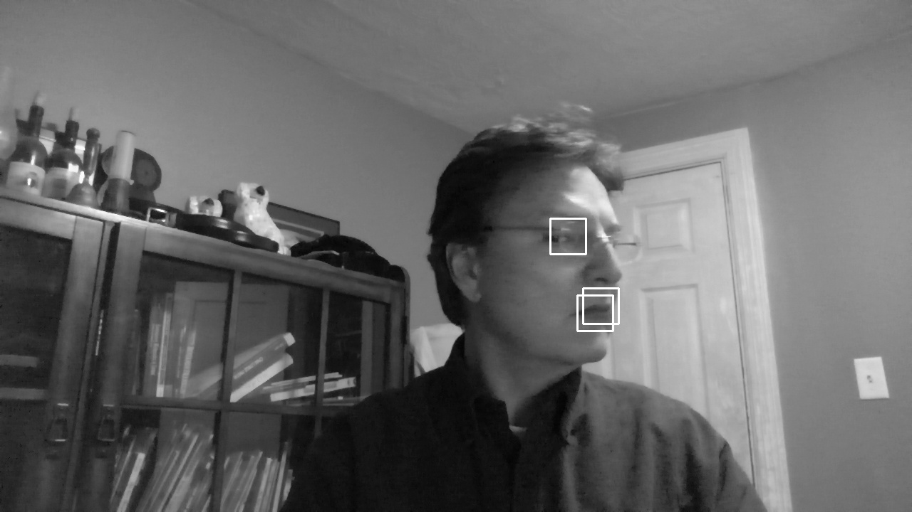

3. Required: Face Tracking, revisited. Combine what you have learned in this homework with

the things you learned about Face Detection and tracking by detection in HW 3. Write a

program that is able to keep a box on your face, even when you rotate your head out of plane

or turn your head sideways. Submit three subsequent images showing your sideways face

being tracked as you move.

I recommend using the face detector to identify a region of the image to crop out as a

template, then, when no faces are detected, use template tracking to keep track of the face

while updating the template. You can also use template tracking to "speed up" the face

detection and tracking { If you only run the face detector every N frames, you can keep track

of the face (as it moves) in between using template tracking.

**Note: The “Black” bounding box in the images is when the Viola/Jones/Haar Filter algorithm is being used. The “White” bounding box is when template matching algorithm is being using.**

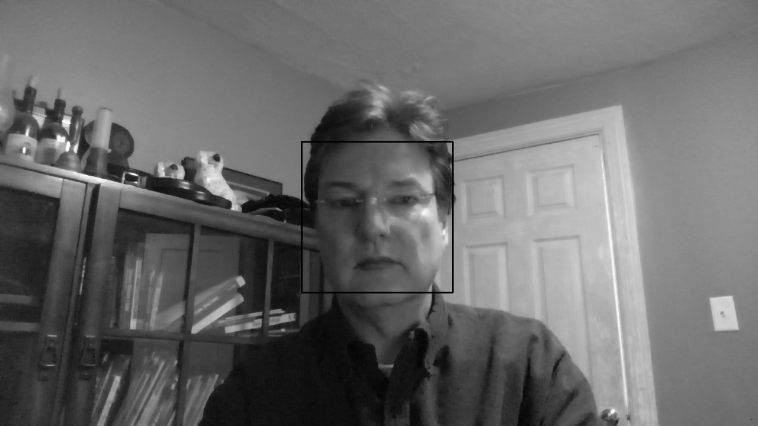

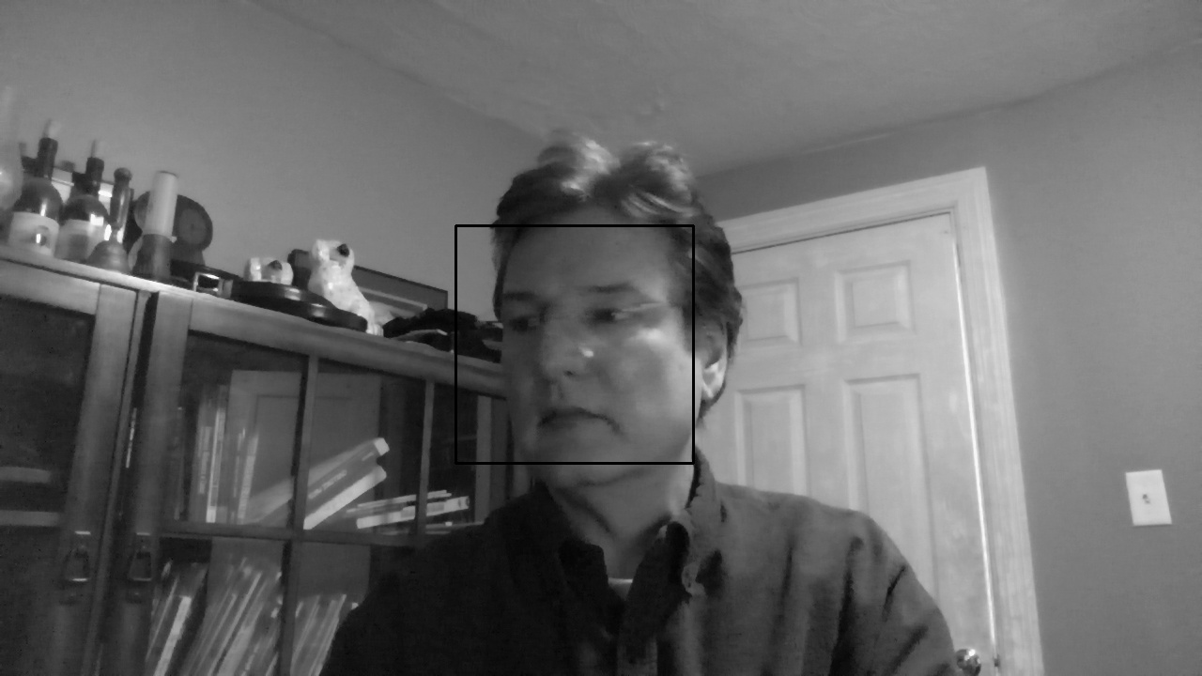

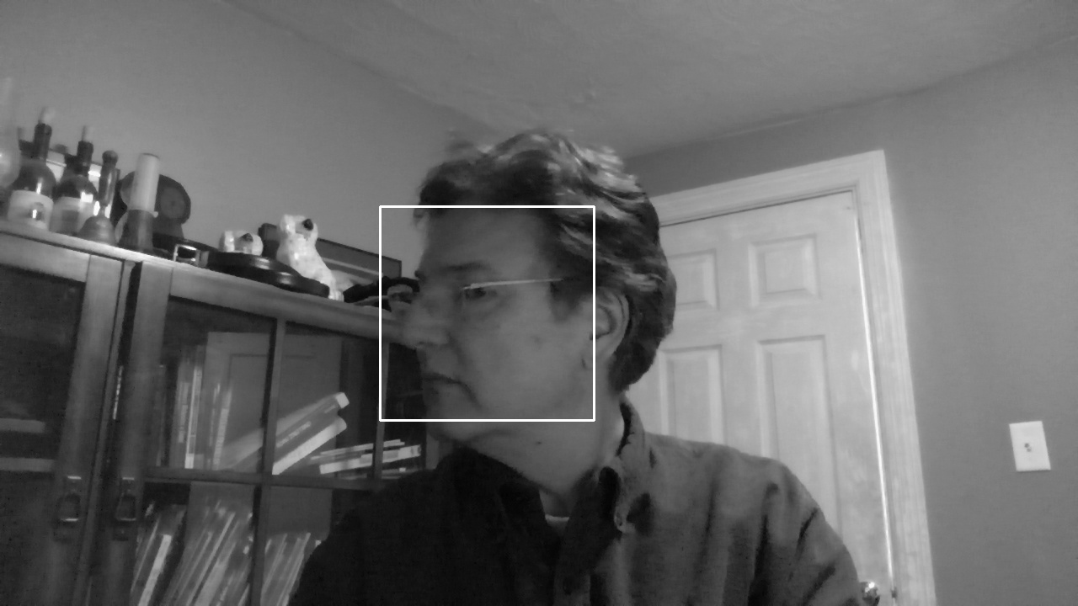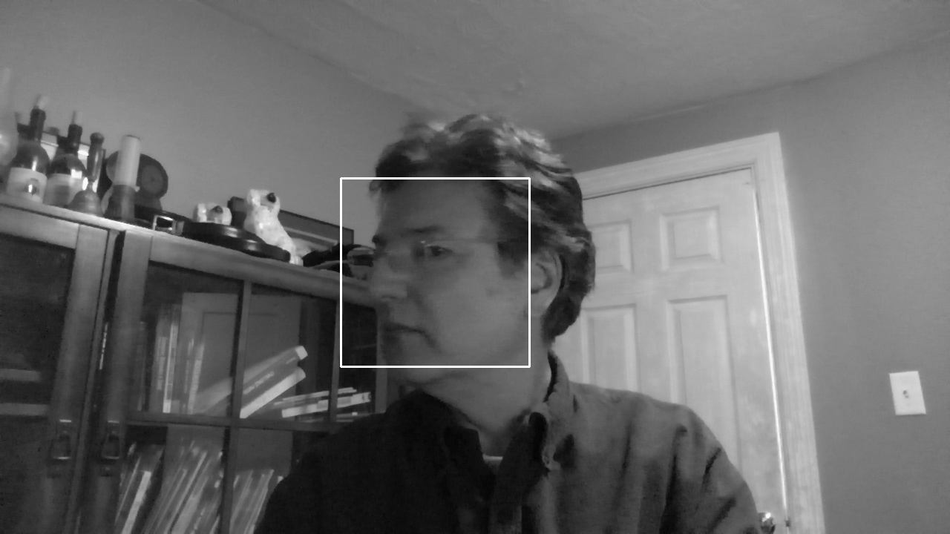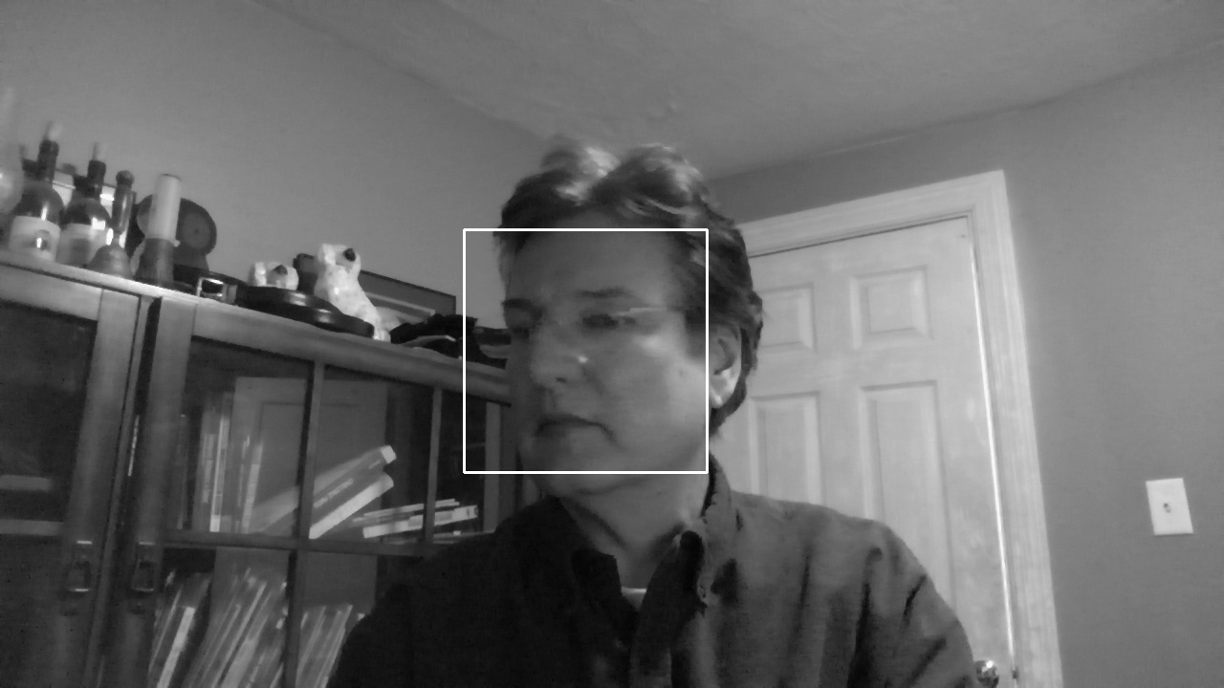

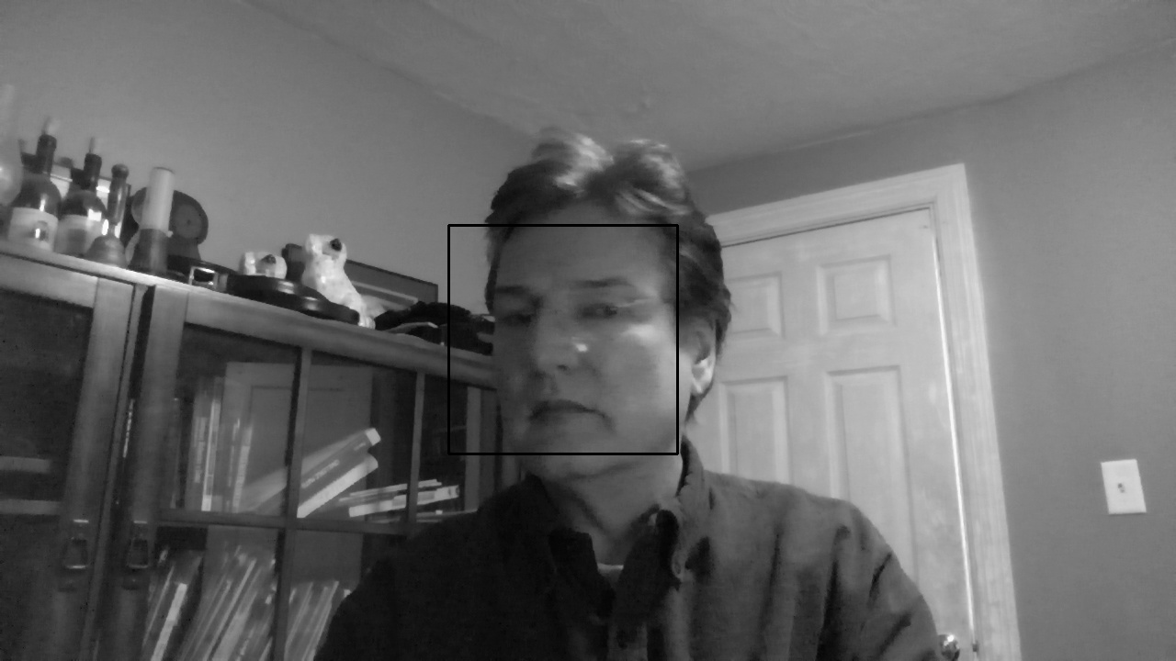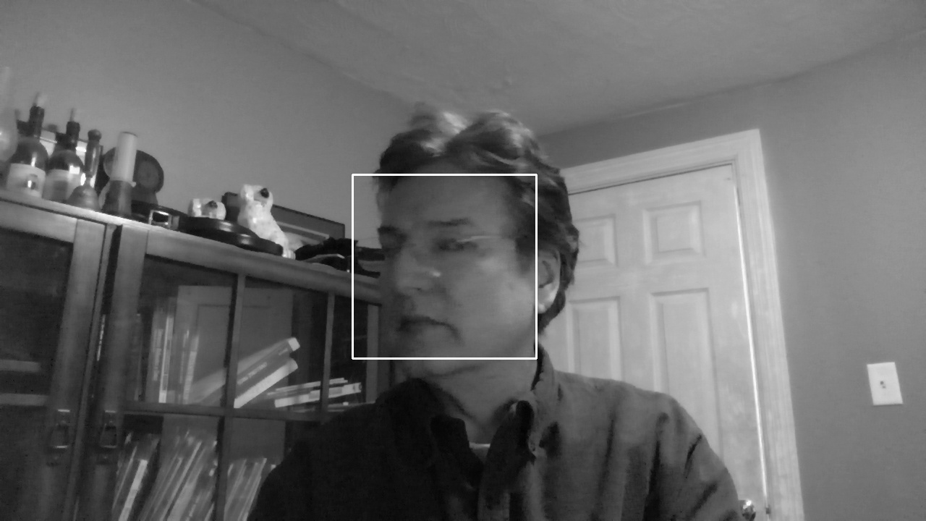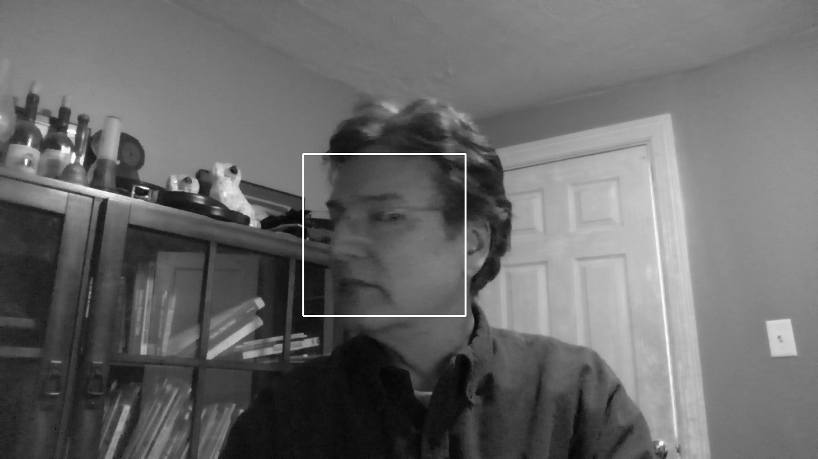

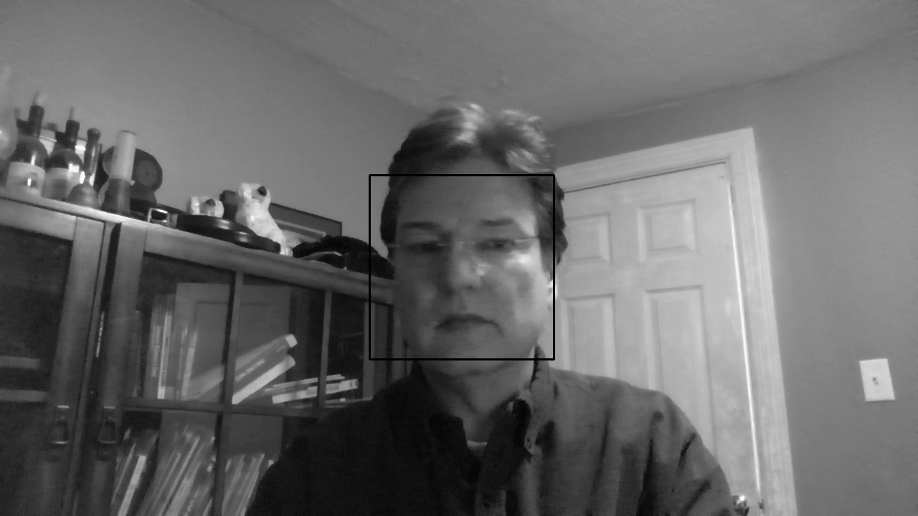

As you can see, the program switches seamlessly between the face and template detecting algorithms depending on which is most appropriate.