Autonomous Snack-Delivery Drone
3D World, Collision, Sensing & Compute-Split Upgrade
Project report · Prepared for Andrey · June 2026

Executive summary
This upgrade adds a real 3D world (authored in Blender or a built-in sample world), collision detection that fails the flight on any crash, a front camera and LiDAR so the drone perceives obstacles, a realistic onboard/ground compute split over a simulated radio link, a manual setup mode, and a combined multi-feed video. The validated flight model and the honest down-camera vision pipeline are preserved unchanged.
The headline guarantee held: with the solid 3D world and collision checking active, the snack still lands a mean of ~7 cm from the marker (worst ~10 cm across the tested seeds), versus ~6.7 cm before — no regression. Every test suite passes.

What was added
Capability | How it works
3D world | Blender → OBJ + scene.json import at real (1 m = 1 m) scale; a procedural sample world ships so it runs without Blender.
Collision → FAILED | The drone is a kinematic body in the world; any contact with a solid object after takeoff and before the home landing fails the flight (records object, place, time).
Front camera + LiDAR | A forward RGB camera and a configurable LiDAR ray-fan; an onboard reflex halts the drone before it hits something.
Compute split + link | Onboard (Pi) and ground (laptop) run as two real processes exchanging serialized messages over a link with latency, bandwidth cap and packet loss; an onboard compute budget flags overload.
Manual setup mode | Wireframe world with glowing DRONE_START / DROP_TARGET points, orbitable, editable, saved back to scene.json.
Multi-feed video | 3rd-person + LiDAR-painted-red, front camera, down camera with ArUco, a LiDAR radar and telemetry, composited and exported.

Architecture

Two interchangeable world backends
The world layer (world.py) exposes one interface with two backends. PyBullet (DIRECT mode + TinyRenderer) is the primary, used on the Mac for exact collision, fast LiDAR and nice camera feeds. A dependency-light pure-numpy fallback (my own Möller–Trumbore ray-casting and point-to-triangle collision, with matplotlib feeds) engages automatically if PyBullet is not installed — so the simulator runs, and is testable, anywhere.

What is preserved
The drone's MOTION is still driven by the existing validated flight model — the world only holds a kinematic body whose pose is set each tick. The down-camera ArUco + solvePnP precision loop is unchanged; the drop target now comes from the scene's DROP_TARGET so the renderer and drop model stay self-consistent.

Onboard vs ground split
Onboard (must be local, low-latency): flight control, state estimation, sensor reads, the down-camera ArUco detection + precision PID, and the LiDAR safety reflex. Ground (latency-tolerant): dispatch, path planning, heavy camera/LiDAR map processing, logging, dashboards and video. The two run in separate OS processes communicating only through the simulated link.

The multi-feed view
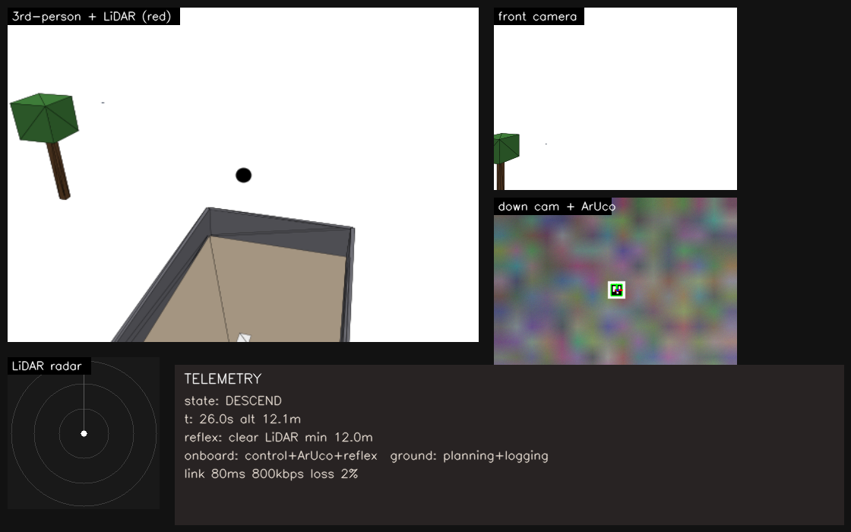
Combined feeds: 3rd-person with LiDAR (red), front camera, down camera with ArUco detection, a LiDAR radar, and telemetry (onboard/ground split + link status).

Measured results
All measured on the sample world with the numpy backend (the PyBullet backend uses the same geometry semantics).
Test | Result
No-regression delivery (3D world active) | drop mean ~7 cm, worst ~10 cm (target ≤ 20 cm; was ~6.7 cm)
Import scale (1 m reference cube) | 1.000 m
Collision detection | triggers as the drone reaches an obstacle; clear paths never false-trigger
LiDAR ranging | 3.70 m to a known tree (expected ~3.7); 12.0 m over open ground
LiDAR reflex | halts the drone ~2 m short of a head-on obstacle (no crash)
Link latency | messages arrive after exactly the configured latency (verified)
Link bandwidth | full-res frames (~7 Mbps) exceed the 800 kbps cap and are dropped; down-sampled frames fit
Compute budget | normal onboard load 6.0/8.0 ms OK; a mis-assigned heavy task → 28 ms → overflow flagged
Automated test suites | 5/5 pass (vision, mission, smoke, world, compute)

Manual setup mode
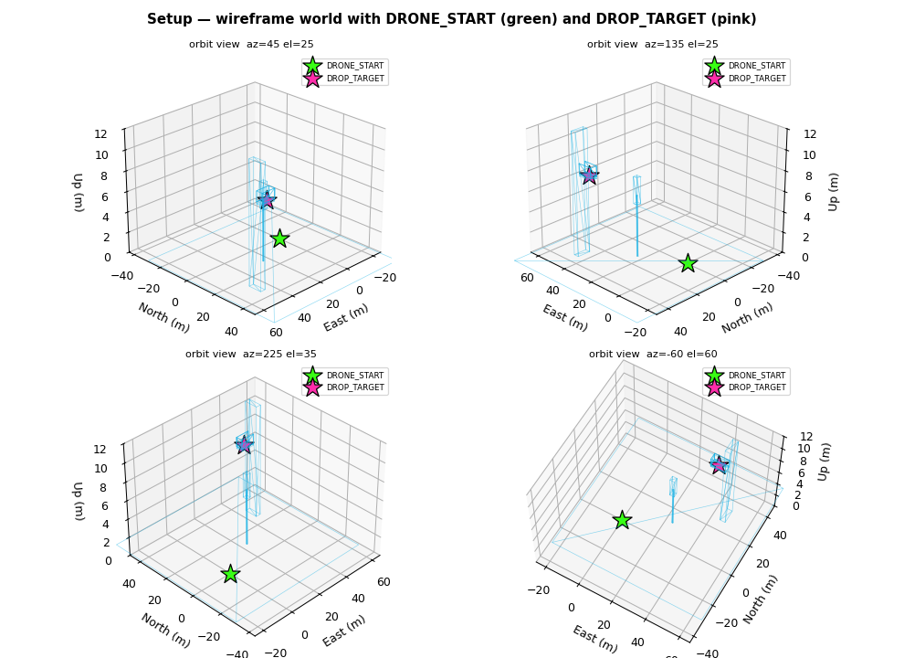
Setup mode: the wireframe world with DRONE_START (green) and DROP_TARGET (pink) drawn on top, from several orbit angles. Positions are editable and saved to scene.json.

Honest limitations
- PyBullet could not be executed in the build/test sandbox (Linux ARM64 has no PyBullet wheel and a source build exceeds the sandbox's time limit). The PyBullet backend is written to its documented API and runs on the Mac, where wheels exist; all geometry/collision/LiDAR results above were verified with the equivalent pure-numpy backend, and the no-regression flight + vision need neither backend.
- The numpy fallback's collision uses unsigned surface distance plus an AABB 'inside' test (conservative for general meshes); PyBullet's signed contacts are exact. Continuous per-tick checking catches approaches either way.
- Obstacle avoidance is a reflex (stop before hitting), not full path-planning around obstacles — the code is structured so a planner can be added on the ground side.
- PyBullet on Python 3.13 may have no wheel yet; the README gives exact Python 3.12 venv steps, and the sim still runs via the fallback if PyBullet is absent.

How to run each mode
- Normal mission in the 3D world: python main.py (or --headless)
- Combined multi-feed video: python main.py --multifeed → outputs/multifeed_demo.mp4
- Onboard/ground split: python main.py --split (or --single-process)
- Place start/drop by hand: python setup_positions.py
- Use your Blender world: run world/export_from_blender.py in Blender, then python main.py --world blender
- Tests: python tests/test_world.py and python tests/test_compute.py (plus the originals)

Where this goes next
The onboard/ground split mirrors the real architecture, so the path to hardware is unchanged: swap the simulated drone backend for MAVLink to PX4/ArduPilot SITL, then a real Pixhawk + Raspberry Pi + ToF, keeping the vision, control, mission and world-sensing interfaces and feeding real camera + LiDAR frames in place of the simulated ones.

