Objective Questions

Q1. What is the total number of attributes in the Customer table?
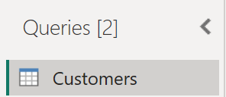
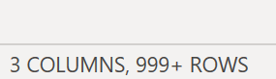
The Customer table contains 3 attributes — CustomerID, Customer Age, and Customer Gender — used to uniquely identify each customer and support demographic analysis.

Q2. How will you get the Customer's age in the Orders table according to Customer ID?
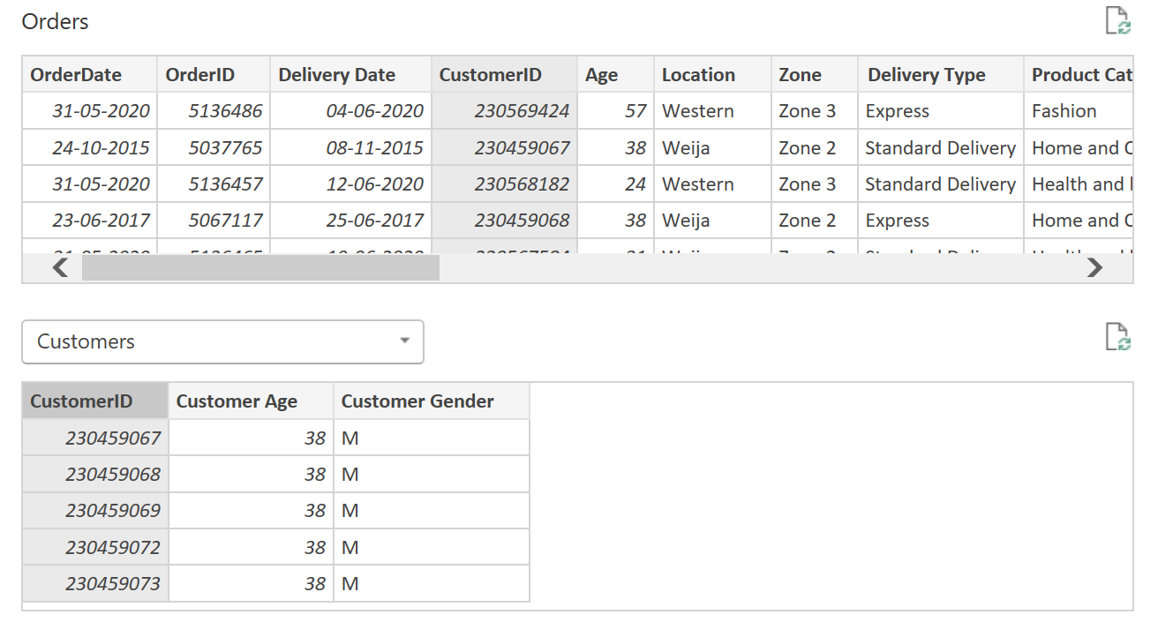
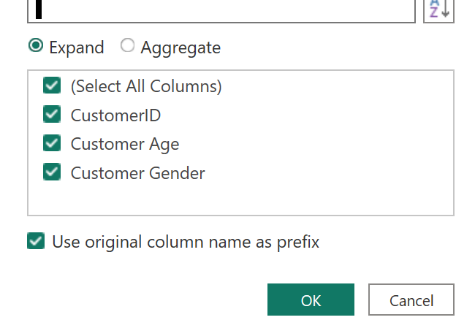
The Orders and Customers tables were merged in Power Query using Customer ID as the key, with a Left Outer Join to keep all Orders records. The Customer Age column was then expanded into Orders, enabling age-based segmentation and analysis.

Q3. What data cleaning steps were taken before analysis in Power BI?
- Corrected data types: Order/Delivery Date → Date; Sale Price/Unit Price → Decimal; Quantity, Rating, Customer Age → Whole Number.
- Removed empty columns and blank rows.
- Checked and removed duplicate records.
- Handled missing (null) values in key columns.
- Trimmed and cleaned text fields (Product Name, Category, Location).
- Standardized text formatting (capitalization, spelling).
- Validated numeric columns for correct values.
- Renamed columns for clarity and consistency.

Q4. How can we calculate the total revenue generated by all sales?
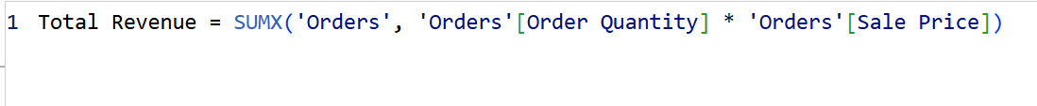
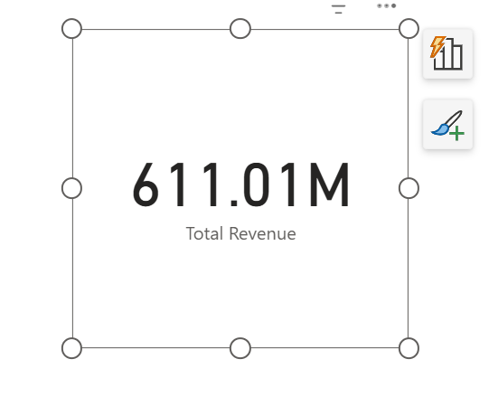
Total revenue was calculated by multiplying Sale Price by Quantity for each order and summing across all transactions. It is displayed as a Card visual — a key KPI for overall business performance.

Q5. What is the total number of unique customers who made purchases each year? Has this increased over time?
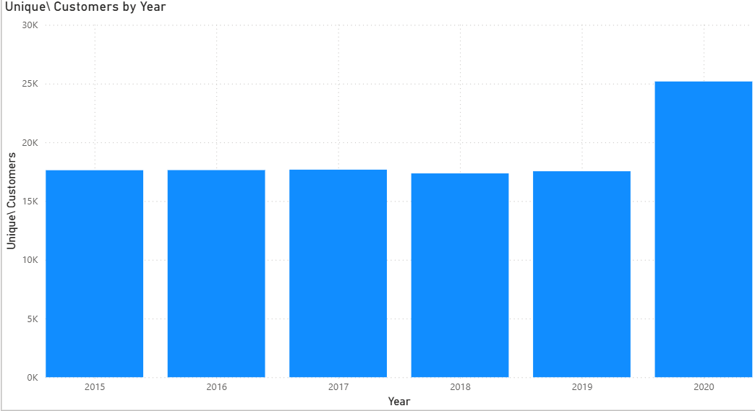
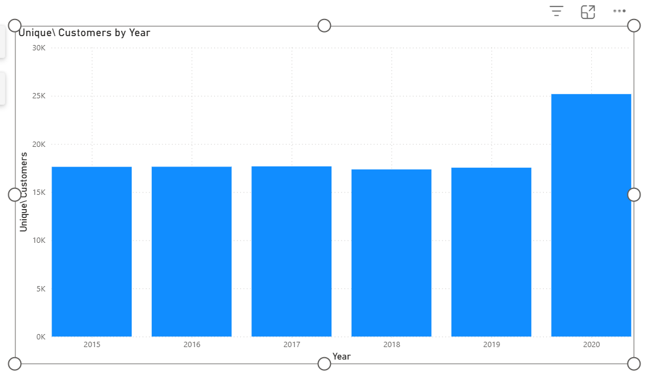
Unique customers were counted using DISTINCTCOUNT() on Customer ID, with a Year column derived via YEAR(Order Date). A column chart tracks customer growth across years, helping assess whether the customer base is expanding.

Q6. How can we determine the total number of unique products available?
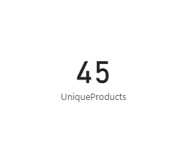
Using DISTINCTCOUNT() on the Product column, the analysis shows 45 unique products, giving an overview of product portfolio diversity.

Q7. What is the average delivery time, using only delivered orders?
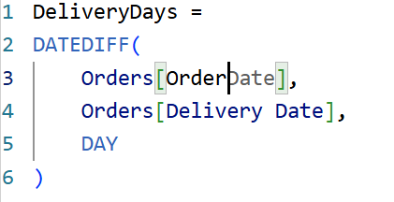
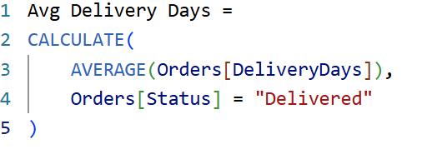
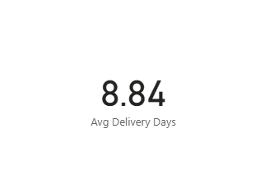
DATEDIFF() calculates days between Order Date and Delivery Date. A CALCULATE() measure filters for Status = "Delivered" only, so cancelled/returned/processing orders don't skew the metric.

Q8. Which products, categories, and subcategories are most popular?
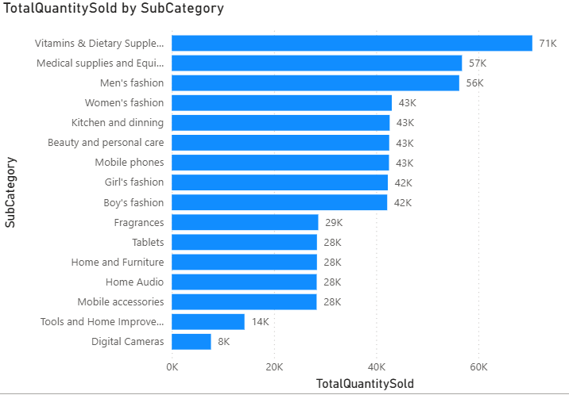
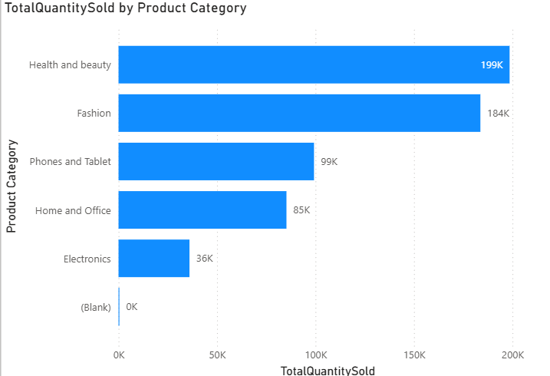
A Total Quantity Sold measure (SUM of Order Quantity) was used in clustered bar charts across products, categories, and subcategories, sorted descending to surface top sellers and guide inventory and promotion decisions.

Q9. Which products have seen an increase or decrease in sales over the years?
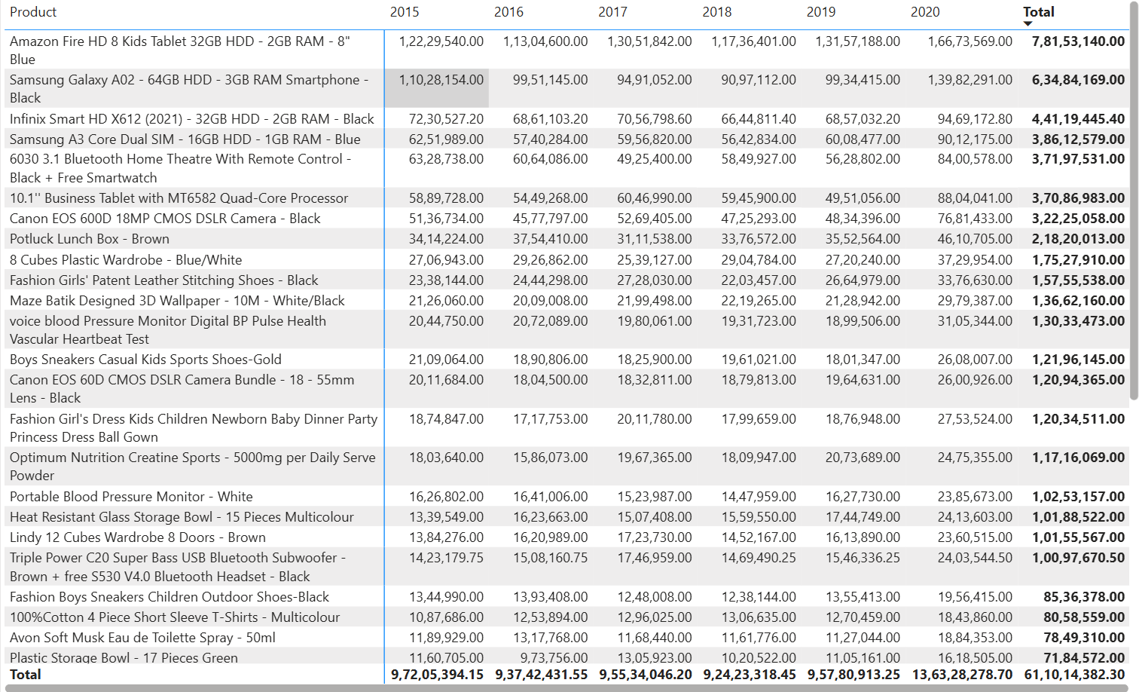
A Total Revenue measure was placed in a Matrix visual with Product as rows and Year as columns. Comparing revenue across years reveals which products are growing versus declining, supporting inventory and marketing decisions.

Q10. What is the relationship type between Customer ID in the Orders and Customers tables?
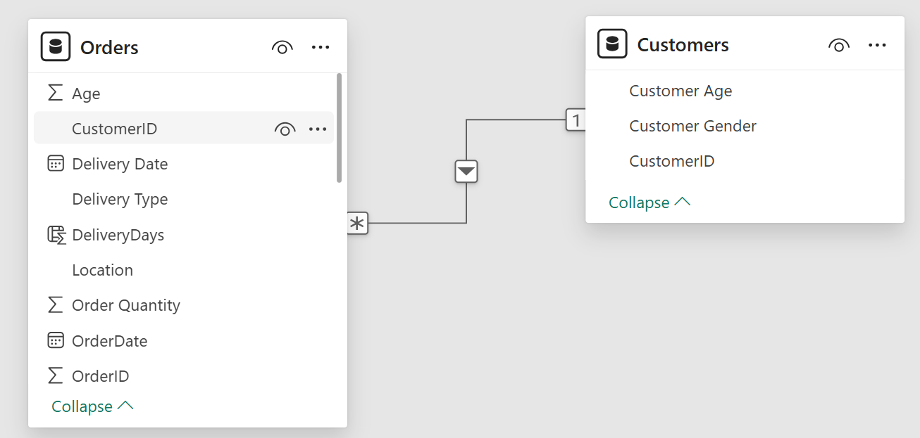
- Relationship type: One-to-Many
- Primary key ("1" side): Customers[CustomerID] — one unique row per customer.
- Foreign key ("Many" side): Orders[CustomerID] — same customer ID can repeat for multiple orders.
- Cross-filter direction: Single, flowing from Customers to Orders, ensuring correct filtering and model performance.

Q11. How were null values in the data handled?
- Checked for nulls in Power Query.
- Replaced missing numeric values with 0 where appropriate.
- Replaced missing text values with "Not Provided."
- Removed rows with missing key identifiers affecting data integrity.
- Verified the cleaned dataset was analysis-ready.
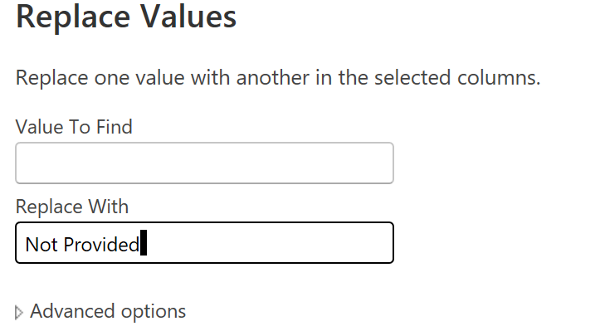

Q12. Were there any data format issues, and how were they handled?
Yes. Order Date and Delivery Date were converted to Date type; Sale Price and Shipping Charges to Decimal Number; Order Quantity, Rating, and Customer Age to Whole Number. Empty columns were removed, and text fields were trimmed and cleaned using Power Query transformations to ensure accurate calculations and reporting.

Q13. What M-language code is generated when adding a column in Power Query, and what is M-Query?
Power Query auto-generates code using Table.AddColumn(). Example, for a Total Amount column:
= Table.AddColumn(#"Previous Step", "Total Amount", each [Order Quantity] * [Sale Price])
M-Query (Power Query M) is a functional, case-sensitive ETL language. Every transformation — data type changes, filters, merges, custom columns — is automatically converted to M code, viewable in the Formula Bar or Advanced Editor.

Q14. Identify the top 5 most valuable customers using a composite score (SQL).
- Total Revenue — 50% weight
- Order Frequency — 30% weight
- Average Order Value — 20% weight
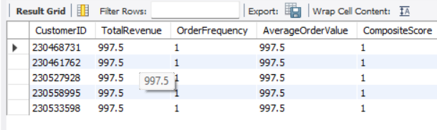
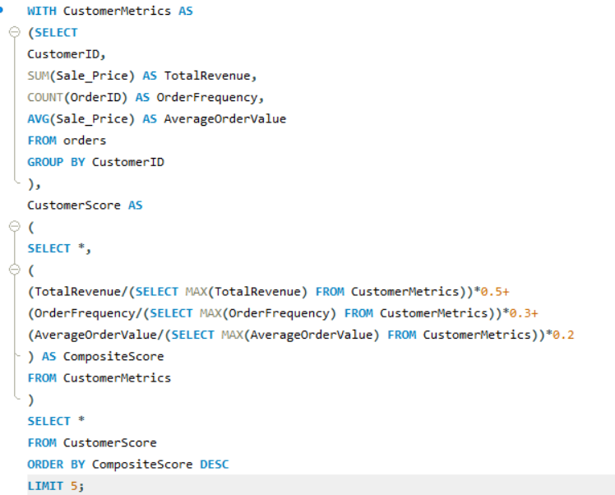

Q15. Calculate month-over-month revenue growth rate across the dataset (SQL).
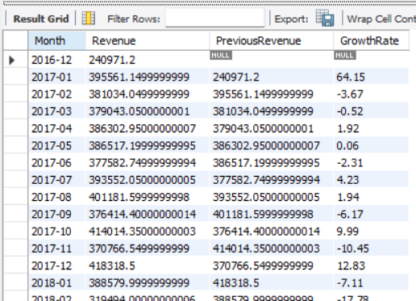
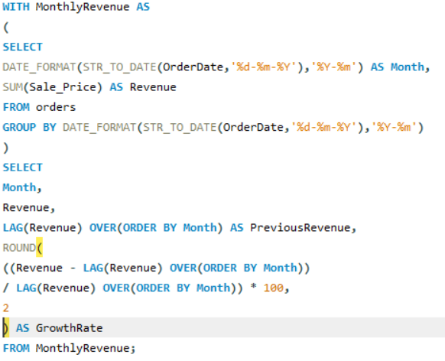

Q16. Calculate the rolling 3-month average revenue for each product category (SQL).
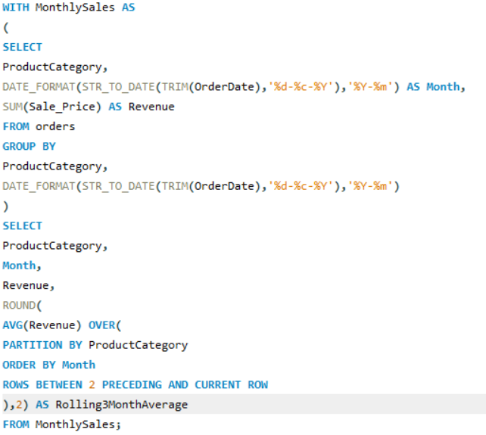
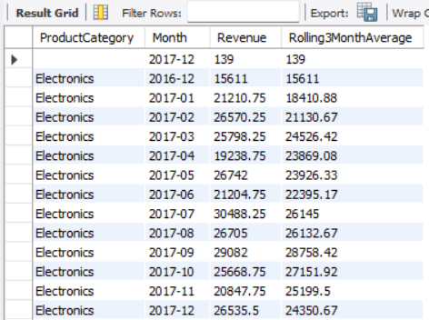

Q17. Apply a 15% discount on Sale Price for customers with at least 10 orders (SQL).
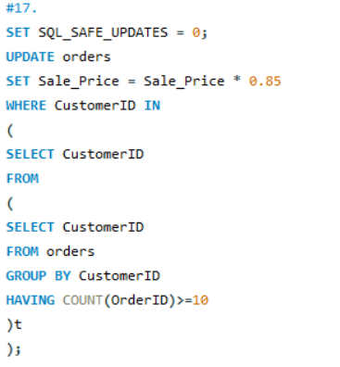

Q18. Calculate the average number of days between consecutive orders for customers with 5+ orders (SQL).
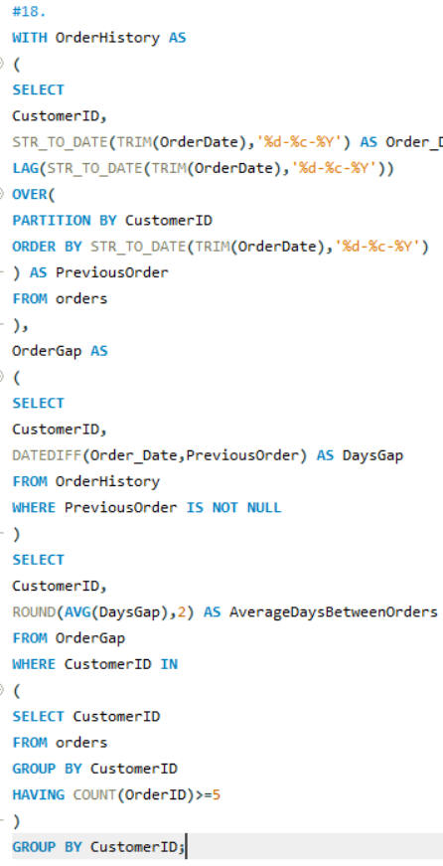
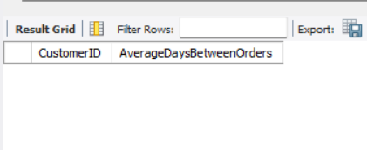

Q19. Identify customers whose revenue is 30%+ above the average per customer (SQL).
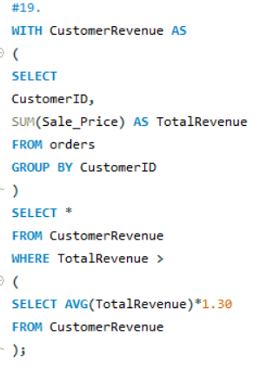
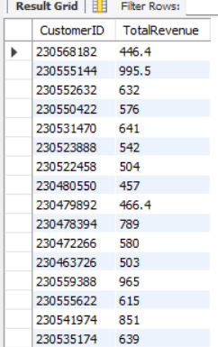

Q20. Determine the top 3 product categories with the highest year-over-year sales increase (SQL).
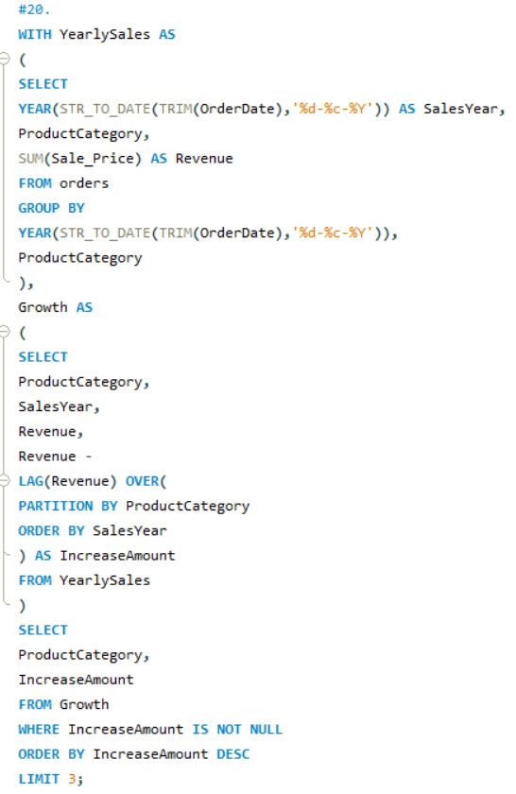
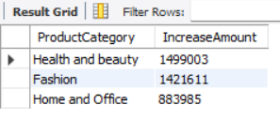

Subjective Questions

Q1. Explain the revenue breakdown by year and product. Suggest ways to boost low-selling items.
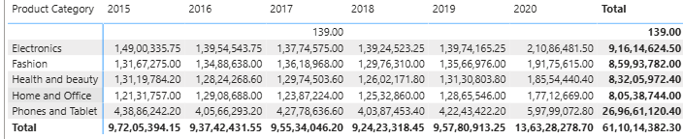
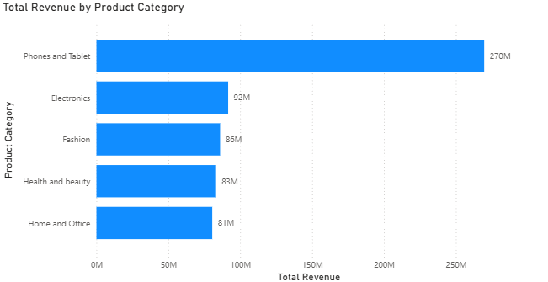
The revenue analysis was performed using a Matrix visual and a Clustered Column Chart in Power BI. The Matrix compared product revenue across different years, while the column chart showed the contribution of each product category to annual revenue. The analysis revealed that a small number of high-performing products contributed a significant portion of total annual revenue, whereas several low-selling products generated relatively low revenue and showed limited growth over time. This distinction helps the business focus attention on where growth is coming from and where it is stagnating, so resources such as marketing spend and inventory investment can be allocated more effectively across the product portfolio.
Recommendations
- Bundle low-selling products with high-demand items.
- Offer targeted promotional discounts.
- Improve product descriptions, tags, and images.
- Run seasonal or clearance campaigns.
- Use "Frequently Bought Together" / "You May Also Like" recommendations.
- Focus marketing on high-margin, low-volume products.

Q2. How many products were returned (DAX)? What might drive returns, and what does it signal?
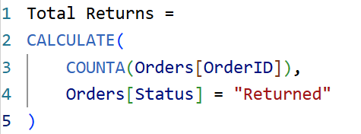
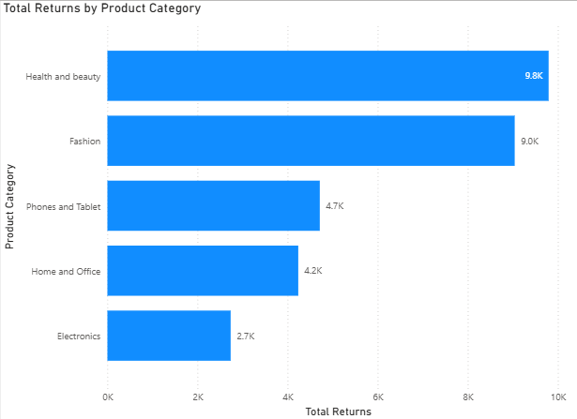
A DAX measure named Total Returns was created using the CALCULATE() function to count the number of returned orders by filtering the dataset where the Status is "Returned". The metric was displayed using a Card visual, while a bar chart was used to analyze returns by product and product category. This analysis helps identify products with high return rates and supports better decision-making for quality improvement and customer satisfaction, since a rising trend in returns for a specific product line is often an early warning sign worth investigating.
Likely causes
A high number of returned products may indicate issues such as poor product quality, inaccurate product descriptions, incorrect sizing, damage during shipping, or products that simply do not meet customer expectations once received. Monitoring return trends over time enables the business to identify problem areas early and implement corrective actions before they affect brand reputation or customer retention.
Recommendations
- Improve descriptions with accurate specs and images.
- Strengthen quality control in manufacturing/packaging.
- Monitor high-return products closely.
- Analyze customer feedback for common return reasons.
- Improve packaging to reduce shipping damage.
- Provide clear sizing/usage guides.

Q3. Do higher-rated products drive more sales? Verify with a visualization.
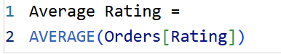
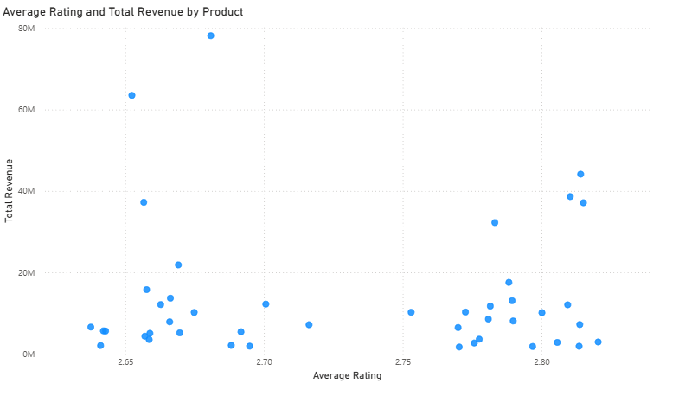
To examine the relationship between product ratings and sales performance, a Scatter Chart was created in Power BI using Average Rating on the X-axis and Total Revenue on the Y-axis, with each data point representing an individual product. This visualization was used to analyze whether products with higher customer ratings tend to generate greater sales revenue. A positive upward trend in the scatter plot would indicate that highly rated products generally achieve higher sales, whereas a weak or scattered pattern suggests that additional factors, such as pricing, promotions, brand reputation, and product availability, also play a significant role in driving sales performance alongside ratings.
Business Insights
- Higher ratings generally build trust and support higher sales.
- Low ratings may signal quality or description issues that hurt sales.
- Regularly monitoring ratings helps catch improvement opportunities early.
- Better quality, accurate descriptions, and genuine reviews boost ratings and long-term sales.
- Pricing, promotions, and availability also matter alongside ratings.

Q4. How does revenue vary by location, and what are the strategic implications?
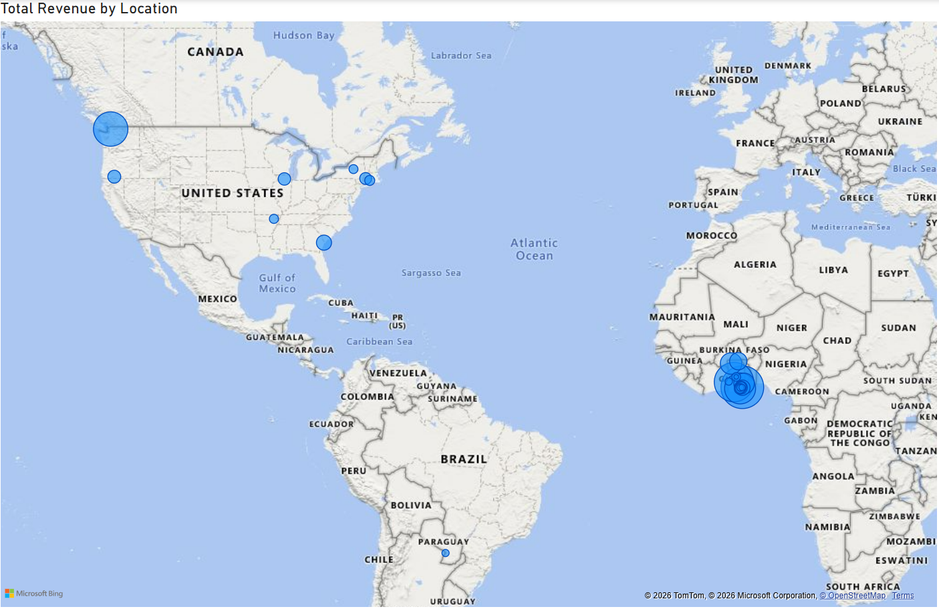
To analyze the geographical distribution of sales, a Map visualization was created in Power BI using the Location field and the Total Revenue measure. The visualization highlights the revenue generated across different regions, making it easy to identify high-performing and low-performing markets. Areas with larger bubbles or darker shades indicate regions contributing a higher share of total revenue, while smaller bubbles or lighter shades represent regions with comparatively lower sales. This geographical view lets the company understand regional sales patterns at a glance and supports data-driven decisions for marketing, inventory distribution, and business expansion.
Business Insights
- High-revenue regions justify continued investment.
- Distribution centers near strong markets cut delivery time and cost.
- Low-revenue regions may be untapped — target with localized campaigns.
- Location-based segmentation improves resource allocation for sales and logistics.
- Tracking regional trends helps spot emerging markets for expansion.

Q5. Which month would benefit most from promotions? Suggest marketing strategies.
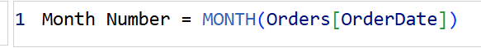
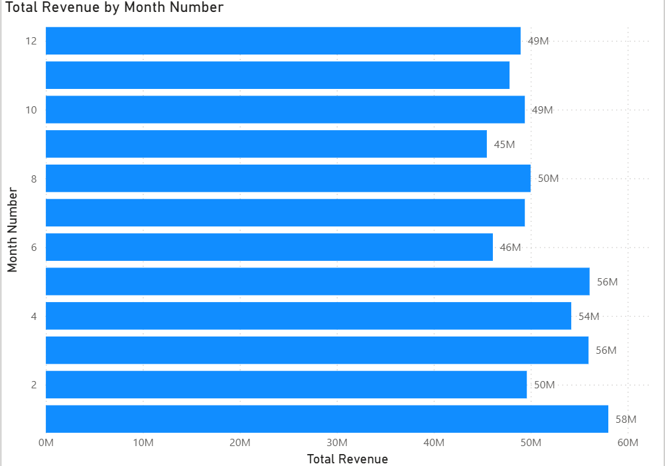
A Clustered Column Chart was created in Power BI to analyze total revenue across different months using the Month extracted from the Order Date. The visualization highlights seasonal sales trends and identifies months with lower revenue compared to the rest of the year. The month with the lowest revenue represents an opportunity for targeted promotional activity to increase customer engagement and improve overall sales performance. Analyzing monthly revenue patterns this way lets the business plan marketing campaigns more effectively and optimize sales activity throughout the year rather than reacting after the fact.
Marketing Strategies
- Seasonal discounts or flash sales in the low month.
- Bundle deals and BOGO offers.
- Loyalty-member exclusive discounts.
- Personalized email/SMS campaigns.
- Targeted social/digital ads.
- Free shipping, cashback, or limited-time coupons.
- Cross-sell/upsell complementary products.
- Festive or seasonal promotional events.

Q6. Which high-priced products underperform in sales and need more marketing?
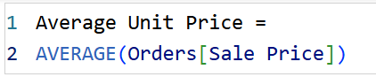
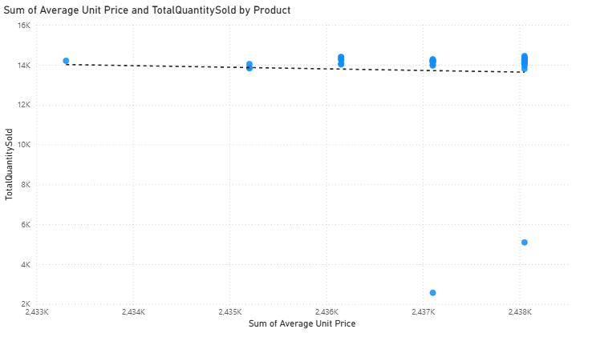
A Scatter Chart was created in Power BI to analyze the relationship between product price and sales volume, with Average Unit Price on the X-axis and Total Quantity Sold on the Y-axis, and each point representing a product. This visualization makes it easy to spot products that are priced higher but generate relatively low sales. Products located in the bottom-right quadrant of the chart — high price, low volume — represent items that may require additional marketing effort to improve customer awareness and justify their price point.
Business Insights
- These products may not communicate value effectively.
- They need stronger campaigns or repositioning.
- Customer feedback can reveal purchase barriers.
- Better descriptions/visuals build buyer confidence.
- Pricing should be reviewed for competitiveness.
Recommended Strategies
- Video demonstrations of features/benefits.
- Influencer or expert collaborations.
- Detailed specs, comparison tables, quality images.
- Limited-time discounts, EMI options, bundles.
- Feature in "Recommended"/"Featured" sections.

Q7. Which products should have discounts, and how can incentives drive sales/loyalty?
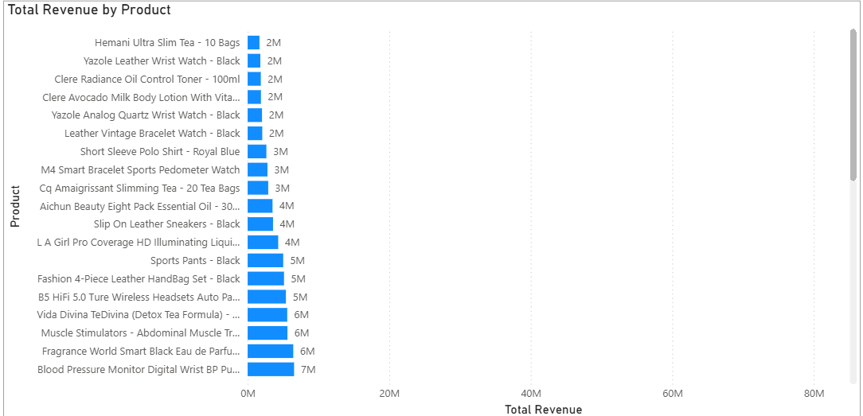
A Clustered Bar Chart was created to compare the sales performance of individual products based on Total Revenue and Total Quantity Sold. Products with consistently low sales were identified as suitable candidates for promotional discounts and targeted marketing campaigns. Offering strategic discounts on these products can help increase customer interest, improve sales volume, and reduce slow-moving inventory, while this data-driven approach ensures pricing decisions are made without compromising overall profitability.
Business Insights
- Discounts can attract customers to low-volume products.
- Focus discounts on underperformers, not high-demand items.
- Limited-time offers speed up purchase decisions.
- Promotions can also boost engagement and repeat purchases.
Marketing Strategies
- BOGO promotions on selected products.
- Bundle discounts pairing low- and high-sellers.
- Seasonal/festive discounts.
- Loyalty rewards, cashback, coupon codes.
- Promote via email and social ads.
- Feature discounted items on the homepage.

Q8. Design a loyalty program with customer segments and tiered benefits.
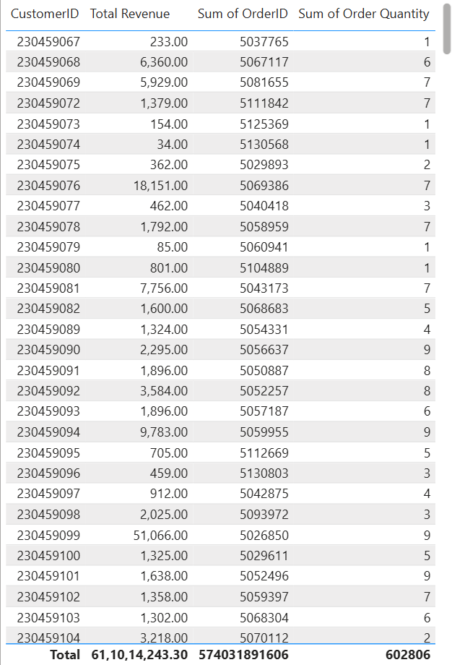
A customer loyalty program can be designed by segmenting customers based on their purchasing behavior, including purchase frequency, total spending, and overall contribution to revenue. Customers with higher purchase frequency and greater spending should receive premium benefits, while customers with lower engagement can be encouraged back through targeted promotional offers. Segmenting customers this way enables the company to improve customer retention, increase repeat purchases, and strengthen long-term customer relationships across the full spectrum of buyers, from first-time shoppers to top spenders.
🥇 Platinum Tier — high frequency & spend, loyal repeat customers
- Free shipping on all orders
- Priority customer support
- Early access to new launches
- Exclusive member-only discounts
- Bonus reward points
🥈 Gold Tier — regular customers, moderate frequency & spend
- Cashback reward points
- Birthday/festival discounts
- Free shipping above a minimum order value
- Exclusive promotional offers
🥉 Silver Tier — occasional, new, or inactive customers
- Welcome coupons
- Limited-time discount vouchers
- BOGO offers
- Personalized email/SMS re-engagement
Business Insights
- Rewarding loyal customers boosts retention and lifetime value.
- Personalized offers can win back inactive customers.
- Tiered rewards motivate higher spend/frequency.
- Loyalty programs strengthen satisfaction and long-term revenue.

Q9. Calculate total sales for the Fashion category shipped from abroad (CALCULATE + iterator DAX). What other DAX functions were used?
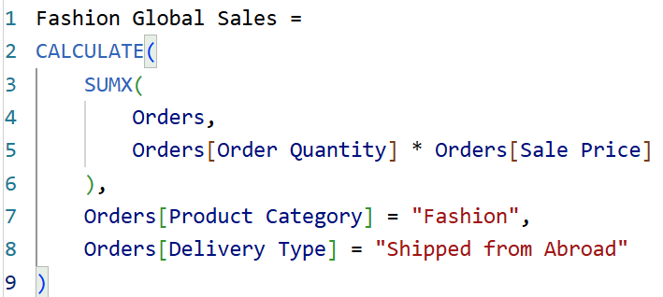
A DAX measure named Fashion Global Sales was created using the CALCULATE() and SUMX() functions to determine the total revenue generated from products in the Fashion category that were delivered using the "Shipped from Abroad" delivery method. The CALCULATE() function applies filters on product category and delivery type, while the SUMX() function iterates through each row and calculates revenue by multiplying Order Quantity by Sale Price. Combining a row-level iterator with a filter-based aggregator like this enables much more granular, condition-specific business analysis than a simple SUM() measure would allow.
Other DAX Function Categories Used
Function Category | Examples
Aggregation | SUM(), AVERAGE(), DISTINCTCOUNT()
Iterator | SUMX()
Filter | CALCULATE()
Date & Time | YEAR(), MONTH(), FORMAT()
Logical | IF()

Q10. How do average wait times vary by product category, to optimize scheduling and staffing?
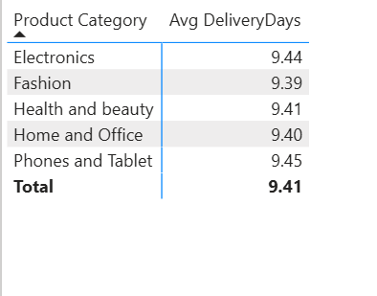
To analyze delivery performance across different product categories, a calculated column named Delivery Days was created using the DATEDIFF() function to calculate the number of days between the Order Date and Delivery Date. An Average Delivery Days measure was then created and displayed in a Matrix visual alongside the product categories. This analysis helps identify categories with longer delivery times, allowing the company to optimize logistics, warehouse operations, and resource allocation. Reducing delivery delays in the slowest categories can meaningfully improve customer satisfaction and overall operational efficiency.
Business Insights
- Categories with higher average delivery time may indicate delays in warehouse processing.
- Staffing and scheduling can be adjusted to match the demand pattern of slower categories.
- Consistent monitoring of this metric helps catch emerging bottlenecks before they affect customers broadly.

Q11. Is there a relationship between Delivery Type and wait time?
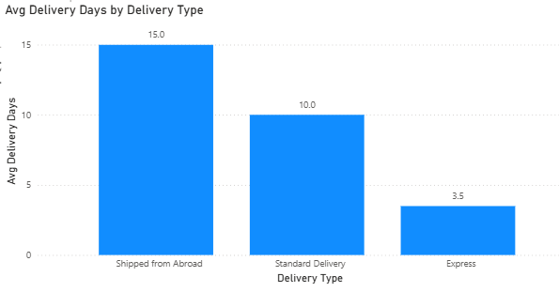
To examine the relationship between Delivery Type and the time taken for customers to receive their orders, a Delivery Days calculated column was created using the DATEDIFF() function to calculate the difference between the Order Date and Delivery Date. An Average Delivery Days measure was then displayed in a Clustered Bar Chart with Delivery Type as the category. The visualization clearly compares the average delivery time for each shipping method, helping identify which delivery options are faster and which require longer transit times, and supports setting realistic delivery expectations for customers up front.
Business Insights
- Express Shipping generally has the shortest delivery time and suits customers who need faster service.
- Standard Shipping offers a reasonable balance between delivery speed and cost.
- Shipped from Abroad usually has the longest delivery time due to international logistics and customs processing.
- Understanding delivery performance by shipping method helps improve logistics planning and customer communication.
- Businesses can optimize warehouse operations and carrier selection to reduce delivery delays and enhance customer satisfaction.

Q12. Is there a relationship between shipping charges and product type?
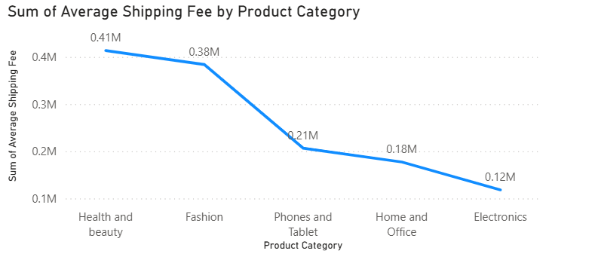
To analyze the relationship between Shipping Charges and Product Type, an Average Shipping Fee measure was created using the AVERAGE() function, ensuring shipping cost is evaluated per item rather than being skewed by order volume. The data was then visualized using a Clustered Column Chart, with Product Category on the X-axis and Average Shipping Fee on the Y-axis, allowing a clear comparison of shipping costs across different product types. This makes it easy to identify whether certain categories consistently incur higher shipping charges, pointing to a relationship between product characteristics and logistics cost.
Business Insights
- Furniture and Large Appliances show the highest shipping charges due to weight, size, and handling requirements.
- Electronics and Home Decor fall in the mid-range due to moderate packaging and fragility considerations.
- Fashion Accessories, Groceries, and Toys have lower shipping costs due to lightweight, compact packaging.
- Shipping cost is not random; it varies significantly based on product category characteristics.
- Logistics cost is directly influenced by product size, weight, and handling complexity, which should feed into pricing and carrier decisions.

Q13. What strategies reduce low-rating orders, considering wait time, shipping type, unit price, etc.?
Low-rated orders (1–2 stars) are first filtered using a dashboard or slicer to focus specifically on dissatisfied customers. These orders are then analyzed against waiting time, shipping type, shipping charges, and unit price to understand the key causes behind the dissatisfaction, rather than treating all low ratings as one undifferentiated problem.
Key Findings
- Longer delivery times correlate with lower ratings.
- High shipping charges hurt satisfaction.
- International/third-party shipping draws more complaints.
- Higher-priced items get stricter ratings.
Strategies
- Speed up delivery via better inventory and logistics partners.
- Improve or replace underperforming shipping partners.
- Offer free shipping or adjust pricing to offset cost impact.
- Provide clear timelines and real-time tracking.
- Boost perceived value of expensive items with offers/bundles.
In conclusion, low ratings are mainly influenced by delivery delays, shipping cost, and service type. Improving logistics efficiency, the shipping experience, and pricing perception can significantly increase customer satisfaction and reduce negative feedback across the board.

Q14. Using time intelligence DAX, compare each month's sales with the same month last year (Year, Month, Total Sales, Previous Year Sales).
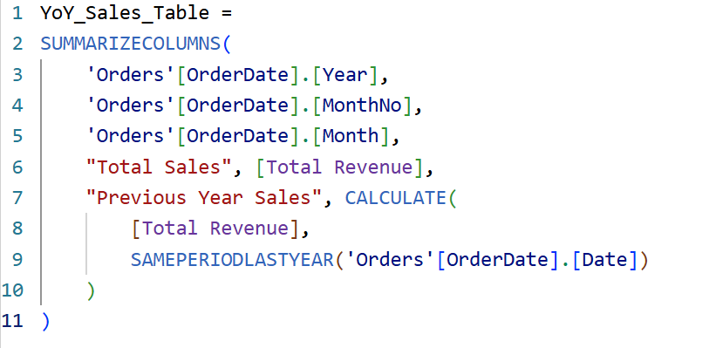
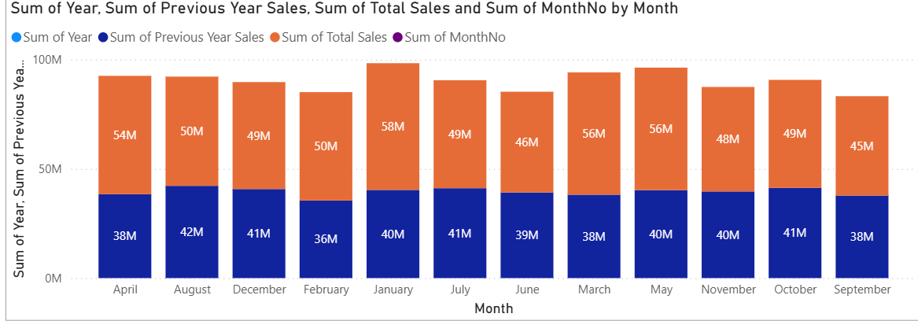
A summary table was built using time intelligence DAX functions such as SAMEPERIODLASTYEAR() alongside a Total Sales measure, producing four columns — Year, Month, Total Sales, and Previous Year Sales. Placing current and prior-year figures side by side like this makes it straightforward to spot months where performance improved or declined year-over-year, which is far more useful for trend analysis than looking at a single year's numbers in isolation.

Q15. What is the Power BI Gateway, and what are its use cases?
A Power BI Gateway is a secure bridge that connects on-premises (local) data sources such as SQL Server, Excel files, file folders, or enterprise databases to the Power BI Service (the cloud platform). It ensures that data stored inside an organization's internal systems can be safely accessed by Power BI reports and dashboards without manually uploading or exposing that data to the public internet. The gateway works as a secure communication channel, allowing the Power BI Service to query or refresh data from local systems while maintaining full security and compliance within the organization's network.
Use Cases
- Automated Data Refresh: allows cloud reports and dashboards to automatically refresh data from on-premises sources at scheduled intervals, so users always see the latest information without manual intervention.
- Scheduled Refresh Capability: organizations can set specific refresh times (daily, hourly, etc.), keeping reports up to date based on business needs without requiring users to reload or re-upload data.
- DirectQuery Support (Real-Time Access): enables DirectQuery mode, where Power BI queries the on-premises database directly instead of storing data in the cloud, giving users near real-time data in reports.
- Secure Data Connectivity: ensures sensitive internal data remains within the organization's network, reducing security risks while still enabling cloud reporting.
- Enterprise Data Integration: helps organizations combine multiple internal data sources with Power BI dashboards, making it easier to build centralized, scalable reporting systems.

Q16. How would you approach this project if no objective/subjective questions were given?
First, the data would be loaded into Power Query for exploratory data analysis to check missing values, duplicates, data types, and formatting issues, then cleaned for analysis. Next, key business metrics such as revenue, delivery time, shipping cost, and customer ratings would be identified across the areas of revenue, operations, and customer satisfaction. After that, dashboards would be designed around the needs of different users such as executives, managers, and analysts. A star schema data model would then be built along with important DAX measures like total revenue and average delivery time. Finally, the dashboard would be developed step by step using KPIs, charts, and filters to provide clear, interactive insights.
Step-by-Step Approach
- Step 1: Load data into Power Query, and check and clean errors or missing/incorrect values.
- Step 2: Identify key metrics such as revenue, delivery time, shipping cost, and customer ratings.
- Step 3: Design dashboards based on the needs of different users — executives, managers, and analysts.
- Step 4: Build a star schema model and create the important DAX measures needed for analysis.
- Step 5: Develop the dashboard using KPIs, charts, and filters to deliver clear, interactive insights.

