Marie Battle

Joshua Hamm

Erik Hernandez

Kody Pope

8-30-24

Assignment 4.1

Moffat Bay: ERD Assignment:

For this module's assignment, you will be creating the Entity Relationship Diagram for the Moffat Bay project.

   
 TDD Structure:

1. **Introduction**
   1. **Purpose**
      1. The purpose of the Moffat Bay project is to develop a website for managing lodge reservations. This website will allow customers to view lodge information, attractions, and make reservations. Customers must register and log in to book a vacation. The system will store reservation details in a MySQL database and provide functionality for customers to view and manage their reservations.
   2. **Terminology**
      1. **Lodge**: The accommodation offered on the Moffat Bay website.
      2. **Reservation**: A booking made by a customer to stay at the lodge.
      3. **Customer**: A user who registers on the website to make reservations.
      4. **Admin**: A user with special access to manage reservations and customer information.
   3. **User Personas**
      1. **Sarah, the Vacation Planner**
         1. 
         2. **Role:** Planner for family vacations.
         3. **Demographics:** Age 30-45, enjoys planning family trips, tech-savvy.
         4. **Goals:** Easily find information about the lodge, book a vacation, and manage reservations.
         5. **Frustrations:** Complicated booking processes, lack of clear information.
      2. **John, the Outdoor Enthusiast**
         1. 
         2. **Role:** Adventurer looking for lodge stays.
         3. **Demographics:** Age 25-40, interested in outdoor activities, prefers quick booking.
         4. **Goals:** View attractions, book a stay with specific requirements, and view past reservations.
         5. **Frustrations:** Difficulty finding activity information, managing multiple reservations.
      3. **Emma, the Lodge Manager**
         1. 
         2. **Role:** Manages lodge bookings and customer interactions.
         3. **Demographics:** Age 35-50, experienced in hospitality management.
         4. **Goals:** Access to reservation details, manage customer information, view summary reports.
         5. **Frustrations:** Inefficient management tools, lack of integration with reservation systems.
   4. **User Stories**
      1. **For Persona 1 (Sarah):**
         1. **As Sarah, I want to view lodge information on the landing page so that I can decide if it’s suitable for my family vacation.**  
            *Acceptance Criteria:* The landing page should include information about the lodge, such as amenities, photos, and a brief description.  
            *Story Points:* 3
         2. **As Sarah, I want to register an account so that I can book a vacation.**  
            *Acceptance Criteria:* Registration page should have fields for email address, first name, last name, telephone, and password. Password should be at least 8 characters long with one uppercase and one lowercase letter. The registration form should validate these requirements and store user information securely.  
            *Story Points:* 5
         3. **As Sarah, I want to book a vacation with specific dates and room preferences so that I can plan my trip effectively.**  
            *Acceptance Criteria:* Booking page should allow selection of room size, number of guests, and check-in/check-out dates. It should calculate the total cost based on the number of guests and room size. The form should submit the reservation details to the database.  
            *Story Points:* 8
      2. **For Persona 2 (John):**
         1. **As John, I want to view attractions on the website so that I can plan activities during my stay.**  
            *Acceptance Criteria:* Attractions page should list available activities such as hiking, kayaking, whale watching, and scuba diving with descriptions and images.  
            *Story Points:* 4
         2. **As John, I want to log in to manage my reservations and view booking history.**  
            *Acceptance Criteria:* Login page should allow John to enter his email address and password. Successful login should create a session for John to access his reservation history and management features.  
            *Story Points:* 5
         3. **As John, I want to search for past reservations by ID or email so that I can easily find my booking details.**  
            *Acceptance Criteria:* Reservation lookup page should have a search field for reservation ID or email address. It should display a summary of the reservation including room size, number of guests, and dates.  
            *Story Points:* 6
      3. **For Persona 3 (Emma):**
         1. **As Emma, I want to view all current reservations so that I can manage bookings efficiently.**  
            *Acceptance Criteria:* Emma should have access to a page displaying all current reservations, including customer details, room size, and dates. This should be accessible through an admin panel.  
            *Story Points:* 7
         2. **As Emma, I want to view a summary of customer information and reservation details so that I can address customer inquiries.**  
            *Acceptance Criteria:* Emma should be able to click on a reservation to view detailed customer and booking information, including contact details and special requests.  
            *Story Points:* 6
         3. **As Emma, I want to manage customer accounts and update reservation statuses so that I can ensure accurate and up-to-date information.**  
            *Acceptance Criteria:* Emma should be able to update reservation statuses, modify customer details, and handle booking changes through the admin interface.  
            *Story Points:* 8
   5. **Work Estimations (ToDo List)**
      1. **Design Landing Page:** Create wireframes and HTML/CSS for the landing page.  
         *Estimated Time:* 8 hours
      2. **Develop Registration and Login Pages:** Implement user registration and login functionalities, including form validation and password hashing.  
         *Estimated Time:* 12 hours
      3. **Implement Booking Functionality:** Develop the reservation page with form selection, validation, and MySQL data submission.  
         *Estimated Time:* 15 hours
      4. **Create Reservation Lookup Page:** Develop functionality to search and view past reservations by ID or email.  
         *Estimated Time:* 10 hours
      5. **Set Up Database:** Design and create tables for users and reservations, including encryption for passwords.  
         *Estimated Time:* 6 hours
2. **Design**
   1. **Prototypes - (*Please scroll down to iii) PROTOTYPE of homepage for PROTOTYPE)***
      1. **Rules:**
         1. **Landing Page Prototype:**
            1. Displays lodge information (amenities, photos, descriptions).
            2. Room types and pricing are shown.
            3. Buttons for "Login" and "Register."
            4. Links to attractions, room details, and booking.
            5. Login Page Prototype:
         2. **Fields for email and password.**
            1. "Remember Me" checkbox.
            2. Links to registration for new users.
         3. **Registration Page Prototype:**
            1. Fields for first name, last name, email, phone number, and password.
            2. Password validation (at least 8 characters, one uppercase and one lowercase).
            3. Submit button to create a user account.
         4. **Booking Form Prototype:**
            1. Room type selection, check-in/check-out dates, and number of guests.
            2. Form to calculate the total cost.
            3. Submission button to send booking details to the database.
         5. **Login Page** 
            1. Include a "Forgot Password" link for password recovery.
         6. **Booking Lookup Page Prototype (Customer):**
            1. Field to search reservations by email or reservation ID.
            2. Display summary of reservation information.
            3. Enable users to modify or cancel their reservation directly from this page.
         7. **Booking Lookup Page Prototype (Manager):**
            1. Filter options to view reservations by date, user, or room.
            2. Display all reservations with the option to manage (update/cancel) bookings.
      2. **Screen recording of walking through the prototype for customer:**
         1. [**https://drive.google.com/file/d/1serZQoR7VVMptM1vU3yiRzkVk_H5ciJx/view?usp=sharing**](https://drive.google.com/file/d/1serZQoR7VVMptM1vU3yiRzkVk_H5ciJx/view?usp=sharing)
      3. **PROTOTYPE of homepage using marvelapp.com:**
         1. [**https://marvelapp.com/prototype/a8d9a9a/screen/95417627**](https://marvelapp.com/prototype/a8d9a9a/screen/95417627)
      4. **PROTOTYPE of Manager front desk screen using marvelapp.com:**
         1. [**https://marvelapp.com/prototype/32c63f46/screen/95406248**](https://marvelapp.com/prototype/32c63f46/screen/95406248)
      5. **Mockup Landing Page:**
         1. 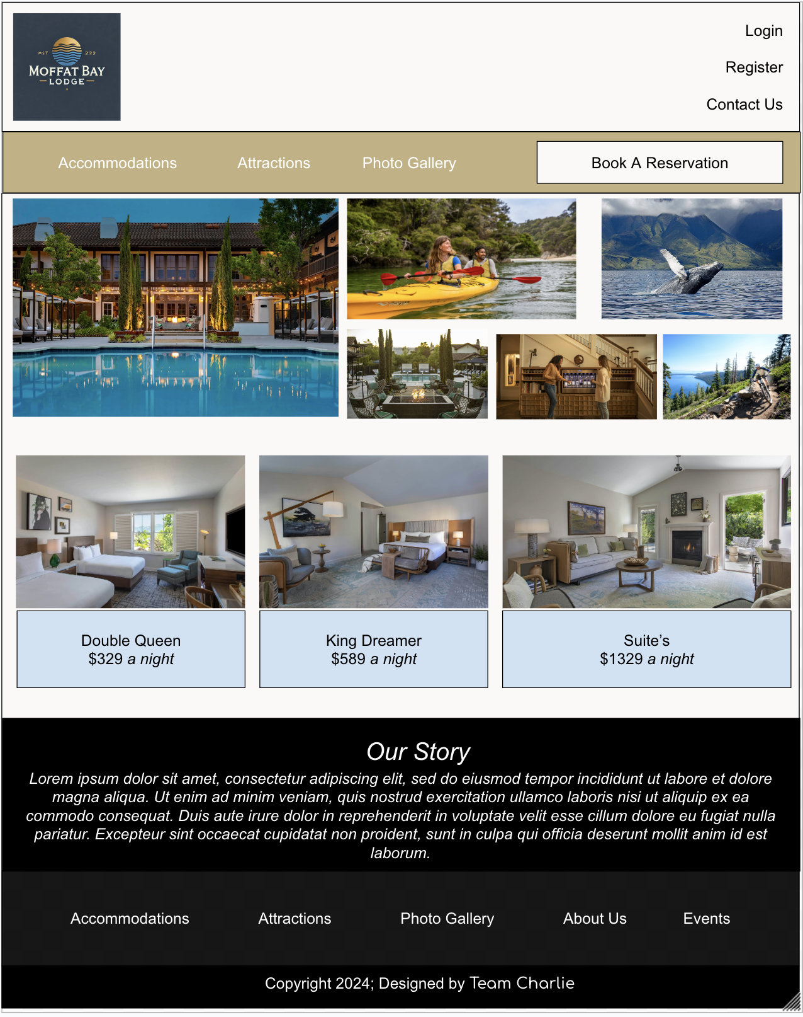
         2. **Link to Word Doc showing Photos for reference:**
            1. <https://docs.google.com/document/d/1Z-F8Ckk6celrmhWfE0V5ulMoBu4wg4Pl/edit?usp=sharing&ouid=104714144269725915606&rtpof=true&sd=true>
   2. **ERD**
      1. 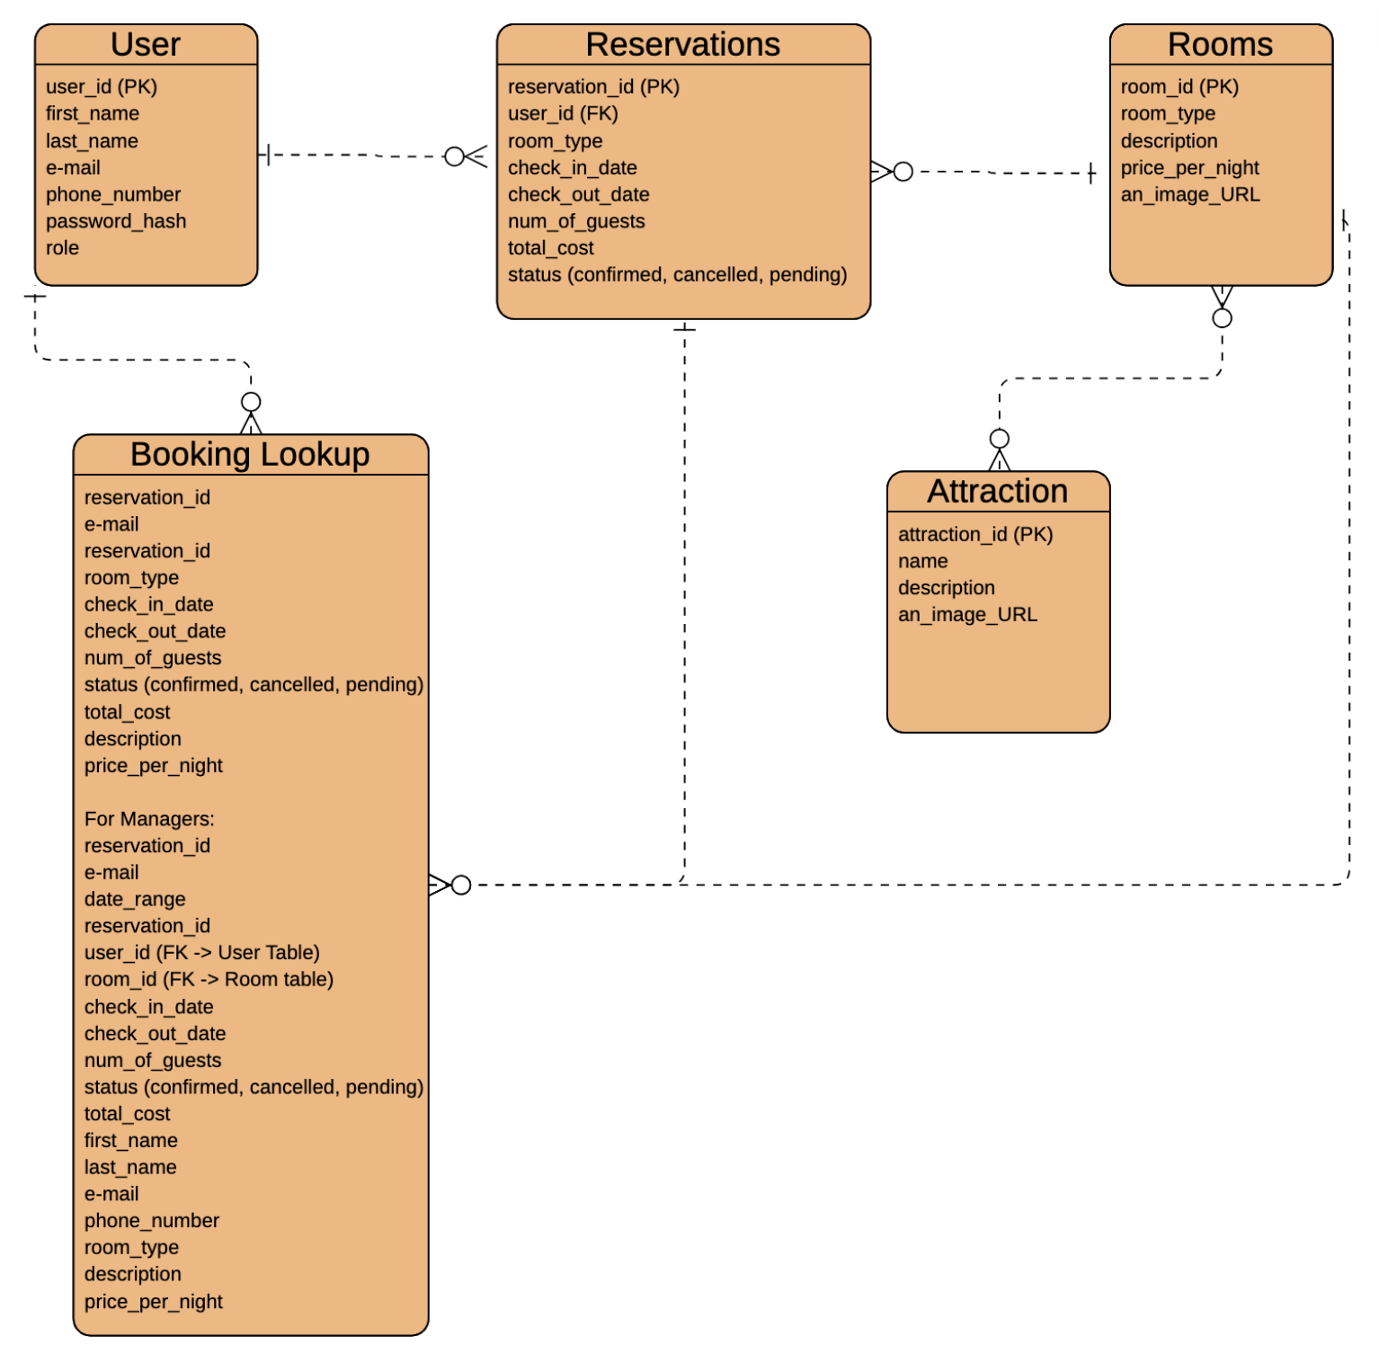
3. **QA Testing**
   1. **QA Test Plan**