Marie Battle

Joshua Hamm

Erik Hernandez

Kody Pope

9-22-24

Assignment 9.1

(Two) Beta Testers

Beta Tester 1

Ryan S.

Tech Savvy

30 Yrs. Old

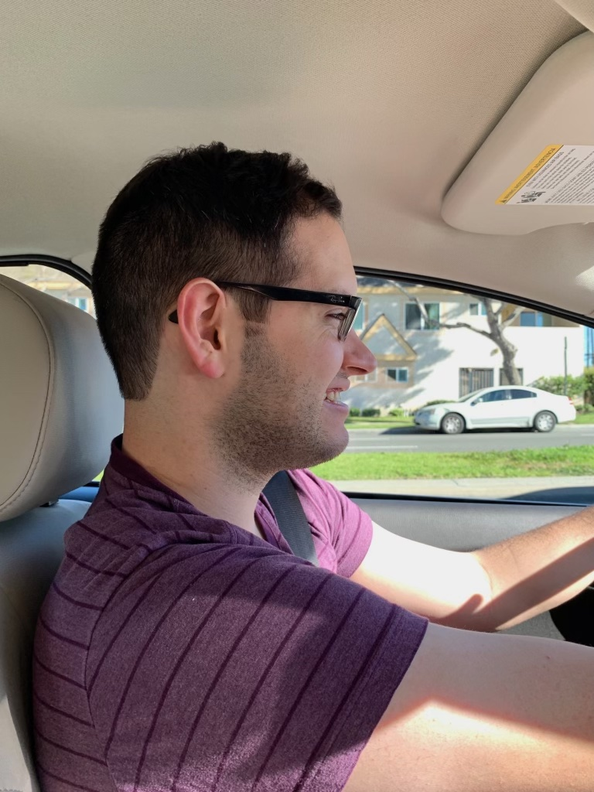

1. Contact page
   1. 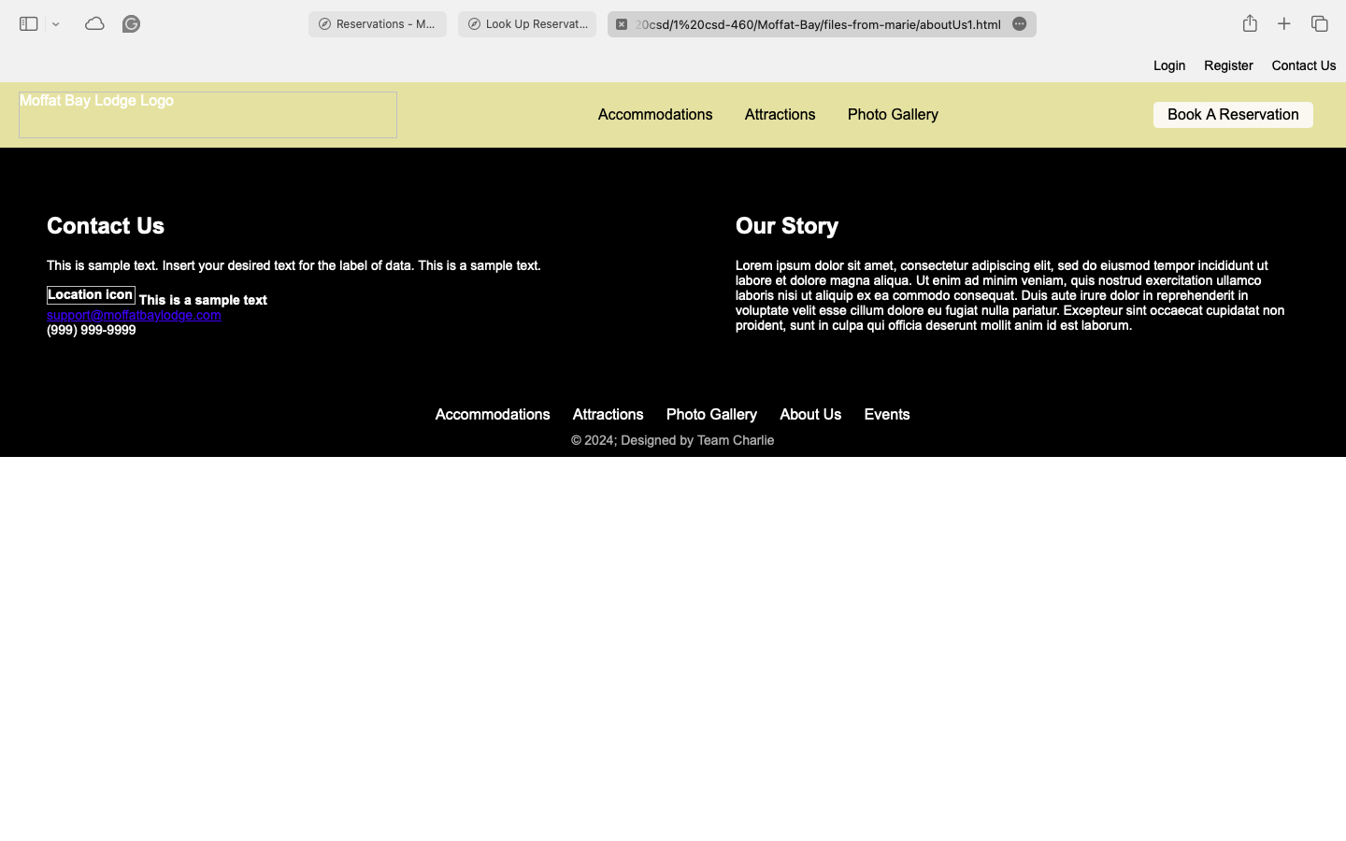
   2. Oh yes, the navigation bar comes easily to me. I like the book reservation button; it catches my eye and looks nice.
   3. The second thing is that the logo on the top left looks like there needs to be an image there, but there is not one.
   4. I like the layout of the sections, the fact that our contact information is on the left, and our stories are on the right. However, I do not like the black background very much. I wish it were just white or a lighter color.
2. Attractions page
   1. 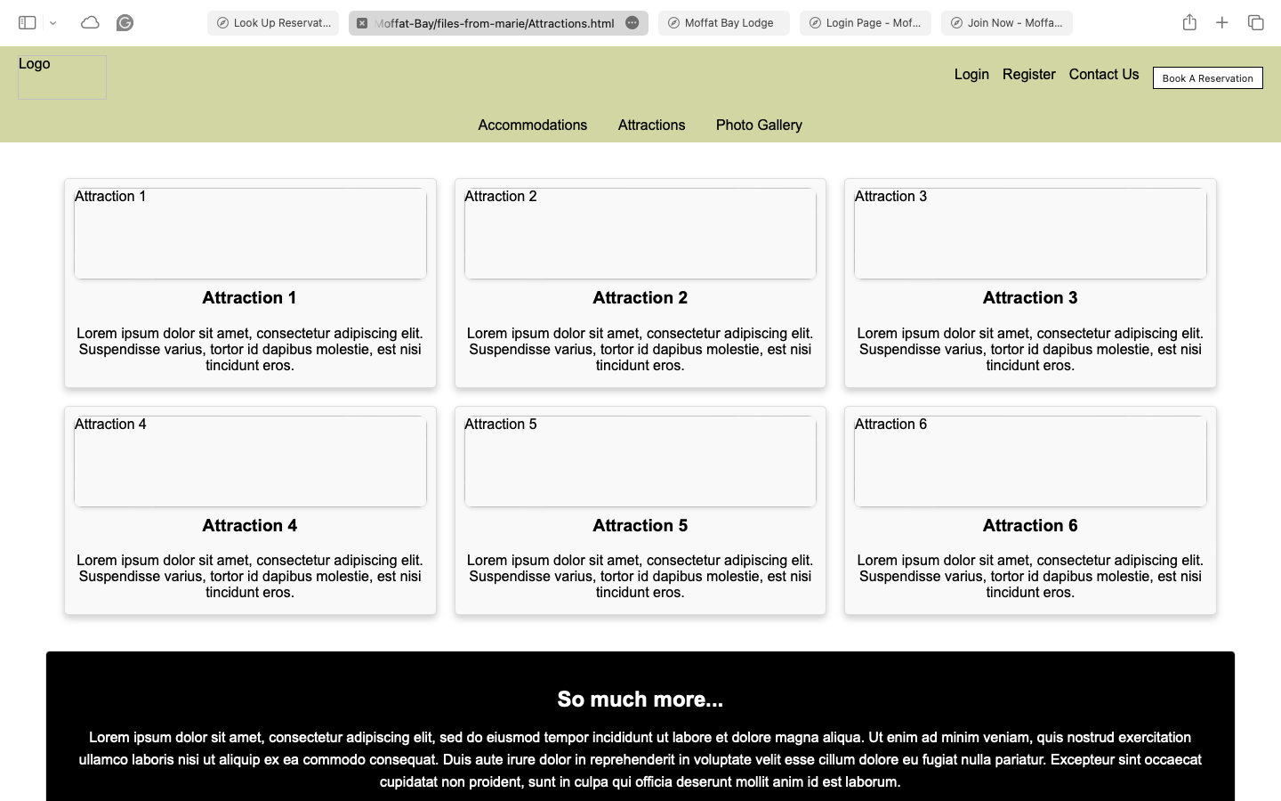
   2. I like the buttons as they pop, but the page is missing pictures throughout the page. I like the button for booking a reservation.
   3. While currently a placeholder, I like how the site is laid out, and if I really were to use it as an attractions site, I would like to go through it. Good layout.
   4. I like that there is an our story section, but it should be a different color than the footer.
3. LandingPPAGe (Kody’s version of landing page)
   1. 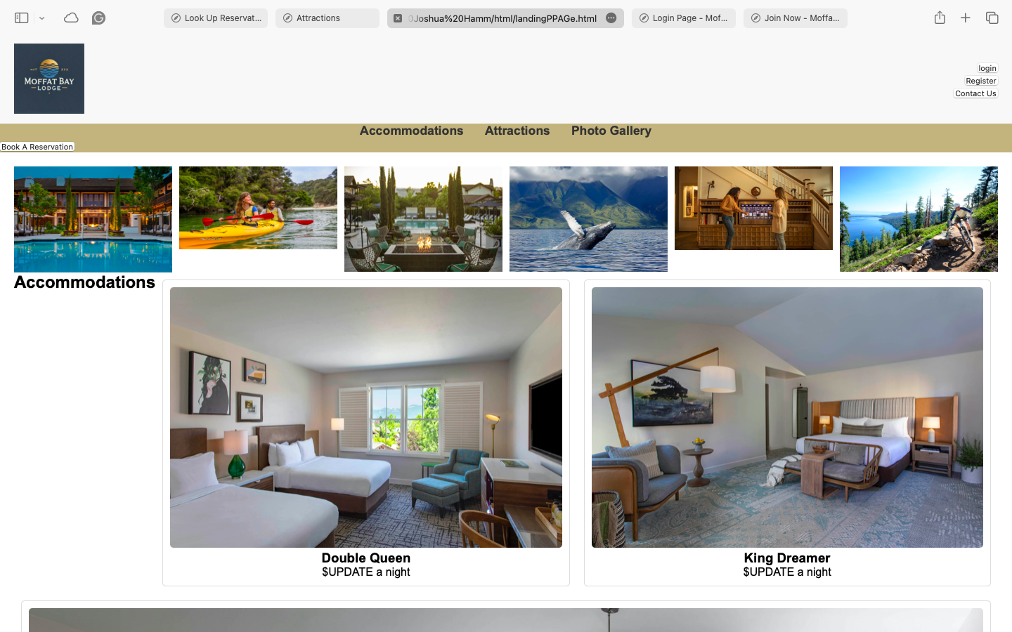
   2. I like all the pictures on it, and I like all the scenery. It looks lovely and grabs attention, along with all the photos of the rooms. This would make me consider actually booking this location if I were an actual customer.
   3. The next thing that grabs my attention is all the calls to action, also known as buttons, such as login, book reservation, etc. I like seeing that there are a lot of options for the customers.
   4. The colors look perfect on this page, and those neutral colors go well with the pictures of the Mountains, and the other scenic scenery picture, and the pictures of the hotel room. It is a perfect color scheme. That was a good pick.
   5. Maybe I am nitpicking, but black still is not my favorite color here, such as the background in our story.
   6. I do not like the bright blue in the footer, a slightly darker blue, or a more muted blue might make it look more professional, but I like it being blue overall. It might like it more if it were not such a bright blue.
   7. Yes, I like that big picture to showcase the best room. It is a good strategy that looks nice but also would draw customers to pick the best room. This is also an excellent way to upsell.
   8. Fix the big white space to the left of the first double queen image.
4. Log in UX window
   1. 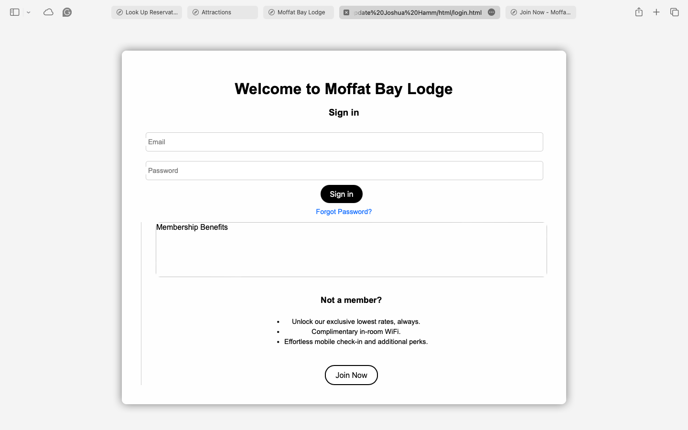
   2. This login page looks very typical of what I would expect from a hotel and a hotel brand, so it looks perfect. It is basic and professional, but in the way I would expect.
   3. I like that there is a membership benefits section, although it does not list the benefits yet, so I would want that filled out. I also like that there is a not a member yet section that gives some reasons for them to join if they have it yet, so I think that that is an appealing session for people to join and a real thing that I most like has an
   4. It is good because the login is clear. This is good.
5. Registration login window
   1. 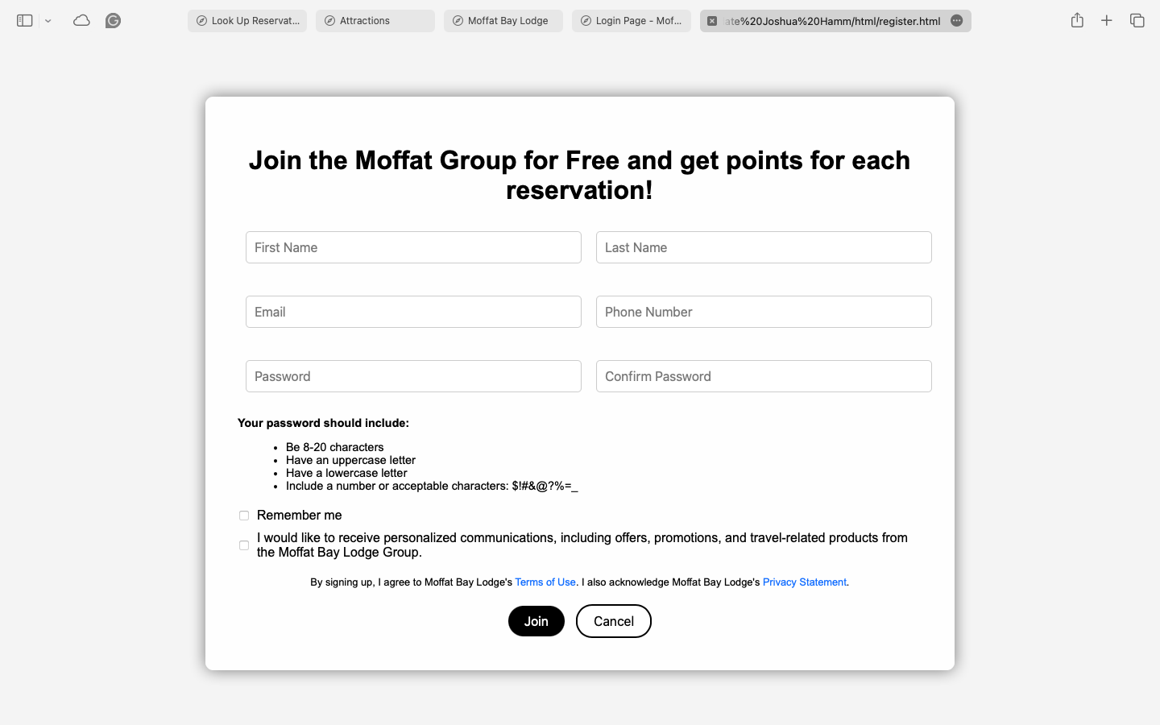
   2. This page gives all of what should be included in the password right off the bat, such as that it needs to be between 8 and 20 characters, have an upper case, etc. Some sites show this only when you make a mistake, which makes it hard for you to know what password need to have in the first place, so I am a big fan of this format.
   3. In addition, this page looks well-styled. It clarifies the difference between the input fields and the password requirements, the remember me button, and the personalized communication button.
6. Lookup reservation
   1. 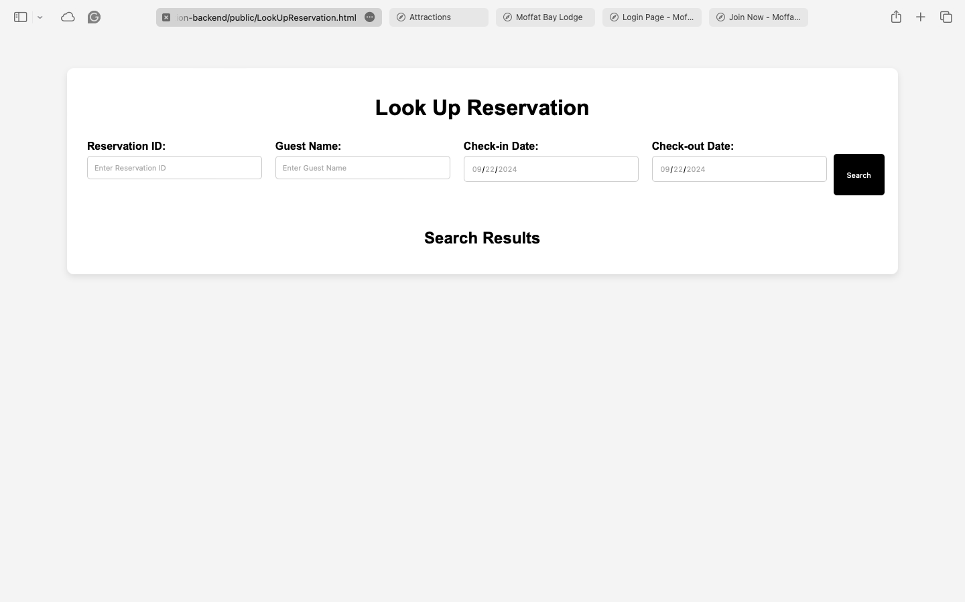
   2. The first thing that pops out to me is I think all of their input fields look really well done, modernizing the whole page; it is really clean.
   3. The only issue I see is that I do not know exactly if I need all of this information to check my reservation or if some of it is optional, so I would instead use something like an asterisk or something to show what I need to input.
   4. Suggestions: maybe all you need is your reservation ID and last name instead of the guest's name and the dates you booked.
   5. However, I like that it appears that once you have successfully searched for the reservation, the search results for your reservation appear on the page itself so that you can see your reservation right there to ensure that everything looks correct.

Beta Tester 2

Alex A

Alex is not very good with technology and often has issues with websites and so I felt she was a good person to be a beta tester.

30

* 1. Contact Page
  2. **Q: What are your thoughts on the navigation?**
  3. A: I found the navigation to be straightforward and easy to use. The book reservation button is particularly appealing and draws my attention immediately.
  4. **Q: What did you think about the layout?**
  5. A: The layout is well-structured, with the contact details prominently displayed. However, I think the black background is too dark; a lighter shade would make it more welcoming.

### Attractions Page

* 1. **Q: How did the buttons and layout work for you?**
  2. A: The buttons are vibrant and engaging, which I really liked. However, the page feels somewhat empty without images to complement the text. Adding visuals could enhance the overall experience.
  3. **Q: What are your impressions of the “Our Story” section?**
  4. A: I think the "Our Story" section adds a nice personal touch, but it should be visually distinct from the footer—perhaps a different background color could help.

### Landing Page (Kody’s version)

* 1. **Q: What did you think of the images on the landing page?**
  2. A: The imagery is fantastic! It really captures the essence of the location and makes me want to explore more. The scenic photos are inviting and create a positive first impression.
  3. **Q: How do you feel about the color scheme?**
  4. A: The colors are well-chosen; they complement the images nicely. However, I believe the black in the "Our Story" section could be toned down to make it feel less harsh. Also, the footer's bright blue might benefit from a more subdued shade.

### Login UX Window

* 1. **Q: What are your thoughts on the design of the login page?**
  2. A: The login page is clean and professional, which I appreciate. It looks exactly like what I’d expect from a hotel website.
  3. **Q: Did you find the membership benefits section useful?**
  4. A: Yes, the membership benefits section is a great addition. However, it would be even better if it listed specific advantages to encourage sign-ups.

### Registration Login Window

* 1. **Q: How did you find the password guidelines?**
  2. A: I love that the password requirements are clearly stated right away. This approach is much better than only showing them after an error occurs.
  3. **Q: What are your thoughts on the overall layout?**
  4. A: The layout is very user-friendly, and I like how the different sections are organized. The distinction between input fields and password rules is also well done.

### Lookup Reservation

* 1. **Q: What did you think of the input fields?**
  2. A: The input fields are modern and visually appealing. They give a fresh look to the page, which I really like.
  3. **Q: Were there any issues you noticed?**
  4. A: I’m unsure which fields are necessary for checking a reservation. Using asterisks to indicate required fields would be helpful. I do appreciate the feature that displays the reservation details right after a successful search—it adds a nice touch of reassurance.