**Group Charlie**

Marie Battle

Joshua Hamm

Kody Pope

Jacob Thompson

12-6-2023

Assignment 11.1

Milestone #3

Bacchus Winery

Report 1:

Description:

Supplier Delivery Performance Report: This report will provide information on the delivery performance of each supplier. It would include details such as expected delivery dates, actual delivery dates, and any delays or gaps between the expected and actual delivery dates. This report would help Stan and Davis identify any problem areas and assess the efficiency of their suppliers.

Screenshot of query:

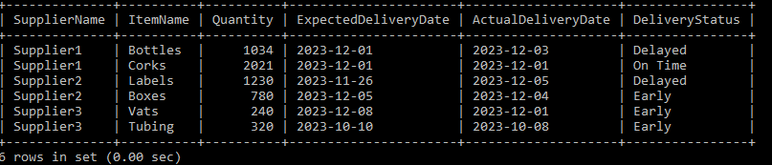

Report 2:

Description:

Wine Sales Report: This report will provide information on the sales performance of each wine variety. It would include details such as the quantity of each wine sold, revenue generated, and the distributor responsible for selling each wine variety. This report would help Stan and Davis determine if all wines are selling as expected and identify any underperforming wines or distributors.

Screenshot of query:

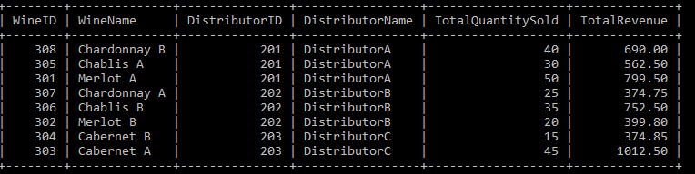

Report 3:

Description:

Employee Work Hours Report: This report will provide information on the number of hours worked by each employee during the last four quarters. It would include the employee's name, quarter, and total hours performed. This report would help Stan and Davis assess the workload and productivity of their employees, identify any imbalances in work distribution, and make informed decisions related to workforce management.

Screenshot of query:

