Kody Pope

Assignment 1.2

GitHub Repo Setup

Screenshot of terminal making module-1:

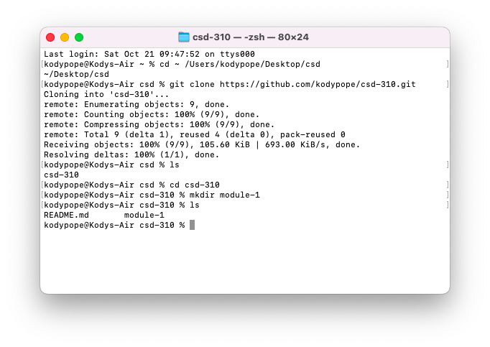

Screenshot of repo with module-1:

Link to GitHub module-1 repo: <https://github.com/kodypope/csd-310/tree/main/module-1>

Deliverables:

Link to GitHub Repo: <https://github.com/kodypope/csd-310/tree/main>

Screenshot of GitHub Repo:

Screenshots of my local directory:

