**Group Charlie**

Marie Battle

Joshua Hamm

Kody Pope

Jacob Thompson

11-28-2023

Assignment 10.1

Milestone #2

Bacchus Winery

**ERD Attributes Suggestion:**

Inbound Delivery

- InboundDeliveryID: (PK)

- SupplierID: (FK)

- ProductID: (FK)

Supplier

- SupplierID: (PK)

- Name:

- Contact:

Product

- ProductID: (PK)

- Name: Wine

- WineTypeID: (FK)

Inventory

- InventoryID: (PK)

- ProductID: (FK)

- Quantity:

Purchase order

- PurchaseOrderID: (PK)

- SupplierID: (FK)

- ProductID: (FK)

- Quantity:

Outbound Delivery

- OutboundDeliveryID: (PK)

- DistributorID: (FK)

- SalesOrderID: (FK)

Sales order

- SalesOrderID: (PK)

- EmployeeID: (FK)

- DistributorID: (FK)

- ProductID: (FK)

Distributor

- DistributorID: (PK)

- Name:

- Contact:

Wine type

- WineTypeID: (PK)

- Type:

Employee

- EmployeeID: (PK)

- Name:

- DepartmentID: (FK)

- ManagerID: (FK)

- HoursID: (FK)

Department

- DepartmentID: (PK)

- Name:

Manager

- ManagerID: (PK)

- Name:

Hours

- HoursID: (PK)

- HoursWorked:

**Screenshot of updated ERD:**

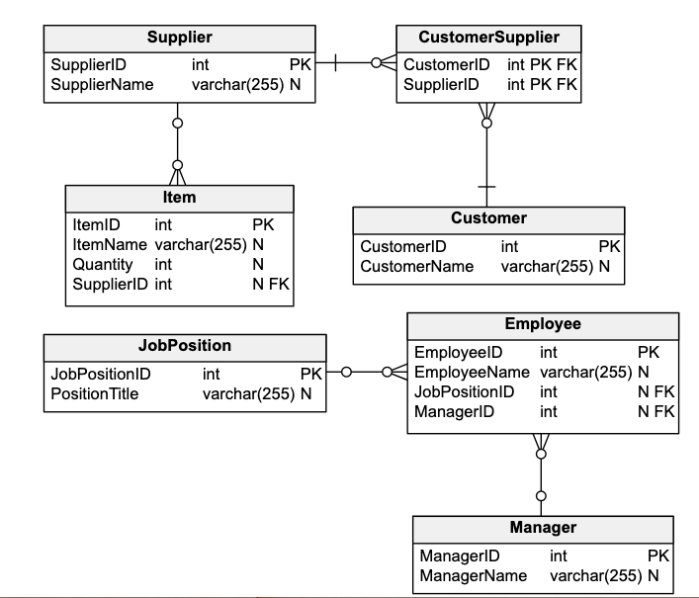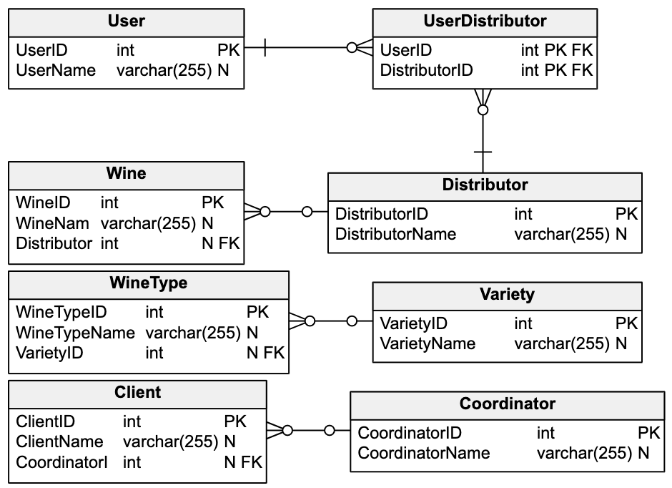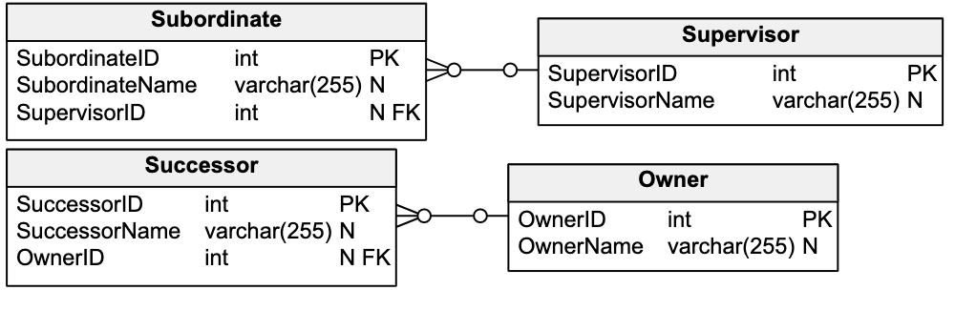

Screenshot of python script results:

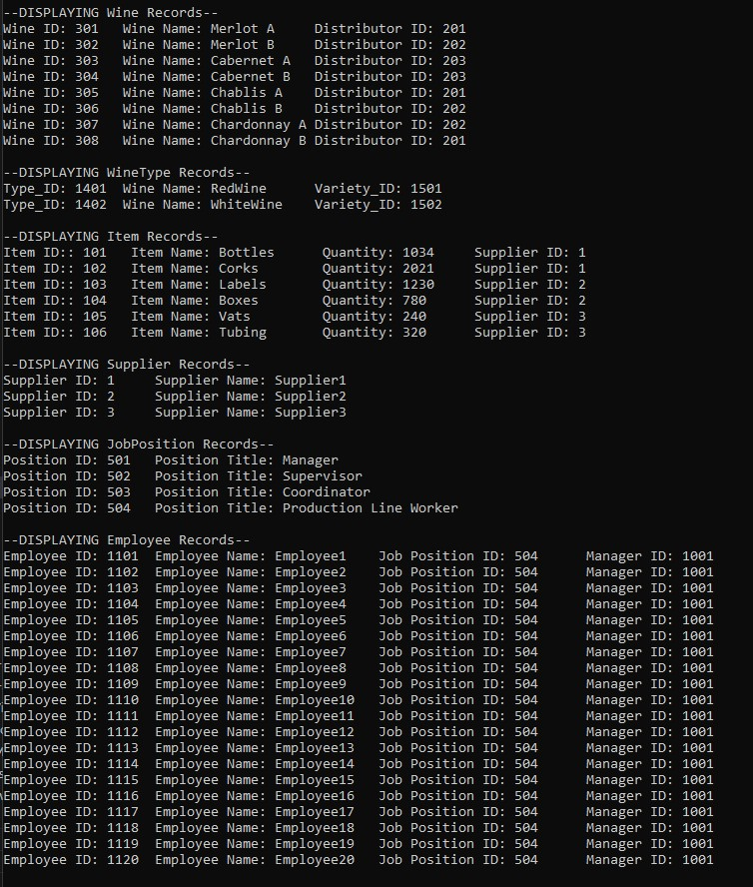

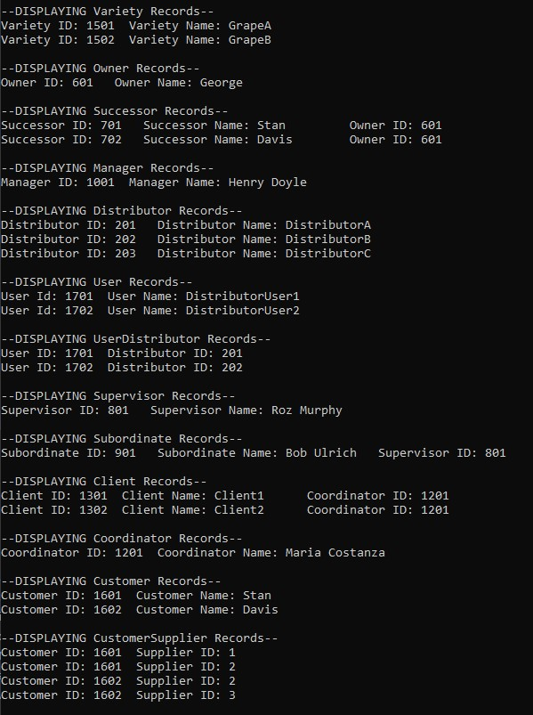

Link to SQL script: <https://github.com/PurpleTrex94/CSD-310/blob/main/module-10/charlie_db_script(1).sql>

Link to Python file: <https://github.com/PurpleTrex94/CSD-310/blob/main/module-10/charlie_db_main(1).py>

Deliverables:

Wednesday: started the Python database script.

Thursday: Started the SQL database script.

Friday: Made edits to rules.

Saturday: Finalized ERD, and Python scripts.

Sunday: Finalized Word document.