Kody Pope

11-12-23

Assignment 5.2

MySQL Functions

After looking at the list of functions, I chose the NOW() function. The code would run as SELECT NOW(); and then, of course, I would include an alias AS, and then I would put in quotations ‘It is now: ‘ which returns a table with a row that says It is now: and then underneath that is a row displaying the current time. The date would include the month, year, day, hour, minutes, and even seconds.

I imagine running a program that would need to know information that pertains to right now, and therefore, we would want to see the time. Let’s say, for example, you’re looking at a weather chart and want to know what the weather is like. You don’t want to know what the weather was like two hours ago as it may have changed, but we do want to know right now, so you would need to use the NOW() function. You would use the alias AS and write in quotations, ‘it is now’ to show the user what is shown in the data field. If you were to write SELECT NOW(); and not add an alias, your first row would say now parentheses, which may confuse the user. They may not understand that they are looking at the current month's date, hour, minute, and seconds.

The following function I chose is the MONTH() function, and inside MONTH(), I have a second function to use the current date. The CURDATE() function returns the current time, the current time being the year, month, and day; in the MONTH() function, all I want to return is the month.

However, in this function, you need to add at least a month, so in this case, if I add the current time, which has a month in it, then it would be able to return the month that we are currently in.

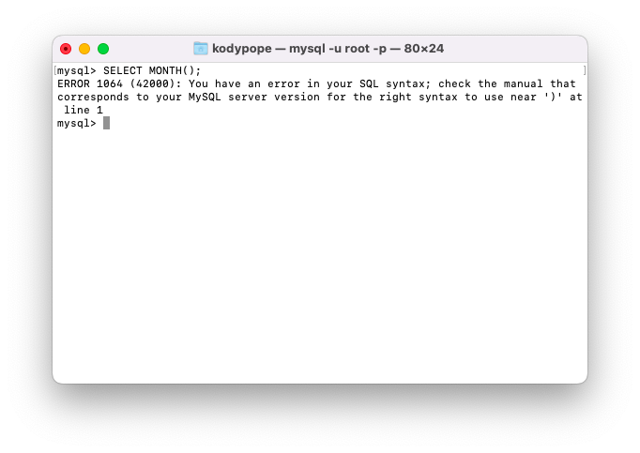

in this case I ran the code in November so that the current date would be 12 November 2023. and then MONTH() looks for the month in the information provided: November, so it returns 11, the 11th month of the year. Running the function without an alias may once again lead to confusion when the user sees a row that says MONTH(CURDATE()).

This function would be useful when you need to know what month it is. For example, let’s say you’re enrolling in classes, but some deadlines must be. Let’s say your deadline was October, but if you could not pull up the month of the current day, then we wouldn’t be able to see what month the information is being used to help determine whether or not the deadline is being met.

The third function I chose was USER(), which will return the current user. We need to use an alias, which is, in my case, current user in quotations. Therefore, we return a table that shows the current user and then gives us the current user.

without the alias, and just typing SELECT USER(); we would see USER() and then current user. This would not be beneficial information for someone needing help understanding how this technology works as ‘user parentheses,’ i.e., USER(), doesn’t particularly inform the user that the information they are looking at is the current user’s information.

Knowing the current user may be necessary when looking at an application where you can switch between different users if, by chance, you’re in a situation where you have, say, a personal profile and a business profile. You wanted to ensure you weren’t posting your business information to your personal profile or vice versa. You would be able to see what user you’re looking for by using the USER() function so we can see what user we are currently in.