**Group Charlie**

Marie Battle

Joshua Hamm

Kody Pope

Jacob Thompson

11-28-2023

Assignment 9.1

Milestone #1

Bacchus Winery

**Business Rules:**

1. Supplier Deliveries: To find out if all suppliers are delivering on time and to determine any gaps between expected and actual delivery times, can generate a month-by-month report that highlights problem areas. This report will provide insights into which suppliers may require closer monitoring or potential improvement.

2. Wine Distribution: To assess the sales performance of different wines, you can analyze whether all wines are selling as expected. It is also important to identify if there is any specific wine that is not selling well. You can determine which distributor carries each wine to evaluate their respective contributions to sales.

3. Employee Time: Assessing employee hours worked over the last four quarters can help you understand their productivity and potential workload concerns. By looking at the number of hours worked by each employee during this period, you can identify patterns, allocate resources effectively, and address any issues related to workload or overtime.

**Supplier ID: (Primary Key)**

A supplier can supply multiple types of items

One item can have one item ID. (foreign key)

Each item is associated with one supplier ID. (foreign key)

The relationship between the Supplier ID entity and the Item ID entity is “One-to-Many.” (foreign key)

**Distributer ID: (Primary Key)**

A distributor can carry multiple types of wines.

Each type of wine is associated with one or more distributors ID. (foreign key)

The relationship between the Distributor ID entity and the Wine entity (item ID) is "One-to-Many." (foreign key)

One wine can sell to many customers ID. (foreign key)

One wine can have one item ID. (foreign key)

**Item ID. (Primary Key)**

One item can sell to many customers.

**Employee ID: (Primary Key)**

One employee can have only one job position within the winery.

Each job position is associated with one or more employees.

The relationship between the Employee entity and the Job Position entity is "One-to-Many."

**Job Position:**

One employee can work many hours.

Hours worked for past four quarters.

One employee can have one employee ID. (foreign key)

One employee can work unlimited overtime.

**Owner ID: (Primary Key)**

George (owner) has two successors, Stan, and Davis. (each under Employee ID: foreign key)

Stan and Davis inherited the winery from George. (each under Employee ID: foreign key)

Relationship: One-to-Many (1:N) from Owner to Successor.

Supervisor Roz Murphy is the supervisor of Bob Ulrich. (each under Employee ID: foreign key)

Bob Ulrich is a subordinate to Roz Murphy. (under Employee ID: foreign key)

Relationship: One-to-Many (1:N) from Supervisor to Subordinate.

**Management ID: (Primary Key)**

Henry Doyle manages the production line employees. (under Employee ID: foreign key)

The production line employees are subordinates to Henry Doyle. (under Employee ID: foreign key)

Relationship: One-to-Many (1:N) from Manager to Subordinates.

**Coordinator ID: (Primary Key)**

Maria Costanza coordinates with distributors. (under Employee ID: foreign key)

Distributors are clients in the distribution process.

Relationship: One-to-Many (1:N) from Coordinator to Clients.

**Wine Type ID: (Primary Key)**

Each wine type is associated with a specific grape variety. (under item ID: foreign key)

One grape variety can be associated with multiple wine types.

Relationship: One-to-Many (1:N) from Variety to Wine Type.

**Customers ID: (Primary Key)**

Stan and Davis (customers) order supplies from multiple suppliers.

Relationship: Many-to-Many (M:N) between Customer ID and Supplier ID. (foreign key)

Users (under customers ID: foreign key)

Distributors (users) place orders through the online ordering system.

The online ordering system serves multiple distributors.

Relationship: Many-to-Many (M:N) between User ID and Customer ID. (Primary Key)

**User ID: (Primary Key)**

Each supplier serves multiple customers.

**ERD:**

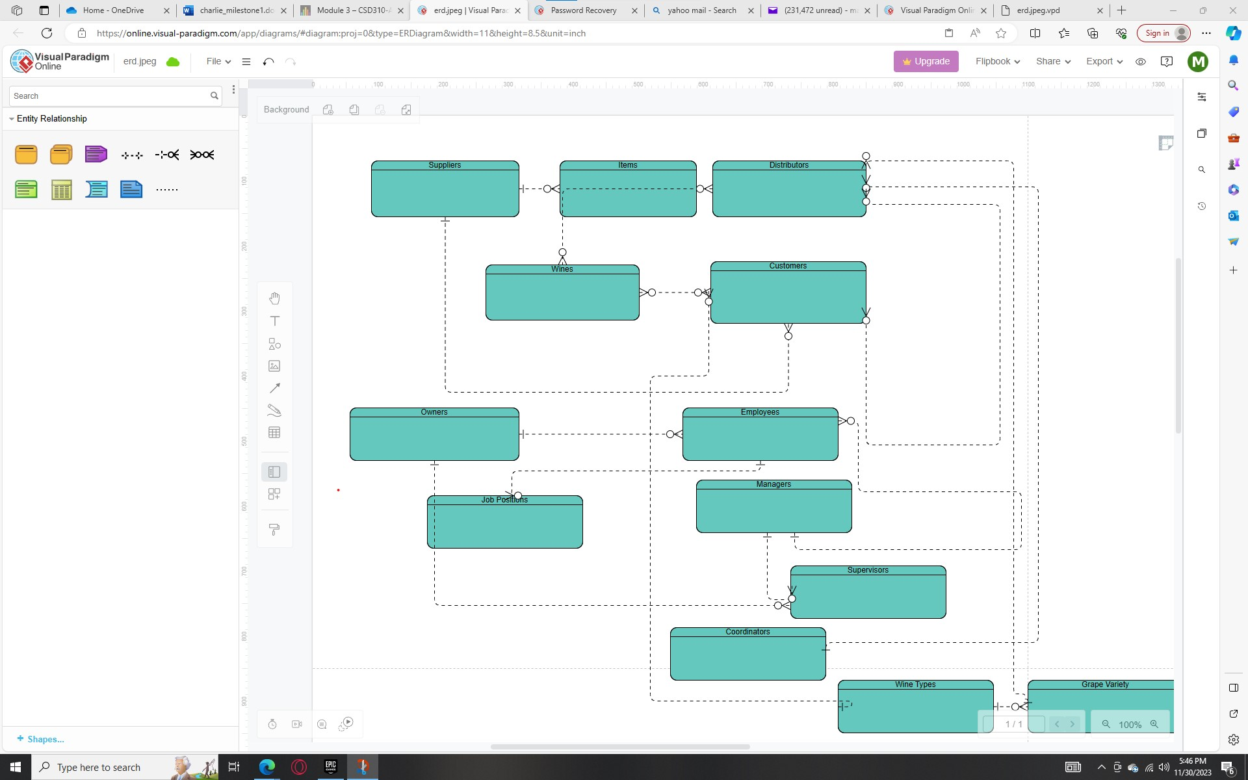

Deliverables:

We first connected through the discussion board for team Charlie. We have been taking turns adding to the project through a shared Word document and adding new "subjects" to the discussion board to further group communication on matters such as discussing any rules we should set or need to include in the final project.

Assumptions made:

We will act as a team working for a company that helps build databases for clients rather than be employees of Bacchus Winery.