Kody Pope

1-12-24

Assignment 1.3

Building a Web Page Exercise, Part 1

Take a screenshot of the validators results (there should be one or more errors):

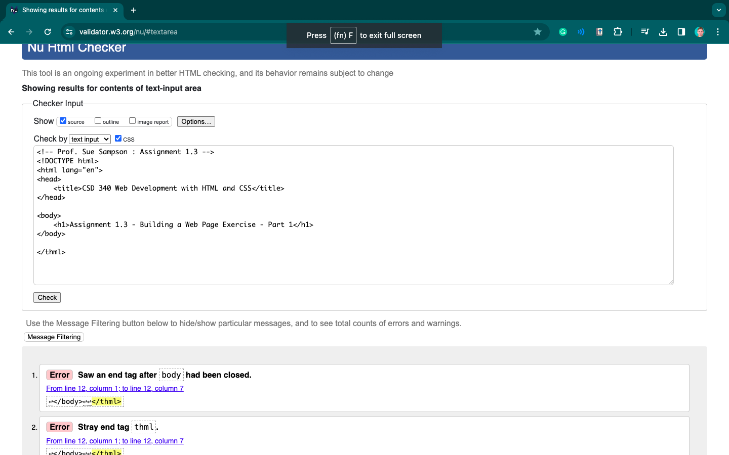

Take a screenshot of the updated results (this time, there should be 0 errors):

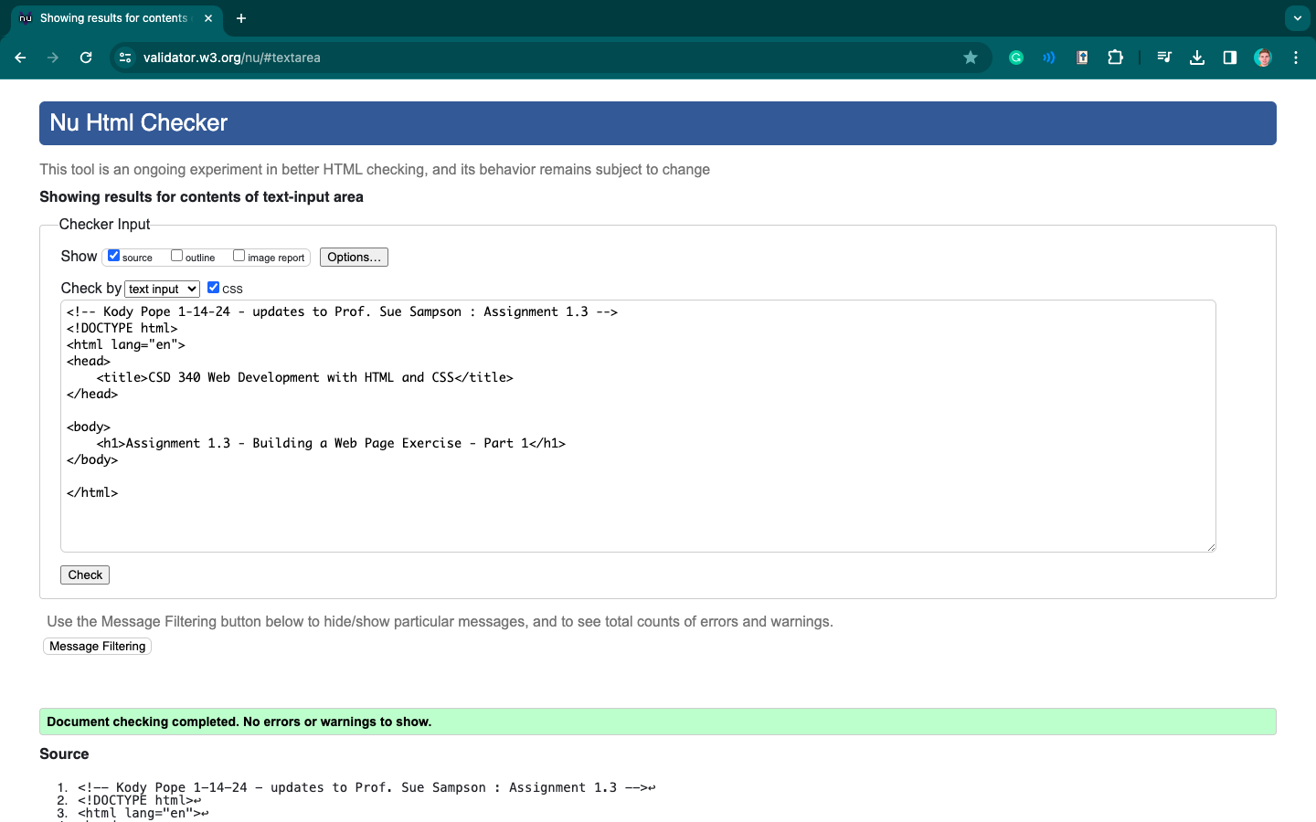

Open the file in your computer's default browser and take a screenshot of the web page:

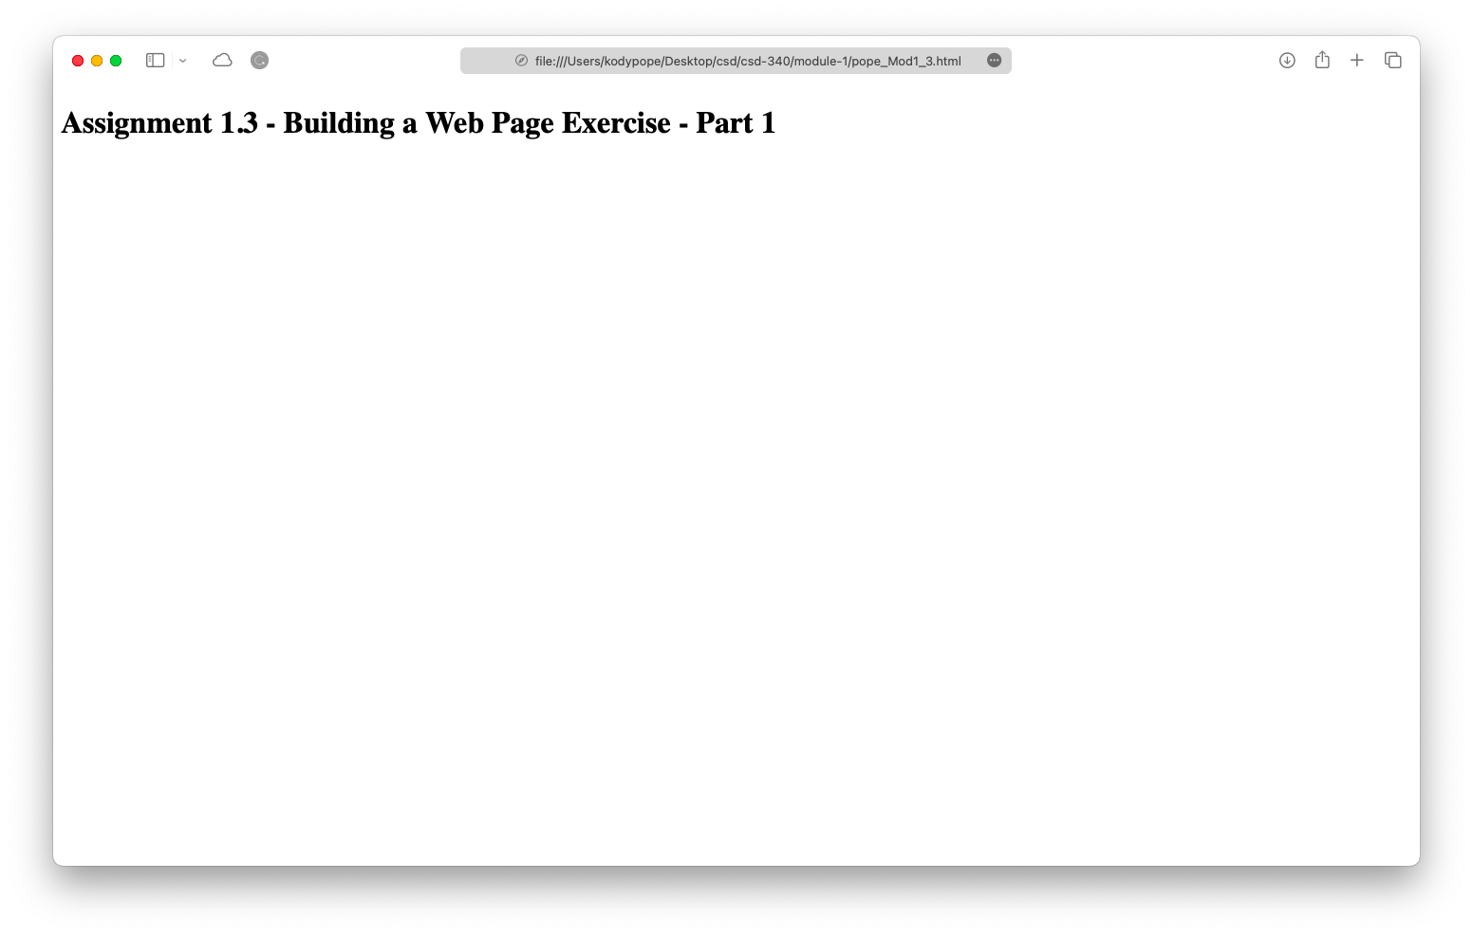

Link to your GitHub repository: <https://github.com/kodypope/csd-340/blob/main/module-1/pope_Mod1_3.html>