Kody Pope

1-14-24

Assignment 1.2

GitHub Repository Setup

1. Link to your GitHub repository: <https://github.com/kodypope/csd-340>
2. Screenshot of your local directory (properly formatted).

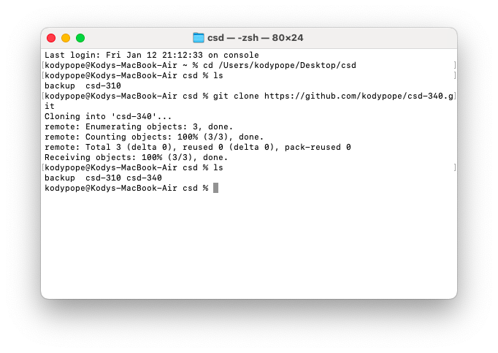

1. Screenshot of your GitHub repository.

