Kody Pope

1-21-24

Assignment 3.2

GitHub Pages

Screenshot of the HTML validators results:

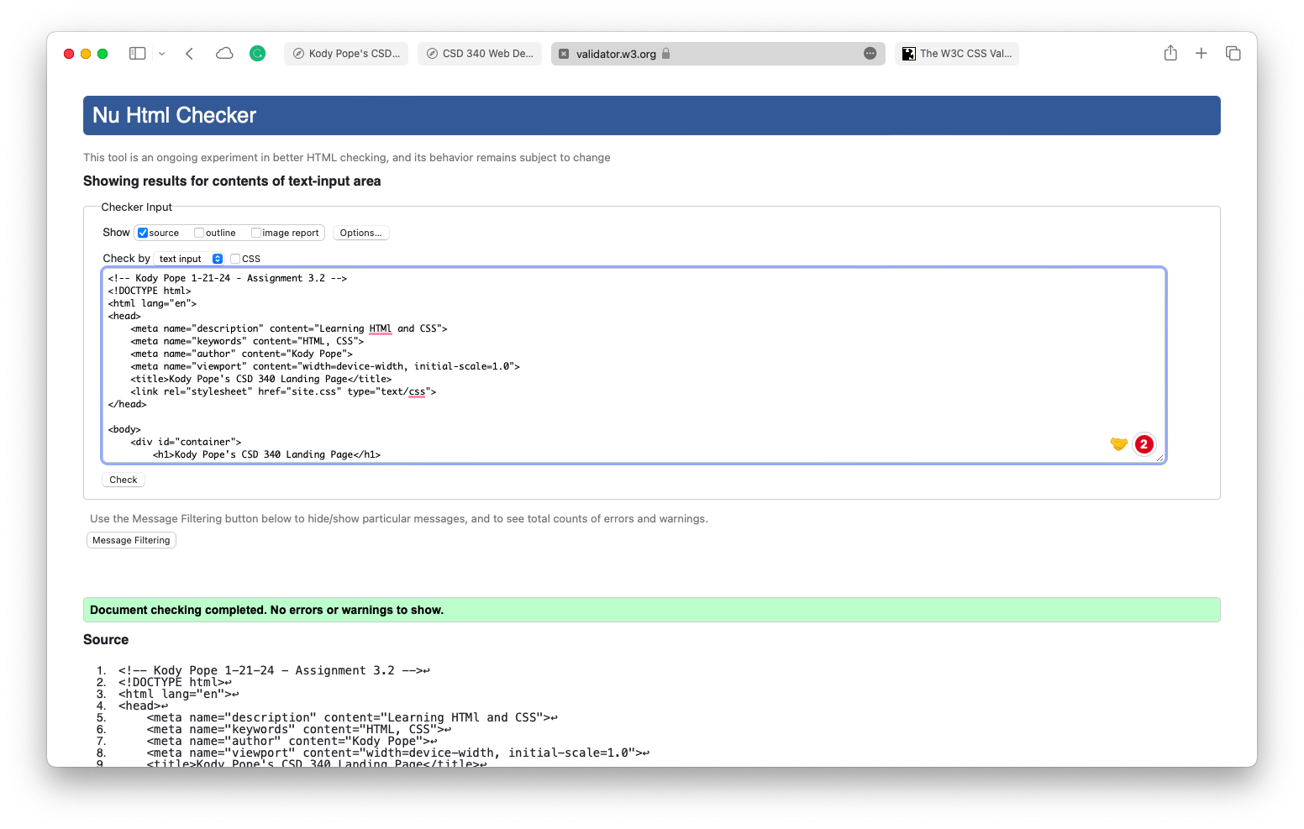

Screenshot of the CSS validators results:

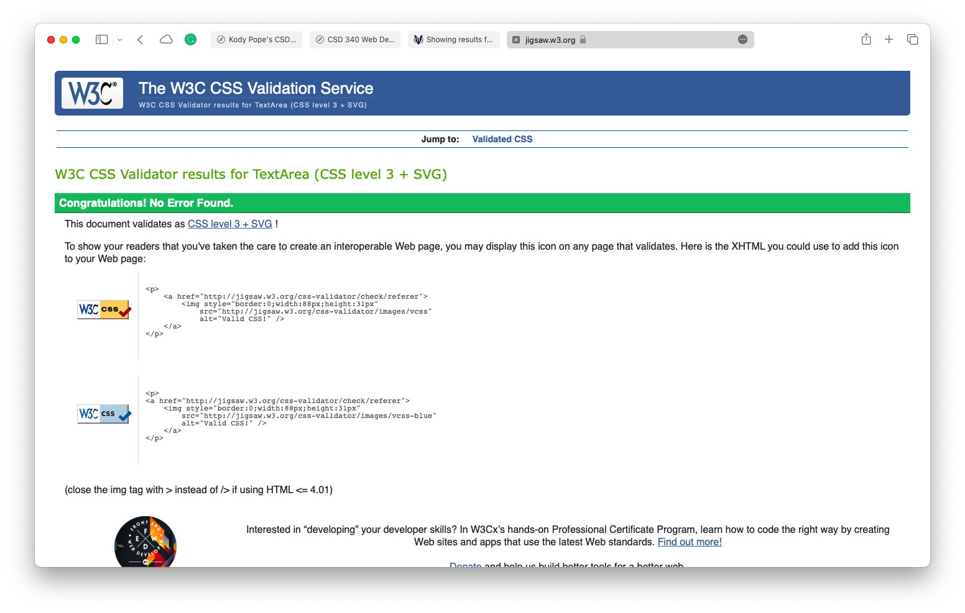

Screenshot of browser:

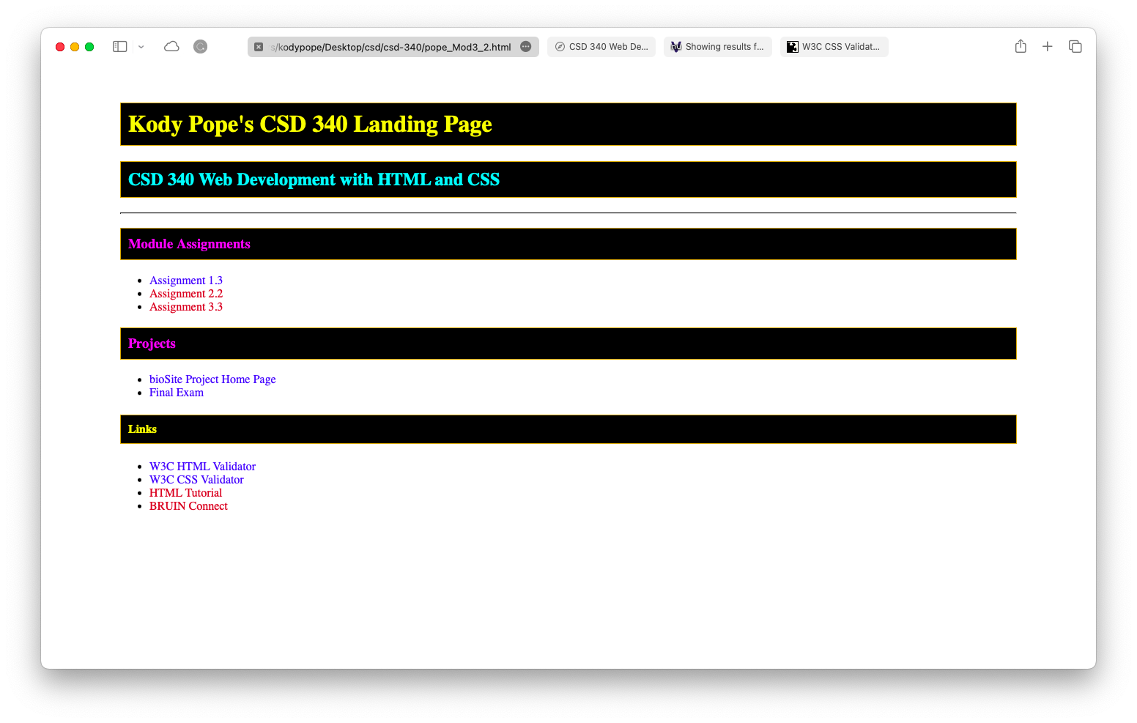

Link to your GitHub repository: <https://github.com/kodypope/csd-340/blob/main/pope_Mod3_2.html>

URL link to the GitHub pages landing page: <https://kodypope.github.io/csd-340/pope_Mod3_2.html>