DHPoly

Team
- Alexander Busch (as xMadUlti) <alexbusch98@gmx.de>
- Sven Köhler (as koehler1000) <koehler9@googlemail.com>
- Rico Kritzer (as K3) <rico@kritzer.net>

Time Spent
- Alexander Busch: 58h 40m
- Sven Köhler: 64h 45m
- Rico Kritzer: 93h 15m

Roles
- Alexander Busch:
  - Project Manager
  - Designer
- Sven Köhler
  - Tool Specialist
  - Requirements Specifier
  - Tester
- Rico Kritzer:
  - Head Implementer / Developer
  - Software-Designer

Use case diagram
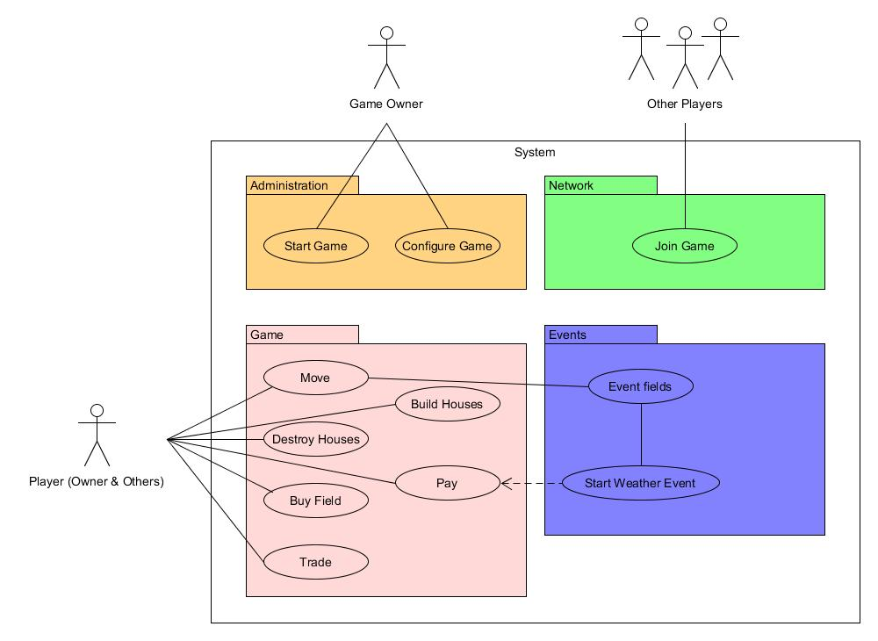UML-Diagram

