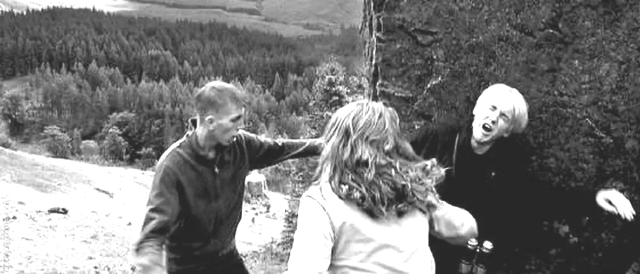
Omnes Draconem pulsant,
Draco omnes pulsat
(Everyone punches Draco,
Draco punches everyone)

Harrius Potter et Porcī:
Pars IV

By Anya

Quid est nomen novō porcō? Nomen eī est Dracō Malfoy.

Draco Malfoy hostiliter dicit, "Salve, Hariī Potter…"

Et Harrius hostiliter respondet, "O, Salve Dracō Malfoy…"

Dracō Malfoy Lunae dicit, "Salve, Porce!"

Luna respondet, "Oink!"

Placetne oinkere Draconī? Non placet. Draco dicit, "Non es Porcus!"

Luna iterum respondet, "OINK!" (Luna vult terrēre Draconem)

Luna mutat sē in hominem. Luna pulsat Draconem! Draco mutat sē in hominem. Luna ambulat ad baristam. Luna capit coffeam. Luna non bibit coffeam, sed fundit coffeam in caput Draconis! Dracō humidus est. Lunam non paenitet!

Draco dicit: "OINK! Non sum porcus!"
(Draco quoque iratus clamat: "Vae vae coffea calida est!")

Draco coffeam capit. Draco bibit coffeam. Non iacit coffeam, sed Draco pulsat Lunam!

Luna non respondet, sed irata discēdit et mutat sē iterum in porcam.

Harrius Potter sumit Lunam et consolatur eam. Harrius Potter videt Album Dumbledore. Estne Albus porcus? ITA Albus quoque porcus est. Albus porcus barbam longam et albam habet. Draco Album Dumbledore pulsat! (Dumbledore habet perspicilla obscura!) Harrius sumit Album Dumbledore et consolatur eum.

Albus plorat! "Vae, vae! Draco mē pulsavit!"

Harrius videt Ronaldum et dicit, "Salve, Ronalde!"

Ronaldus respondet, "O, Salve Harrī!"

Iam Albus non plorat. Dicit, "Salve, Ronalde!"

Draco pulsat Ronaldum! Ronaldus quoque pulsat Draconem!

Harrius videt Hermionem. "Salve Harrī," dicit Hermione. "Salve, Hermione", dicit Harrius. Draco quoque dicit, "Salve, Hermione!"

Hermione verō pulsat Draconem. Draco plorat! Draco dicit, "decem puncta ā Griffendorensīs!"

FINIS CAPITULĪ
ā: by/away from
ad: toward/to
albam: white
album: white
albus: white
ambulat: walks
barbam: beard
baristam: barista
bibit: drinks
calida: hot
capit: grabs, snatches, takes
capitulī: of the chapter
caput: head
clamat: shouts
coffea: coffee
coffeam: coffee
consolatur: consoles
decem: 10
dicit: says
discēdit: leaves
eam: her
eī: to him/her/it
es: you are
est: is
estne: is...?
et: and
eum: him/it
finis: end
fundit: pours
griffendorensīs: to/with/etc Griffendor
habet: has
harrī: of Harry; Harry's; Harry!
harrius: Harry
hominem: person
hostiliter: in an unfriendly mannner
humidus: wet
iacit: throws
iam: now/still/already
in: in/on/into
irata: angry
iratus: angry
ita: yeah
iterum: again
longam: long
mē: me
mutat: changes
nomen: name
non: not
novō: to/with/etc new
o: oh!
obscura: dark
oinkere: to oink (not really)
paenitet: "accusative_noun + paenitet" = accusative_noun is sorry
perspicilla: glasses
placet: is pleasing
placetne: is it pleasing...?
plorat: cries
porcam: pig
porce: oh pig!
porcō: to the pig/with the pig/etc
porcus: pig
pulsat: hits
pulsavit: co punched
puncta: points
quid: what
quoque: also
respondet: responds
salve: hi!
sē: he/she/itself (the subject of the sentence)
sed: but
sum: I am
sumit: picks up
terrēre: to scare
vae: ahh!
verō: truly, in truth, really
videt: sees
vult: wants

