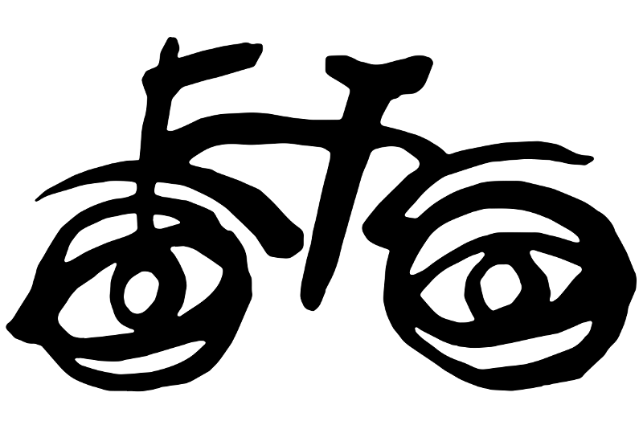
Birotae Vivae
(The Living Bikes)

By Sappho
Ecce birota. Estne birota magica? Nōn. Sed est birota viva! Mirabile dictū! Quid vult haec birota? Estne birota laeta? Estne birota tristis? Decem annōs laeta erat. Hūc illūc errābat.

Sed nunc vetus est. Homo cuius birota est vult birotam novam. Homo emit birotam novam, claram, et egregiam. Quid agit homo cum birotā vetere? Homo non intellegit birotam veterem vivam esse.

Birotae habent linguam propriam et ergo possunt inter sē colloquī. Quid dicunt birotae? Birota nova dicit: "Sum NOVA birota! Es birota VETUS! Nēmō tē amat!"

Birota vetus respondet: "Falsum est! Homo meus mē amat! Improba es!"
Birota nova vult hominem eicere birotam veterem in scrūta. Sed homo non solum novam birotam, sed etiam veterem birotam amat, et non vult eicere birotam veterem in scruta!

Birota nova habet consilium. Birota nova videt oleum in domō suā et oleum capit. Ubi ponit Birota Nova oleum? Sub cumulō foliōrum post aedificium pro birotīs. Et homo non potest invenīre oleum. Birota nova quoque paulum solvit catenam birotae veteris.

Unō diē, homo vult agere birotam veterem. Homo agit birotam, sed difficile est: catena non bene movet, ergo birota non bene movet. Subitō, catena dē birotā delabitur et birota cadit: caditne quoque homo!? Ita homo quoque cadit.

Sed consilium birotae novae non tam bonum quam putavit. Homo non dicit, "Haec birota mala est! Non amō hanc birotam." Homo birotam veterem fert ad tabernam ubi birotae reficiendae sunt. Homo vult tabernarium illīc birotam veterem optime reficere.

Birota nova irata est et clamat: "Eheu! Consilium meum malum erat. Nunc fortasse birota vetus melior est quam ego."

Homo domum revenit cum birotā vetere et putat: "Non necesse est mihi habēre duās birotās!" Et vendit birotam novam tabernariō. Birota nova plorat, birota vetus laetātur. Homo multōs annōs birotā vetere fruitur.

FINIS
ad: toward/to
aedificium: building
agere: to do
agit: is doing/does
amat: loves
amō: I love
annōs: years
bene: well
birota: bike
birotā: with/etc bike
birotae: of/to bike; bikes
birotam: bike
birotās: bikes
birotīs: with/to/etc bikes
bonum: good
cadit: falls
caditne: does co fall?
capit: grabs, snatches, takes
catena: chain
catenam: chain
clamat: shouts
claram: shiny, bright, clear
colloquuntur: converse
consilium: plan
cuius: whose, of whom
cum: with/when
cumulō: with/to/etc pile
dē: down from/about
decem: 10
delabitur: slips off
dicit: says
dictū: with regard to saying
dicunt: say
diē: on the day
difficile: difficult
domō: in/with/etc home
domum: home, to home
duās: two
ecce: behold!
ego: I
egregiam: amazing, special
eicere: to throw away
emit: buys
erat: was
ergo: therefore
errābat: co wandered; co made a mistake
es: you are
esse: to be; is
est: is
estne: is...?
et: and
etiam: also
falsum: false; a lie
fert: carries, bears
finis: end
foliōrum: of leaves
fortasse: maybe
fruitur: enjoys + ABL
habent: they have
habēre: to have
habet: has
haec: this
hanc: this
hominem: person
homo: human
hūc: to here
illīc: there
illūc: to there
improba: badly-behaved
in: in/on/into
intellegit: understands
inter: among/between
invenīre: to find
irata: angry
ita: yeah
laeta: happy
laetātur: is happy
linguam: tongue; language
magica: magical
mala: evil; bad
malum: evil/bad
mē: me
melior: better
meum: my
meus: my
mihi: to me
mirabile: amazing
movet: moves
multōs: many
necesse: necessary
nēmō: nobody
non: not
nōn: not/no
nova: new
novae: new
novam: new
nunc: now
oleum: oil
optime: very very well
paulum: somewhat; a bit
plorat: cries
ponit: puts
possunt: can
post: behind a thing; after (in time)
potest: can
pro: for
propriam: own (as in "their own"); appropriate
putat: thinks
putavit: thought
quam: as, which
quid: what
quoque: also
reficere: to repair
reficiendae: repairing, to be repaired
respondet: responds
revenit: returns
scruta: trash
sē: he/she/itself (the subject of the sentence)
sed: but
solum: only; floor/ground
suā: their own
sub: under/beneath
subitō: suddenly
sum: I am
sunt: they are
tabernam: shop (acc)
tabernariō: to/with/etc shopkeeper
tabernarium: shopkeeper
tam: so
tē: you
tristis: sad
ubi: where
unō: with/on/to one
vendit: sells
vetere: old
veterem: old
veteris: old
vetus: old
videt: sees
viva: living
vivam: living
vult: wants

"...among themselves..."
"...not only the new bike, but also the old bike..."
"bike shed" (lit: a building for bikes)
"...not as good as she thought."
"...where bikes are repaired."

