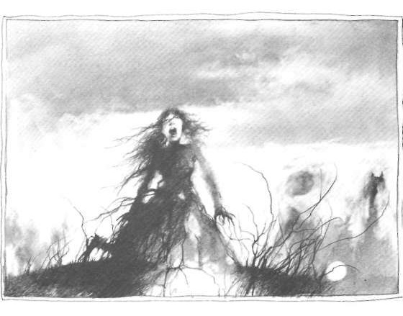
Sepulcretum
The graveyard

[scariness rating: 3/10 – not enough for Sappho]

translated and put into dialogue form
by Keegan Dunn
Unā nocte, apud convivium:

Marcus: Sepulcretum non procul ā nobīs est.

Laura: O! Ita! Sepulcretum! Sepulcretum prope est! Sepulcretum mē terret!

Marcus: Sepulcretum quoque mē terret. Noctē, numquam in sepulcretō sta!

Laura: Cur noctē in sepulcretō stāre non debeō?

Marcus: Quia, noctē, homo mortuus manum suum ex terrā tendet…

Laura: Vae!!!

Marcus: Homo mortuus manum suum tendet et tē capiet!

Laura: Fabula tua mē terret!

Marcus: Est fabula vera.

Laura: Vera non est! Est fabula falsa!

Marcus: Immo, vera fabula est.

Laura: Sed hominēs mortuī movēre non possunt! Mortuī sunt, O puer stulte!

Marcus: Age! Age ad sepulcretum! Age et sta in sepulcretō!

Laura: Ita ad sepulcretum eō! Fabula tua stulta est. Tū stultus es.

Marcus: Habe hoc cultrum. Pone cultrum in terram sepulcretī.

Laura: Cur vīs mē cultrum in terram sepulcretī ponere?

Marcus: Quia non tēcum eō, et cultrum in terrā probābit tē illīc fuisse.

Laura: Da mihi cultrum, O timide puer.

Marcus cultrum Laurae dat.

Laura: Vale, timide!

Marcus: Vale, insana!

Laura discedit et ad sepulcretum ambulat. Vidēre non bene potest, quia nox est. Timet, sed in mediō sepulcretō stat et cultrum in terram ponit.

Laura expectat. Homo mortuus nullus eam capit. Laura conatur discedere…sed non potest. Iterum conatur discedere, sed movēre non potest. Laura perterritus est.

Laura: Vae! Ambulāre non possum! Vae! Aliquis mē tenet! Iuvā mē! Iuvā mē!

Mane, Marcus Lauram in scholā non videt. Post scholam, Marcus ad sepulcretum it.

Laura mortua illīc est. Ea posuerat cultrum per gunnam [skirt] suam in terram. Nemō eam cēperat, sed tam valdē perterrita erat ut morerētur.
ā: by/away from
ad: toward/to
age: go! do!
aliquis: somebody
ambulāre: to walk
ambulat: walks
apud: next to/alongside/at
bene: well
capiet: co will grab
capit: grabs, snatches, takes
cēperat: co had grabbed
conatur: tried
convivium: party
cultrum: knife
cur: why?
da: give!
dat: co gives
debeō: I should
discedere: to leave
discedit: leaves
ea: she, those things
eam: her
eō: I go; with/by/etc him/it
erat: was
es: you are
est: is
et: and
ex: out from
expectat: waits
fabula: story/tale/fable
falsa: false, untrue
gunnam: skirt
habe: have! take!
hoc: this
hominēs: people
homo: human
illīc: there
immo: on the contrary
in: in/on/into
insana: insane
it: goes
ita: yeah
iterum: again
iuvā: help!
mane: morning, in the morning, stay!
manum: hand
mē: me
mediō: middle, the middle of
mihi: to me
mortua: dead
mortuī: dead
mortuus: dead
movēre: to move
nemō: nobody
nobīs: to/from/with/etc us
nocte: at night, in/by/during night
noctē: at night, with the night, etc
non: not
nox: night
nullus: no (as in "no coffee")
numquam: never
o: oh!
per: through
perterrita: real scared
perterritus: really afraid
pone: put!
ponere: to put
ponit: puts
possum: I can
possunt: can
post: behind a thing; after (in time)
posuerat: co had put
potest: can
probābit: will prove
procul: far away
prope: near
puer: boy
quia: because
quoque: also
scholā: by means of/in/on school
scholam: class; school
sed: but
sepulcretī: of the graveyard; graveyards
sepulcretō: to/with/by/etc graveyard
sepulcretum: graveyard
sta: stand!
stāre: to stand
stat: stands
stulta: stupid
stulte: O stupid!
stultus: stupid
suam: their own
sunt: they are
suum: their own
tam: so
tē: you
tēcum: with you (cum tē)
tendet: stretches
tenet: holds
terrā: on/with/by the earth
terram: land (acc)
terret: scares/terrorizes
timet: fears
timide: fearful; fearfully
tū: you
tua: your
unā: one; together
ut: so that/like
vae: ahh!
valdē: really, strongly
vale: bye!
vera: true; real
vidēre: to see
videt: sees
vīs: you want

"...will prove that you were there!"
"...that she died."

