Invasio Carnalum Virorum Turpum
(Invasion of the Gross Meat-Men)
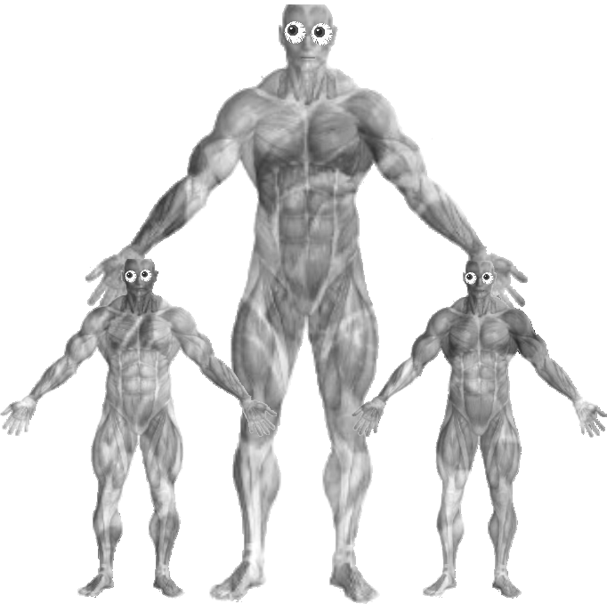
by zadek and keegan and mala
Olim, Zadekus et Keegus et Mala ambulant per Sylvam Umbrae. Duh duh duhhhhh! Subito vir salit de arbore! Dicit, "Sum carnalis vir, coruscans carnalis vir!" Zadekus dicit: "Iste vir ex carne factus est!" Mala ridet et respondet: "O Zadeke, omnēs hominēs ex carne factī sunt!" Sed Zadekus respondet: "Immo hic vir ex carne TURPE factus est!"

Carnalis vir salit in Malam et incipit ponere carnem turpem in eā! Mala incipit mutāre in carnem! Vae! "Non!" Mala clamat et currit ā carnale virō celere. Subitō, multī carnalēs virī saliunt ex arboribus et sequuntur Keegum et Zadekum ex sylvā.

Zadekus et Keegus currunt in oppidum et celant in arboribus. Interim Mala invenit fluvium et lintrem. Postquam Mala lintrem intrat, audit sonum inusitatum sub sē. Carnalis vir tam ingens tam turpis salit ex aquā et ruit lintrem Malae! Vae! Illō momentō, aliquis apparet ā tergō arboris et dicit, "Sum holus-femina! Fortis, fortis holus-femina!" Carnalis vir ingens ēst Malam et holus-feminam sed sapor non placet virō et vomit et spuit et barfit Malam et holus-feminam.

Mala cadit in fluvium. Holus-femina quoque cadit in fluvium. Quid agit carnalis vir!? Carnalis-vir esurit sed Mala et holus-femina non habent saporem bonum. Carnalis-vir ingens putat: "Hmmm, fortasse sapor hōrum hominum melior sit, si sal in eīs sint!" Carnalis-vir ingens ambulat secundum fluvium ad mare ut sal maris capiat. Interim, Zadekus et Keegus in arboribus bonum consilium habent: volunt iacere turpem, veterum carnem ad carnalēs-virōs ut carnalēs-virī ipsī turpēs fient. carnalēs-virī ā carnē pulsantur sed caro fit pars eōrum et iī fiunt maiorēs! Vae! Subitō, canis cui nomen est Khaleesi apparet et incipit manducāre crura carnalum-virōrum.

Khaleesi mordet pedēs ex corporibus carnalum-virōrum. Deinde, ēst corpora tota carnalum-virōrum! Khaleesi non curat utrum carnem bonum an turpem esse: Khaleesi ēst omnia! Sed nunc, Khaleesi crassa fit et non esurit. carnalis-vir ingens iam vivit et quaerit sal.

Deinde, Smokey apparet. Sed, estne Smokey satis magnus ut edat carnalem-virum tam ingentem? Ita. Smokey aperit os tam tam latē et ēst carnalem-virum ingentem unō morsō.
FINIS
ā: by/away from
ad: toward/to
agit: doing/does
aliquis: somebody
ambulant: walk
ambulat: walks
an: or; (sometimes just opens a yes/no question)
aperit: opens
apparet: appears
aquā: water
arbore: by means of/with the tree
arboribus: to/with/etc trees
arboris: of the tree
audit: co hears
barfit: (not a real latin word)
bonum: good
cadit: falls
canis: dog
capiat: may/might grab/snatch/take; let co grab/etc!
carnale: with/etc meaty/fleshy
carnalem: meaty/fleshy
carnalēs: meaty/fleshy
carnalis: meaty, of the meaty
carnalum: of the meaty (plural)
carne: with/etc flesh
carnē: with/etc flesh
carnem: flesh
caro: flesh
celant: hide
celere: quickly
clamat: shouts
consilium: plan/idea
corpora: bodies
corporibus: to/with/etc bodies
coruscans: flashing/glimmering/shining
crassa: fat
crura: lets
cui: to whom
curat: worries; takes care of
currit: runs
currunt: they run
de: down from/about
deinde: then...
dicit: says
eā: with/etc her
edat: co might/may eat; co eats
eīs: to/with/etc them (plural)
eōrum: of them
esse: to be; is
est: is
ēst: eats
estne: is...?
esurit: hungers; is hungry
et: and
ex: out from
factī: happened; made of
factus: made of; became
femina: woman
feminam: woman
fient: become
fit: becomes
fiunt: they become
fluvium: river
fortasse: maybe
fortis: strong; brave
habent: they have
hic: this
holus: veggie
hominēs: people
hominum: of people
hōrum: of these
iacere: to throw
iam: now/still/already
iī: they
illō: with/etc that
immo: on the contrary
in: in/on/into
incipit: begins
ingens: huge
ingentem: huge
interim: meanwhile
intrat: enters
inusitatum: unusual
invenit: finds
ipsī: those
iste: that
ita: yeah
latē: widely, broadly
lintrem: boat
magnus: big
maiorēs: bigger; older; greater
manducāre: to chew
mare: sea
maris: of the sea
melior: better
momentō: with/etc a moment
mordet: bites
morsō: with/etc a bite
multī: many; of much
mutāre: to change
nomen: name
non: not
nunc: now
o: oh!
olim: once upon a time, some time later
omnēs: everyone, all of the
omnia: everything, all of the
oppidum: town
os: mouth
pars: part
pedēs: feet
per: through
placet: is pleasing
ponere: to put
postquam: after
pulsantur: are punched/hit
putat: thinks
quaerit: looks for
quid: what
quoque: also
respondet: responds
ridet: laughs
ruit: destroys
sal: salt
salit: jumps
saliunt: jump
sapor: taste
saporem: taste
satis: enough, enough of
sē: he/she/itself (the subject of the sentence)
secundum: following; second; according to
sed: but
sequuntur: follow
si: if
sint: they may/might be; are; let them be
sit: may be, is
sonum: sound
spuit: spits
sub: under/beneath
subito: suddenly
subitō: suddenly
sum: I am
sunt: they are
sylvā: with/by/etc forest
sylvam: forest
tam: so
tota: entire
turpe: filthy, gross, ugly, rotten
turpem: filthy, gross, ugly, rotten
turpis: filthy, gross, ugly, rotten
umbrae: of/to the shade; shades
unō: with/on/to one
ut: so that/like
utrum: whether; (introduces an either/or question)
vae: ahh!
veterum: old
vir: man
virī: men; of a man
virō: to/with/etc the man
virōrum: of men
virōs: men
virum: man
vivit: lives
volunt: they want
vomit: vomits

