Week 6: Lab - Text Mining (Sentiment Analysis)

Alex Koener

2/28/21

# Instructions

Conduct sentiment analysis on MLK’s speech to determine how positive/negative his speech was. Split his speech into four quartiles to see how that sentiment changes over time.Create two bar charts to display your results.

# Add your library below.  
  
library(XML)  
library(tidyverse)  
library(tm)

# Step 1 - Read in the positive and negative word files

## Step 1.1 - Find the files

Find two files (one for positive words and one for negative words) from the UIC website. These files are about halfway down the page, listed as “A list of English positive and negative opinion words or sentiment words”. Use the link below:

* <http://www.cs.uic.edu/~liub/FBS/sentiment-analysis.html>

Save these files in your “data” folder.

# No code necessary; Save the files in your project's data folder.

## Step 1.2 - Create vectors

Create two vectors of words, one for the positive words and one for the negative words.

# Write your code below.  
  
pos <- "data/pos-words.txt"  
neg <- "data/neg-words.txt"  
p <- scan(pos, character(0), sep="\n")  
n <- scan(neg, character(0), sep="\n")  
head(p, 50)

## [1] ";;;;;;;;;;;;;;;;;;;;;;;;;;;;;;;;;;;;;;;;;;;;;;;;;;;;;;;;;;;;;;;;;;;;;;;;;;;;"   
## [2] "; "   
## [3] "; Opinion Lexicon: Positive"   
## [4] ";"   
## [5] "; This file contains a list of POSITIVE opinion words (or sentiment words)."   
## [6] ";"   
## [7] "; This file and the papers can all be downloaded from "   
## [8] "; http://www.cs.uic.edu/~liub/FBS/sentiment-analysis.html"   
## [9] ";"   
## [10] "; If you use this list, please cite the following paper:"   
## [11] ";"   
## [12] "; Minqing Hu and Bing Liu. \"Mining and Summarizing Customer Reviews.\" "   
## [13] "; Proceedings of the ACM SIGKDD International Conference on Knowledge "   
## [14] "; Discovery and Data Mining (KDD-2004), Aug 22-25, 2004, Seattle, "   
## [15] "; Washington, USA, "   
## [16] "; Notes: "   
## [17] "; 1. The appearance of an opinion word in a sentence does not necessarily "  
## [18] "; mean that the sentence expresses a positive or negative opinion. "   
## [19] "; See the paper below:"   
## [20] ";"   
## [21] "; Bing Liu. \"Sentiment Analysis and Subjectivity.\" An chapter in "   
## [22] "; Handbook of Natural Language Processing, Second Edition, "   
## [23] "; (editors: N. Indurkhya and F. J. Damerau), 2010."   
## [24] ";"   
## [25] "; 2. You will notice many misspelled words in the list. They are not "   
## [26] "; mistakes. They are included as these misspelled words appear "   
## [27] "; frequently in social media content. "   
## [28] ";"   
## [29] ";;;;;;;;;;;;;;;;;;;;;;;;;;;;;;;;;;;;;;;;;;;;;;;;;;;;;;;;;;;;;;;;;;;;;;;;;;;;"   
## [30] "a+"   
## [31] "abound"   
## [32] "abounds"

head(n, 50)

## [1] ";;;;;;;;;;;;;;;;;;;;;;;;;;;;;;;;;;;;;;;;;;;;;;;;;;;;;;;;;;;;;;;;;;;;;;;;;;;;;;"  
## [2] "; "   
## [3] "; Opinion Lexicon: Negative"   
## [4] ";"   
## [5] "; This file contains a list of NEGATIVE opinion words (or sentiment words)."   
## [6] ";"   
## [7] "; This file and the papers can all be downloaded from "   
## [8] "; http://www.cs.uic.edu/~liub/FBS/sentiment-analysis.html"   
## [9] ";"   
## [10] "; If you use this list, please cite the following paper:"   
## [11] ";"   
## [12] "; Minqing Hu and Bing Liu. \"Mining and Summarizing Customer Reviews.\" "   
## [13] "; Proceedings of the ACM SIGKDD International Conference on Knowledge "   
## [14] "; Discovery and Data Mining (KDD-2004), Aug 22-25, 2004, Seattle, "   
## [15] "; Washington, USA, "   
## [16] ";"   
## [17] "; Notes: "   
## [18] "; 1. The appearance of an opinion word in a sentence does not necessarily "  
## [19] "; mean that the sentence expresses a positive or negative opinion. "   
## [20] "; See the paper below:"   
## [21] ";"   
## [22] "; Bing Liu. \"Sentiment Analysis and Subjectivity.\" An chapter in "   
## [23] "; Handbook of Natural Language Processing, Second Edition, "   
## [24] "; (editors: N. Indurkhya and F. J. Damerau), 2010."   
## [25] ";"   
## [26] "; 2. You will notice many misspelled words in the list. They are not "   
## [27] "; mistakes. They are included as these misspelled words appear "   
## [28] "; frequently in social media content. "   
## [29] ";"   
## [30] ";;;;;;;;;;;;;;;;;;;;;;;;;;;;;;;;;;;;;;;;;;;;;;;;;;;;;;;;;;;;;;;;;;;;;;;;;;;;;;"  
## [31] "2-faced"   
## [32] "2-faces"   
## [33] "abnormal"   
## [34] "abolish"   
## [35] "abominable"   
## [36] "abominably"   
## [37] "abominate"   
## [38] "abomination"   
## [39] "abort"   
## [40] "aborted"   
## [41] "aborts"   
## [42] "abrade"   
## [43] "abrasive"   
## [44] "abrupt"   
## [45] "abruptly"   
## [46] "abscond"   
## [47] "absence"   
## [48] "absent-minded"   
## [49] "absentee"   
## [50] "absurd"

## Step 1.3 - Clean the files

Note that when reading in the word files, there might be lines at the start and/or the end that will need to be removed (i.e. you should clean your dataset).

# Write your code below.  
  
p <- p[-1:-29]  
n <- n[-1:-30]  
head(p, 50)

## [1] "a+" "abound" "abounds" "abundance"   
## [5] "abundant" "accessable" "accessible" "acclaim"   
## [9] "acclaimed" "acclamation" "accolade" "accolades"   
## [13] "accommodative" "accomodative" "accomplish" "accomplished"   
## [17] "accomplishment" "accomplishments" "accurate" "accurately"   
## [21] "achievable" "achievement" "achievements" "achievible"   
## [25] "acumen" "adaptable" "adaptive" "adequate"   
## [29] "adjustable" "admirable" "admirably" "admiration"   
## [33] "admire" "admirer" "admiring" "admiringly"   
## [37] "adorable" "adore" "adored" "adorer"   
## [41] "adoring" "adoringly" "adroit" "adroitly"   
## [45] "adulate" "adulation" "adulatory" "advanced"   
## [49] "advantage" "advantageous"

head(n, 50)

## [1] "2-faced" "2-faces" "abnormal" "abolish"   
## [5] "abominable" "abominably" "abominate" "abomination"   
## [9] "abort" "aborted" "aborts" "abrade"   
## [13] "abrasive" "abrupt" "abruptly" "abscond"   
## [17] "absence" "absent-minded" "absentee" "absurd"   
## [21] "absurdity" "absurdly" "absurdness" "abuse"   
## [25] "abused" "abuses" "abusive" "abysmal"   
## [29] "abysmally" "abyss" "accidental" "accost"   
## [33] "accursed" "accusation" "accusations" "accuse"   
## [37] "accuses" "accusing" "accusingly" "acerbate"   
## [41] "acerbic" "acerbically" "ache" "ached"   
## [45] "aches" "achey" "aching" "acrid"   
## [49] "acridly" "acridness"

# Step 2: Process in the MLK speech

## Step 2.1 - Find and read in the file.

Find MLK’s speech on the AnalyticTech website. Use the link below:

* <http://www.analytictech.com/mb021/mlk.htm>

Read in the file using the XML package. Otherwise, cut and paste the document into a .txt file.

# Write your code below.  
  
mlkLocation <- URLencode("http://www.analytictech.com/mb021/mlk.htm")

## Step 2.2 - Parse the files

If you parse the html file using the XML package, the following code might help:

# Read and parse HTML file  
  
doc.html = htmlTreeParse('http://www.analytictech.com/mb021/mlk.htm',   
 useInternal = TRUE)  
  
# Extract all the paragraphs (HTML tag is p, starting at  
# the root of the document). Unlist flattens the list to  
# create a character vector.  
  
doc.text = unlist(xpathApply(doc.html, '//p', xmlValue))  
  
# Replace all \n by spaces  
doc.text = gsub('\\n', ' ', doc.text)  
  
# Replace all \r by spaces  
doc.text = gsub('\\r', ' ', doc.text)

# Write your code below, if necessary.  
  
doc.html = htmlTreeParse(mlkLocation, useInternal = TRUE)  
mlk = unlist(xpathApply(doc.html, '//p', xmlValue))  
mlk = gsub('\\n', '', mlk)  
mlk = gsub('\\r', ' ', mlk)

## Step 2.3 - Create a term matrix

Create a term matrix.

# Write your code below.  
  
words.vec <- VectorSource(mlk)  
words.corpus <- Corpus(words.vec)  
words.corpus

## <<SimpleCorpus>>  
## Metadata: corpus specific: 1, document level (indexed): 0  
## Content: documents: 26

words.corpus <- tm_map(words.corpus, content_transformer(tolower))

## Warning in tm_map.SimpleCorpus(words.corpus, content_transformer(tolower)):  
## transformation drops documents

words.corpus <- tm_map(words.corpus, removePunctuation)

## Warning in tm_map.SimpleCorpus(words.corpus, removePunctuation): transformation  
## drops documents

words.corpus <- tm_map(words.corpus, removeNumbers)

## Warning in tm_map.SimpleCorpus(words.corpus, removeNumbers): transformation  
## drops documents

words.corpus <- tm_map(words.corpus, removeWords, stopwords("english"))

## Warning in tm_map.SimpleCorpus(words.corpus, removeWords, stopwords("english")):  
## transformation drops documents

words.corpus

## <<SimpleCorpus>>  
## Metadata: corpus specific: 1, document level (indexed): 0  
## Content: documents: 26

tdm <- TermDocumentMatrix(words.corpus)  
mlkMatrix <- as.matrix(tdm)

## Step 2.4 - Create a list

Create a list of counts for each word.

# Write your code below.  
  
wordCounts <- rowSums(mlkMatrix)  
wordCounts <- sort(wordCounts, decreasing=TRUE)  
head(wordCounts)

## will freedom one ring dream let   
## 16 13 12 12 11 10

mlkWordcount <- length(wordCounts)

# Step 3: Positive words

Determine how many positive words were in the speech. Scale the number based on the total number of words in the speech. **Hint:** One way to do this is to use match() and then which().

# Write your code below.  
  
words <- names(wordCounts)  
matchedpWords <- match(words, p, nomatch=0)  
mpCounts <- matchedpWords[which(matchedpWords!=0)]  
totalPos <- length(mpCounts)  
  
totalPos

## [1] 29

totalPos / mlkWordcount

## [1] 0.1111111

# Step 4: Negative words

Determine how many negative words were in the speech. Scale the number based on the total number of words in the speech.  
**Hint:** This is basically the same as Step 3.

# Write your code below.  
  
wordsNeg <- names(wordCounts)  
matchednWords <- match(wordsNeg, n, nomatch=0)  
mnCounts <- matchednWords[which(matchednWords!=0)]  
totalNeg <- length(mnCounts)  
  
totalNeg

## [1] 24

totalNeg / mlkWordcount

## [1] 0.09195402

# Step 5: Get Quartile values

Redo the “positive” and “negative” calculations for each 25% of the speech by following the steps below.

## 5.1 Compare the results in a graph

Compare the results (e.g., a simple bar chart of the 4 numbers).  
For each quarter of the text, you calculate the positive and negative ratio, as was done in Step 4 and Step 5.  
The only extra work is to split the text to four equal parts, then visualize the positive and negative ratios by plotting.

The final graphs should look like below:  
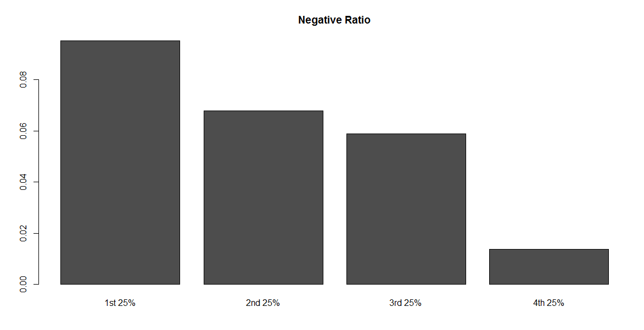 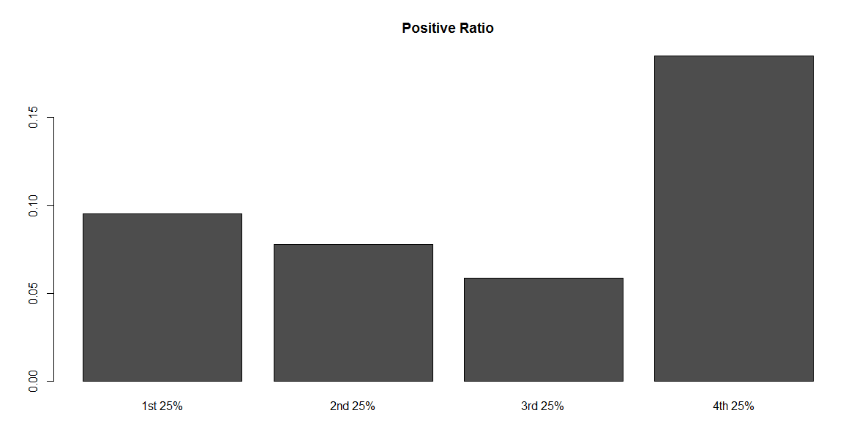

**HINT:** The code below shows how to start the first 25% of the speech. Finish the analysis and use the same approach for the rest of the speech.

# Step 5: Redo the positive and negative calculations for each 25% of the speech  
 # define a cutpoint to split the document into 4 parts; round the number to get an interger  
 cutpoint <- round(length(words.corpus)/4)  
   
# first 25%  
 # create word corpus for the first quarter using cutpoints  
 words.corpus1 <- words.corpus[1:cutpoint]  
 # create term document matrix for the first quarter  
 tdm1 <- TermDocumentMatrix(words.corpus1)  
 # convert tdm1 into a matrix called "m1"  
 m1 <- as.matrix(tdm1)  
 # create a list of word counts for the first quarter and sort the list  
 wordCounts1 <- rowSums(m1)  
 wordCounts1 <- sort(wordCounts1, decreasing=TRUE)  
 # calculate total words of the first 25%

# Write your code below.  
  
# Step 5: Redo the positive and negative calculations for each 25% of the speech  
 # define a cutpoint to split the document into 4 parts; round the number to get an interger  
 cutpoint <- round(length(words.corpus)/4)  
   
# First 25%  
words.corpus1 <- words.corpus[1:cutpoint]  
tdm1 <- TermDocumentMatrix(words.corpus1)  
m1 <- as.matrix(tdm1)  
wordCounts1 <- rowSums(m1)  
wordCounts1 <- sort(wordCounts1, decreasing=TRUE)  
length(wordCounts1)

## [1] 93

# Positive  
words1 <- names(wordCounts1)  
matchedpWords1 <- match(words1, p, nomatch=0)  
mpCounts1 <- matchedpWords1[which(matchedpWords1!=0)]  
totalPos1 <- length(mpCounts1)  
Q1P <- totalPos1 / length(wordCounts1)  
  
# Negative  
wordsNeg1 <- names(wordCounts1)  
matchednWords1 <- match(wordsNeg1, n, nomatch=0)  
mnCounts1 <- matchednWords1[which(matchednWords1!=0)]  
totalNeg1 <- length(mnCounts1)  
Q1N <- totalNeg1 / length(wordCounts1)  
  
  
# Second 25%  
words.corpus2 <- words.corpus[cutpoint+1:cutpoint*2]  
tdm2 <- TermDocumentMatrix(words.corpus2)  
m2 <- as.matrix(tdm2)  
wordCounts2 <- rowSums(m2)  
wordCounts2 <- sort(wordCounts2, decreasing=TRUE)  
length(wordCounts2)

## [1] 91

# Positive  
words2 <- names(wordCounts2)  
matchedpWords2 <- match(words2, p, nomatch=0)  
mpCounts2 <- matchedpWords2[which(matchedpWords2!=0)]  
totalPos2 <- length(mpCounts2)  
Q2P <- totalPos2 / length(wordCounts2)  
  
# Negative  
wordsNeg2 <- names(wordCounts2)  
matchednWords2 <- match(wordsNeg2, n, nomatch=0)  
mnCounts2 <- matchednWords2[which(matchednWords2!=0)]  
totalNeg2 <- length(mnCounts2)  
Q2N <- totalNeg2 / length(wordCounts2)  
  
  
# Third 25%  
words.corpus3 <- words.corpus[cutpoint*2+1:cutpoint*3]  
tdm3 <- TermDocumentMatrix(words.corpus3)  
m3 <- as.matrix(tdm3)  
wordCounts3 <- rowSums(m3)  
wordCounts3 <- sort(wordCounts3, decreasing=TRUE)  
length(wordCounts3)

## [1] 32

# Positive  
words3 <- names(wordCounts3)  
matchedpWords3 <- match(words3, p, nomatch=0)  
mpCounts3 <- matchedpWords3[which(matchedpWords3!=0)]  
totalPos3 <- length(mpCounts3)  
Q3P <- totalPos3 / length(wordCounts3)  
  
# Negative  
wordsNeg3 <- names(wordCounts3)  
matchednWords3 <- match(wordsNeg3, n, nomatch=0)  
mnCounts3 <- matchednWords3[which(matchednWords3!=0)]  
totalNeg3 <- length(mnCounts3)  
Q3N <- totalNeg3 / length(wordCounts3)  
  
  
# Fourth 25%  
words.corpus4 <- words.corpus[cutpoint*3+1:cutpoint*4]  
tdm4 <- TermDocumentMatrix(words.corpus4)  
m4 <- as.matrix(tdm4)  
wordCounts4 <- rowSums(m4)  
wordCounts4 <- sort(wordCounts4, decreasing=TRUE)  
length(wordCounts4)

## [1] 38

# Positive  
words4 <- names(wordCounts4)  
matchedpWords4 <- match(words4, p, nomatch=0)  
mpCounts4 <- matchedpWords4[which(matchedpWords4!=0)]  
totalPos4 <- length(mpCounts4)  
Q4P <- totalPos4 / length(wordCounts4)  
  
# Negative  
wordsNeg4 <- names(wordCounts4)  
matchednWords4 <- match(wordsNeg4, n, nomatch=0)  
mnCounts4 <- matchednWords4[which(matchednWords4!=0)]  
totalNeg4 <- length(mnCounts4)  
Q4N <- totalNeg4 / length(wordCounts4)  
  
  
# Graphing  
qPos <- c(Q1P, Q2P, Q3P, Q4P)  
qNeg <- c(Q1N, Q2N, Q3N, Q4N)  
df <- data.frame(qPos, qNeg)  
df$Qs <- c("Q1", "Q2", "Q3", "Q4")  
  
# Positive Graphing  
ggplot(df, aes(x=Qs, y=qPos)) +  
 geom_col() +  
 labs(title = "Positive Ratio")

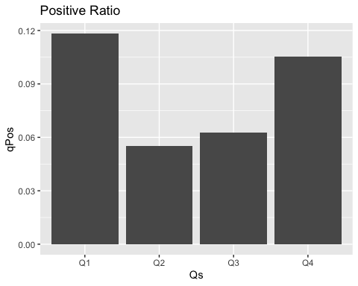

# Negative Graphing  
ggplot(df, aes(x=Qs, y=qNeg)) +  
 geom_col() +  
 labs(title = "Negative Ratio")

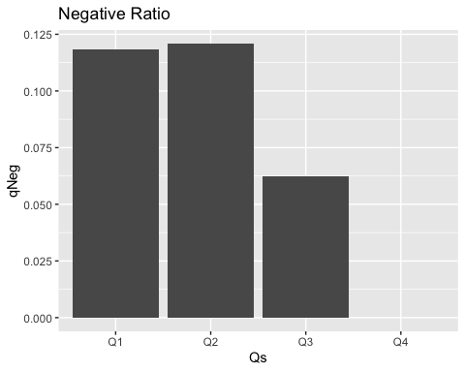

# 5.2 Analysis

What do you see from the positive/negative ratio in the graph? State what you learned from the MLK speech using the sentiment analysis results:

The positive graph shows that the speech started very positive, spiked to lowest, and slowly increased. The negative graph shows that the speech started very negative and then decreased. These results may imply that the speech started controversial, became negative, and ended positive.