r-viz-code.R

alexkoener

2021-03-14

library(ggplot2)  
library(tidyverse)

## ── Attaching packages ────────────────────────────── tidyverse 1.3.0 ──

## ✓ tibble 3.0.3 ✓ dplyr 1.0.2  
## ✓ tidyr 1.1.2 ✓ stringr 1.4.0  
## ✓ readr 1.3.1 ✓ forcats 0.5.0  
## ✓ purrr 0.3.4

## ── Conflicts ───────────────────────────────── tidyverse_conflicts() ──  
## x dplyr::filter() masks stats::filter()  
## x dplyr::lag() masks stats::lag()

library(reshape2)

##   
## Attaching package: 'reshape2'

## The following object is masked from 'package:tidyr':  
##   
## smiths

library(lattice)  
  
# Data wrangling -------------  
df1 <- read.csv("GoldSilver.csv")  
df1$X <- as.Date(df1$X)  
df1$date <- df1$X  
df1 <- df1[,-1]  
  
# Ggplot2 --------------------  
ggplot(df1, aes(x=date)) +  
 geom_line(color="red",aes(y=gold)) +  
 geom_line(aes(y=silver))

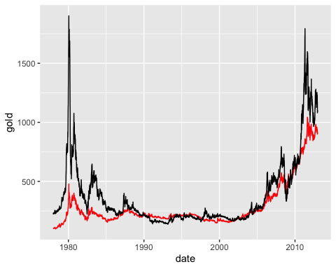

## Base Plot -----------------  
plot(x=df1$date, y=df1$silver, type = "l", xlab = "Year", ylab = "Silver Price")+  
lines(x=df1$date, y=df1$gold, type = "l", xlab = "Year", ylab = "Gold Price", col="red")

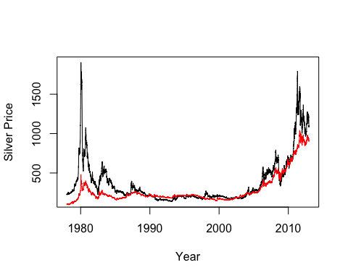

## integer(0)

## Lattice -------------------  
xyplot(gold+silver~date, data = df1, type="l")

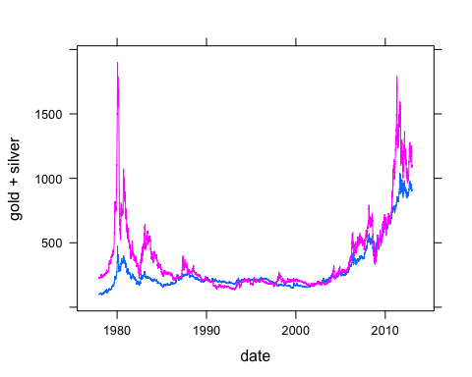

## Analysis/Conclusion -------  
  
 # All graphs feature gold and silver prices 1977-2012.  
 # Ggplot is best for displaying complicated data due to its wide range of options and features.  
 # Lattice is best for quick and medium simple graphs.  
 # Base R plot is best for very simple and quick visualizations for understanding data.