time-series-stocks.R

alexkoener

2021-03-20

## Libraries ---------------------  
  
library(quantmod)

## Loading required package: xts

## Loading required package: zoo

##   
## Attaching package: 'zoo'

## The following objects are masked from 'package:base':  
##   
## as.Date, as.Date.numeric

## Loading required package: TTR

## Registered S3 method overwritten by 'quantmod':  
## method from  
## as.zoo.data.frame zoo

library(ggplot2)  
library(tidyquant)

## Loading required package: lubridate

##   
## Attaching package: 'lubridate'

## The following objects are masked from 'package:base':  
##   
## date, intersect, setdiff, union

## Loading required package: PerformanceAnalytics

##   
## Attaching package: 'PerformanceAnalytics'

## The following object is masked from 'package:graphics':  
##   
## legend

## ══ Need to Learn tidyquant? ══════════════════════════════════════  
## Business Science offers a 1-hour course - Learning Lab #9: Performance Analysis & Portfolio Optimization with tidyquant!  
## </> Learn more at: https://university.business-science.io/p/learning-labs-pro </>

## Data + Cleaning ---------------  
  
loadSymbols(c("AMZN","GOOG","BABA", "GME"))

## 'getSymbols' currently uses auto.assign=TRUE by default, but will  
## use auto.assign=FALSE in 0.5-0. You will still be able to use  
## 'loadSymbols' to automatically load data. getOption("getSymbols.env")  
## and getOption("getSymbols.auto.assign") will still be checked for  
## alternate defaults.  
##   
## This message is shown once per session and may be disabled by setting   
## options("getSymbols.warning4.0"=FALSE). See ?getSymbols for details.

## [1] "AMZN" "GOOG" "BABA" "GME"

GME <- as.data.frame(GME)  
GME$dates <- row.names(GME)  
head(GME)

## GME.Open GME.High GME.Low GME.Close GME.Volume GME.Adjusted  
## 2007-01-03 27.555 27.570 26.670 27.450 3981200 18.48209  
## 2007-01-04 27.615 28.050 27.410 27.705 4851600 18.65378  
## 2007-01-05 27.705 28.030 27.655 27.745 2687800 18.68072  
## 2007-01-08 27.750 27.840 27.060 27.250 2613600 18.34743  
## 2007-01-09 27.275 28.325 27.260 28.175 3217800 18.97023  
## 2007-01-10 28.120 28.360 27.935 28.320 1680000 19.06786  
## dates  
## 2007-01-03 2007-01-03  
## 2007-01-04 2007-01-04  
## 2007-01-05 2007-01-05  
## 2007-01-08 2007-01-08  
## 2007-01-09 2007-01-09  
## 2007-01-10 2007-01-10

plot(GME$GME.Adjusted, type = "l")

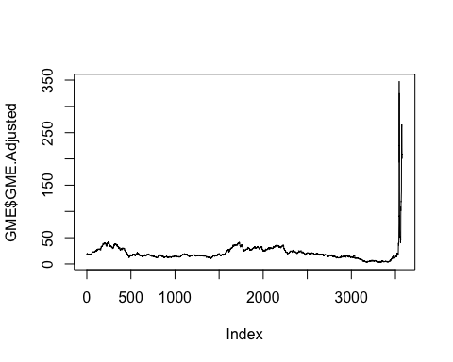

GMEindex <- c(3500:3578)  
  
  
## Visualizations --------------  
  
# Gamestop Candlesticks  
ggplot(GME[GMEindex,], aes(x=dates)) +  
 geom_candlestick(aes(middle=,  
 close=GME.Close,   
 open=GME.Open,  
 high=GME.High,  
 low=GME.Low)) +  
 theme(axis.text.x = element_text(angle = 90, vjust = 0.5, hjust=1))

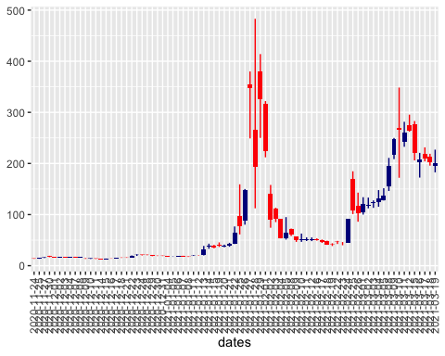

# Gamestop Line Graph + Colors  
ggplot(GME[GMEindex,], aes(x=dates, y=GME.Adjusted)) +  
 geom_line(aes(group=1, color=GME.Volume)) +  
 theme(axis.text.x = element_text(angle = 90, vjust = 0.5, hjust=10)) +  
 geom_point(aes(color=GME.Volume, size=GME.Volume)) +  
 labs(title = "Gamestop Stock Prices and Trade Volume",   
 x = "Date",  
 y = "Stock Price in USD",  
 color = "Trade Volume",  
 size = "Trade Volume")

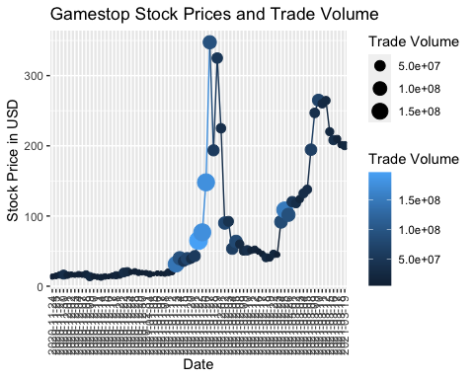

# Gamestop Bar Graph + Colors  
ggplot(GME[GMEindex,], aes(x=dates, y=GME.Adjusted)) +  
 geom_col(aes(fill=GME.Volume)) +  
 theme(axis.text.x = element_text(angle = 90, vjust = 0.5, hjust=10)) +  
 labs(title = "Gamestop Stock Prices and Trade Volume",   
 x = "Date",  
 y = "Stock Price in USD",  
 fill = "Trade Volume",  
 size = "Trade Volume")

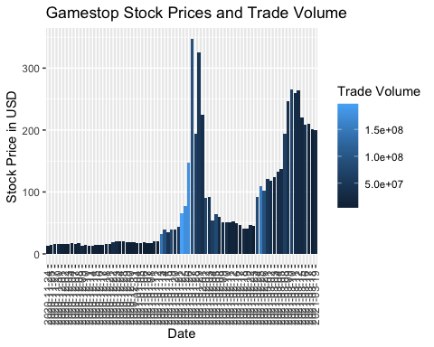

## Examples ----------------  
  
# Hotdogs Base R  
hotdogs <- read.csv("http://datasets.flowingdata.com/hot-dog-contest-winners.csv")  
head(hotdogs)

## Year Winner Dogs.eaten Country New.record  
## 1 1980 Paul Siederman & Joe Baldini 9.10 United States 0  
## 2 1981 Thomas DeBerry 11.00 United States 0  
## 3 1982 Steven Abrams 11.00 United States 0  
## 4 1983 Luis Llamas 19.50 Mexico 0  
## 5 1984 Birgit Felden 9.50 Germany 0  
## 6 1985 Oscar Rodriguez 11.75 United States 0

colors <- ifelse(hotdogs$New.record == 1, "darkred", "grey")  
barplot(hotdogs$Dogs.eaten, names.arg = hotdogs$Year, col=colors, border=NA,  
 main = "Nathan's Hot Dog Eating Contest Results, 1980-2010", xlab="Year", ylab="Hot dogs and buns (HDBs) eaten")

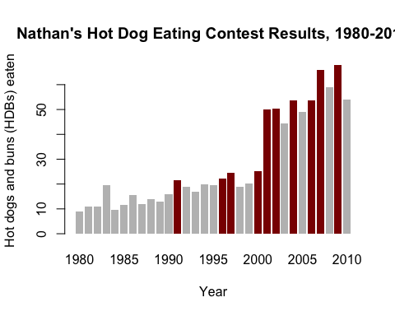

# Hotdogs ggplot  
ggplot(hotdogs) +  
 geom_bar(aes(x=Year, y=Dogs.eaten, fill=factor(New.record)), stat="identity") +  
 labs(title="Nathan's Hot Dog Eating Contest Results, 1980-2010", fill="New Record") +  
 xlab("Year") +  
 ylab("Hot dogs and buns (HDBs) eaten")

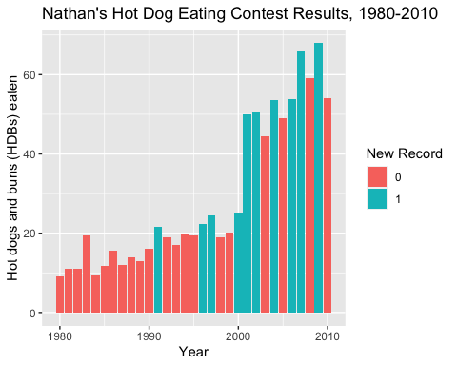

# Econ Base R  
head(economics)

## # A tibble: 6 x 6  
## date pce pop psavert uempmed unemploy  
## <date> <dbl> <dbl> <dbl> <dbl> <dbl>  
## 1 1967-07-01 507. 198712 12.6 4.5 2944  
## 2 1967-08-01 510. 198911 12.6 4.7 2945  
## 3 1967-09-01 516. 199113 11.9 4.6 2958  
## 4 1967-10-01 512. 199311 12.9 4.9 3143  
## 5 1967-11-01 517. 199498 12.8 4.7 3066  
## 6 1967-12-01 525. 199657 11.8 4.8 3018

year <- function(x) as.POSIXlt(x)$year + 1900  
economics$year <- year(economics$date) # we setting up our analysis  
head(economics)

## # A tibble: 6 x 7  
## date pce pop psavert uempmed unemploy year  
## <date> <dbl> <dbl> <dbl> <dbl> <dbl> <dbl>  
## 1 1967-07-01 507. 198712 12.6 4.5 2944 1967  
## 2 1967-08-01 510. 198911 12.6 4.7 2945 1967  
## 3 1967-09-01 516. 199113 11.9 4.6 2958 1967  
## 4 1967-10-01 512. 199311 12.9 4.9 3143 1967  
## 5 1967-11-01 517. 199498 12.8 4.7 3066 1967  
## 6 1967-12-01 525. 199657 11.8 4.8 3018 1967

plot1 <- qplot(date, unemploy / pop, data = economics, geom = "line")  
plot1

