Visual-Distribution-Analysis-code.R

alexkoener

2021-02-25

## Instructions -------------  
 # Create your own visual analytics based on Distribution analysis.  
 # The visual will follow our textbook recommendation to use grid to enhance the comparisons between scatter plots or your variables.  
  
  
## Packages -----------------  
library(tidyverse)

## ── Attaching packages ────────────────────────── tidyverse 1.3.0 ──

## ✓ ggplot2 3.3.2 ✓ purrr 0.3.4  
## ✓ tibble 3.0.3 ✓ dplyr 1.0.2  
## ✓ tidyr 1.1.2 ✓ stringr 1.4.0  
## ✓ readr 1.3.1 ✓ forcats 0.5.0

## ── Conflicts ───────────────────────────── tidyverse_conflicts() ──  
## x dplyr::filter() masks stats::filter()  
## x dplyr::lag() masks stats::lag()

## Code ---------------------  
  
carsDF <- as.data.frame(mtcars)  
  
  
## Visualizations -----------  
  
# Cylinders histogram.  
ggplot(carsDF, aes(x=cyl)) +  
 geom_histogram(bins = 5) +  
 labs(title="Cylinders Histogram", x="Cylinders in Car",y="Number of Cars")

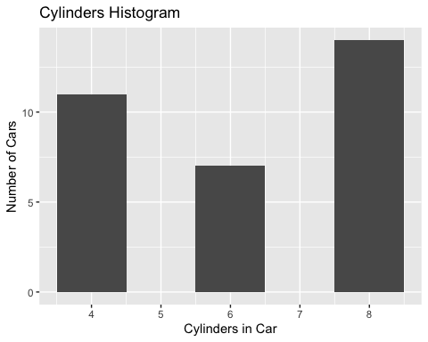

# Cylinders vs Horsepower boxplot.  
ggplot(carsDF, aes(x=cyl, y=hp, group=cyl)) +  
 geom_boxplot() +  
 labs(title="Cylinders vs Horsepower", x="Cylinders in Car",y="Horsepower")

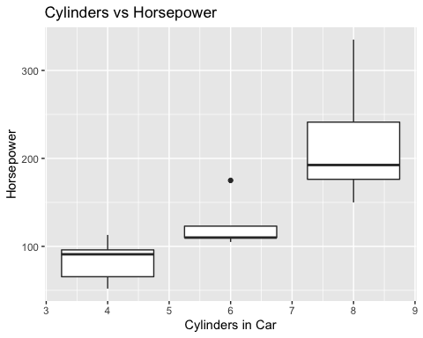

# Cylinders vs Weight boxplot.  
ggplot(carsDF, aes(x=cyl, y=wt, group=cyl)) +  
 geom_boxplot() +  
 labs(title="Cylinders vs Weight", x="Cylinders in Car",y="Weight in Thousands of Lbs")

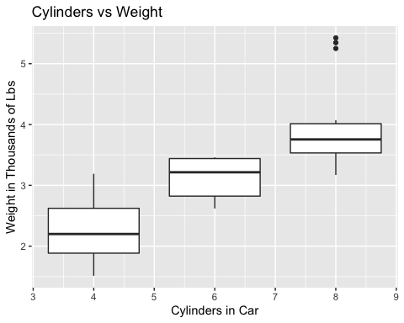

# Cylinders vs Miles per Gallon boxplot.  
ggplot(carsDF, aes(x=cyl, y=mpg, group=cyl)) +  
 geom_boxplot() +  
 labs(title="Cylinders vs Miles per Gallon", x="Cylinders in Car",y="Miles per Gallon")

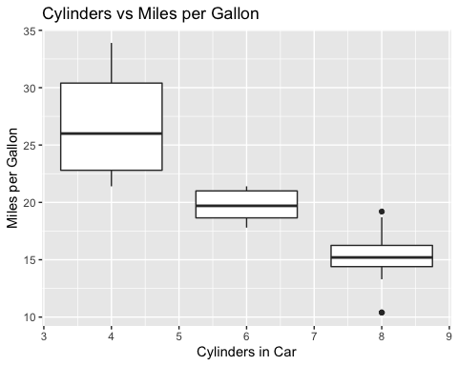

# Miles per Gallon vs Horsepower scatterplot.  
ggplot(carsDF, aes(x=mpg, y=hp)) +  
 geom_point() +  
 labs(title="Miles per Gallon vs Horsepower", x="Miles per Gallon",y="Horsepower")

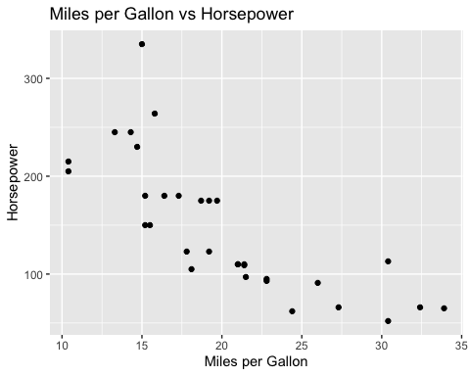

# Miles per Gallon vs Weight scatterplot.  
ggplot(carsDF, aes(x=mpg, y=wt)) +  
 geom_point() +  
 labs(title="Miles per Gallon vs Weight", x="Miles per Gallon",y="Weight")

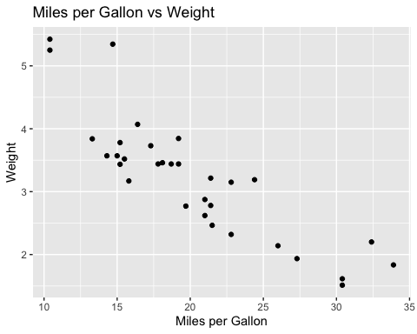

# Miles per Gallon vs Displacement scatterplot.  
ggplot(carsDF, aes(x=mpg, y=disp)) +  
 geom_point() +  
 labs(title="Miles per Gallon vs Displacement", x="Miles per Gallon",y="Displacement")

