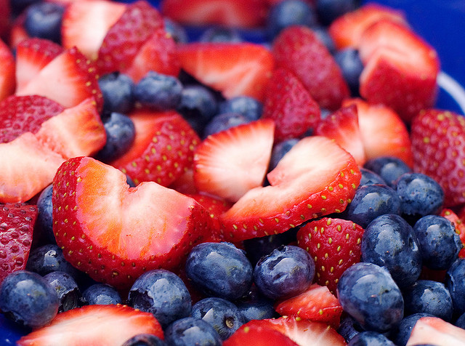

4 mei 2017

Koen van der heide, Thomas Reinders en rick beeloo

Plan Van aanpak

course 8a

***Introduction***

Anthocyanins are water-soluble vacuolar pigments that may appear in various colors depending on the pH. Besides coloration they play an important role in plants against reactive oxygen species caused by abiotic stresses such as overexposure to ultra-violet light and temperature. They also have potential in food value. Anthocyanins belong to a parent class of molecules called flavonoids synthesized via the phenylpropanoid pathway. The diversity of properties lead to a general question introduced by Anna Czerednik: “How to improve plants using secondary metabolites (anthocyanins)” This question was broken down into three more manageable questions: “Which plants produce anthocyanin(s) under stress?”, “Which genes regulate anthocyanin production?” and “Which circumstances effect anthocyanin production?” Translating these questions in bioinformatics questions: Which genes are coupled to the term “anthocyanin” in the NCBI gene database? To which organisms do these genes correspond? What conditions are mentioned in published articles concerning the previously found genes that have an influence on the expression of these genes? Our approach to answer these questions will consist of database searches in combination with text-mining.

***Material & methods***

We will determine which plants produce anthocyanin and which conditions might influence this production by first searching for genes known to be involved in anthocyanin production in general. The names of the genes found, combined with keywords indicating a conditional change, will then be searched for in biomedical research articles (PubMed database1) to discover known relationships between certain conditions and changes in gene expression levels.

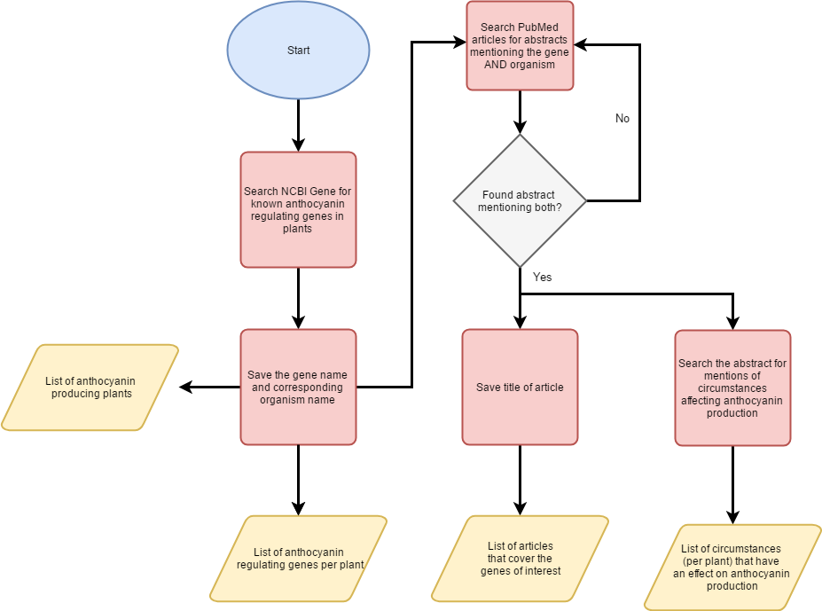

Figure1, **Flowchart**. This flowchart shows the different steps which will answer three questions: “Which plants produce anthocyanin(s)?”,”which genes regulate anthocyanin production?”, “Which circumstances effect anthocyanin production?”. A more detailed overview of “Search the abstract for mentions of circumstances affecting anthocyanin production” can be seen in **figure 2**.

Retrieval of anthocyanin genes

The NCBI Gene (Maglott, Ostell, Pruitt, & Tatusova, 2010) database will be searched for genes regulating anthocyanin expression under stress. To retrieve these genes the NCBI database will be queried with the terms “anthocyanin” coupled with “Embryophyta” so that only plants are found. This will result in a list of genes involved in anthocyanin regulation. Fortunately NCBI couples every gene to the organism in which it is present. Therefore the second research question: “Which plants produce anthocyanin under stress?” can be directly inferred from the gene list (assuming that a gene for anthocyanin is found, this plant will be either naturally or artificially capable to express this gene). This is not the only approach, another option would be the usage of text-mining where we search for gene names and stress conditions in individual articles. However we would prefer to not use text-mining to determine the relevant genes for several reasons. The first and most important reason is reliability, despite the advanced training methods a text mining algorithm will never fit every article. Basically these training approaches build a model from the input data and use this to search words/sentences which fit this model. However, there is no real “standard” nomenclature for writing articles, as a result some authors will use unorthodox words and/or unusual sentence structures, inevitably leading to false negatives. Secondly search time should be considered. The NCBI gene database has predefined keywords coupled to every gene (anthocyanin in this case). Consequently a search with keywords against this database is extremely fast whereas text-mining searches are proportional to the inputted text (the number of articles). Lastly text-mining is limited in the sense of data availability. These limitations are either due to PubMed or the article authors. For example PubMed only allows the retrieval of article titles, abstracts and keywords (due to transfer size). Even if we bypass this and download full articles we will be hindered by articles which are not freely accessible and significantly increase the search time (as the entire text of the article will be searched through). On the other hand the NCBI gene database isn’t limited regarding accessibility. To summarize we prefer to search for genes and organism using the NCBI gene database instead of PubMed (using text-mining) because of reliability, speed and accessibility.

Circumstances which influence anthocyanin expression

For this step we will search through biomedical articles in PubMed. Although we mentioned above that text-mining has its issues there is no alternative for finding the various stress conditions influencing anthocyanin expression. We will however undertake several steps to reduce the false positive rate. We know that the previously found genes are relatively reliable and using these while searching through PubMed will therefore reduce the amount of false positives. This will however limit the search terms used and could consequently introduce false negatives; genes which are not included in the NCBI gene database but are known in literature will not be found with this method.

We will now explain the whole “searching” step in more detail. We will first search for the gene names + organism name + anthocyanin in the PubMed database, adding the organism name is a necessity as the same gene name can be used for different organisms. If this doesn’t result in sufficient matches the search will be repeated but this time without the gene names, so only organism + anthocyanin. The resulting articles are then subjected to an algorithm which retrieves the title and abstract of the articles. Another algorithm will then search for sentences which contain words indicating some sort of circumstance (e.g. condition, while, under, during, etc.) and the word “anthocyanin”(***see figure 2****)*. From these sentences the conditions will be extracted and saved. 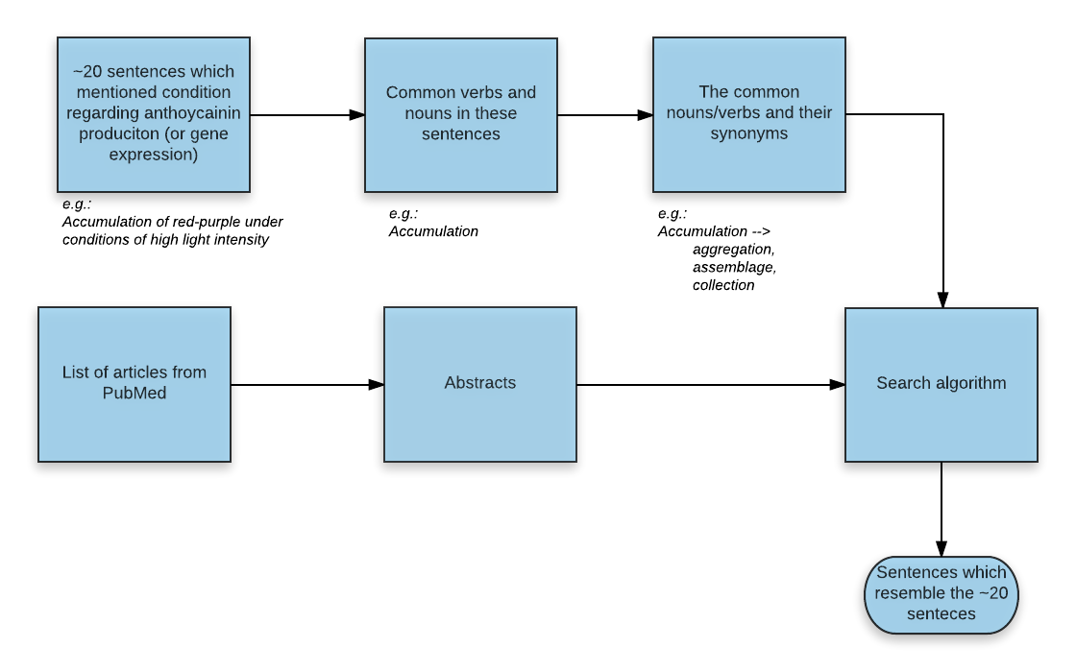

Figure2, **Detailed overview of abstract analysis**. We will first “train” our algorithm to detect sentences which could mention circumstances affecting anthocyanin production. This training will be done by manually selecting approximately 20 sentences which mention circumstances from random articles. Followed by noun and verb extraction (these are the most important words in a sentence). For every verb/noun synonyms will be retrieved to extend the word list but remaining the initial meaning. These words can then be used to search through all the abstracts and select sentences which resemble the 20 sentence used during training.

Data visualization

After the retrieval of the gene names, organism names and stress circumstances all the data will be visually coupled. This might result in a graph like this:

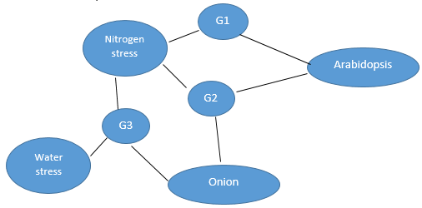

Figure3, **Expected visualization.** This figure shows the expected visualization in which all sub results are coupled into a single graph.

Table 1, **Expected Table**, This table shows the expected output (underlying the above graph)

|  |  |  |  |
| --- | --- | --- | --- |
| **Plant** | **Genes** | **Condition** | **Literature** |
| *Arabidopsis* | *G1*  *G2* | *Nitrogen stress*  *Nitrogen stress* | *Article x, article y*  *Article x* |
| *Onion* | *G3* | Nitrogen stress, Water stress | *Article z* |

***Steps***

The flowchart below shows the planned activities, each coloured area indicates activities belonging to the indicated product.

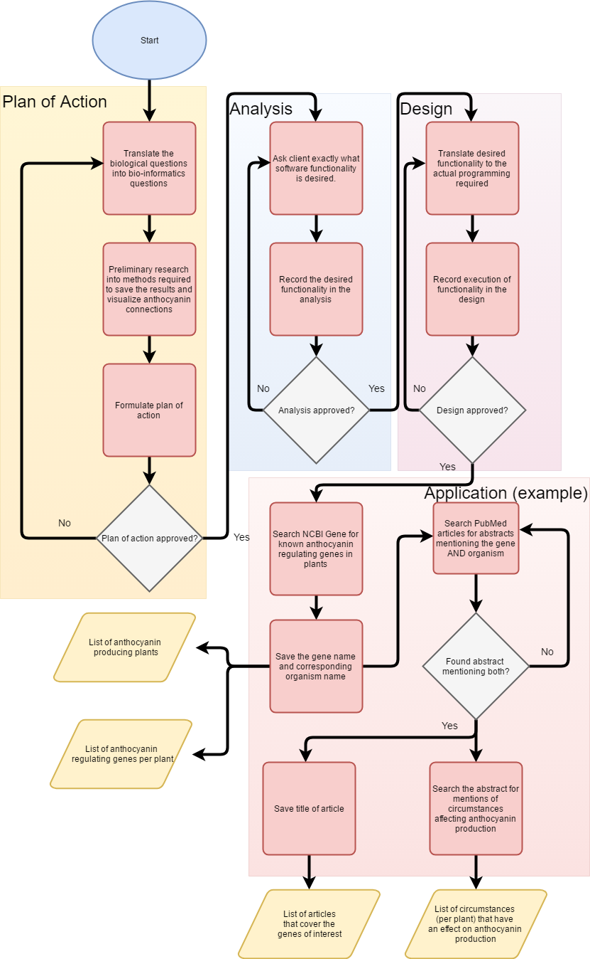

Figure 4, **Flowchart of planned activities.** This figure shows the planned activities, each coloured area indicates activities belonging to the indicated product.

The activities described in the above flowchart are also processed into a schedule:

Table 1: overview of time planning for the project, each product is a separate item to be made and reviewed, these products are split up into segments suitable for individual work that can be found under the “wat” column.

|  |  |  |  |  |
| --- | --- | --- | --- | --- |
| Product | Wat | Wie | Hoe lang (uren) | Week |
| Plan van aanpak | Inleiding | Thomas | 3 | 1 |
| Materiaal en Methode | Rick | 3 |
| Stappenplan | Koen | 3 |
| Analyse | Inleiding | Koen | 2 | 2 |
| Functionele/niet-functionele eisen | Koen | 4 |
| Use cases | Thomas | 5 |
| Architectuur | Rick | 4 |
| Ontwerp | Systeemarchitectuur | Thomas | 4 | 2-3 |
| Softwarearchitectuur | Rick | 5 |
| Technische gegevens structuur | Koen | 4 |
| Applicatie | Zoeken van juiste genen met bijbehorende organismes in NCBI Gene | Rick | 8 | 2-4 |
| Doorzoeken van PubMed artikelen op omstandigheden | Koen | 9 |
| SQL Database opzetten | Thomas | 8 |
| Genen, organismes en omstandigheden verbinden | Thomas | 9 | 4 |
| Gevonden genen, organismes en omstandigheden bruikbaar maken voor de visualisatie en database | Rick & Koen | 6 (elk) |
| Web interface (exclusief visualisatie) | Rick | 9 | 4-5 |
| Database vullen met resultaten | Thomas | 6 |
| Visualisatie van de resultaten | Koen | 8 |
| Poster | Inleiding | Koen | 4 | 5-6 |
| Methode | Rick | 4 |
| Resultaten | Thomas | 5 |
|  |  |  |  |  |

***References***

Maglott, D., Ostell, J., Pruitt, K. D., & Tatusova, T. (2010). Entrez Gene: gene-centered information at NCBI. Nucleic Acids Research, 39(Database).