## boxplot of Ra-226 (Bq/kg)

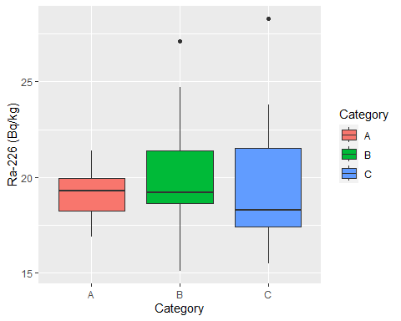

## boxplot of Th-232 (Bg/kg)

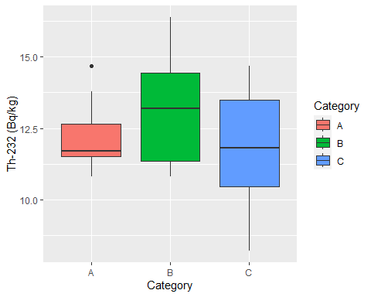

## boxplot of K-40 (Bq/kg

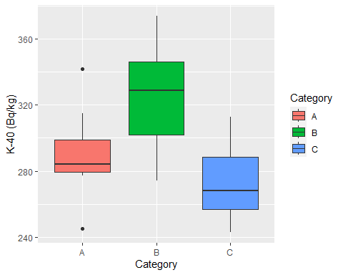

## boxplot of Cs-137 (Bq/kg

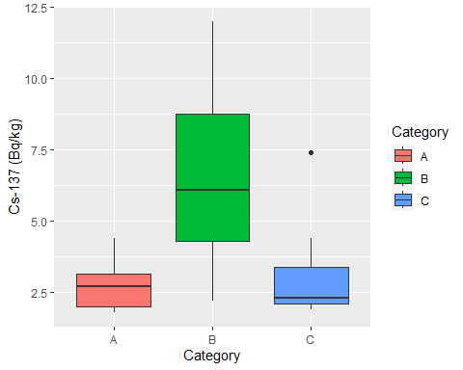

## surface plot of Cs-137 (Bq/kg)

