Data Preprocessing Report
Feature Engineering & Data Preprocessing | Loan Prediction Dataset (train: 614 rows, test: 367 rows)

1. Business problem and goal
Predict whether a home-loan application should be approved (Loan_Status). This report documents every preprocessing decision made to turn the raw application data into a machine-learning-ready dataset, and why. Code and outputs are in the accompanying notebook.

2. Data inspection – key observations
- 614 rows x 13 columns; no duplicate rows and no duplicate Loan_IDs.
- Seven columns have missing values: Credit_History 50 (8.1%), Self_Employed 32, LoanAmount 22, Dependents 15, Loan_Amount_Term 14, Gender 13, Married 3.
- Dependents is text because of the value “3+”; Credit_History and Loan_Amount_Term are floats that act as categories.
- Incomes and loan amounts are very right-skewed (applicant income skew 6.5, maximum 81,000 against a median of 3,812).
- The target is imbalanced: 68.7% approved.
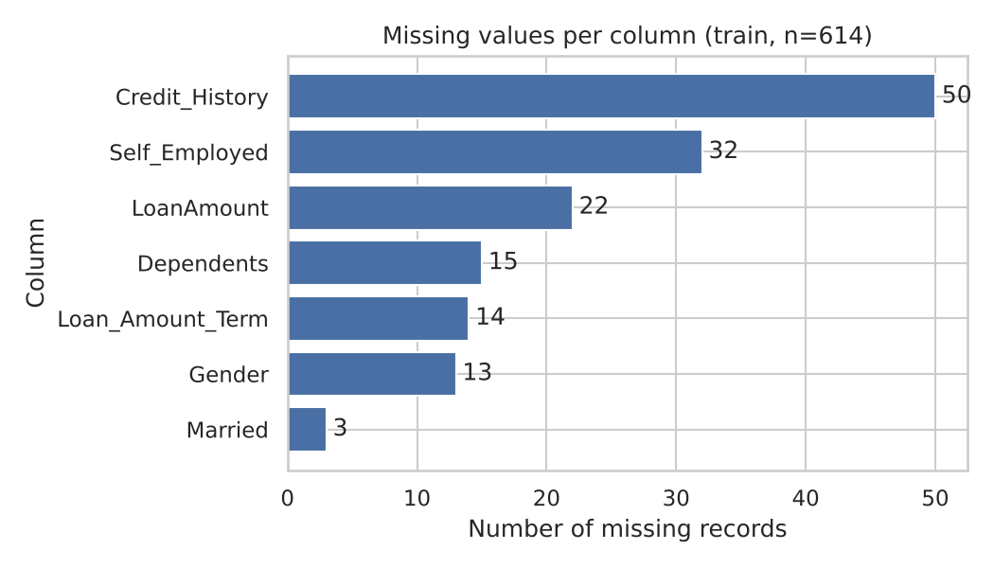
Figure 1 – Missing values per column

3. Data cleaning
Issue | Decision | Justification
Duplicates | Checked rows and Loan_ID; none removed | None existed; check kept in the pipeline
Column names | Renamed to descriptive snake_case (e.g. LoanAmount → loan_amount_k) | Clarity; unit (thousands) is now explicit
Dependents “3+” | Replaced with 3, converted to integer | Makes the ordinal count numeric; “3 or more” is a small approximation
Categorical missing (gender, married, dependents, self_employed) | Mode imputation | Preserves the category distribution; missingness is small
Credit_History missing (50) | Mode (1.0) + flag column credit_history_missing | Keeps rows; flag lets a model learn if “no record” is informative
Loan_Amount_Term missing (14) | Mode (360 months) | 85% of loans use 360 months
LoanAmount missing (22) | Median + flag column loan_amount_missing | Median is robust to very large loans
Types | Credit history, term, dependents → int | Correct data types

No rows were dropped: with only 614 records, deleting every row with a missing value would have discarded roughly a fifth of the data. After cleaning there were 0 missing values.

4. Feature engineering
New feature | Formula | Business rationale
total_income | applicant + co-applicant income | Households, not individuals, repay loans
has_coapplicant | co-applicant income > 0 | Captures dual-income applications
emi | loan amount x 1000 / term (months) | Approximate monthly instalment (interest ignored)
emi_to_income | emi / total income | Affordability of the instalment
loan_to_income | loan amount x 1000 / total income | Loan size relative to earning power
credit_history_missing, loan_amount_missing | missing-value flags | Retain information lost by imputation

Irrelevant feature removed: Loan_ID (unique identifier with no predictive value). The cleaned, human-readable dataset (614 x 19) was saved as loan_cleaned.csv.
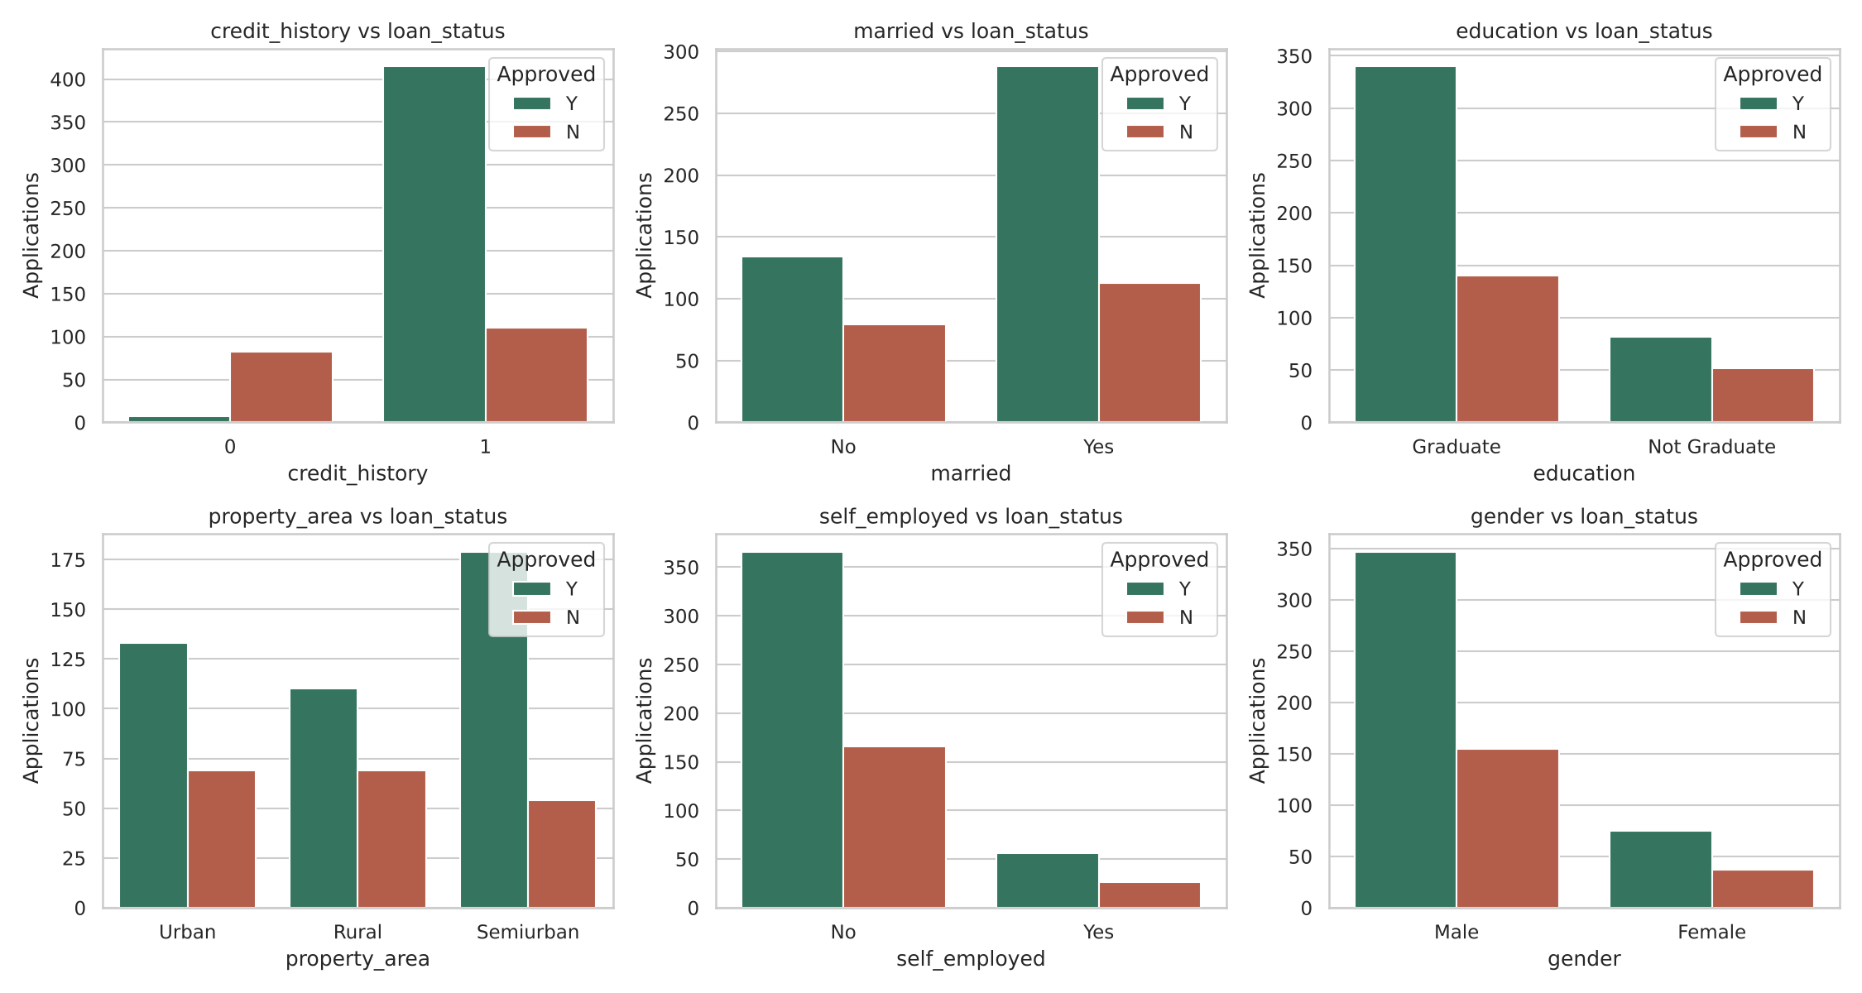
Figure 2 – Approval outcome by categorical feature (credit history shows the clearest separation)

5. Outlier detection and treatment
Outliers were detected with boxplots, the 1.5 x IQR rule and Z-scores. Counts of IQR outliers: applicant income 50, co-applicant income 18, total income 50, loan amount 41, EMI 50, EMI-to-income 51, loan-to-income 25. The extremes look like genuine high-income applicants, not entry errors, so deleting them would bias the model against high earners and shrink an already small dataset.
Treatment: (1) log1p transform to compress the skew, then (2) cap (winsorise) at the IQR bounds computed on the training data. Skewness fell from 6.5 to 0.5 for applicant income, 7.5 to -0.2 for co-applicant income, 2.7 to 0.04 for loan amount and 11.3 to 0.2 for EMI-to-income. No rows were removed.
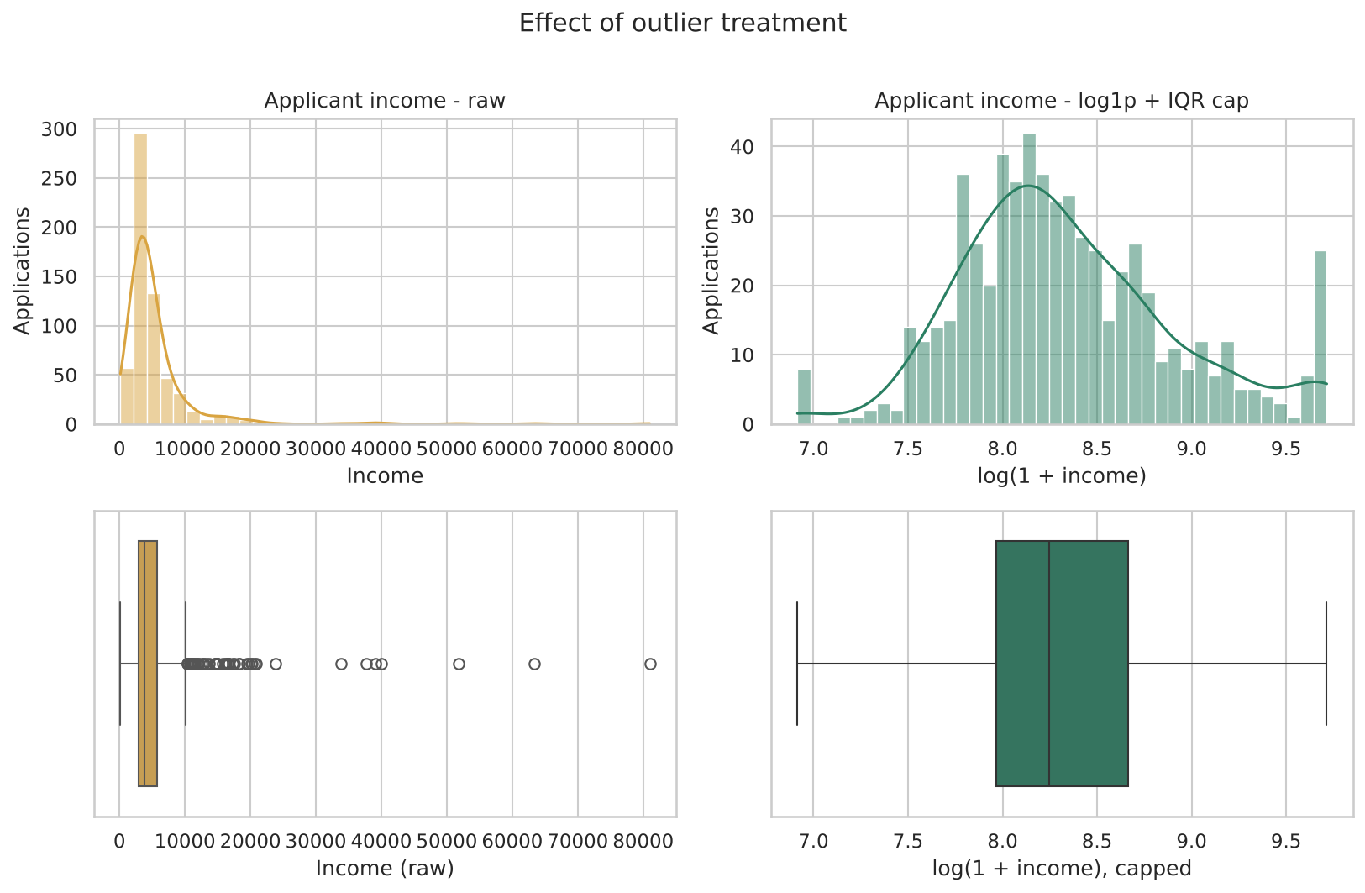
Figure 3 – Applicant income before and after log transform and IQR capping

6. Feature encoding
Feature | Technique | Why
loan_status (target) | Label encoding Y=1, N=0 | Numeric target, 1 = approved
gender, married, education, self_employed | Binary (0/1) label encoding | Two categories only: one column, no extra dimensions
property_area (Rural/Semiurban/Urban) | One-hot encoding, drop first | Nominal: no natural order, so integer labels would imply a false ranking; dropping one level avoids the dummy-variable trap
dependents | Kept as ordered integer 0–3 | Order is meaningful

7. Feature scaling
StandardScaler (mean 0, standard deviation 1) was applied to the continuous columns after the log transform and capping: applicant, co-applicant and total income, loan amount, EMI, EMI-to-income, loan-to-income, loan term and dependents. It was chosen because outliers were already handled (its main weakness), and distance- and gradient-based models such as logistic regression, KNN and SVM need comparable scales. RobustScaler would have been the choice had raw extremes been kept; MinMaxScaler was rejected because any remaining extreme value compresses the rest of the range. Binary and one-hot columns were left unscaled. The scaler parameters were learned on the training file only.

8. Feature selection
Three views were combined: a correlation heatmap, Random Forest importance and mutual information with the target.
- Most important: credit_history by a wide margin (RF importance 0.29, correlation with approval 0.54, mutual information 0.13). The affordability and income features follow in RF importance (about 0.09–0.10 each) but have weak linear correlation with the target (|r| < 0.06). Semiurban property area (r = 0.14), married and education carry modest signal.
- Highly correlated pairs (|r| > 0.80): has_coapplicant vs coapplicant_income_log (r = 0.99) and loan_amount_k_log vs emi_log (r = 0.88).
- Removed: has_coapplicant and loan_amount_k_log, the lower-importance member of each pair. No feature met all three “uninformative” criteria, so no others were dropped.
- Check: 5-fold cross-validated ROC-AUC of a logistic regression was 0.747 with all 19 candidate features and 0.746 with the 17 selected, so the removal costs nothing.
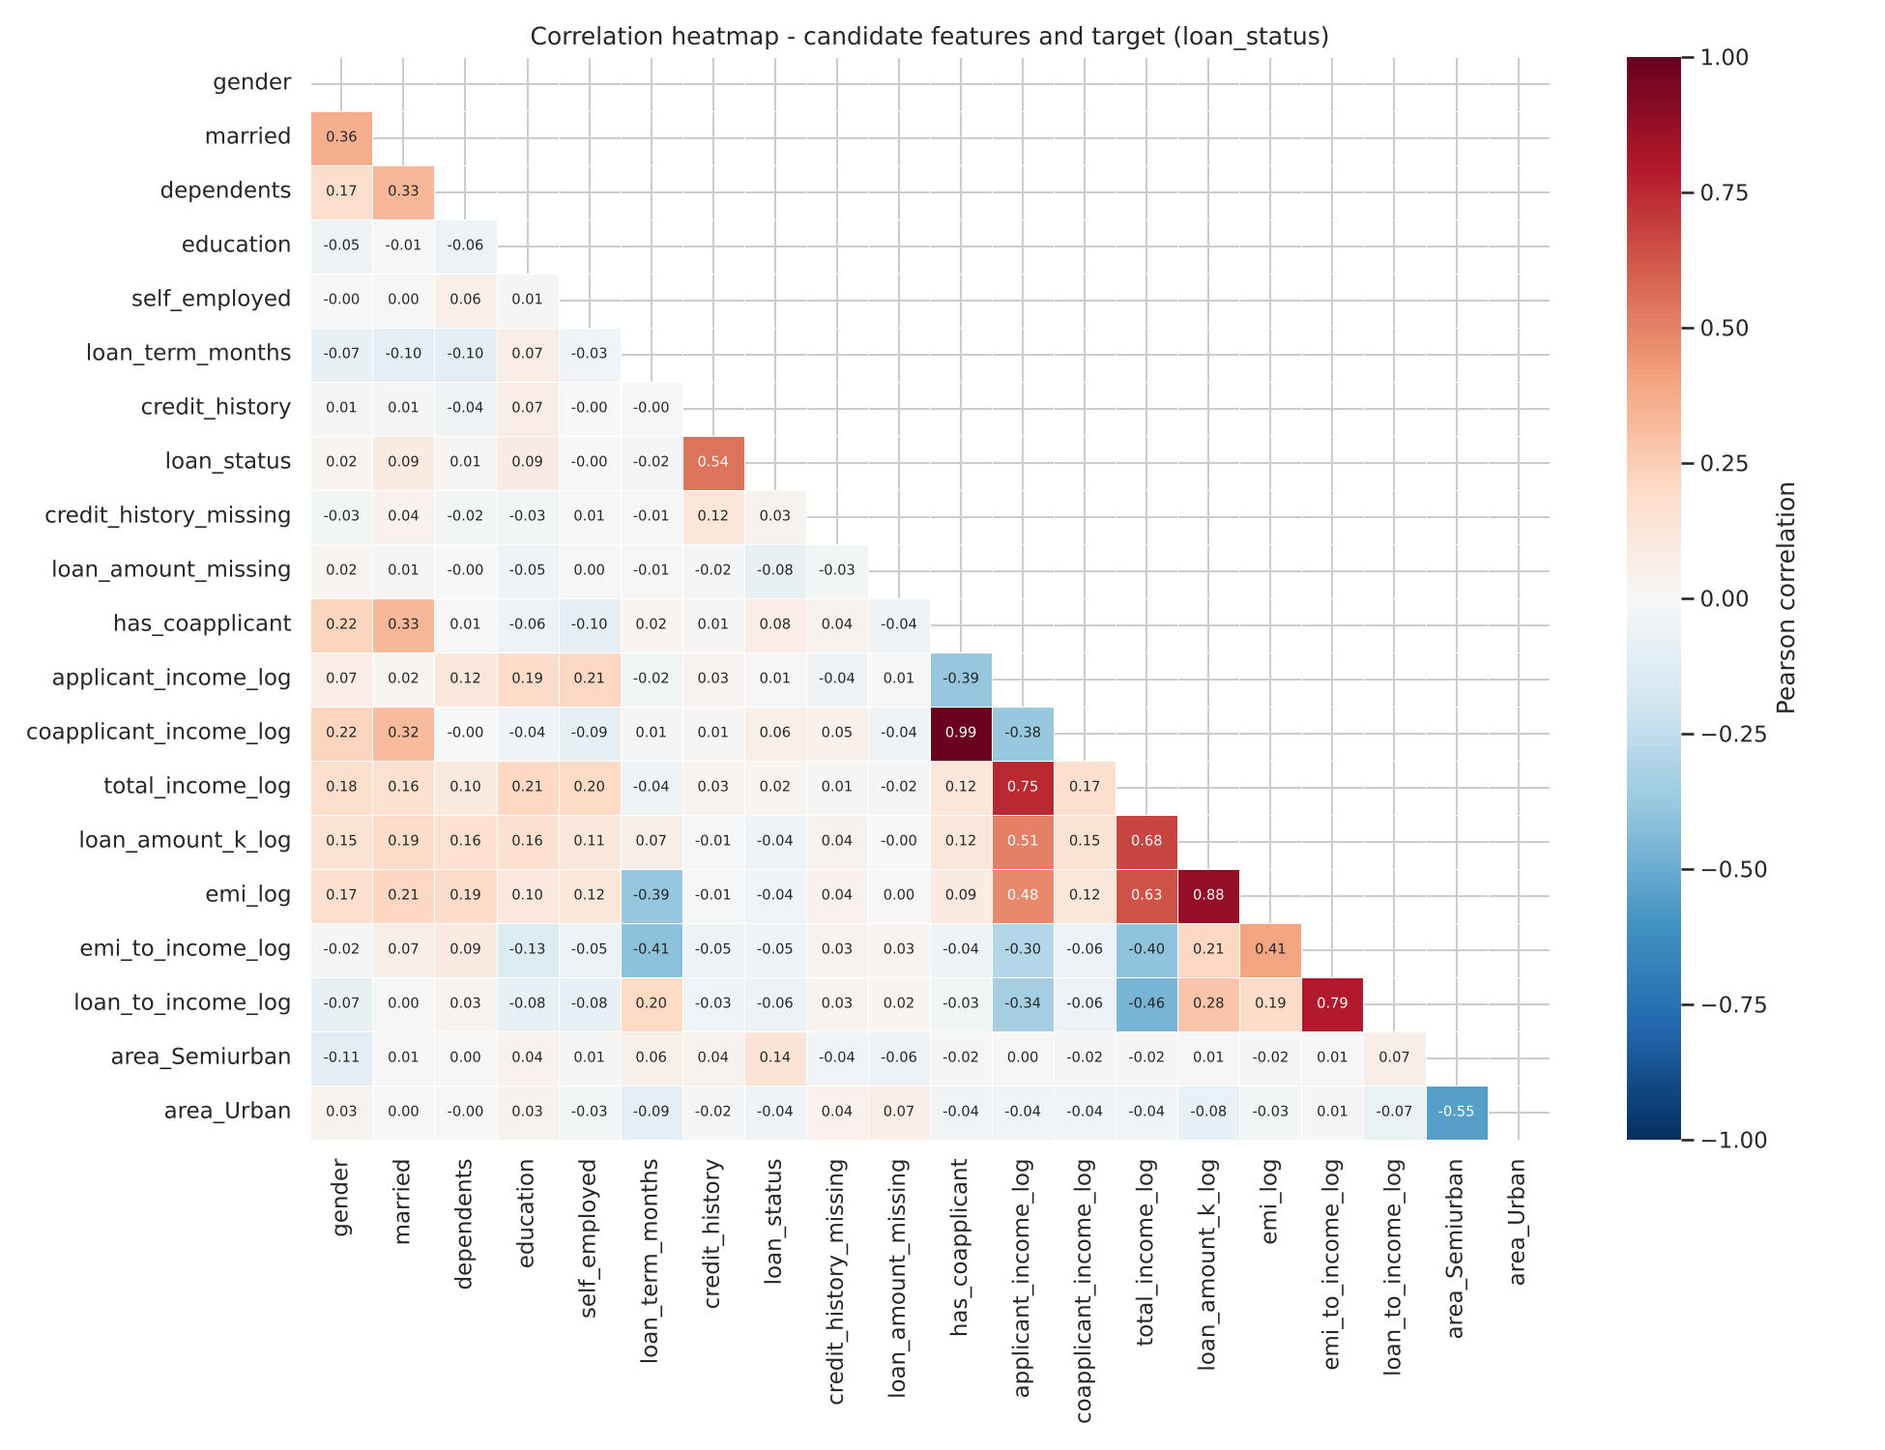
Figure 4 – Correlation heatmap of candidate features and the target
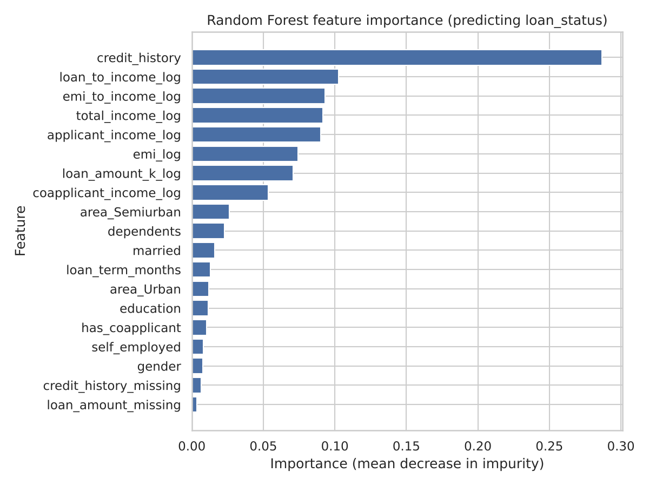
Figure 5 – Random Forest feature importance

9. Final machine-learning dataset
loan_ml_ready.csv: 614 rows x 18 columns (17 features + loan_status), no missing values, all numeric, identifiers removed, target 68.7% / 31.3%. The same pipeline, using only parameters learned on the training file, was applied to the 367-row test file (loan_ml_ready_test.csv, 17 features plus Loan_ID); re-running the pipeline on the training file reproduced the ML-ready features exactly.
Final feature group | Columns
Binary / ordinal | gender, married, dependents, education, self_employed, credit_history
Missing-value flags | credit_history_missing, loan_amount_missing
Scaled continuous | applicant_income_log, coapplicant_income_log, total_income_log, emi_log, emi_to_income_log, loan_to_income_log, loan_term_months
One-hot | area_Semiurban, area_Urban

10. Is the dataset ready for machine learning?
Yes. It is complete, numeric, scaled and free of identifiers or test-set leakage. Remaining caveats: (1) the target is imbalanced, so use stratified splits and ROC-AUC/F1; (2) imputation values, capping bounds and the scaler were fitted on the whole training file, so a full modelling project should refit them inside each cross-validation fold; (3) the dataset is small, which favours simple, regularised models.

