Inside The Chimera

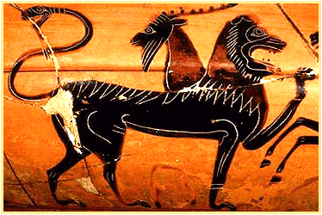

Tigran Mkrtchyan
dCache.ORG
2007

SQL Definitions

t_<name> database table
i_<name> index name
v_<name> view name
To exclude name clash with some key words in database implementations, all find name begins with 'i'.

Definitions

Inside this document following assumptions is used:

integer 32 bit natural number
long 64 bit natural number

Requirements

- Unique file ID independent from name
- Path  ID mapping
- Mechanism for clients to store metadata
- Directory tags, inherited by subdirectories
- Callbacks on FS events (at least on rm)
- platform independence ( runtime + persistent)
- custom dCache integration
- multiple front-ends running in parallel
- Extendable/pluggable front ends
- Extendable/pluggable ACL modules

Design

API
Event Manager
User Applications
ACL-Module
JDBC Driver
RDBMS
SQL Query Engine
FS Simulation
User level
System Level
Callback API
The basic idea behind Chimera is the FsInode which represent File System unit. FsInode supports all kind of operations which associated a file system. Each FsInode has a 36 character long unique id: first 4 character represent Instance ID and remaining 32 UUID. The Instance ID used to create a reference to remote instance. To be compliant with existing PnfsIDs, ChimeraIDs represented as one hex string. This allows to use Chimera as a namespace for dCache version >= 1.7.0. As a persistency level RBDMS was chosen. A modern RDBMS provides all necessary functionality as:

- Well known and widely used ( world wide expertise )
- Query language
- built in Backup/Recovery/Replication possibility
- fast
- consistency checks
- transaction isolation
- stored procedures and triggers

To keep compatibility with pnfs system Chimera supports several types of inodes:

inode | Regular file. Has 8 levels, where level 0 is the file data itself. Levels 1-7 can be used to store metadata associated with the file.
tags | A virtual file. The content of the file represents the list of tags associated with the directory.
ID | A virtual file. The content of the file represents the UUID of the file.
tag | A virtual file which represents a tag.
nameof | A virtual file. The content of the file represents the name of the file. In case of hard links, one of the possible names.
pathof | A virtual file. The content of the file represents the full name of the file.
pget
pset | A virtual file. Updating mtime of the file executes a command, depending on the arguments.
parent | A virtual file. The content of the file represents the UUID of the parent directory. In case of hard links, on of the possible parents.
const | A virtual file. The content of the file represents the come information about Chimera.

Please note, that only inode type is persistent.

The FsInode uses JdbcFs abstraction to keep the File system in a Relational Database. The JdbcFs is a low-level component which maps filesystem operations to SQL queries. Depending on RDBMS implementation, JdbcFs can use a vendor specific SQL engine or a generic one. While there is no internal concurrency management, only transactional databases have to be used. Chimera successfully tested on PostgreSQL 8.x and Oracle 10g. Never the less, pure JDBC implementation allows other databases to be used.

Table layout
The database schema based on Adjacency List Model with Domain Key Normal Form (DKNF).

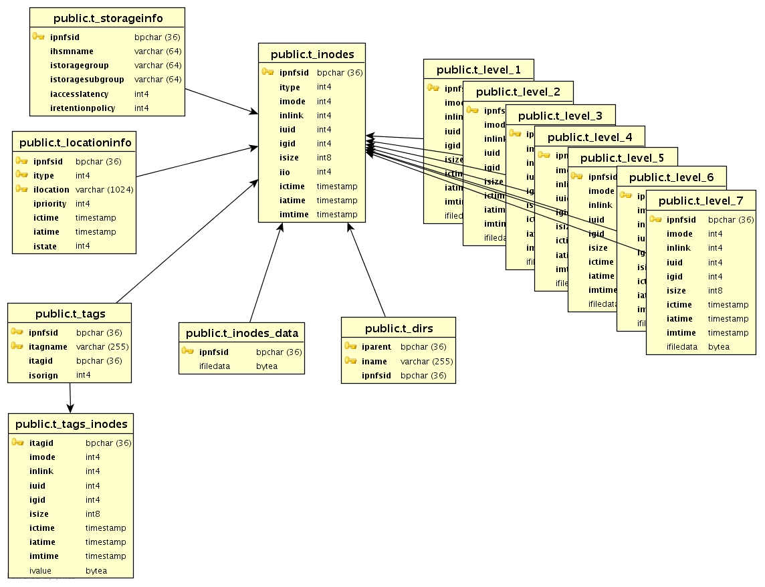

The core functionality is based on two tables: t_inodes and t_dirs, which represent the
list of inodes and files hierarchy, respectively.

Attribute | type | Description
ipnfsid | CHAR(36) | Inode ID
itype | integer | Inode type, e.g. File, directory, symlink and so on
imode | integer | Permission mode in UNIX notation. In future reference to ACL.
inlink | integer | The reference count. For a file number of known references within filesystem, for a directory – number of entries.
iuid | integer | Virtual user id.
igid | integer | Virtual group id.
isize | long | The file size. For a directory 512.
iio | integer | File IO flag. For all files have to be 0. If the file should be stored in the backend database, like config files, then 1.
ictime | long | File creation time in milliseconds.
iatime | long | File last access time in milliseconds. Never updated.
imtime | long | File last modification time in milliseconds.

One of the main differences with pnfs is that levels are created on demand.

dCache integration

Except basic namespace operations Chimera is able to provide storage and location information.

PnfsManager V3
Namespace
Operations
Cache
Locations
Storage(HSM)
Information
Namespace
provider
CacheInfo
provider
StorageInfo
Provider

Never the less, due to modularity of PnfsManager, some functionality can be delegated to external service. It's convenient to keep location information ( AKA cacheInfo ) in different database, allows not only to reduce the load of Chimeras backend database, but share the same namespace over multiple dCache instances.

Attribute | type | Description
ipnfsid | CHAR(36) | inode id
itype | integer | type of location e.g. DISK, TAPE and so on
ilocation | VARCHAR | the location
ipriority | integer
ictime | long | location creation time
iatime | long | location access time, not updated
istate | integer | location state, e.g. ON-LINE, OFF-LINE

The PnfsManager uses type=disk, istate=online to store/retrieve cacheLocation of a file.

Attribute | type | Description
ipnfsid | CHAR(36) | inode id
ihsmName | CHAR(64) | hsm name
istoraceGroup | CHAR(64)
istoraceSubGroup
iaccessLatency | integer | File access latency policy. ONLINE to keep the file on a fast media (disk) or NEAR-LINE to keep the file on a slow media ( tape).
iretentionPolicy | integer | File retention policy. CUSTODIAL for a safe media (tape) or OUTPUT for unsafe media ( disk )

The storageInfo used by dCache created based on location and storage informations.

Remote references

As mentioned before, the first 4 character of InodeId represent Instance ID. An Inode with special type RemoteRef indicates a link to a remote instance. The calls with like inode2path and path2inode have a field upto and startFrom to limit the scope of the operations. On the local fsid upTo and startFrom is always the root inode.

NFSv4.1 door

In addition to name space functionality, NFSv4.1 ( AKA pNFS ) gives possibility to provide native NFS access to dCache. The distributed architecture of NFSv4.1 and OPEN/CLOSE semantic fits well into design of dCache. In this perspective, Chimera with NFSv4.1 door takes the role of MDS, while pools becomes Storage Devices.

Hacking

New inode type:

To add a new inode type is necessary to add a FsInode_XXX class, adjust in JdbsFs.inodeOf () and add generation of new inode depending on NFS filehandle. The toFullString method is used for generation NFS filehandle, which return a string in the following format:

<fs id>:<inode type><inode id>:<type specific data>

References:

http://www.dcache.org
http://www-pnfs.desy.de
http://www.nfsv4-editor.org/drafts/drafts.html

ToBe implemented

The calls with like inode2path and path2inode have a field upto and startFrom to limit the scope of the operations. On the local fsid upTo and startFrom is always the root inode.

