Policy Memo: Why Limiting Climate Change Matters for Niger
To: Minister of Environment, Head of Niger’s UNFCCC delegation | From: KOUAME Koffi Fidèle, Climate Adviser
Date: 14 October 2026 | Subject: Climate risks for Niger and the case for limiting global warming

Key message
Models indicate that dangerous heat in Niger is projected to rise in every scenario, but far less if warming is limited: about 54 days a year by 2050 under Current policies against 45 under Below 2 °C (31 today), a gap that widens to 91 against 42 days by 2100. Extreme rainfall follows the same pattern, whereas severe drought is projected to affect almost all of the country by 2050 in all three scenarios. Niger therefore has a direct interest both in faster global emission cuts and in adaptation finance now.

Three priority impacts
Impact (CIE indicator) | Today (2020) | 2050  Net Zero 2050 | 2050  Below 2 °C | 2050  Current policies | 2100  Below 2 °C | 2100  Current policies
Dangerous heat: days per year with a daily maximum heat index above 40 °C | 31  [25 to 38] | 41  [29 to 60] | 45  [33 to 69] | 54  [41 to 84] | 42  [29 to 72] | 91  [59 to 134]
Severe drought: share of land with at least one month of SPEI below −1.5 | 84 %  [72 to 97] | 97 %  [82 to 100] | 99 %  [85 to 100] | 100 %  [96 to 100] | 98 %  [81 to 100] | 100 %  [98 to 100]
Extreme rainfall: annual maximum 5-day rainfall, change from 1995–2014 | +8 %  [−7 to +29] | +16 %  [−1 to +49] | +18 %  [0 to +55] | +24 %  [−1 to +67] | +17 %  [−1 to +54] | +43 %  [+5 to +110]
Table 1. Source: Climate Impact Explorer (Climate Analytics, 2026), Niger, annual values, area-weighted average. NGFS scenarios, with global warming in 2100 as given in the CIE data: Net Zero 2050 (1.3 °C), Below 2 °C (1.6 °C) and Current policies (2.9 °C). Median of five climate models (18 for extreme rainfall); 5–95 % range in brackets. The tool marks values after 2060 as indicative.
Dangerous heat. The indicator counts days on which the daily maximum heat index exceeds the “danger” threshold of 40 °C (Climate Analytics, 2026). By 2050, models project about 54 such days a year under Current policies, against 45 under Below 2 °C and 41 under Net Zero 2050; by 2100 the gap widens to 91 against 42 days. This matters because agriculture employs over 80 % of the population (World Bank, 2024), and farming and herding are outdoor work.
Severe drought. This indicator accounts for evaporation as well as rainfall. About 84 % of the land already experiences at least one month of severe drought a year; models project about 96 % by 2030 and 97 to 100 % by 2050 in all three scenarios, with largely overlapping ranges. On this indicator, limiting warming makes little difference before mid-century, so rain-fed millet, sorghum and pastures are likely to face more frequent water stress whatever the global outcome.
Extreme rainfall. The heaviest five-day rainfall of the year could intensify by about 24 % by 2050 under Current policies, against 18 % under Below 2 °C; by 2100 the projected change is +43 % against +17 %, although ranges are wide. Heavier downpours would raise flood risk in Niamey and the Niger River valley, where people, infrastructure and irrigated rice are concentrated.
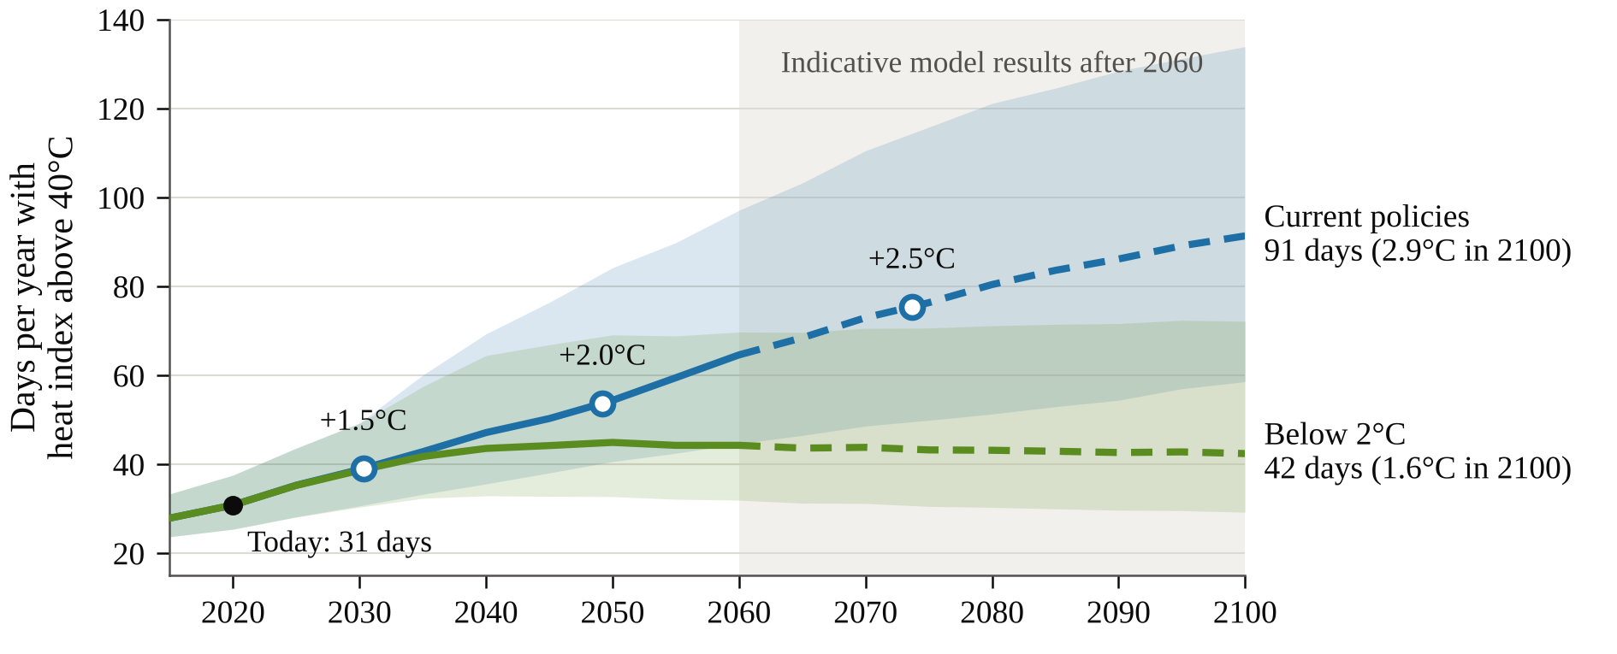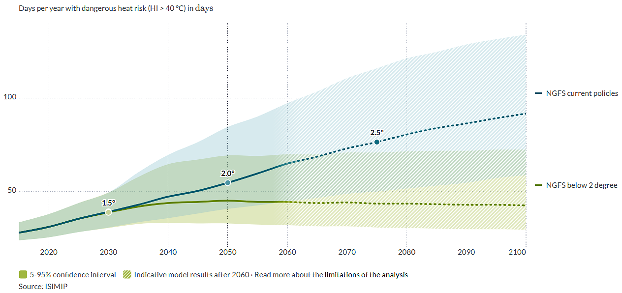
Figure 1. Days of dangerous heat per year in Niger under Below 2 °C and Current policies. The curves separate after 2030; the gap is what limiting warming avoids. Open circles mark the years in which global warming reaches +1.5 °C (about 2030), +2.0 °C (2049) and +2.5 °C (2074) under Current policies. Bands: 5–95 % model range; dashed lines: indicative results after 2060. Chart drawn from Climate Impact Explorer data (Climate Analytics, 2026).

Implications for Niger’s national interest
Compared with Current policies, Below 2 °C would avoid about 9 days of dangerous heat a year by 2050 and about 49 by 2100, and would limit the intensification of extreme rainfall to +17 % instead of +43 % by 2100. Of the three indicators, heat separates the scenarios most clearly: by 2100, even the low end of the Current policies range (59 days) lies above the central Below 2 °C value (42 days), whereas the rainfall ranges overlap. The World Bank estimates that climate change could reduce Niger’s annual GDP by 2.2 % in wetter scenarios and by 11.9 % in drier ones by 2050. It links extreme weather to low agricultural production, high food prices and food insecurity, and notes growing competition between farmers and pastoralists for scarce resources (World Bank, 2022). Because drought is projected to spread in every scenario, Niger should defend the 1.5 °C goal in the negotiations while seeking adaptation finance for drought-tolerant crops, water harvesting and early warning.

Uncertainty
These are projections, not forecasts, with wide model ranges; this memo emphasises 2050 because results after 2060 are indicative. The heat index relies on estimated humidity, and the drought indicator saturates. Given Niger’s high vulnerability, actual impacts may exceed what these hazard indicators suggest.

References
Climate Analytics (2026). Climate Impact Explorer: Niger. Indicators: days per year with dangerous heat risk (HI > 40 °C), area under severe drought (SPEI < −1.5) and annual maximum 5-day precipitation; NGFS Net Zero 2050, Below 2 °C and Current Policies scenarios; ISIMIP data. https://climate-impact-explorer.climateanalytics.org (accessed 9 October 2026).
World Bank (2022). G5 Sahel Region Country Climate and Development Report. CCDR Series. Washington, DC: World Bank. http://hdl.handle.net/10986/37620
World Bank (2024, 28 June). The World Bank supports food security and climate resilience for households in Niger [Press release, posted online 1 July 2024]. https://www.worldbank.org/en/news/press-release/2024/07/01/the-world-bank-supports-food-security-and-climate-resilience-for-households-in-niger

