Policy Memo | Why Limiting Climate Change Matters for Niger
To: Minister of Environment, Head of Niger’s UNFCCC delegation | From: KOUAME Koffi Fidèle, Climate Adviser
Date: 14 October 2026 | Subject: Climate risks for Niger and the case for limiting global warming

Summary
Niger faces a sharp rise in dangerous heat. Under current global policies, days of dangerous heat would increase from 31 a year today to 91 by 2100. Below 2 °C of warming, they would stay near 42. Severe drought will affect almost the whole country by 2030 in all scenarios. Niger should support rapid global emission cuts and seek adaptation finance now.

A. Situation
- Agriculture and livestock generate almost 40 % of GDP and over 80 % of jobs. Both depend on rainfall (World Bank, 2024).
- Climate shocks are already severe. The 2024 floods killed 339 people and affected 1.1 million (AFP, 2024).
- Niger’s emissions are negligible. Its exposure depends on the emissions of other countries.

B. Projected impacts
Impact (CIE indicator) | Today (2020) | 2100, below 2 °C | 2100, current policies
Dangerous heat (days per year with heat index above 40 °C) | 31  [25–38] | 42  [29–72] | 91  [59–134]
Severe drought (share of land with at least one month of SPEI below −1.5) | 84 %  [72–97] | 98 %  [81–100] | 100 %  [98–100]
Extreme rainfall (annual maximum 5-day rainfall, change from 1995–2014) | +8 %  [−7, +29] | +17 %  [−1, +54] | +43 %  [+5, +110]
Table 1. Source: Climate Impact Explorer, Niger, annual, area-weighted average. NGFS scenarios: 1.6 °C and 2.9 °C of global warming in 2100. Median of five models; 5–95 % range in brackets. Results after 2060 are indicative.
- Heat. Dangerous-heat days triple under current policies. The increase is twice as large in the populated south as in the north. Outdoor work becomes hazardous (Sylla et al., 2018).
- Drought. About 96 % of the land is affected by 2030 in all scenarios. Only a 1.5 °C pathway reduces this share (87 % by 2100). Millet yields are expected to fall (Mohamed et al., 2025).
- Rainfall. Extreme rainfall rises by 43 % under current policies, against 17 % below 2 °C. Flood risk grows in Niamey and the Niger River valley (Taylor et al., 2017).
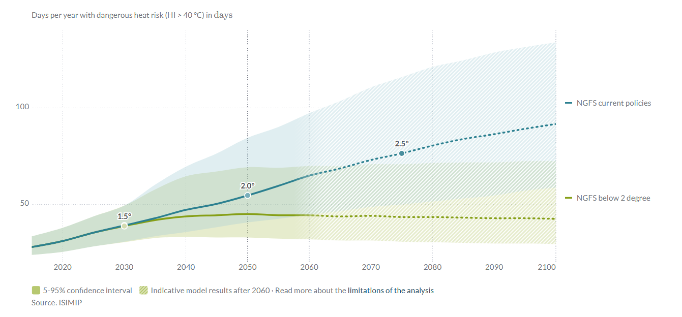
Figure 1. Days of dangerous heat per year in Niger. The two pathways separate after 2030. In 2100, the low end of the current-policies range (59 days) is above the central below-2 °C value (42 days). Source: Climate Impact Explorer, Climate Analytics.

C. Assessment
- Limiting warming below 2 °C avoids about 49 days of dangerous heat a year by 2100. It also cuts the rise in extreme rainfall from 43 % to 17 %. A 1.5 °C pathway keeps heat near today’s level.
- Climate change could reduce Niger’s annual GDP by 2.2 % to 11.9 % by 2050 (World Bank, 2022).
- Drought increases in all scenarios. Adaptation is therefore needed now, whatever the outcome of the negotiations.

D. Recommendations
- Support the 1.5 °C goal and national plans consistent with a rapid phase-out of fossil fuels.
- Link Niger’s support for any agreement to more adaptation finance, with simple access for Least Developed Countries.
- Seek support from the Loss and Damage Fund for droughts and floods, with the African Group and the LDC Group.
- At home, fund drought-tolerant millet and sorghum, water harvesting and early warning systems.

E. Limits of the analysis
- These figures are projections, not forecasts. Model ranges are wide, the drought indicator saturates, and the tool does not model millet or sorghum. Given Niger’s vulnerability, real impacts are likely to be larger.

References
AFP (2024, 9 October). Niger ups flood toll to 339 dead, more than 1 million affected. Inquirer.net. https://globalnation.inquirer.net/251812/niger-ups-flood-toll-to-339-dead-more-than-1-million-affected
Climate Analytics (2026). Climate Impact Explorer: Niger. Indicators: days per year with dangerous heat risk (HI > 40 °C), area under severe drought (SPEI < −1.5) and annual maximum 5-day precipitation; NGFS Below 2 °C, Current Policies and Net Zero 2050 scenarios; ISIMIP data. https://climate-impact-explorer.climateanalytics.org (accessed 9 October 2026).
Mohamed, A. M. L., Salack, S., Mkuhlani, S., Chemura, A., et al. (2025). Impact of climate change on millet yield under different fertilization levels in three agroecological zones of Niger Republic. PLOS ONE, 20(10), e0333963. https://doi.org/10.1371/journal.pone.0333963
Sylla, M. B., Faye, A., Giorgi, F., Diedhiou, A., & Kunstmann, H. (2018). Projected heat stress under 1.5 °C and 2 °C global warming scenarios creates unprecedented discomfort for humans in West Africa. Earth’s Future, 6(7), 1029–1044. https://doi.org/10.1029/2018EF000873
Taylor, C. M., Belušić, D., Guichard, F., Parker, D. J., Vischel, T., Bock, O., Harris, P. P., Janicot, S., Klein, C., & Panthou, G. (2017). Frequency of extreme Sahelian storms tripled since 1982 in satellite observations. Nature, 544, 475–478. https://doi.org/10.1038/nature22069
World Bank (2022). G5 Sahel Region Country Climate and Development Report. CCDR Series. Washington, DC: World Bank. http://hdl.handle.net/10986/37620
World Bank (2024, 28 June). The World Bank supports food security and climate resilience for households in Niger [Press release]. https://www.worldbank.org/en/news/press-release/2024/07/01/the-world-bank-supports-food-security-and-climate-resilience-for-households-in-niger

