Policy Memo | Why Limiting Climate Change Matters for Niger
Advice to the national delegation to the UNFCCC
To: Minister of Environment, Head of Niger’s UNFCCC delegation | From: KOUAME Koffi Fidèle, Climate Adviser
Date: 14 October 2026 | Subject: What Niger stands to lose, and what it gains if warming is limited
Key message
By 2100, current global policies would roughly triple the number of days on which heat becomes dangerous in Niger, from about 31 a year today to 91; holding warming below 2 °C would cap it at about 42. With more than 80 % of Nigeriens working outdoors in farming and herding, this is the largest loss that global mitigation can still prevent. The heaviest multi-day rains would also intensify far more under current policies (+43 %) than below 2 °C (+17 %). Severe drought, by contrast, reaches almost the whole country by 2030 in every scenario. Niger’s national interest is therefore twofold: press for a rapid global phase-out of emissions, and secure the finance to adapt now.

1. Why the stakes are unusually high for Niger
- An economy that works in the open air. Agriculture and livestock generate almost 40 % of GDP and over 80 % of employment, and depend overwhelmingly on rainfall (World Bank, 2024).
- Shocks that are already frequent and deadly. The 2005 and 2010 droughts triggered national food crises; the 2024 floods killed 339 people and affected more than 1.1 million (AFP, 2024).
- Exposure without responsibility. Niger emits a negligible share of global greenhouse gases. The losses described below are driven by other countries’ emissions and can only be limited by their cuts.

2. Three priority impacts, compared across scenarios
Source: Climate Impact Explorer (Climate Analytics), Niger, annual values, area-weighted average. NGFS “Below 2 °C” scenario (1.6 °C of global warming in 2100) versus “Current policies” (2.9 °C). Median of five climate models, with the 5–95 % model range in brackets; the tool flags results after 2060 as indicative.
Impact (CIE indicator) | Today (2020) | Below 2 °C | Current policies | Why it matters for Niger
1. Dangerous heat  Days per year with a heat index above 40 °C | 31 days  [25–38] | 2050: 45  [33–69]  2100: 42  [29–72] | 2050: 54  [41–84]  2100: 91  [59–134] | Beyond this threshold, sustained physical work exposes people to heat exhaustion and heat stroke, yet most Nigeriens farm, herd or build outdoors with little access to cooling. The tool’s maps show the increase is about twice as large in the densely populated south as in the north (+44 versus +21 days at 2 °C compared with 1 °C of global warming). WASCAL researchers already project heat discomfort for more than half of West Africa’s population at 1.5–2 °C (Sylla et al., 2018).
2. Severe drought  Share of land with at least one month of SPEI below −1.5 (%) | 84 %  [72–97] | 2050: 98 %  [85–100]  2100: 98 %  [81–100] | 2050: ≈100 %  [96–100]  2100: 100 %  [98–100] | Because SPEI accounts for evaporation as well as rainfall, it captures how heat dries out soils, crops and pastures. Around 96 % of the country is affected by 2030 in every scenario, so severe drought months become the norm whatever the world does; only a 1.5 °C pathway brings the share back down (87 % by 2100). WASCAL crop modelling projects declining millet yields in most scenarios (Mohamed et al., 2025).
3. Extreme rainfall  Annual maximum 5-day precipitation, change from 1995–2014 (%) | +8 %  [−7 to +29] | 2050: +18 %  [0 to +55]  2100: +17 %  [−1 to +54] | 2050: +24 %  [−1 to +67]  2100: +43 %  [+5 to +110] | Heavier downpours on bare, crusted soils produce the floods that strike Niamey and the Niger River valley, where people, infrastructure and irrigated rice are concentrated. Under current policies, even the low end of the model range shows an increase by 2100, and extreme Sahelian storms have already tripled in frequency since 1982 (Taylor et al., 2017).
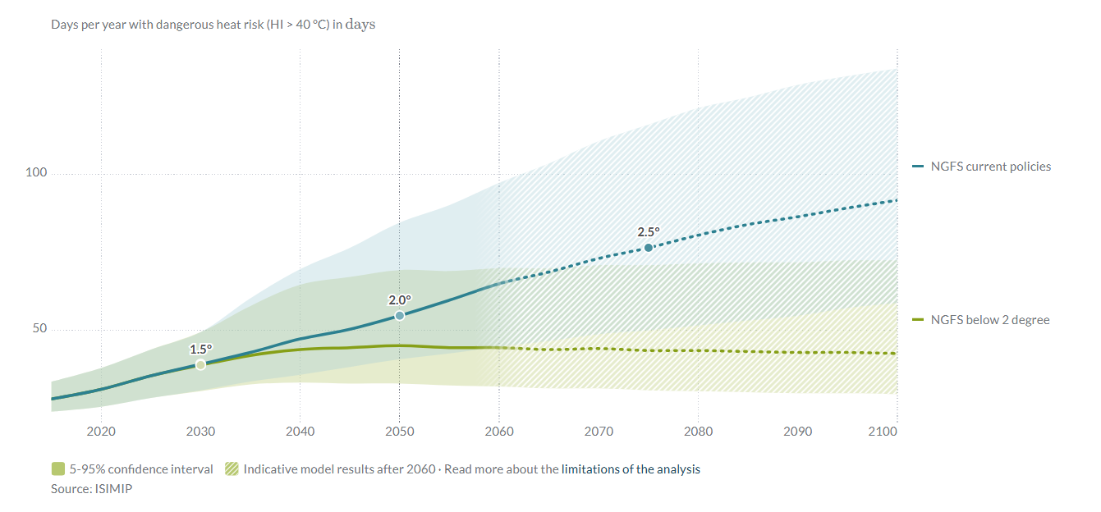
Figure 1. Days of dangerous heat per year in Niger: the gap between the two curves is what limiting warming saves. The two pathways are identical until about 2030 and then diverge. By 2100, current policies (blue) lead to about 91 days a year, against 42 below 2 °C (green) and 31 today. The shaded uncertainty bands overlap, yet even the low end of the current-policies range (59 days) exceeds the central below-2 °C estimate. Hatched area: results after 2060 are indicative. Source: Climate Impact Explorer, Climate Analytics (ISIMIP data).

3. What limiting warming would change for Niger
The gains are large and concentrated where people live. Compared with current policies, a below-2 °C world would spare Niger about 49 days of dangerous heat a year by 2100, nearly two months in which outdoor work, livestock and health are at risk, and would cut the intensification of extreme rainfall from +43 % to +17 %. A 1.5 °C pathway would go further, holding dangerous-heat days near today’s level (32 a year by 2100). The economic stakes are of the same order: climate change could reduce Niger’s annual GDP by 2.2 % in a wet, optimistic scenario and by 11.9 % in a dry, pessimistic one by 2050, before counting migration or conflict (World Bank, 2022).
Drought makes adaptation urgent in every scenario. Because severe drought months spread to almost the whole country by 2030 regardless of emissions, adaptation cannot wait for the outcome of negotiations: drought-tolerant millet and sorghum, water harvesting, early warning and the protection of herders’ mobility are needed now. The danger lies in a cascade rather than a single number: a hot, dry year → failed harvests and pastures → higher grain prices and distress sales of livestock → malnutrition, household debt and farmer–herder tensions → emergency spending that crowds out investment. Every tenth of a degree avoided makes such years rarer and the adaptation bill smaller.
Recommended negotiating position
- Defend the 1.5 °C goal, the only pathway that keeps dangerous heat near today’s level and reverses the spread of drought, and press major emitters for NDCs consistent with a rapid fossil-fuel phase-out.
- Link Niger’s support for any agreement to scaled-up adaptation finance with simplified access for Least Developed Countries.
- Use the Loss and Damage Fund for droughts and floods, in coalition with the African Group of Negotiators and the LDC Group.

4. Confidence and limits of the evidence
The direction of change is robust for heat, but its size is uncertain: under current policies, models span 59 to 134 dangerous-heat days in 2100. The heat index relies on an approximation of humidity during the hottest hour, a limitation the tool acknowledges. The drought indicator counts a single month of severe drought, so it saturates and barely separates the scenarios. For extreme rainfall, the model range includes no change under low warming but not under current policies by 2100. The tool’s crop indicators (maize, rice, soy) were deliberately set aside because Niger’s staples, millet and sorghum, are not modelled. Finally, these figures are hazard projections, not forecasts: given Niger’s high social vulnerability, real impacts are likely to be larger.

References
AFP (2024, 9 October). Niger ups flood toll to 339 dead, more than 1 million affected. Inquirer.net. https://globalnation.inquirer.net/251812/niger-ups-flood-toll-to-339-dead-more-than-1-million-affected
Climate Analytics (2026). Climate Impact Explorer: Niger. Indicators: days per year with dangerous heat risk (HI > 40 °C), area under severe drought (SPEI < −1.5) and annual maximum 5-day precipitation; NGFS Below 2 °C, Current Policies and Net Zero 2050 scenarios; ISIMIP data. https://climate-impact-explorer.climateanalytics.org (accessed 9 October 2026).
Mohamed, A. M. L., Salack, S., Mkuhlani, S., Chemura, A., et al. (2025). Impact of climate change on millet yield under different fertilization levels in three agroecological zones of Niger Republic. PLOS ONE, 20(10), e0333963. https://doi.org/10.1371/journal.pone.0333963
Sylla, M. B., Faye, A., Giorgi, F., Diedhiou, A., & Kunstmann, H. (2018). Projected heat stress under 1.5 °C and 2 °C global warming scenarios creates unprecedented discomfort for humans in West Africa. Earth’s Future, 6(7), 1029–1044. https://doi.org/10.1029/2018EF000873
Taylor, C. M., Belušić, D., Guichard, F., Parker, D. J., Vischel, T., Bock, O., Harris, P. P., Janicot, S., Klein, C., & Panthou, G. (2017). Frequency of extreme Sahelian storms tripled since 1982 in satellite observations. Nature, 544, 475–478. https://doi.org/10.1038/nature22069
World Bank (2022). G5 Sahel Region Country Climate and Development Report. CCDR Series. Washington, DC: World Bank. http://hdl.handle.net/10986/37620
World Bank (2024, 28 June). The World Bank supports food security and climate resilience for households in Niger [Press release]. https://www.worldbank.org/en/news/press-release/2024/07/01/the-world-bank-supports-food-security-and-climate-resilience-for-households-in-niger

