Policy Memo: Why Limiting Climate Change Matters for Niger
To: Minister of Environment, Head of Niger’s UNFCCC delegation | From: KOUAME Koffi Fidèle, Climate Adviser
Date: 14 October 2026 | Subject: Climate risks for Niger and the case for limiting global warming

Key message
Models indicate that, under current global policies, Niger could face about 91 days of dangerous heat a year by 2100, three times today’s level, against about 42 if warming is held below 2 °C and 32 on a 1.5 °C pathway. Because most Nigeriens farm and herd outdoors, this is the largest loss that faster global emission cuts can still avoid. Severe drought, by contrast, is projected to become near-universal in every scenario, so Niger also needs adaptation finance now.

Three priority impacts
Impact (CIE indicator) | Today (2020) | 2100: 1.5 °C path | 2100: below 2 °C | 2100: current policies
Dangerous heat: days per year with a daily maximum heat index above 40 °C | 31  [25–38] | 32  [24–50] | 42  [29–72] | 91  [59–134]
Severe drought: share of land with at least one month of SPEI below −1.5 | 84 %  [72–97] | 87 %  [66–100] | 98 %  [81–100] | 100 %  [98–100]
Extreme rainfall: annual maximum 5-day rainfall, change from 1995–2014 | +8 %  [−7, +29] | +9 %  [−6, +38] | +17 %  [−1, +54] | +43 %  [+5, +110]
Table 1. Source: Climate Impact Explorer (Climate Analytics, 2026), Niger, annual values, area-weighted average. NGFS scenarios: Net Zero 2050 (1.3 °C of global warming in 2100), Below 2 °C (1.6 °C) and Current policies (2.9 °C). Median of five models; 5–95 % range in brackets. Values after 2060 are indicative.
Dangerous heat. The number of days with a daily maximum heat index above 40 °C, the “danger” threshold used in heat warnings, is projected to rise from about 31 today to 91 by 2100 under current policies, against 42 below 2 °C. The two pathways only separate after 2030 (Figure 1). This matters because agriculture and livestock employ more than 80 % of the population, mostly outdoors and without cooling (World Bank, 2024).
Severe drought. This indicator accounts for evaporation as well as rainfall. About 84 % of the land already experiences at least one month of severe drought a year, and models project 98 to 100 % by 2100 both below 2 °C and under current policies; only the 1.5 °C pathway keeps the share lower (87 %). Rain-fed millet, sorghum and pastures are therefore likely to face more frequent water stress whatever the global outcome.
Extreme rainfall. The heaviest five-day rainfall of the year could intensify by about 43 % by 2100 under current policies, against 17 % below 2 °C, although the model range is wide. Heavier downpours would raise flood risk in Niamey and the Niger River valley, where people, infrastructure and irrigated rice are concentrated.
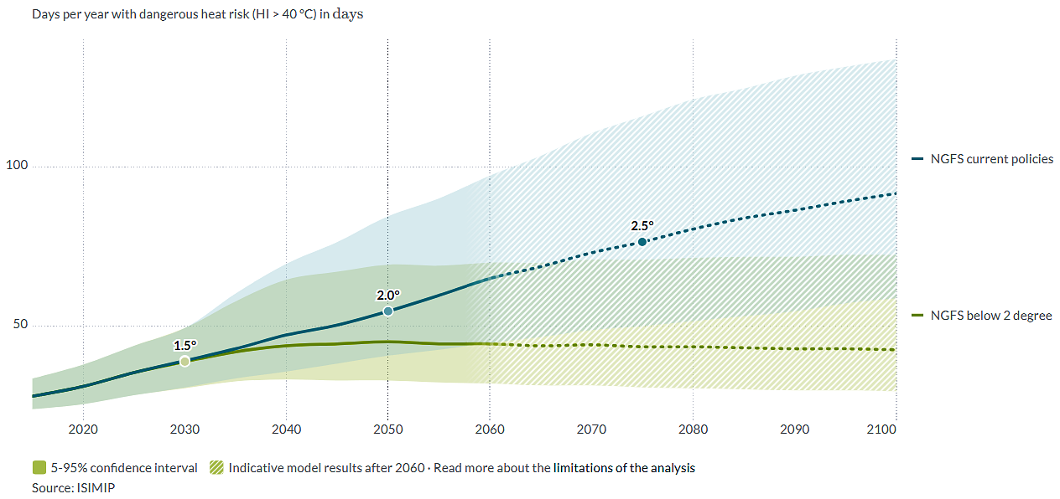
Figure 1. Days of dangerous heat per year in Niger, below 2 °C (green) and under current policies (blue). The curves are identical until about 2030; the gap that opens afterwards is what limiting warming avoids. Even the low end of the current-policies range in 2100 (59 days) lies above the central below-2 °C value (42 days). Source: Climate Impact Explorer (Climate Analytics, 2026).

Implications for Niger’s national interest
Limiting warming is in Niger’s direct interest. Compared with current policies, a below-2 °C world would avoid about 49 days of dangerous heat a year by 2100 and reduce the projected intensification of extreme rainfall from 43 % to 17 %; a 1.5 °C pathway would keep heat close to today’s level. The World Bank estimates that climate change could reduce Niger’s annual GDP by 2.2 % in wetter scenarios and by 11.9 % in drier ones by 2050 (World Bank, 2022). These losses can cascade: a hot, dry year cuts harvests and pasture, raises grain prices, forces households to sell livestock, and can deepen malnutrition and tensions between farmers and herders. Because drought is projected to spread in every scenario, Niger should defend the 1.5 °C goal in the negotiations while seeking adaptation finance for drought-tolerant crops, water harvesting and early warning.

Uncertainty
These figures are projections, not forecasts, and model ranges are wide (59 to 134 heat days in 2100 under current policies). The heat index relies on an estimate of humidity, and the drought indicator counts a single month of drought, so it saturates. Given Niger’s high vulnerability, actual impacts may exceed what these hazard indicators suggest.

References
Climate Analytics (2026). Climate Impact Explorer: Niger. Indicators: days per year with dangerous heat risk (HI > 40 °C), area under severe drought (SPEI < −1.5) and annual maximum 5-day precipitation; NGFS Net Zero 2050, Below 2 °C and Current Policies scenarios; ISIMIP data. https://climate-impact-explorer.climateanalytics.org (accessed 9 October 2026).
World Bank (2022). G5 Sahel Region Country Climate and Development Report. CCDR Series. Washington, DC: World Bank. http://hdl.handle.net/10986/37620
World Bank (2024, 28 June). The World Bank supports food security and climate resilience for households in Niger [Press release]. https://www.worldbank.org/en/news/press-release/2024/07/01/the-world-bank-supports-food-security-and-climate-resilience-for-households-in-niger

