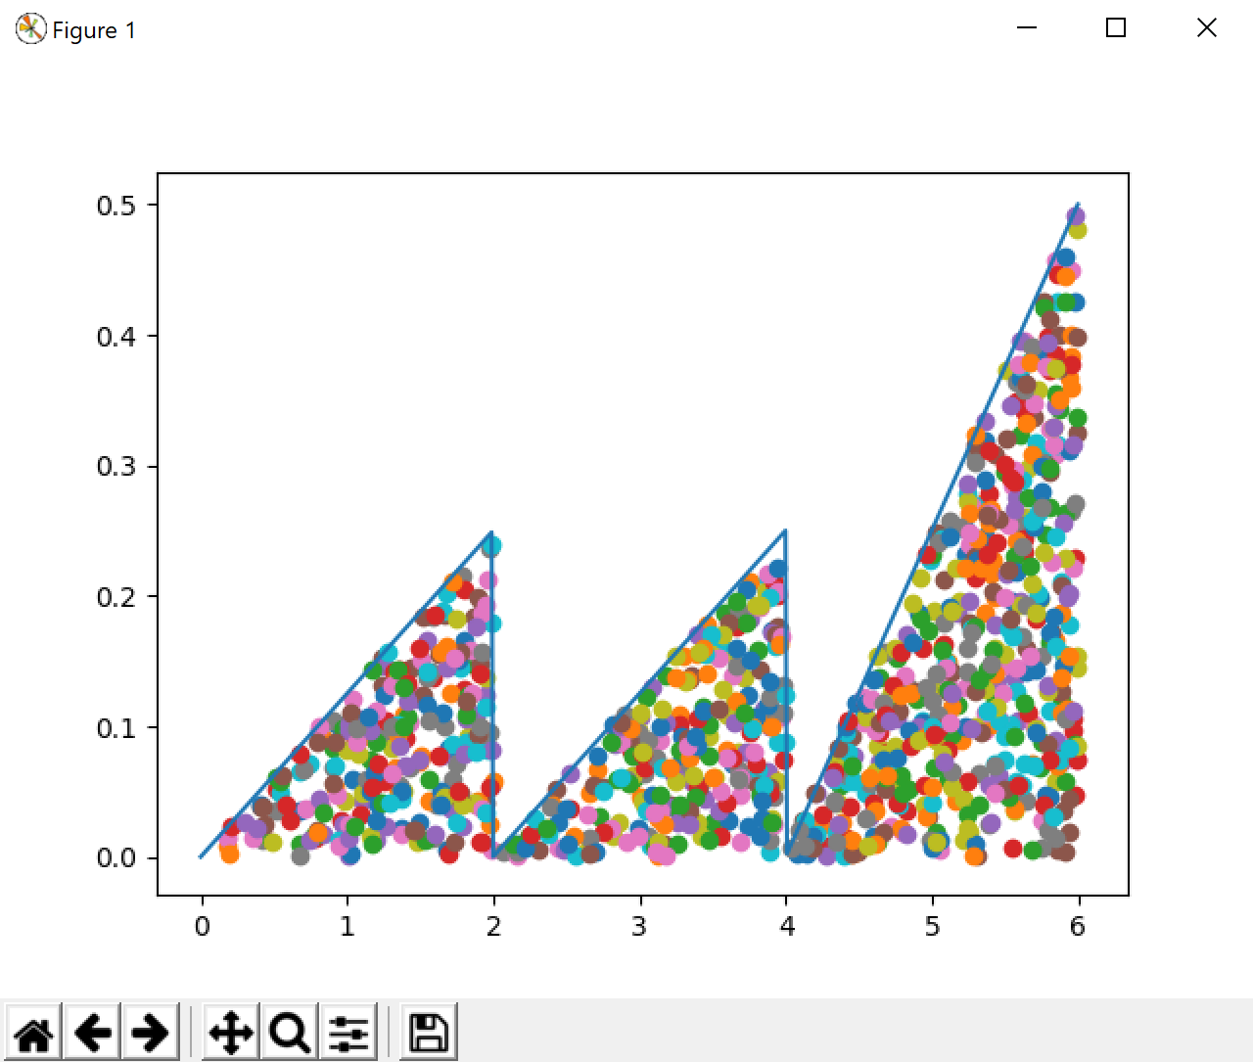

import matplotlib.pyplot as plt

import random

def function(x):

if 0<=x <2:

return (0.25\*x)/2

elif 2 <=x <4:

return (0.25\*(x-2))/2

elif 4 <=x <6:

return (0.5\*(x-4))/2

else:

return 0

numOfpoints = 5000

M = .8

x = []

a,b = 0,6

while a<=b:

x.append(a)

a+=.01

y = [function(i) for i in x]

points = []

plt.figure()

plt.plot(x,y)

for i in range(0,numOfpoints):

r1 = random.random()

r2 = random.random()

x0 = r1\*6

tempY = r2\*M

if (tempY < function(x0)):

plt.scatter(x0,tempY)

plt.show()

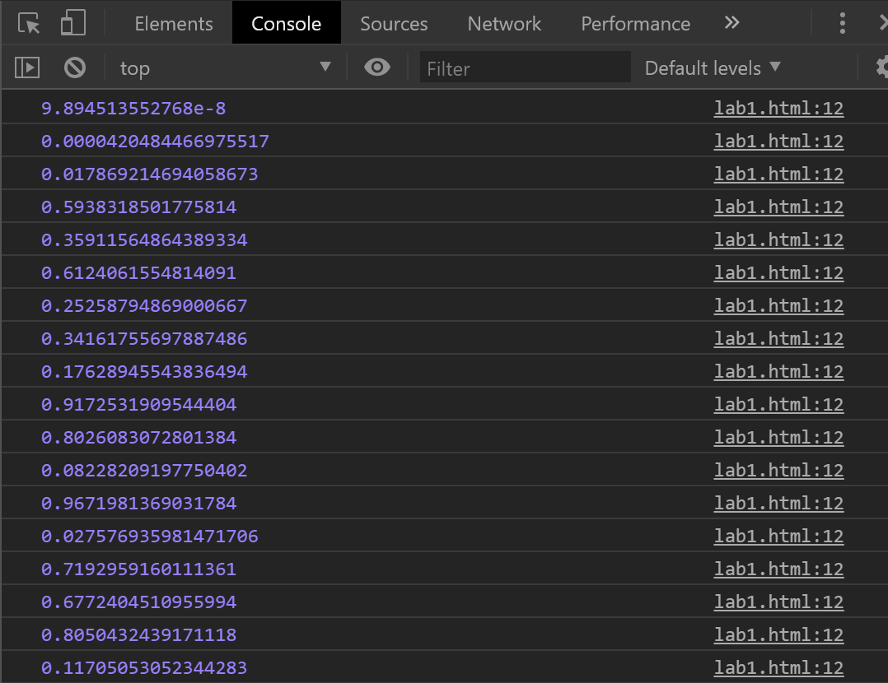

<script>

var m = 2.3283e-10;

var M = 424.967296;

var lastX = m;

for (var i = 0; i < 100; i++) {

var newX = (M \* lastX)%1;

lastX = newX;

console.log (newX);

}

</script>

<script>

class Point {

constructor(x, y) {

this.x = x;

this.y = y;

}

}

class Point3 {

constructor(x, y, z) {

this.x = x;

this.y = y;

this.z = z;

}

}

function printPoint(p){

console.log(p.x + "\t" + p.y + "\t" + p.z);

}

function indexOf(list, x){

for(var i = 0; i < list.length; i++){

if(list[i].x == x)

return i;

}

return -1;

}

var points = [new Point(2, 0.04), new Point(3, 0.15), new Point(7, 0.2),new Point(12, 0.25), new Point(19, 0.2), new Point(23, 0.15), new Point(30, 0.01)];

var intervals = [];

var randomValues = [];

var frequency = [];

var x0 = 0, x1 = 0;

for(var i = 0; i < points.length; i++){

x0 = x1;

x1 = x0 + points[i].y;

intervals.push(new Point3(x0, x1, points[i].x));

frequency.push(0);

}

for(var i = 0; i < 100; i++){

var value = Math.random();

randomValues.push(value);

for(var j = 0; j < intervals.length; j++){

var currentInterval = intervals[j];

if(value >= currentInterval.x && value < currentInterval.y){

console.log(value.toFixed(4) + " : \t" + currentInterval.z);

frequency[indexOf(points, currentInterval.z)] += 1;

}

}

}

console.log("Frequencies");

for(var i = 0; i < points.length; i++)

console.log(points[i].x + " :\t" + frequency[i]);

</script>

