**SQL HOMEWORK**

**EMPLOYEE DATABASE: A Mystery in Two Parts**

**INTRODUCTION:**

The homework seeks to highlight the understanding of PostgreSQL by applying the skills developed in:

* Data Modelling and Engineering
* Data Analysis
* As a bonus: Test the credibility of dataset

1. **Data Modelling and Engineering**

From the csv files provided, a sketch of an ERD (Entity Relationship Diagram) is carried using [https://www.quickdatabasediagrams.com] as a tool which is saved as QuickDBD-SQL_Home_Work.png. Based on the data primary keys are assigned to unique columns in order to identify a row and importantly is to import the data based on the same order that the tables were created by accounting for headers. Table schema, saved as Schemas.sql.

1. **Data Analysis**

From the schema created, a database (SQL_homework) was created in order to be able to carry out the analysis on the following:

1. List the following details of each employee: employee number, last name, first name, sex, and salary.

2. List first name, last name, and hire date for employees who were hired in 1986.

3. List the manager of each department with the following information: department number, department name, the manager's employee number, last name, first name.

4. List the department of each employee with the following information: employee number, last name, first name, and department name.

5. List first name, last name, and sex for employees whose first name is "Hercules" and last names begin with "B."

6. List all employees in the Sales department, including their employee number, last name, first name, and department name.

7. List all employees in the Sales and Development departments, including their employee number, last name, first name, and department name.

8. In descending order, list the frequency count of employee last names, i.e., how many employees share each last name.

The queries to the above questions are saved as Queries.sql.

1. **As a bonus: Test the credibility of dataset**

The requirement is to clear every suspicion in the data by generating some visualization of the data.

**Solution:**

To achieve this the database, SQL_homework was exported into Jupyter Notebook by importing the following dependencies:

import os

import pandas as pd

import psycopg2

from matplotlib import pyplot as plt

import sqlalchemy

from sqlalchemy.ext.automap import automap_base

from sqlalchemy.orm import Session

from sqlalchemy import create_engine, inspect

%matplotlib notebook

From the Analysis a histogram visualization is created figure 1.0 and 1.1 showing the distribution of salary ranges for all employees. It can be observed that the average salary for all employees is around 52970, with the 25th percentile at 40000, 75th percentile at 61758 and a maximum salary standing at 129493.

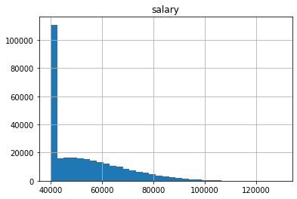

Fig. 1.0: A histogram plot for salary ranges of employees

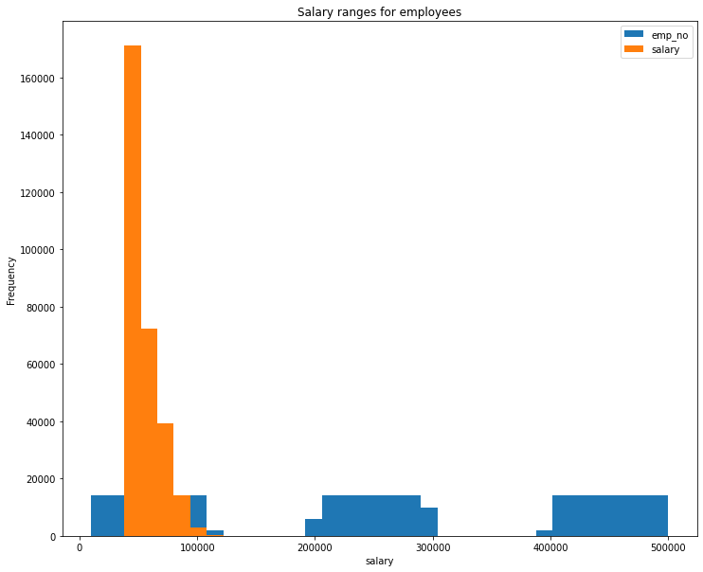

Fig.1.1: Showing salary ranges for employees with label

Finally, a bar chart is plotted based on the average salary by title. Table 1.0 and Figure 1.3 as shown below.

Table 1.0: Average salary by Title of employees

|  |  |
| --- | --- |
| Title | Average Salary |
| Staff | 58465.382850 |
| Senior Staff | 58550.172704 |
| Assistant Engineer | 48564.434447 |
| Engineer | 48535.336511 |
| Senior Engineer | 48506.799871 |
| Technique Leader | 48582.896092 |
| Manager | 51531.041667 |

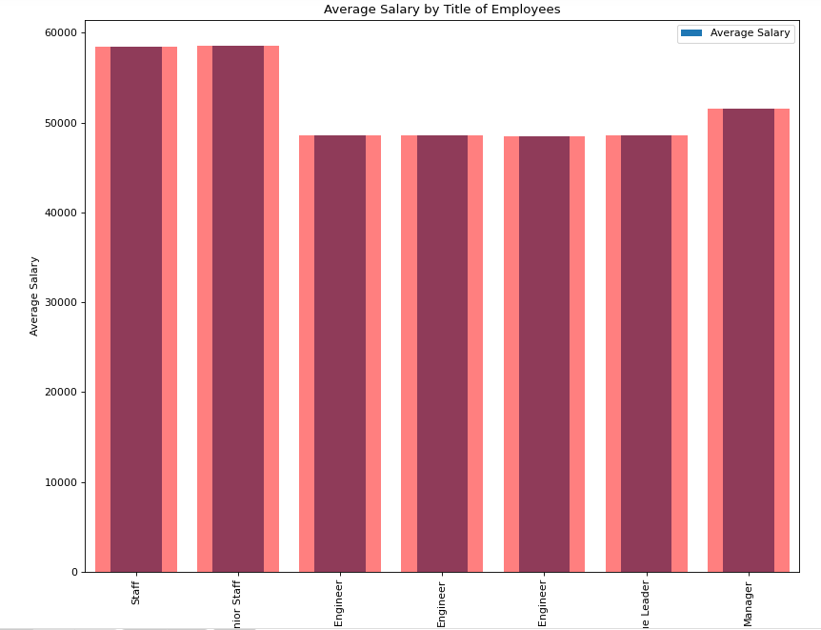

Fig. 1.3: Bar chart of Average salaries by Title of Employees

**CONCLUSION:**

The sql-challenge was an experienced with the use of many different tools. The major one was getting the database into Jupyter notebook. I had to dig deep as it took majority of this assignment but was at the end a success. Critically, the visualization shows the very import details.