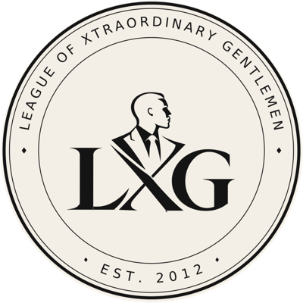 | THE LXG REUNION  Programme
Adi Lake Resort, Akosombo, Eastern Region ◆ 13 – 14 November 2026
DAY ONE Friday 13 November
5:00 PM | Arrival & Check-in
7:00 PM | Welcome Address  LOC Chairman
 | Dinner Buffet & Introductions
8:00 PM | Breakout Groups & Games
9:00 PM | Work Stream Discussions & Presentations
10:00 PM | Closing Remarks  Summary of resolutions & action owners — Senior LXG Member  Vote of thanks — Senior LXG Member
DAY TWO Saturday 14 November
8:00 AM | Breakfast
10:00 AM | Boat Riding, Jet Skiing & Golf
After activities | Group Pictures
1:00 PM | Departure
BREAKOUT GROUPS
Group 1: Vision & Mission
- Who are we and what do we stand for
- Vision and mission
- Values
Group 2: LXG Business
- Collective investment and business opportunities
- Welfare discussions
- Structure, roles and accountability
Group 3: Governance & Framework — Entry and Exit
- Code & conduct of members
- Restoration of exited members
- New members
WHAT TO BRING
- Smart-casual outfit for dinner
- Swimwear and sun protection
- Golf attire

