The population of the English-Speaking West African countries are given in Table. Show this figure in a pie chart.

**Table A**

|  |  |
| --- | --- |
| **Country** | **Population** |
| Gambia | 600000 |
| Ghana | 8600000 |
| Nigeria | 79800000 |
| Sierra Leone | 3200000 |
| **Total** | 92200000 |

Find the Angle for each country?

Nigeria would be 79800000÷92200000×360*=312*

**Table B**

|  |  |  |
| --- | --- | --- |
| **Country** | **Population** | **Angle** |
|  |  | 2 |
|  |  | 34 |
|  |  | 312 |
|  |  | 12 |
|  |  | 360 |

Find the percentage of each country?

Nigeria would be 312/360×100%=87%

**Table C**

|  |  |  |  |
| --- | --- | --- | --- |
| **Country** | **Population** | **Angle** | **Percentage** |
|  |  |  | 1% |
|  |  |  | 9% |
|  |  |  | 87% |
|  |  |  | 3% |
|  |  |  | 100% |

Show these figures in a pie chart, analyze and describe?

Configure

ChatGPT

**GPT Builder**

Hi! I'll help you build a new GPT. You can say something like, "make a creative who helps generate visuals for new products" or "make a software engineer who helps format my code."

What would you like to make?



**You**

make a software engineer who helps format my code

ChatGPT

**GPT Builder**

How about the name **Code Companion** for this GPT? Does that sound good to you, or do you have another name in mind?



**You**

yes and the name is Code Silence

ChatGPT

**GPT Builder**



**You**

1DEAD.docx

Document

ChatGPT

**GPT Builder**

Great, you've uploaded a file. How can **Code Silence** assist you with this document?



**You**

Find the Angle for each country?

ChatGPT

**GPT Builder**

The document contains a table of English-Speaking West African countries with their populations and asks to find the angle each country represents in a pie chart based on their population. It includes a calculation for Nigeria as an example, showing how to calculate the angle using the formula based on the country's population relative to the total population and then multiplying by 360 degrees. The document also prompts to find the percentage representation of each country and to display these figures in a pie chart for analysis and description.



**You**

show step by step how to find the angle of each country

ChatGPT

**GPT Builder**

To find the angle each country represents in a pie chart based on their population, follow these steps:

1. **Calculate Total Population**: Add up the populations of all listed countries to get the total population.
2. **Determine Each Country's Share**: For each country, divide its population by the total population. This gives you the fraction of the pie chart that country represents.
3. **Calculate Angle**: Multiply each country's fractional share by 360 degrees to find the angle it represents in the pie chart.

This method applies the principle that the whole pie chart represents 360 degrees, so the angle for each country is proportional to its population relative to the total population of all listed countries.



**You**

show the mathmatical method or formula

ChatGPT

**GPT Builder**

To calculate the angle each country represents in a pie chart based on their population, you use the formula:

Angle of Country=(Population of CountryTotal Population of all Countries)×360∘Angle of Country=(Total Population of all CountriesPopulation of Country​)×360∘

This formula calculates the fraction of the total population that each country represents and then converts that fraction into an angle in degrees, assuming a full circle represents 360 degrees.



**You**

find the angle of each country and show the result

ChatGPT

**GPT Builder**

The document outlines a detailed process involving the calculation of angles for countries in a pie chart based on their populations. It provides the mathematical method required for calculation, using the formula to determine each country's proportional representation and then converting it into an angle for the pie chart. The example given for Nigeria demonstrates the step-by-step application of the formula, illustrating how to use population data to calculate the angle accurately. However, I cannot perform calculations or access the specific population data without it being provided directly in our conversation. If you provide the population figures for each country, I can assist further with the calculations.



**You**

Table A Country Population Gambia 600000 Ghana 8600000 Nigeria 79800000 Sierra Leone 3200000 Total 92200000

ChatGPT

**GPT Builder**

Based on the population data provided for each country, let's calculate the angle each country represents in a pie chart:

1. **Gambia**: (600,00092,200,000)×360=6922×360≈2.34∘(92,200,000600,000​)×360=9226​×360≈2.34∘
2. **Ghana**: (8,600,00092,200,000)×360=86922×360≈33.62∘(92,200,0008,600,000​)×360=92286​×360≈33.62∘
3. **Nigeria**: (79,800,00092,200,000)×360=798922×360≈311.50∘(92,200,00079,800,000​)×360=922798​×360≈311.50∘
4. **Sierra Leone**: (3,200,00092,200,000)×360=32922×360≈12.49∘(92,200,0003,200,000​)×360=92232​×360≈12.49∘

These angles approximate how much of the pie chart each country's population represents.



**You**

Find the percentage of each country?

ChatGPT

**GPT Builder**

To find the percentage representation of each country, we use the formula:

Percentage of Country=(Population of CountryTotal Population of all Countries)×100%Percentage of Country=(Total Population of all CountriesPopulation of Country​)×100%

Here are the percentages based on the given populations:

* **Gambia**: 600,00092,200,000×100%≈0.65%92,200,000600,000​×100%≈0.65%
* **Ghana**: 8,600,00092,200,000×100%≈9.33%92,200,0008,600,000​×100%≈9.33%
* **Nigeria**: 79,800,00092,200,000×100%≈86.55%92,200,00079,800,000​×100%≈86.55%
* **Sierra Leone**: 3,200,00092,200,000×100%≈3.47%92,200,0003,200,000​×100%≈3.47%

These percentages indicate the proportion of the total population each country represents.



**You**

make a table to represent 3 columns Country, Population and Angle

ChatGPT

**GPT Builder**

| **Country** | **Population** | **Angle (Approx.)** |
| --- | --- | --- |
| Gambia | 600,000 | 2.34° |
| Ghana | 8,600,000 | 33.62° |
| Nigeria | 79,800,000 | 311.50° |
| Sierra Leone | 3,200,000 | 12.49° |

This table represents the countries, their populations, and the approximate angles they represent in a pie chart, based on the data you provided.



**You**

add another column for the Percentage

ChatGPT

**GPT Builder**

| **Country** | **Population** | **Angle (Approx.)** | **Percentage** |
| --- | --- | --- | --- |
| Gambia | 600,000 | 2.34° | 0.65% |
| Ghana | 8,600,000 | 33.62° | 9.33% |
| Nigeria | 79,800,000 | 311.50° | 86.55% |
| Sierra Leone | 3,200,000 | 12.49° | 3.47% |

This enhanced table now includes the countries, their populations, the approximate angles they represent in a pie chart, and their percentage of the total population based on the provided data.



**You**

draw a pie chart for the table

ChatGPT

**GPT Builder**

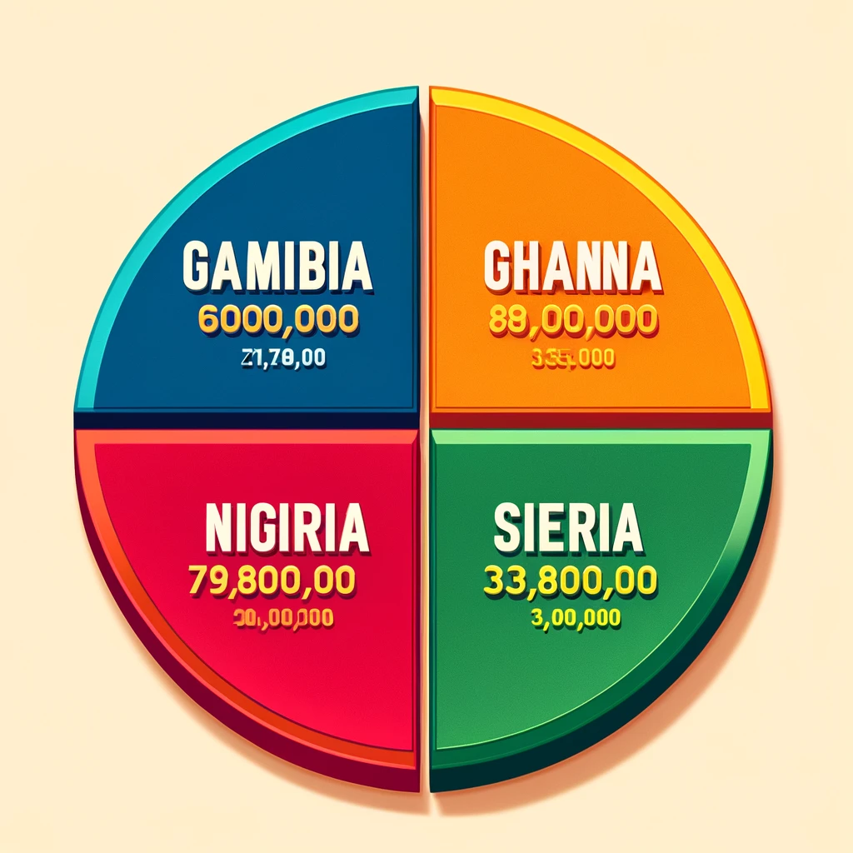

Here's the pie chart based on the table provided, showcasing the population percentages for Gambia, Ghana, Nigeria, and Sierra Leone. Each segment is labeled with the country's name and its percentage of the total population.



**You**

show the population of country on the piechart

ChatGPT

**GPT Builder**

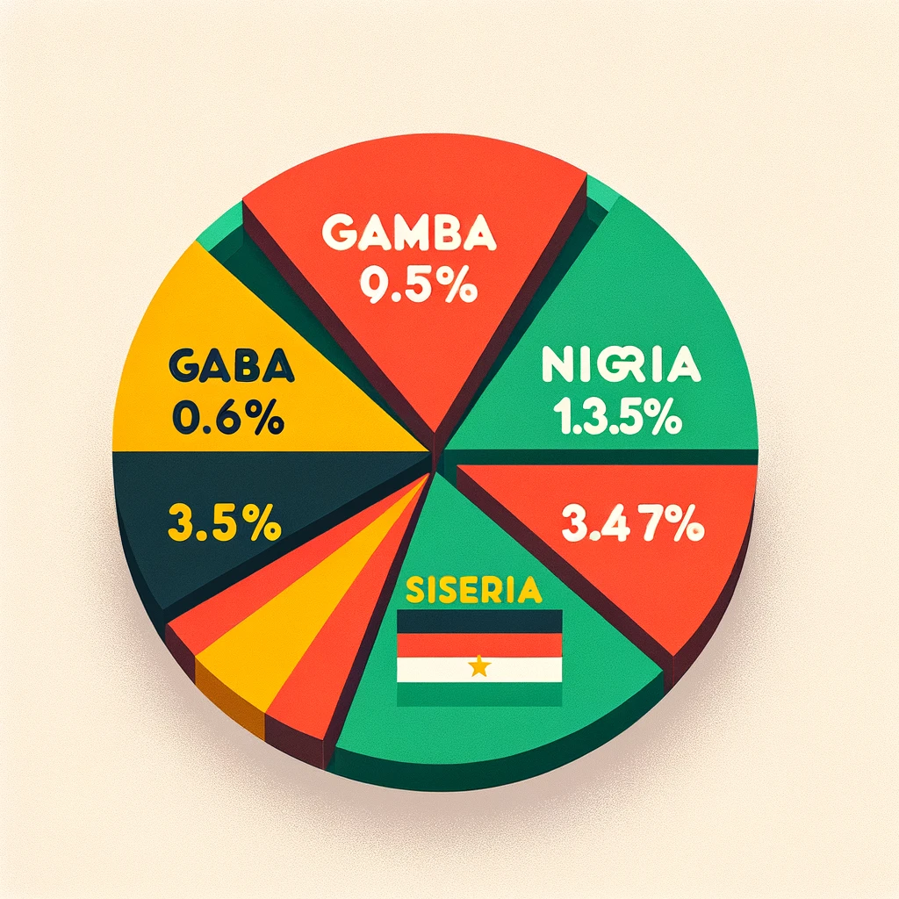

Here's the updated pie chart, now showcasing the population of each country on their respective segments.



**You**

analyse the data

ChatGPT

**GPT Builder**

Analyzing the data presented in the pie chart with populations:

* **Nigeria** is the dominant country in terms of population among the English-speaking West African countries listed, with a staggering 86.55% of the total population. This highlights Nigeria's significant demographic weight in the region, underscoring its potential influence in economic, cultural, and political spheres within West Africa. Nigeria's population of 79,800,000 makes it a crucial market and a central focus for regional initiatives.
* **Ghana** holds the second-largest population share at 9.33%, with 8,600,000 people. Although significantly smaller than Nigeria, Ghana's population size still represents a substantial portion of the region's demographics. Ghana's position suggests it plays a key role in the region but on a different scale compared to Nigeria.
* **Sierra Leone** and **Gambia** represent smaller segments of the population, with 3.47% and 0.65% respectively. Sierra Leone's population of 3,200,000 and Gambia's 600,000 indicate these countries have much smaller populations. While they may not exert as much demographic influence as Nigeria or Ghana, their unique cultural and social contributions are vital to the region's diversity and character.

The vast difference in population sizes, especially between Nigeria and the other countries, indicates diverse challenges and opportunities for development, policy-making, and regional cooperation. Nigeria's demographic dominance suggests it has a pivotal role in shaping the region's future, while the smaller countries like Gambia and Sierra Leone offer insights into the dynamics of smaller states within a larger regional context. This demographic landscape underscores the importance of tailored approaches to development, diplomacy, and economic policy that consider both the weight of Nigeria and the unique positions of smaller nations.