EBS 221 HW 2

Benoit Rouchy and Kevin Oghalai

- Part a) was implemented in code and is tested in subsequent sections.

- This was implemented and is shown in the next section.
- The implemented closed loop control is shown in Figure 1.
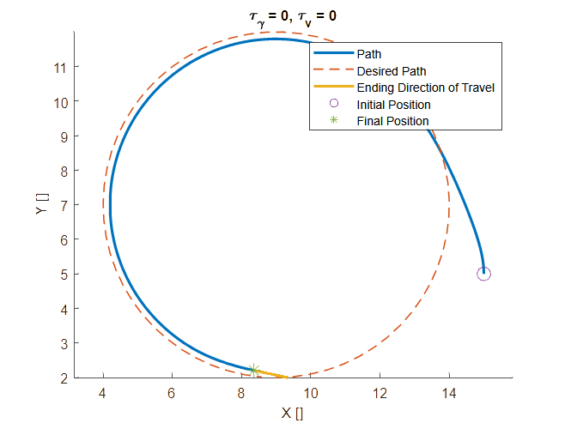Figure 1: Initial pure pursuit controller with goal points spaces 0.1 radians apart.
One thing that was unexpected was that the robot did not follow the path perfectly. Through testing, this was determined to be an issue with the pure pursuit controller, as it’s goal point did not update for significant periods of time, since each goal point was fairly spread out(0.1 radians apart). By decreasing the distance between points on the path(goal points every 0.1 radians), this consistent error was able to be decreased to nearly 0. Shown in Figure 2 is a plot of what that looks like.
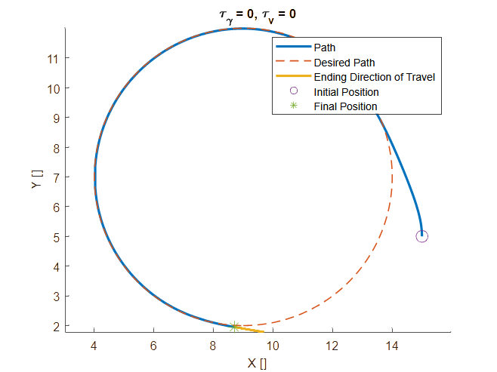Figure 2: Pure pursuit controller with points spaced 0.01 radians apart.
- The cross track error for the points spaced every 0.1 radians is plotted below in blue. There is a steady state error and jagged behavior. The steady state error is caused by goal points that are spaced too wide, and the jagged behavior is caused by the error increasing when the vehicle is in between two goal points. The error rapidly increases, then decreases as the robot gets further from the point that is behind it, eventually getting closer to a point in front, at which the distance to the closest point starts to rapidly decrease. Figure 3 shows that the jagged behavior was able to be alleviated by interpolating between goal points, so that the cross track error is measured as being the closest distance to the target path, rather than the closest distance to a target point.
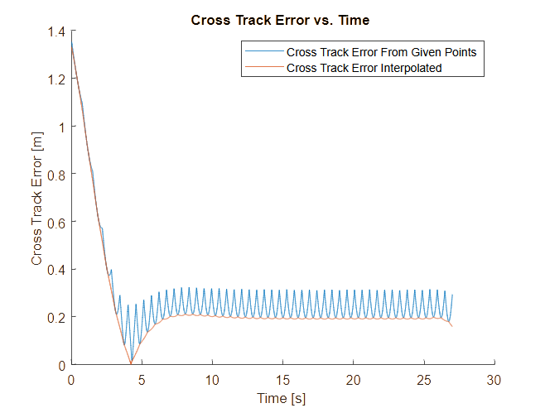Figure 3: Cross track error from pure pursuit controller with wide path point spacing.
- Shown in Figure 4 are the results when goal points are more closely located together, with interpolation between closest points. This leads to roughly a steady state error of 0 with smooth behavior.
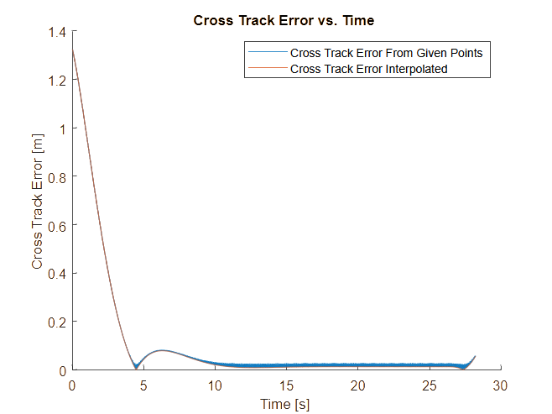Figure 4: Cross track error from pure pursuit controller with narrower path point spacing.
c)
    - The path was implemented and the results are shown below
    - The paths in Figure 5 are aggregated data of various lookahead distances from 0.5 to 3.5 m, since this is required for later steps.
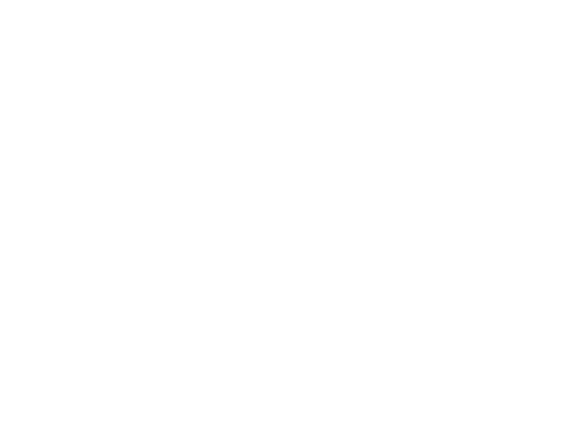Figure 5: Pure pursuit controller with lane change operation and varying lookahead distance.
Although all of the paths are smooth, the shorter lookahead distances tended to lead to large overshoots of the first turn, which generally led to large overshoots when correcting back to a horizontal direction later. Large lookahead times cut the first corner more, but this ended up leading to a more direct path to the ending, since they did not have the large overshoots later. Shown in Figure 6 is a plot of the cross track errors over time for these trials.

Figure 6: Cross track error for lane change with various lookahead distances.
As shown in the earlier figure, the larger lookahead distances had a larger and earlier deviation from the initial horizontal path, which can be seen from the peaks around 10 seconds. Bigger lookahead distances had the error start earlier and peak larger than short lookahead distances, however this led to lower overall overshoots during the correction back to horizontal movement around 20 seconds in. Shown in Figure 7 are error statistics created from the multiple runs. Maximum, mean, Root Mean Square(RMS) and 95 percentile values for the cross track error at various lookahead distances are shown in

A histogram of the cross track error for a single run is shown in Figure 8. This was created with the data from a lookahead distance of 2 meters.
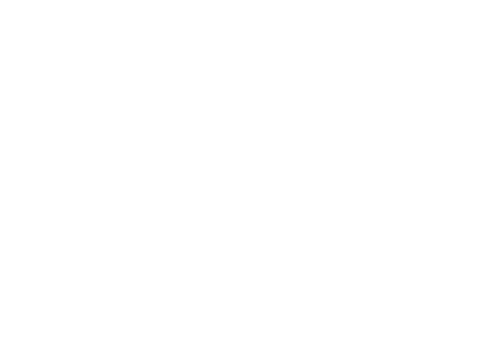Figure 7: Statistics from cross track error on lane change.
iv) The lane change operation was later carried out with varying speeds, rather than steering parameters. The results are shown in Figure 9.
Figure 8: Histogram of cross track error from lane change with a lookahead distance of 2 meters.

The lines basically overlap, so one is plotted slightly below the other, and as can be seen in the figure, they took essentially the same path, showing that the pure pursuit controller’s behavior is not speed dependent in ideal circumstances. The cross track error is shown in Figure 10.
Figure 9: Lane change with two different speeds
As would be expected, the cross track errors show the same trends, although one occurs at twice the speed of the other. Shown in Figure 11 are error statistics from these trials.
Figure 10: Cross track error from lane change with two speeds.
As described above, the error is the same, only occurring at different rates, which is represented in the statistics.
Figure 11: Cross track error statistics with changing velocity.
d)
I) Trials with changing time constants for the velocity and steering angle are shown in Figure 12. Additionally, trials with a different maximum steering angle are also shown.
Figure 12: Trials with varying time constants for steering angle and velocity, repeated with varying maximum steering angle.
As would be expected, with a time constant of 0, the turns are made more quickly and are tighter, leading to lower overshoots of the path. Also, with a lower maximum turning angle, the same thing appears to happen. The three trials with lower maximum steering angles overshot further of the first turn and correction back to horizontal. Cross track errors for the trials shown above are in Figure 13.

As stated above, increasing time constants led to larger overshoots, which can be seen around 14 and 20 seconds. The cross track error here is higher for the trials with larger time constants. Shown in Figure 14 is a comparison of the maximum cross track error achieved by various configurations.
Figure 13: Cross track error for varying time constants and maximum steering angle.
As could be seen qualitatively earlier, the maximum cross track error is higher for higher time constants. A similar comparison is done for varying maximum steering angles in Figure 15.
Figure 14: Comparison of maximum cross track error for varying time constants on velocity and steering angle.
Like seen in the figure, lower maximum steering angles led to larger overshoots, which manifested as larger maximum cross track errors.
Figure 15: Comparison of maximum cross track errors for varying maximum steering angle.

